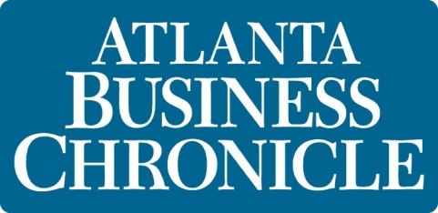
100 Most Influential Atlantans
Donna Hyland
President and CEO, Children’s Healthcare of Atlanta
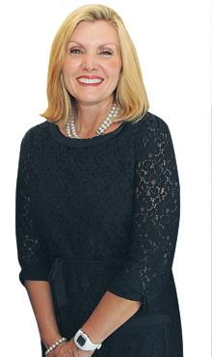
Donna Hyland
Donna Hyland
President and CEO, Children’s Healthcare of Atlanta
To know how influential Donna Hyland is, you only need to ask most any parent with small children in metro Atlanta. She runs an organization that cares for more than half a million patients annually. Patient visits grew from 553,000 in 2008 to almost 741,000 in 2010. Children’s operates 520 beds and employs more than 7,500. Surgeons at Children’s were involved in more than 38,000 surgeries in 2010, or more than 100 a day, ranging from common procedures to extensive transplants.
Children’s also operates as a subsidiary the Marcus Autism Center, battling a disease that continues to grow.
Hyland has served as CEO since November 2007.
On June 4, Children’s and Georgia Tech announced a$20 million research initiative that will focus on developing medical technologies aimed at pediatric care. The investment, which will help recruit new scientists, will focus on medical devices, nanomedicine and regenerative medicine research.
“This is all about kids and the lives of kids,” Hyland said. “It’s not just about taking care of kids when they are sick, but what can we do to keep them from getting sick.”

