104 Chi Tai Hse On Tai Estate, Sau Mau Ping, KLN, HK
John Chin
Tel: +852-60171279
E-mail: chinhotak@gmail.com

Resume
Objective
Visionary eCommerce strategist with over 15 years of global experience in managing eCommerce platforms, optimizing operations, and driving innovation across North America, Japan, and the EU5. Expertise in advanced analytics, AI integration, and digital marketing to achieve transformative growth for brands in competitive markets.
Language
Fluent in English, Cantonese, and Mandarin

Key Skills
- eCommerce Management: Shopify, Amazon, Walmart, Etsy, and TikTok platform expertise
- Analytics & AI Integration: Python (Pandas, NumPy), Google Analytics, and data-driven BI solutions
- Digital Marketing: SEO, online advertising, UGC campaigns, and CRM implementation
- Leadership: Team building, training, and cross-functional collaboration
- Languages: Fluent in English, Cantonese, and Mandarin

Professional Experience
Amazon Certified Trainer & Community Ambassador
Contracted Trainer | 2019–Present
- Collaborated directly with Amazon leadership to release and test cutting-edge tools and strategies for sellers.
- Developed and delivered licensed training modules across Greater China, educating sellers on platform optimization, advertising, and compliance.
- Guest speaker for Helium10 and Amazon’s China and USA projects, providing actionable insights on data analytics and eCommerce trends.

Shopify Project for Fashion Brands
Freelance Consultant | 2024
- Reduced ad spend from HKD 20K+ to HKD 8K/month while driving sales growth from HKD 60K to HKD 100K/month in pure profit.
- Optimized product listings, ad targeting, and audience segmentation to achieve significant ROI.
- Leveraged analytics tools and customer feedback to refine strategies and enhance engagement.

Amazon Licensed Service Partner
Advisor | 2019–Present
- Developed a Python-based learning model that integrates regional data (user reviews, ad reports, search trends) to deliver actionable insights with 80% accuracy.
- Implemented UGC syndication strategies, boosting brand visibility and increasing organic sales.
- Advised clients on Amazon Accelerator Brand compliance, ensuring product standards for multiple international markets.

Panda Ocean Inc.
General Manager | 2007–2023
- Managed eCommerce operations across Amazon, Shopify, and Walmart in the USA, Canada, Japan, and EU5 regions.
- Transitioned from an Amazon Licensed Brand seller to leading Accelerator Brand programs focused on compliance and growth.
- Conducted factory audits and ensured alignment with local and international policies to support successful product launches.

Certification

- Licensed Amazon Service Partner
- Licensed Amazon Seller Trainer
- Licensed Amazon Community Ambassador
- AI, Business & the Future of Work Certification

Education

- AI, Business & the Future of Work Certification, Lund University, May 3, 2024
- Social Media Marketing Program from British Columbia Institute of Technology, Canada, 2017
- Columbus University, Bachelor of Business Administration and Hotel Management, 2005
- Network Administrator Technician from British Columbia Institute of technology, Canada, 2003

VOLUNTEER EXPERIENCE
Business Advisor | HSBC x Junior Achievement (JA) Hong Kong

- Mentored high school students through the JA Company Program, fostering entrepreneurial skills and sustainability awareness.
- Delivered workshops on financial literacy and critical business skills, empowering students to succeed in the 21st-century economy.

Corporate Reference #1 – Former Li & Fung Logistic CEO

Organization | GPTBot.ai
Title | CBO
Contact Person | Tommy Lui
Phone # | 96137773
Details | Former Li & Fung Logistic CEO and project responsible on Client’s Ecommerce / App-Based Accessory Project

Corporate Reference #2 – China – Cross Border Ecommerce Manufacturing

Organization | DongGuan Chuanda Metal Produce CO., LTD
Title | CEO
Contact Person | Wang Zhaolong
Phone # | 0769-8201 2692
Details | John Chin served as our E-commerce Senior Consultant from 2011 to 2019, demonstrating profound expertise in platform management and staff training. His leadership significantly elevated our online presence, especially on major platforms like Amazon, Walmart, and eBay

Corporate Reference #3 – China – HK – Canada Ecommerce Logistic

Organization | Saint Way (Shenzhen) Marketing Company Limited
Title | CEO
Contact Person | Dickio Xie
Phone # | +86 13509606550
Details | I met with John by Canada Trade Commissioner’s referral, and we worked for few ecommerce projects to build up HK, China and Canada crossborder trading solutions. Please feel free to contact me at +86 13509606550

Amazon Work Proof – Amazon Advertising

Organization | Amazon China – Advertising Department
Details | If there is any of my identity proof needs on my Amazon Seller Trainer status, please let me know and I will arrange Amazon South China Manager Venissa (Wechat: sunting512) in China for further contact

Work Portfolio
Case 1 (Short Term Project):
Successfully restructured ad strategies on Google and Facebook for a local Hong Kong fashion brand, reducing ad costs by 15% while driving a 25% increase in website sales across the HK/Macau market from June to August.

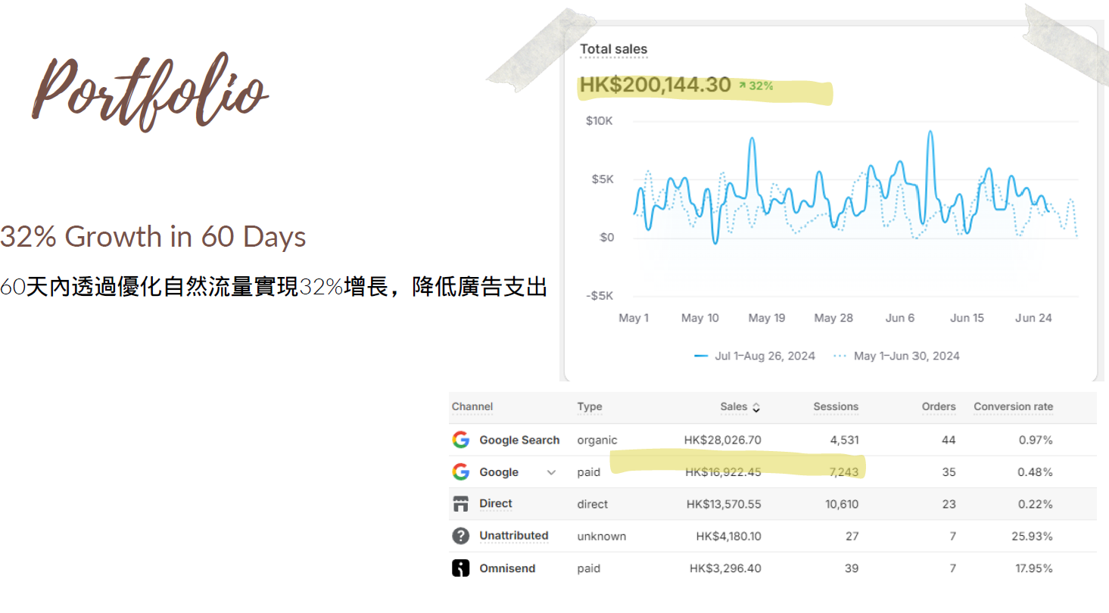

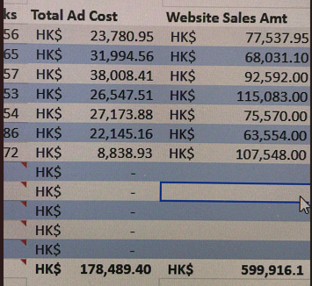

Case 2 – Training Material Project:

As an official Amazon Seller Trainer, I have extensive experience in global e-commerce in multi-platform distribution, specializing in AI/Machine Learning and data analytics

https://www.amazon.com/dp/B09X6WM4PP

Review Boosting for the FMCG products in 3 months by generating amazon traffic in cost of CPC 0.09USD per Clicks

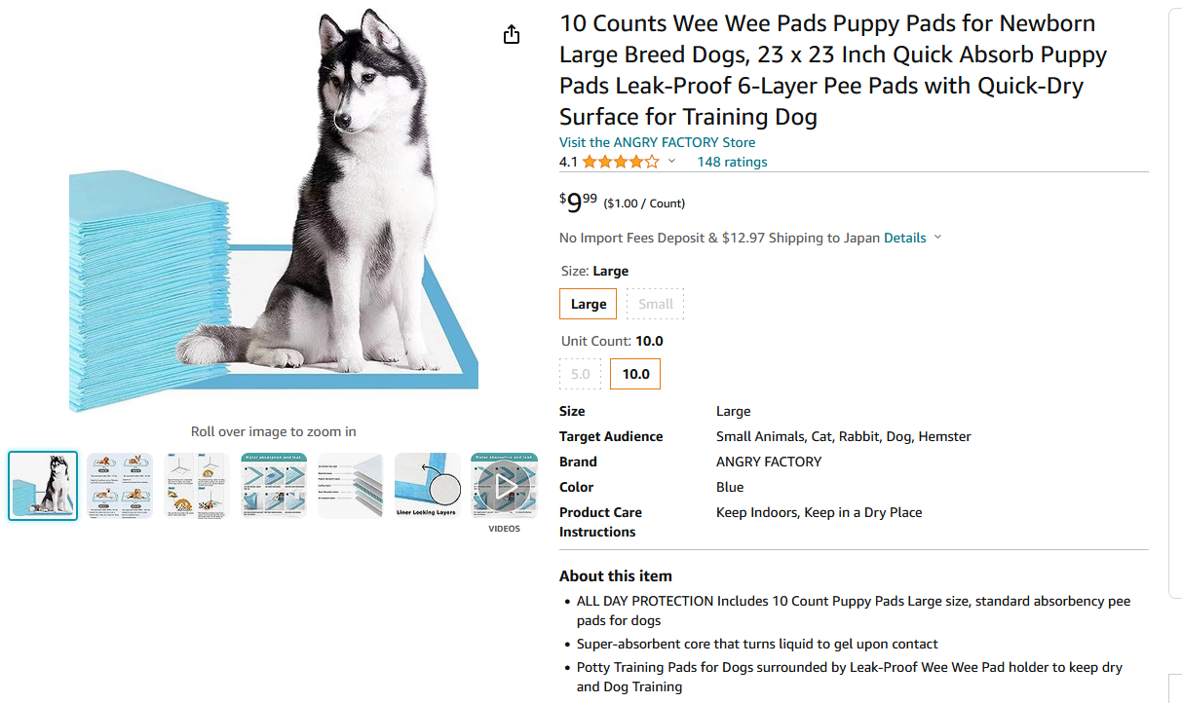
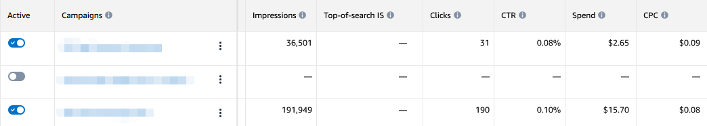
Case 3 – 6 Months Short Project:

Completely Restructure Swiss Watch Amazon Webshop with full optimize SEO and web cluster.



Result: Successfully cost down CPC from USD$1.5 to USD$0.5 with $0.47 with Brand Video/Retargeting Shopping Funnels

