Problem 2012 Analysis
There are various approaches to this problem, combining fields of mathematics such as trigonometry, geometry and vectors with computer programming techniques like divide and conquer, binary search, shortest path algorithms and dynamic programming. But it mainly lies in the field of Graph Theory
The first step to a solution is finding an appropriate representation of the input data. An intuitive structure is a graph whose vertices represent airports and whose edges represent potential flights. Each flight has two characteristics (besides its endpoints) – its length and the amount of fuel it uses up. Thus we have a weighted undirected graph with N vertices and M edges with two weights per edge. For convenience, we can assume that the fuel of each edge is positive and we’ll work with the total amount of used fuel, making sure it doesn’t exceed C (rather than having negative fuel for each edge and taking account of the fuel that’s left). It is obvious that the length of the optimal route uniquely determines the minimum total time, for the airplane’s speed is constant, so we’ll simply look for the shortest path. But unlike the fuel, the length of each flight is not given directly in the input and will have to be computed from the coordinates of the airports. There are several possible ways to do that:
- Geometry approaches: these are based on various basic geometry theorems. They all rely on the fact that the length of an arc from a circle can be represented as αR, where α is the angle corresponding to the arc and R is the sphere’s radius. Therefore all we need to do is compute the angle of the arc. There exist several ways for this:
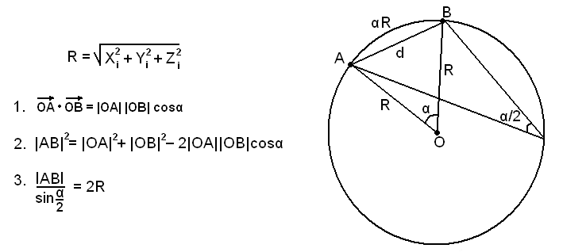
- Scalar (dot) product – probably all contestants are aware of the term applied to 2-D vectors and of the fact that it is equal to the product of the vectors’ lengths times the cosine of the angle between them. This definition extends naturally to 3-D: the dot product of vectors a and b is simply a_{x}*b_{x} + a_{y}*b_{y} + a_{z}*b_{z}. Dividing this expression by the lengths of the two vectors gives us the cosine of the angle. And since all angles required for the computations lie in the interval [0; π] we can use the acos function that returns an angle in the same interval.
- Law of cosines –looking at the triangle with the centre of the sphere and the airports the distance between which we are calculating as vertices, we can calculate all three sides – two of them are equal to R, and the third one is easily calculated knowing the coordinates of the airports. Applying the law of cosines for the central angle gives us its cosine and once again we can find the angle using arccosine.
- Law of sines – if we choose a random point from the bigger arc of the great circle (not the arc we’re trying to calculate, but the complementary one), we know that the inscribed angle with this point as its vertex and the vectors from it to the airports as its sides is twice as small as the central angle we’re trying to find. Applying the law of sines for this angle gives us its sine. Since it’s half the central angle, it lies in the interval [0; π/2] and we can easily calculate the according angle using arcsine.
- Divide and conquer
Two not so mathematical observations give us the ability to write an algorithm based on the “divide and conquer” technique. Those are the following:
- The radii that halves a given chords also halves the according arc.
- If the Euclidean distance between two points on a sphere is small enough, we can assume that it’s also equal to the spherical distance between them. (Also known as the mathematical statement (sin x)/x1 when x0)
We can now implement the following algorithm: if the distance between the two points is small enough, we assume it to be equal to the spherical distance. Otherwise calculate the length of half of the arc and multiply it by 2.
We can experimentally deduce when to stop the algorithm so that our function gives good enough results.
The part of this algorithm that is not absolutely clear is finding the middle of the arc. This is achieved by finding the middle of the segment and continuing it until its length is equal to the radius of the sphere. Here we can again use mathematical and not-so-mathematical approaches. The mathematical way is to multiply the vector by a coefficient that is found in one simple equation.
The other possible approach is to use binary search, thus avoiding the need of the mentioned equation (even though the equation is a trivial one, this is also a possible approach). Anyway, this approach is too slow because of the nested complexities and might not be good enough for the specific task.
All approaches are implemented in maths.cpp. The file basic.cpp contains basic functions for input, output and data management and is required by all supplied solutions. In order to experiment with the different ways to compute the length of an arc, simply substitute the „arclength_cos” function in basic.cpp with any of the available functions from math.cpp.
Let’s denote the distance of the flight between airports u and v with dist[u][v] and the fuel with fuel[u][v]. Now let’s solve the problem. We have a graph with two weights on each edge and we’re looking for a shortest path in one of the weights (route distance), but we also want the other weight to stay below a given constant (used fuel). We’re basically trying to minimize both at once. A naïve approach would be to try all possible routes from S to T, calculating the total distance and total fuel on-the-go. Bearing in mind that a vertex may be accessed at most two times in an optimal route, we could either count how many times we’ve visited each vertex or implement a DFS with iterative deepening. Either approach receives 40 points. A C++ implementation is available in the file bruteforce.cpp
However, a standard efficient algorithm for solving the problem in the given form doesn’t exist so it’s a good idea to look for a different representation of the data. We could build a new graph whose vertices represent airports combined with the current value either of the fuel or the distance, and whose edges again represent flights but only with a single weight (the other one). Thus we’ll have to minimize only one criterion. Since the length of a flight is a real number, the number of pairs (airport, current distance) is too big, so it would be better to use the pairs (airport, used fuel) for vertices in the new graph. And their number is quite limited – at most N airports times at most C+1 possible values for the fuel (we need not consider situations where we’re out of fuel) or about a million vertices total. There will be an edge from (v, f_v) to (u, f_u) if there is a flight between airports u and v and f_v + fuel[v][u] = f_u. The weight of that edge will be dist[v][u]. So the number of edges each flight corresponds to is equal to the number of different amounts of used fuel that could be reached in its airports. This makes at most 2MC = 20 million edges. Finding all shortest paths from (S, 0) to (T, i) and taking the shortest one over all i would give the answer.
In fact this situation closely resembles the problem “Bicriterial routing” from The Baltic Olympiad in Informatics 2002 – in that problem we’re looking for all minimal routes from A to B in a graph with cost and time defined for each edge. The solution to our problem would be the same as the dynamic programming part of the solution to “Bicriterial routing”:
dp[u][f_u] = min{ dp[v][ f_u – fuel[v][u] ] + dist[v][u] } over all v that are neighbors of u. The base case is dp[S][0] = 0. The answer is min{ dp[T][i] } / V over all valid i.
But we still haven’t taken into account the airports where we can refuel. Let’s call them stations. One way is to modify the edges in the new graph: take each edge from (v, f_v) to (u, f_v + fuel[v][u]) and “redirect” it to (u, 0) if u is a station (and, of course, if f_v + fuel[v][u] ≤ C). What we basically do is reset the amount of used fuel each time we pass a station. However, another problem arises – cycles may form in the new graph after this modification. In fact, the abovementioned dynamic programming approach relies on the fact that each traversed edge increases the amount of used fuel which guarantees that no vertex can be visited more than once. But now it’s possible, for example, to have the cycle (3, 10) -> (5, 0) -> (3, 10) if fuel[3][5] = 10 and airport 5 is a station. Before considering the stations, this would look like (3, 10) -> (5, 20) -> (3, 30) and dynamic programming would work. But now it’s wrong. There are two solutions to this problem:
- Find all shortest paths from (S, 0) to (T, i) using Dijkstra’s shortest path algorithm and again take the minimal one. An effective implementation with a heap or priority queue would yield a complexity of O( 2MC*log(NC) ) or about 400 million iterations in the worst case. A C++ implementation can be found in dijkstra.cpp
- We could build a third graph whose vertices are only S, T and the stations. The weight of an edge from u to v would be equal to the length of shortest path between u and v that doesn’t require refueling. Obviously we don’t need to consider the fuel in this graph since it is always reset when passing through a vertex. Also, each path in this graph corresponds to a valid route in the original graph. And since it has no more than 21 vertices we could simply run any shortest path algorithm (e.g. Floyd-Warshall) to find the answer. All we have to do is find the shortest path between each pair of stations that doesn’t pass through other stations. This could be done using the abovementioned dynamic programming approach by running it once for each station w with dp[w][0] = 0 as a base case. We simply ignore other stations except w and the endpoints of a route (i.e. we don’t advance in the above formula if v is a station, unless v = w). The overall complexity is O( 2MC*K ) where K is the number of stations. At most 200 million total. A C++ implementation is available in dpfloyd.cpp
Surprisingly, the log(NC) factor in reality is much less than anticipated (most of the time, the size of the priority queue is much less than NC) thus making the Dijkstra approach faster than the dynamic programming one. The former receives full credit, and the latter – 90 points.
Since this problem has “Dijkstra” written all over it, the author’s initial idea was a slightly different full-score solution. We can notice that most of the vertices visited in any of the two algorithms above are obsolete. Imagine two vertices (v, f_v1) and (v, f_v2) for which f_v1 < f_v2 and the shortest path from (S, 0) to the first is smaller than that to the second. Then there’s no need to consider (v, f_v2) for it will always yield a worse result than (v, f_v1). We can use a heuristic in the Dijkstra approach that only visits meaningful vertices and ignores those that are no good. The trouble is that although this heuristic makes the algorithm about a hundred times faster on the average, the worst case performance of both algorithms eventually turns out to be the same. Here’s a short description:
- Each airport has a current (distance, fuel) pair. Initially, only S has such a pair – (0, 0) and it is initialized (inserted in the priority queue).
- While there are initialized pairs (pairs in the priority queue) take the minimal one, i.e. with smallest distance, or with smallest fuel in case of ties. Let’s denote it by (d_v, f_v) and suppose it corresponds to airport v.
- Make this pair current for airport v.
- For each u that is a neighbor of v, create the pair (d_v + dist[v][u], f_v + fuel[v][u]) and check if it could be the next pair of u, i.e. if the current pair for u is (d_u, f_u) we see whether d_u < d_v + dist[v][u] and f_u > f_v + fuel[v][u] (in fact, we only care about the second – the first will always be true). If yes, then initialize the new pair (push it in the priority queue).
Thus for each airport, we visit pairs (distance, fuel) in increasing distance and decreasing fuel. We only consider “minimal” incomparable pairs. A C++ implementation can be found in pfs.cpp
In test cases, coordinates of airports are generated randomly and then connected in a way that ensures a certain amount of refuels in the optimal route. The generator also tries to create a maximum amount of edges in the new graphs described above. Unfortunately, randomness of coordinates prevents the creation of a worst test case that will push all solutions to the limit. One such case is the following graph:
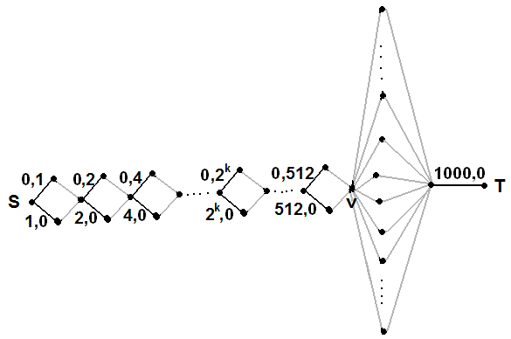
Pairs represent edge weights (distance, fuel) while grey edges are fictive - 0 distance and 0 fuel. This way each route from S to v leads to a different pair (distance, fuel) that cannot be compared with the other pairs. However we build the rest of the graph from v to T, the solutions in 1 and 2 will most probably be forced to use almost all edges in their graphs. Dijkstra’s algorithm with the heuristic is still much faster, unless we connect the rest of the vertices as shown in the picture. That way we’ll force all pairs of (distance, fuel) to be traversed for all vertices before advancing to T, which makes the heuristic useless. Although such a case isn’t present in the test set, we encourage readers to think about the proposed heuristic and why it is indeed correct, and in which other cases it might turn to be as slow as a normal Dijkstra’s algorithm.
Description of test cases (K = number of stations in optimal route besides S):
Test | N | M | K | Description
0 | 6 | 9 | 1 | Example test
1 | 4 | 5 | 0 | Random connected graph
2 | 5 | 6 | 1 | Random connected graph
3 | 6 | 13 | 0 | Random connected graph
4 | 7 | 10 | 1 | Random connected graph
5 | 7 | 8 | 1 | Random connected graph
6 | 8 | 11 | 1 | Random connected graph
7 | 7 | 8 | 1 | Random connected graph
8 | 8 | 9 | 2 | Two cycles in the form of an 8 with S and T at both ends
9 | 209 | 565 | 6 | About 40 collections of airports with edges between them, connected in a tree-like fashion
10 | 316 | 417 | 10 | Similar to the path from S to v in the abovementioned worst case
11 | 393 | 4104 | 1 | About 10 collections
12 | 464 | 2112 | 3 | About 10 collections
13 | 523 | 1100 | 11 | About 60 collections and a few more random edges
14 | 666 | 3000 | 4 | Random connected graph
15 | 724 | 4116 | 6 | Random connected graph
16 | 795 | 940 | 13 | Random connected graph with a few cycles that begins as the abovementioned worst case
17 | 845 | 2978 | 2 | About 100 collections + random edges
18 | 902 | 1201 | 18 | Similar to the path from S to v in the abovementioned worst case
19 | 993 | 9250 | 1 | About 100 collections + random edges
20 | 999 | 9993 | 3 | About 100 collections + random edges; starts similarly to the abovementioned worst case

