数字信号处理第二次Matlab实验报告

**515021910446 彭嘉辉**

**练习题1**

***Matlab代码：***

%%

clear;

clc;

close all;

%%

fc = 300; fr = 200;

fs = 1000;

rp = 0.8; rs = 20;

%%

wc = 2*fs * tan(2*pi*fc/(2*fs));

wr = 2*fs * tan(2*pi*fr/(2*fs));

%%

[N, wn] = cheb1ord(wc, wr, rp, rs, 's');

[B, A] = cheby1(N, rp, wn, 'high', 's');

[bz, az] = bilinear(B, A, fs);

[h, w] = freqz(bz, az);

f = w * fs / (2*pi);

%%

bz

az

figure(1);

plot(f, 20*log10(abs(h)));

axis([0 fs/2 -80 10]);

% axis([200 fs/2 -1 0.2]);

grid;

xlabel('Freq/Hz');

ylabel('Amp/dB');

%%

***结果：***

bz =

0.0262 -0.1047 0.1570 -0.1047 0.0262

az =

1.0000 1.5289 1.6537 0.9452 0.2796

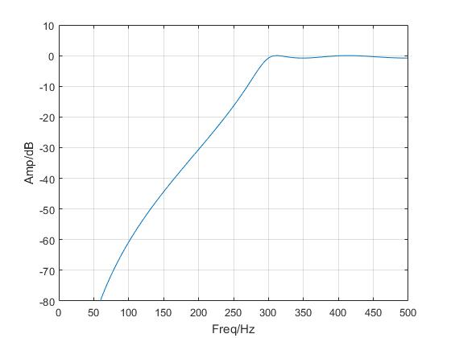

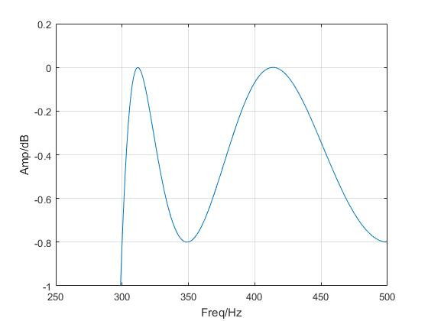

通带波动小于0.8 。

可知系统函数为：

$$H(z)=\frac{0.0262-0.1047z^{-1}+0.1570z^{-2}-0.1047z^{-3}+0.0262z^{-4}}{1.0000+1.5289z^{-1}+1.6537z^{-2}+0.9452z^{-3}+0.2796z^{-4}}$$

**练习题2**

***Matlab代码：***

%%

close all;

clear;

clc;

%%

fc = 200; fr = 300;

fs = 1000;

rp = 1; rs = 25;

%% Impinvar

wp = 2 * pi * fc;

ws = 2 * pi * fr;

[N, wn] = buttord(wp, ws, rp, rs, 's');

[b1, a1] = butter(N, wn, 's');

[bz1, az1] = impinvar(b1, a1, fs);

[h1, w] = freqz(bz1, az1);

%% Bilinear

wp = 2 * fs * tan(2*pi*fc/(2*fs));

ws = 2 * fs * tan(2*pi*fr/(2*fs));

[N, wn] = buttord(wp, ws, rp, rs, 's');

[b2, a2] = butter(N, wn, 's');

[bz2, az2] = bilinear(b2, a2, fs);

[h2, w] = freqz(bz2, az2);

f = w * fs / (2*pi);

%%

bz1

az1

bz2

az2

figure(2);

plot(f, abs(h1), '-r', f, abs(h2), '-b');

grid;

xlabel('Freq/Hz');

ylabel('Amp/dB');

legend('Impinvar', 'Bilinear');

%%

***结果：***

bz1 =

0.0000 0.0002 0.0153 0.0995 0.1444 0.0611 0.0075 0.0002 0.0000 0

az1 =

1.0000 -1.9199 2.5324 -2.2053 1.3868 -0.6309 0.2045 -0.0450 0.0060 -0.0004

bz2 =

0.0179 0.1072 0.2681 0.3575 0.2681 0.1072 0.0179

az2 =

1.0000 -0.6019 0.9130 -0.2989 0.1501 -0.0208 0.0025

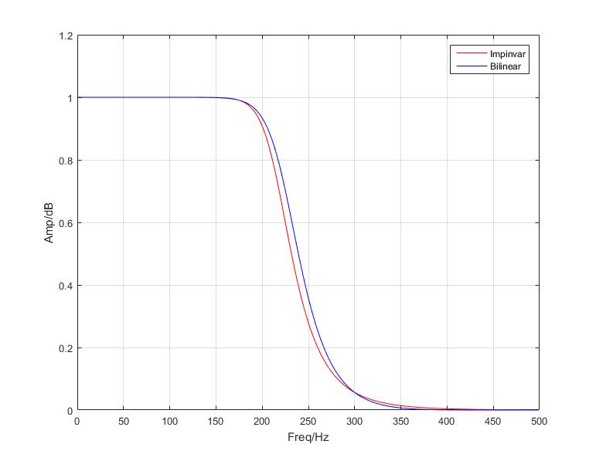

脉冲响应不变法的系统函数：

$$H_{imp}(z)=\frac{0.0002z^{-1}+0.0153z^{-2}+0.0995z^{-3}+0.1444z^{-4}+0.0611z^{-5}+0.0075z^{-6}+0.0002z^{-7}}{\begin{aligned}1-1.9199z^{-1}+2.5324z^{-2}-2.2053z^{-3}+1.3868z^{-4}-0.6309z^{-5}+0.2045z^{-6}-0.0450z^{-7}+0.0060z^{-8}-0.0004z^{-9}\end{aligned}}$$

双线性变换法：

$$H_{imp}(z)=\frac{0.0179+0.1072z^{-1}+0.2681z^{-2}+0.3575z^{-3}+0.2681z^{-4}+0.1072z^{-5}+0.0179z^{-6}}{\begin{aligned}1-0.6019z^{-1}+0.9130z^{-2}-0.2989z^{-3}+0.1501z^{-4}-0.0208z^{-5}+0.0025z^{-6}\end{aligned}}$$

比较：脉冲响应不变法的阶数为9，双线性变换法的阶数为6。双线性变换法的过渡带比较窄，脉冲响应的衰减比较快。

**练习题3**

***Matlab代码：***

%%

close all;

clear;

clc;

%%

fs = 8000;

fc = 1200; fr = 2000;

rp = 0.5; rs = 40;

%% Buttord

wp = 2 * fs * tan(2*pi*fc/(fs*2));

ws = 2 * fs * tan(2*pi*fr/(fs*2));

[N, wn] = buttord(wp, ws, rp, rs, 's');

[b1, a1] = butter(N, wn, 's');

[bz1, az1] = bilinear(b1, a1, fs);

[h1, w] = freqz(bz1, az1);

%% Cheby

wc = 2 * fs * tan(2*pi*fc/(2*fs));

wt = 2 * fs * tan(2*pi*fr/(2*fs));

[N, wn] = cheb1ord(wc, wt, rp, rs, 's');

[b2, a2] = cheby1(N, rp, wn, 'low', 's');

[bz2, az2] = bilinear(b2, a2, fs);

[h2, w] = freqz(bz2, az2);

%% Ellipse

wp = 2 * fs * tan(2*pi*fc/(fs*2));

ws = 2 * fs * tan(2*pi*fr/(fs*2));

[N, wn] = ellipord(wp, ws, rp, rs, 's');

[b3, a3] = ellip(N, rp, rs, wp, 'low', 's');

[bz3, az3] = bilinear(b3, a3, fs);

[h3, w] = freqz(bz3, az3);

f = w*fs / (2*pi);

%%

bz1

az1

bz2

az2

bz3

az3

figure(3);

plot(f, 20*log10(abs(h1)), '-r', f, 20*log10(abs(h2)), '-b', f, 20*log10(abs(h3)), '-g');

axis([0 fs/2 -100 10]);

grid;

xlabel('Freq/Hz');

ylabel('Amp/dB');

legend('Buttord', 'Cheby', 'Ellipse');

%%

***结果：***

bz1 =

0.0004 0.0032 0.0129 0.0302 0.0453 0.0453 0.0302 0.0129 0.0032 0.0004

az1 =

1.0000 -2.7996 4.4582 -4.5412 3.2404 -1.6330 0.5780 -0.1370 0.0197 -0.0013

bz2 =

0.0026 0.0132 0.0264 0.0264 0.0132 0.0026

az2 =

1.0000 -2.9775 4.2932 -3.5124 1.6145 -0.3334

bz3 =

0.0389 0.0363 0.0665 0.0363 0.0389

az3 =

1.0000 -2.1444 2.3658 -1.3250 0.3332

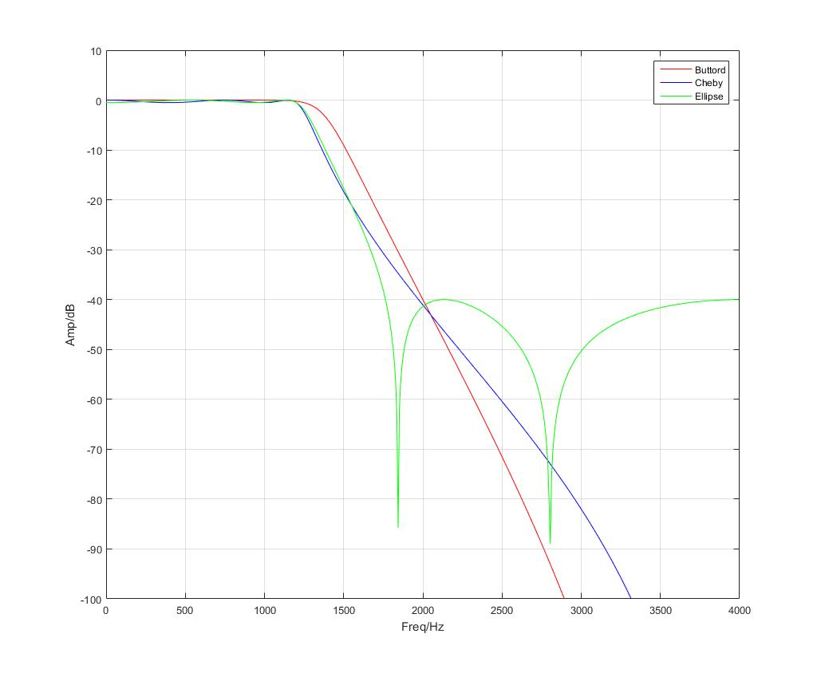

巴特沃斯法的系统函数：（阶数为9）

$$H_{imp}(z)=\frac{0.0004+0.0032z^{-1}+0.0129z^{-2}-0.0302z^{-3}+0.0453z^{-4}+0.0453z^{-5}+0.0302z^{-6}+0.0129z^{-7}+0.0032z^{-8}+0.0004z^{-9}}{\begin{aligned}1.0000-2.7996z^{-1}+4.4582z^{-2}-4.5412z^{-3}+3.2404z^{-4}-1.6330z^{-5}+0.5680z^{-6}-0.1370z^{-7}+0.0197z^{-8}-0.0013z^{-9}\end{aligned}}$$

切比雪夫法的系统函数：（阶数为5）

$$H_{imp}(z)=\frac{0.0026+0.0132z^{-1}+0.0264z^{-2}+0.0264z^{-3}+0.0132z^{-4}+0.0026z^{-5}}{\begin{aligned}1.0000-2.9775z^{-1}+4.2932z^{-2}-3.5124z^{-3}+1.6154z^{-4}-0.3334z^{-5}\end{aligned}}$$

椭圆型的系统函数：（阶数为4）

$$H_{imp}(z)=\frac{0.0389-0.0363z^{-1}+0.0665z^{-2}-0.0363z^{-3}+0.0389z^{-4}}{\begin{aligned}1.0000-2.1444z^{-1}+2.3658z^{-2}-1.3250z^{-3}+0.3332z^{-4}\end{aligned}}$$

**练习题4**

***Matlab代码：***

%%

close all;

clear;

clc;

%%

N = 11; M = 128;

b1 = fir1(N, 0.5, boxcar(N+1));

b2 = fir1(N, 0.5, hanning(N+1));

b3 = fir1(N, 0.5, blackman(N+1));

h1 = freqz(b1, 1, M);

h2 = freqz(b2, 1, M);

h3 = freqz(b3, 1, M);

f = 0: 0.5/M: 0.5-0.5/M;

%%

figure(4)

plot(f, abs(h1), '-r', f, abs(h2), '-b', f, abs(h3), '-g');

legend('Boxcar', 'Hanning', 'Blackman');

grid;

xlabel('w/(2\pi)');

ylabel('Magnitude Response');

axis([0 0.5 0 1.2]);

%%

***结果：***

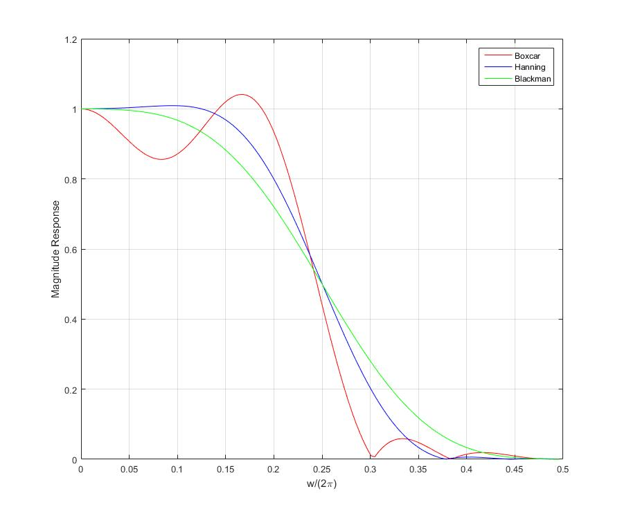

**练习题5**

***Matlab代码：***

%%

close all;

clear;

clc;

%%

wp = 0.2 * pi;

ws = 0.3 * pi;

as = 50;

tr_width = ws - wp;

M = ceil(6.2*pi / tr_width); % For Hanning

n = 0: 1: M-1;

wc = (ws+wp) / 2;

hd = ideallp(wc, M);

w_han = (hamming(M))';

h = hd.*w_han;

[H, W] = freqz(h, 1);

%%

figure(5);

subplot(2, 2, 1);

stem(n, hd);

title('ideal lp');

axis([0 M-1 -0.1 0.3]);

grid;

subplot(2, 2, 2);

stem(n, w_han);

title('Hanning');

axis([0 M-1 0 1.1]);

grid;

subplot(2, 2, 3);

stem(n, h);

title('real lp');

axis([0 M-1 -0.1 0.3]);

grid;

subplot(2, 2, 4);

plot(W/pi, 20*log10(abs(H)));

title('Amp');

axis([0 1 -100 10]);

grid;

%%

***结果：***

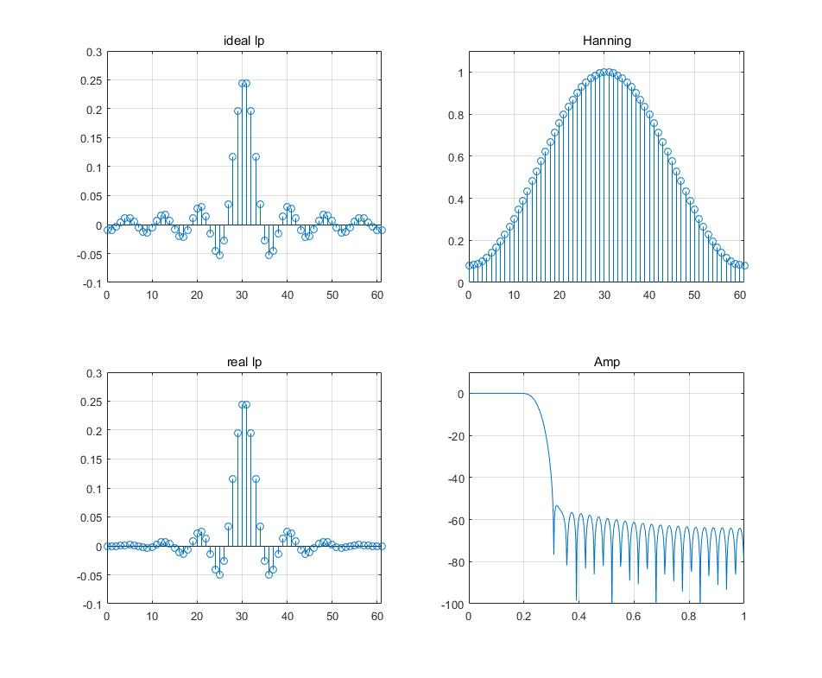

**练习题6**

***Matlab代码：***

%%

close all;

clear;

clc;

%%

wp1 = 0.35*pi;

wp2 = 0.8*pi;

ws1 = 0.5*pi;

ws2 = 0.65*pi;

dert_w = min((ws1 - wp1), (wp2 - ws2));

N = ceil(6.2*pi / dert_w);

n = 0: 1: N-1;

wc1 = (wp1+ws1) / 2;

wc2 = (wp2+ws2) / 2;

hd = ideallp(pi, N) - ideallp(wc2, N) + ideallp(wc1, N);

B = hanning(N)';

h = hd.*B;

[H, m] = freqz(h, 1);

mag = abs(H);

db = 20*log10((mag+eps) / max(mag));

pha = angle(H);

w = m/pi;

%%

figure(6);

subplot(2, 2, 1);

stem(n, hd);

title('ideal lp');

grid;

xlabel('n');

ylabel('sa(n)');

subplot(2, 2, 2);

stem(n, B);

title('Hanning');

grid;

xlabel('n');

ylabel('B');

subplot(2, 2, 3);

plot(w, mag);

title('Amp');

grid;

xlabel('f/Hz');

ylabel('amp');

subplot(2, 2, 4);

plot(w, db);

title('Fading');

grid;

xlabel('f/Hz');

ylabel('DB/db');

%%

***结果：***

