数字信号处理第一次Matlab实验报告

**515021910446 彭嘉辉**

**练习题1**

***Matlab代码：***

%%

clear;

close all;

clc;

%%

nn1 = 0: 20;

f1 = power(0.8, nn1);

nn2 = 0: 10;

f2 = heaviside(nn2+1);

y = conv(f1, f2);

%%

l = 0: length(y)-1;

figure(1);

stem(l, y, '.');

xlabel('n');

ylabel('y(n)');

%%

***结果：***

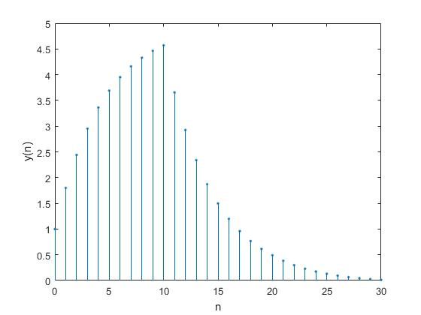

**练习题2**

***Matlab代码：***

%%

clc;

clear;

close all;

%% p1 = 0.2

z = [0]'; k = 1;

n = (0: 500)*pi/500;

p1 = [0.2]';

[b1, a1] = zp2tf(z, p1, k);

[h1, w1] = freqz(b1, a1, n);

%% p2 = 0.5

p2 = [0.5]';

[b2, a2] = zp2tf(z, p2, k);

[h2, w2] = freqz(b2, a2, n);

%% p3 = 0.8

p3 = [0.8]';

[b3, a3] = zp2tf(z, p3, k);

[h3, w3] = freqz(b3, a3, n);

%%

figure(1);

subplot(3,2,1);

zplane(b1, a1);

subplot(3,2,2);

plot(w1/pi, abs(h1));

xlabel('\omega/\pi');

ylabel('|H(e^j^\omega)|');

subplot(3,2,3);

zplane(b2, a2);

subplot(3,2,4);

plot(w2/pi, abs(h2));

xlabel('\omega/\pi');

ylabel('|H(e^j^\omega)|');

subplot(3,2,5);

zplane(b3, a3);

subplot(3,2,6);

plot(w3/pi, abs(h3));

xlabel('\omega/\pi');

ylabel('|H(e^j^\omega)|');

%%

***结果：***

**（从上到下极点依次为p=0.2；p=0.5；p=0.8）1**

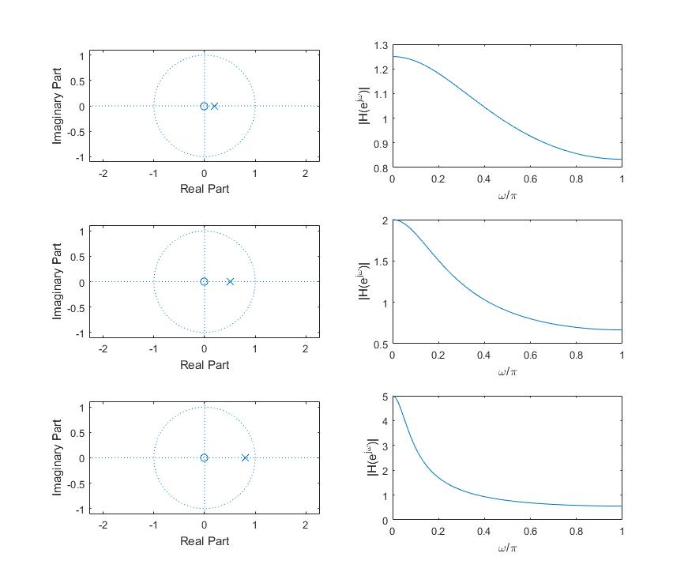

**练习题3**

***Matlab代码：***

%%

clc;

close all;

clear;

%%

xn = [0 1 2 3 4 5 6 7];

N = length(xn);

n = 0: (N-1);

k = 0: (N-1);

Xk = xn*exp(-1i*2*pi/N).^(n'*k);

x = (Xk*exp(1i*2*pi/N).^(n'*k))/N;

%%

figure(1);

subplot(2, 2, 1);

stem(n, xn);

title('x(n)');

subplot(2, 2, 2);

stem(n, x);

title('x(n) by IDFT');

subplot(2, 2, 3);

stem(k, abs(Xk));

title('|X(k)|');

subplot(2, 2, 4);

stem(k, angle(Xk));

title('arg|X(k)|');

%%

***结果：***

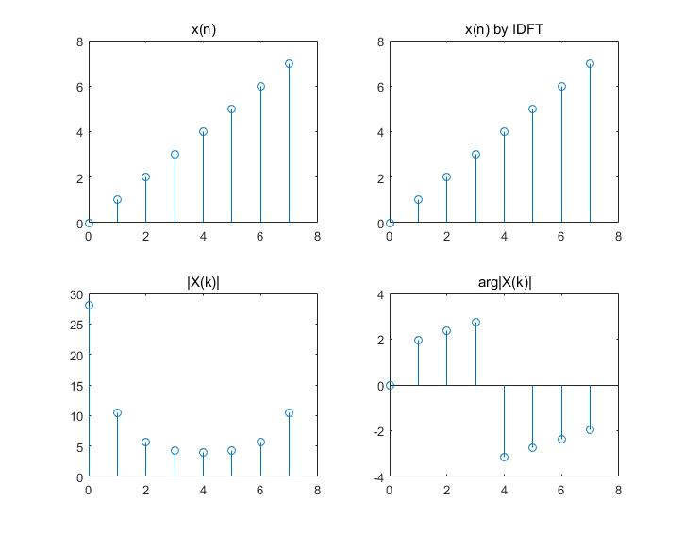

**练习题4**

***Matlab代码：***

%%

clc;

close all;

clear;

%%

B = [1, -1];

A = [1, -2.5, 1];

[Hk, w] = freqz(B, A, 'whole');

%%

figure(1);

subplot(1, 2, 1);

zplane(B, A);

subplot(1, 2, 2);

plot(w/pi, abs(Hk));

xlabel('\omega/\pi');

figure(2);

stepz(B, A, 20);

%%

***结果：***

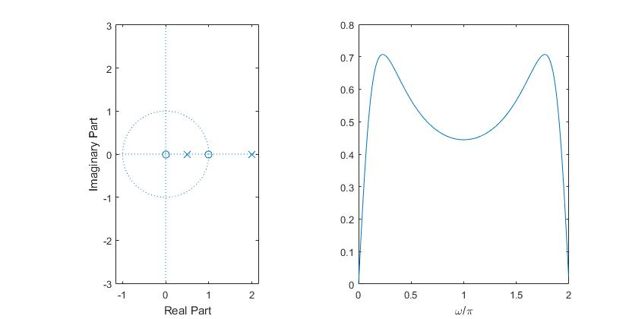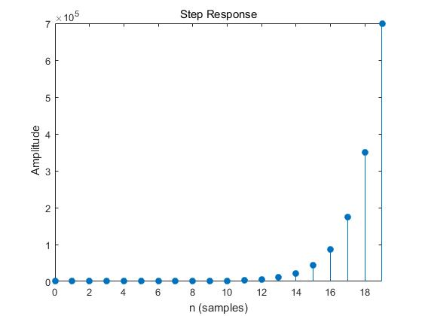

**根据图像，有一个极点位于单位圆外，且单位阶跃响应图有向无限延伸的趋势，所以该系统不稳定。**

**练习题5**

***Matlab代码：***

%%

clc;

close all;

clear;

%%

B = [4, -1, 7, -2];

A = [1, -1.5, 0.5, -0.75];

%%

Hz1 = filt(B, A)

[sos, G] = tf2sos(B, A)

[c, b, a] = tf2par(B, A)

%%

***结果：***

**Hz1 =**

**4 - z^-1 + 7 z^-2 - 2 z^-3**

**-----------------------------------**

**1 - 1.5 z^-1 + 0.5 z^-2 - 0.75 z^-3**

**sos =**

**1.0000 -0.2841 0 1.0000 -1.5000 0**

**1.0000 0.0341 1.7597 1.0000 0.0000 0.5000**

**G =**

**4**

**c =**

**2.6667**

**b =**

**-3.4545 -2.1818**

**4.7879 0**

**a =**

**1.0000 0.0000 0.5000**

**1.0000 -1.5000 0**

**根据结果可以写出原传递函数的级联型和并联型如下：**

$$H\left(z\right)=4*\frac{1-0.2841z^{-1}}{1-1.5z^{-1}}*\frac{1+0.0341z^{-1}+1.7597z^{-2}}{1+0.5z^{-2}}$$

$$H\left(z\right)=2.6667+\frac{-3.4545-2.1818z^{-1}}{1+0.5z^{-2}}+\frac{4.7879}{1-1.5z^{-1}}$$