***Lab1: Characteristics of the Basic Functional Circuit Blocks***

Name: Jiahui Peng Date: 2017-11-8

Student ID: 515021910446 Location: SEIEE 4-402/404

Teammate: Leyu Yao

***PRINCIPLES & OBJECTIVE***:

Operational amplifiers (Op-amps) are among the most widely used electronic devices today, being used in a vast array of consumer, industrial, and scientific devices. They are called “operational” amplifiers, because they can be used to perform arithmetic operations (addition, subtraction, multiplication) with signals. In fact, op-amps can also be used to integrate (calculate the areas under) and differentiate (calculate the slopes of) signals.

The objective of this lab is to study how to build the basic function blocks by op-amps, and study the static and dynamic characteristics of these blocks.

***EQUIPMENTS INVOLVED***:

1. Analog Discovery 2 (AD2), by DIGILENT from National Instruments (NI)

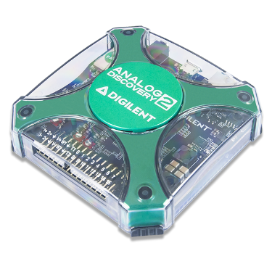

1. Waveforms, PC Virtual Instruments application by DIGILENT from NI

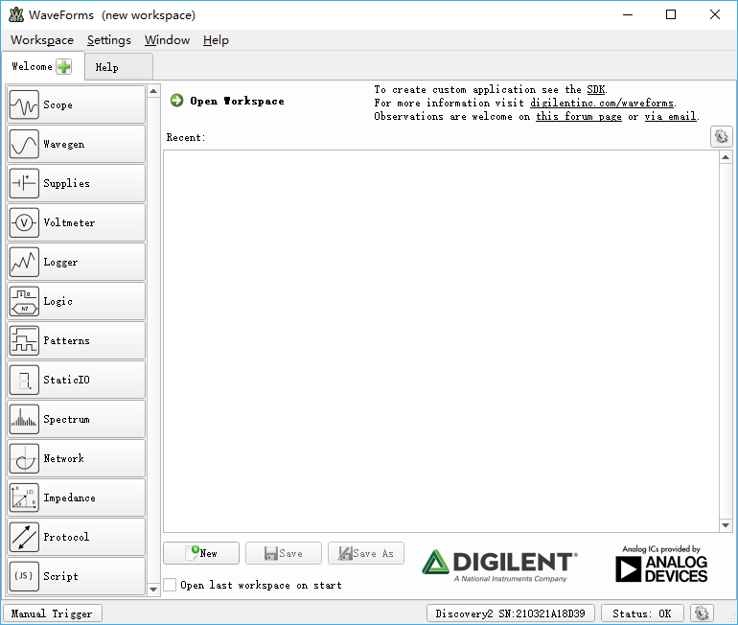

1. ACLab Experimental Kit

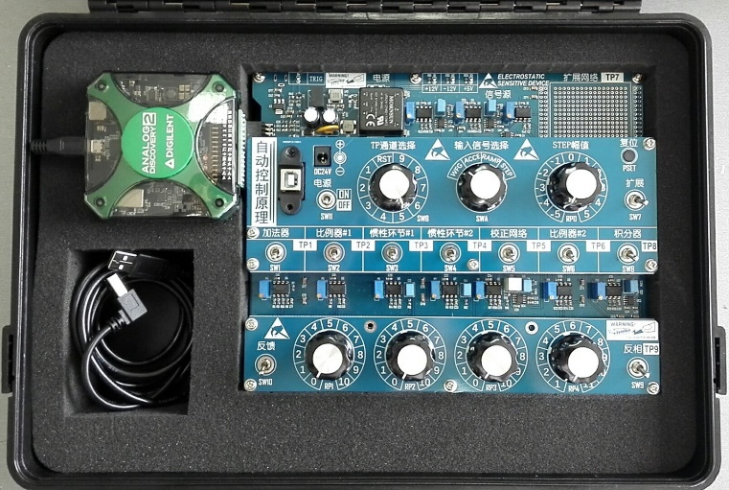

***PRE-LAB KNOWLEDGE***:

1. The fundamentals of operational amplifier analog circuits.
2. General operation skills on traditional instruments and virtual instruments.

***PROCEDURE***:

1. Step signal generation (SWA: STEP; AD2 SCOPE: CH1)

Run SCOPE to observe and read the “Step”, which is directly related to RP0 switch position. Switch RP0 to the listed positions and read Step values. RS1 and RS12 have been so calibrated that 1 step of RP0 position produces a change of 0.5V on Step signal amplitude.



|  |  |  |  |
| --- | --- | --- | --- |
| No. | RP0 position | Step Value  *Read* | Step Value  *Calculated* |
| 1 | -4 | -2.184V | -2.0V |
| 2 | 0 | -11.38mV | 0V |
| 3 | 4 | 1.907V | 2.0V |
| 4 | 5 | 2.386V | 2.5V |

1. Inverted Proportional Amplifier (SW2: ON; SWA: STEP; AD2 SCOPE: CH2; SWB: 2)

Configure circuit blocks properly for inverted proportional amplifier #1. Then run SCOPE to observe and read the response at the output of U5 (TP2).



|  |  |  |  |  |
| --- | --- | --- | --- | --- |
| No. | RP0 Position | RP1 Position | TP2 *Read* | TP2 *Calculated* |
| 1 | 2 | 0 | 10.83mv | 0 |
| 2 | 2 | 5 | 491.4mv | 0.5V |
| 3 | 2 | 10 | 968.6mv | 1.0V |
| 4 | 2 | 8 | 774.1mv | 0.8V |

1. Integrator with step input (SW8: ON; SW9: ON; SWA: STEP; SWB: 9)

Configure circuit blocks properly for positive integrator circuit (Inverted Integrator plus Inverted). Then run SCOPE to observe and capture the response at the output of U11 (TP9).

|  |  |  |  |
| --- | --- | --- | --- |
| No. | RP0 Position | TP9 *read* at t=1s | TP9 *Calculated* at t=1s |
| 1 | 1 | 2.473V | 2.5V |
| 2 | 2 | 4.883V | 5.0V |

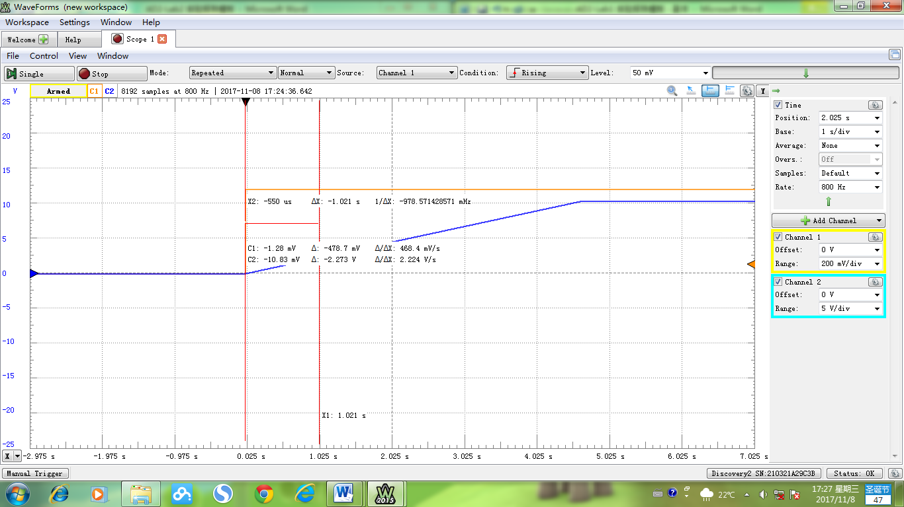

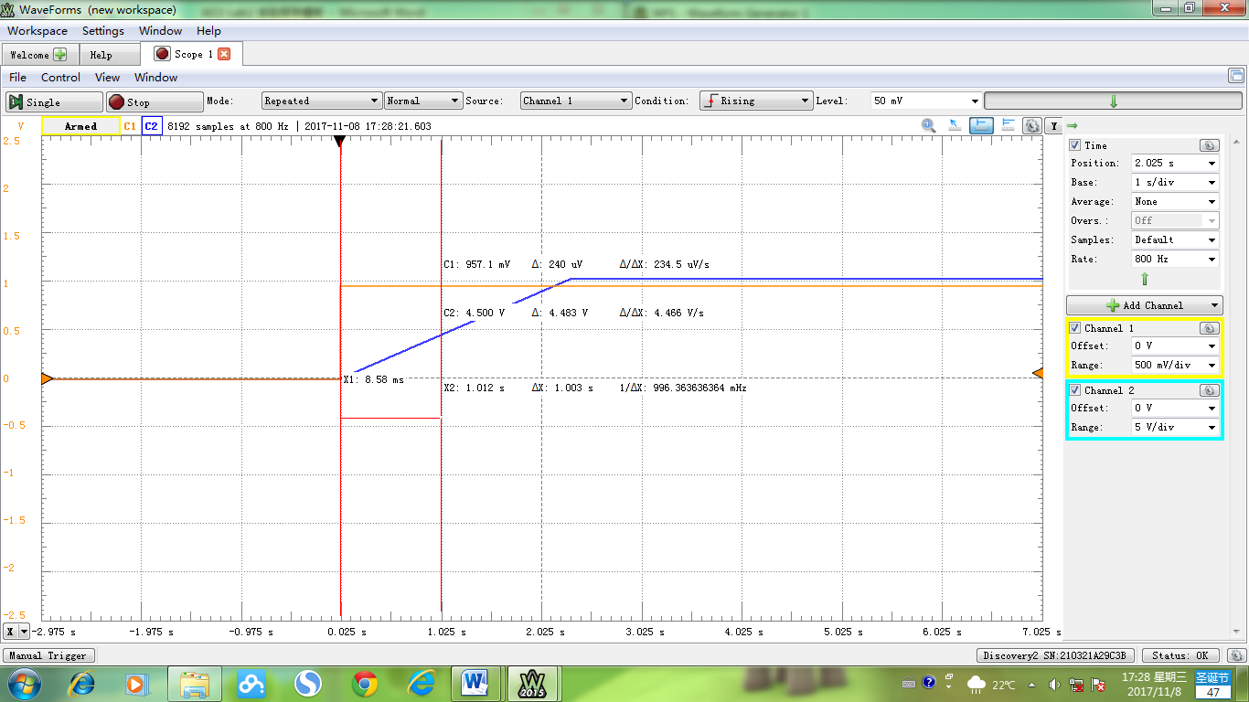

 

The transfer function is:

1. Inertial element with sinusoidal input (SW4: ON; SWA: WFG; SWB: 4)
2. Select WFG (Waveform Function Generator) as input by switching SWA.
3. Configure circuit blocks properly for inertial element.



1. Run Wavegen from Waveforms App and configure sinusoidal signal, set proper values for Frequency and Amplitude.

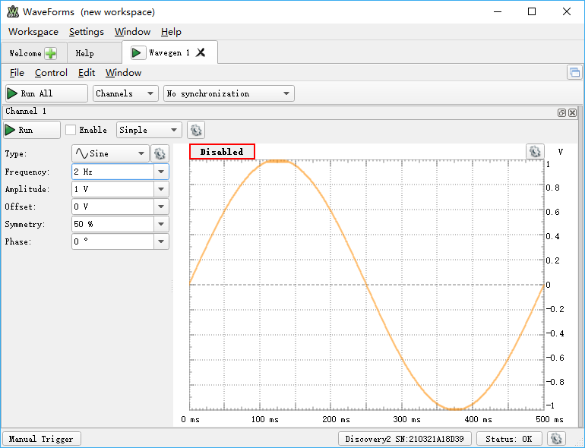

1. Run Scope from Waveforms App and capture the response.

Read and calculate the phase difference between input and output signals, compare it with the result of your theoretical analysis.

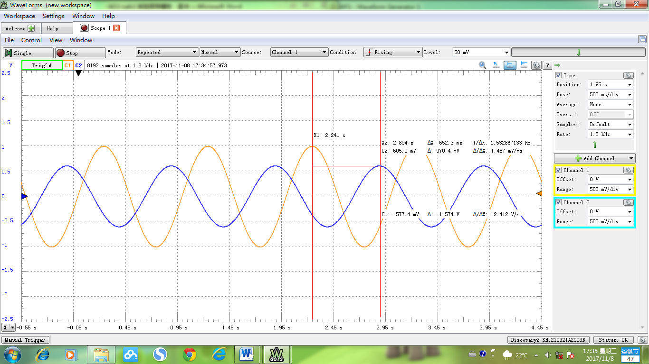

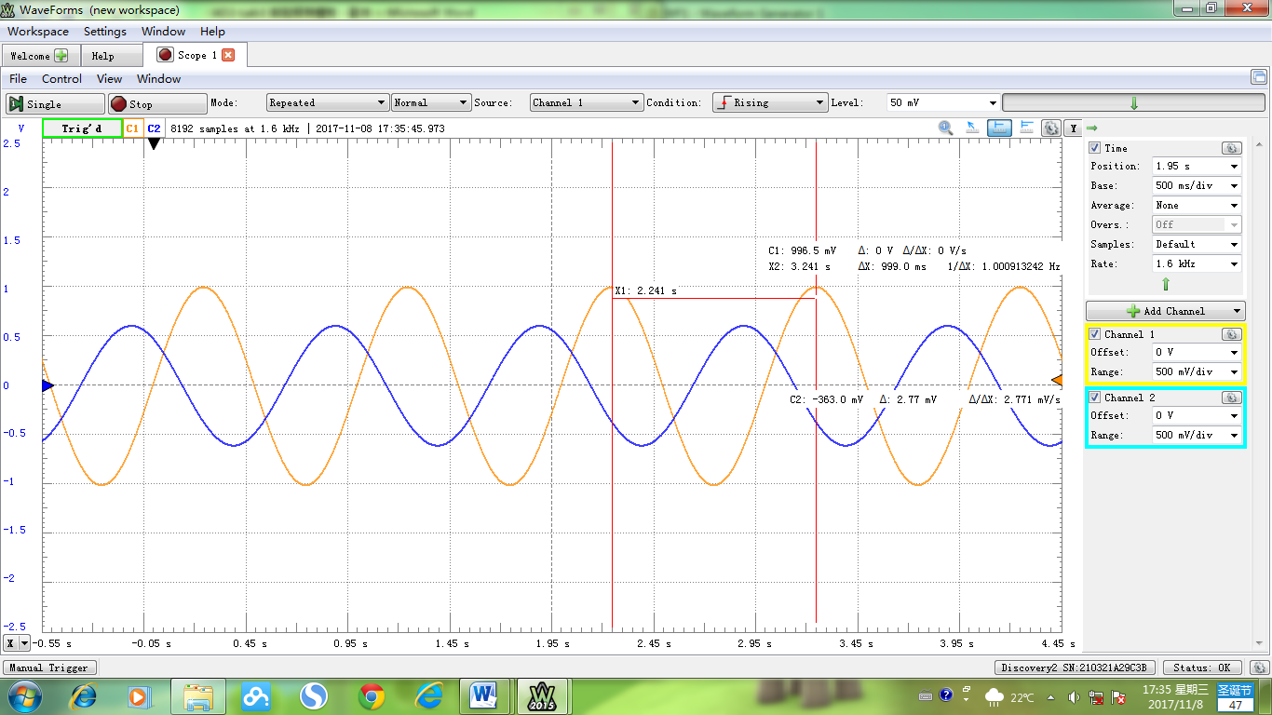

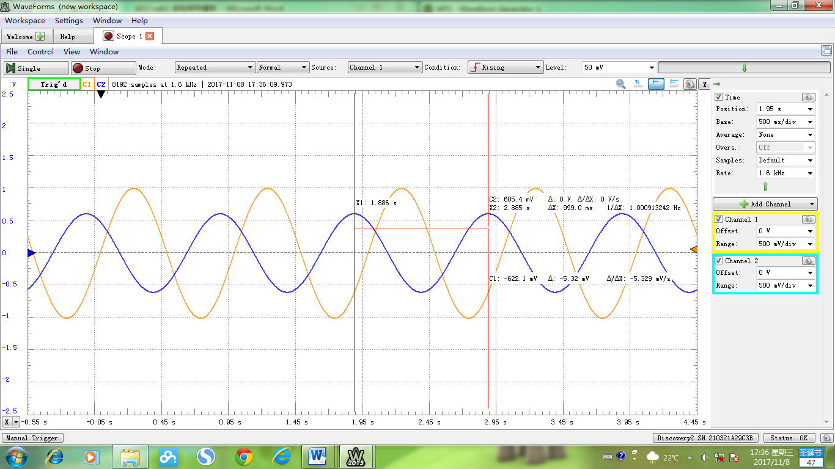

***RESULTS ANALYSIS***:

From the screenshot of response, delta t = 0.653s, the amplitude of Uo is 0.61V.

Input function is:

Transfer function is:

That is:

From this function, delta t = 0.4s, the AMP is 0.85V, which, unfortunately, is quite different from the experiment results.