***Lab2: Transient Response of a Second Order System***

Name: Jiahui Peng Date: 2017-11

Student ID: 515021910446 Location: SEIEE 4-402/404

Teammate: Leyu Yao

***PRINCIPLES & OBJECTIVE***:

There are two important parameters that define the performance of a second order system. They are the damping ratio  and the undamped natural frequency . The change in value of of and will result in corresponding change of the settling time, the overshoot, and the amplitude of the transient response of a closed loop system. In other words, we can change the performance of the closed loop system by adjusting the these parameters. Keeping the remaining parameters unchanged, the value of and  can be adjusted by changing the forward path gain *K*.

The objective of this lab is to study the influence of the parameters on the performance of a given second order system by measuring the step response under different system parameters.

***EQUIPMENTS INVOLVED***:

1. Analog Discovery 2 (AD2), by DIGILENT from National Instruments (NI)

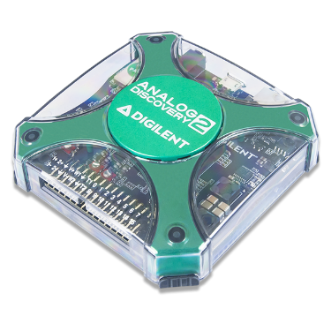

1. Waveforms, PC Virtual Instruments application by DIGILENT from NI

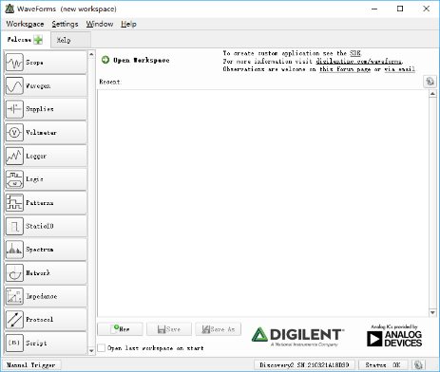-

1. ACLab Experimental Kit

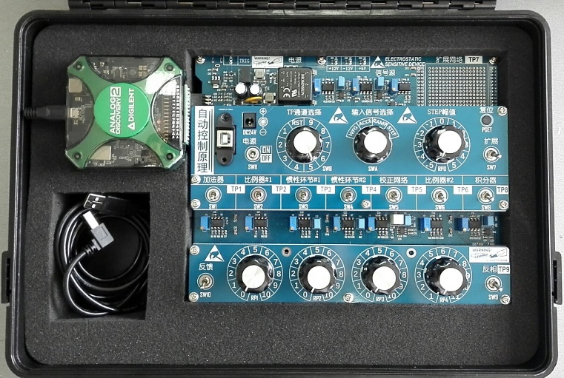

***PRE-LAB KNOWLEDGE***:

1. Understand the relationship between system performance and the parameters *ξ* and *ωn*.
2. Familiar with the computation of *K* from the given values of *ξ*.

***PROCEDURE***:

1. Build a 2nd-order system by setting the 10 SW switches properly.

A second order system could be built by:

1. Connect 1 adder, 1 proportional amplifier, 1 inertial element, 1 integrator in serial. CB4 and CB6 will be used in this mission.
2. Close-loop the circuit as negative feedback.



Build a 2nd-order system by setting the 10 SW switches properly:



(You can find the explanation of each circuit block in file “Lab introduction.pdf”)

1. Select STEP as the input signal, and switch RP0 to set step signal amplitude as 1V.
2. Run Scope from Waveforms app and select test point for proper signal observation. Set proper position for SWB switch according to your circuit configuration.
3. Change *K* in the system block diagram, by switching RP4 to the given positions as listed below. Capture the transient response, read the peak value, settling time, and compare them to the calculated results of theoretical analysis. Expand or add new table as needed to hold your results, show your analysis work in “RESULTS ANALYSIS” section.

|  |  |  |  |  |  |
| --- | --- | --- | --- | --- | --- |
| No. | RP0 position | RP4 position | Peak Value  *Read* | Peak Value  *Calculated* | Settling Time  *Read*  (Δ=0.05) |
| 1 | 2 | 1 | 1.107V | 1.163V | 1.556s |
| 2 | 2 | 5 | 1.463V | 1.486V | 2.443s |
| 3 | 2 | 10 | 1.580V | 1.605V | 2.353s |

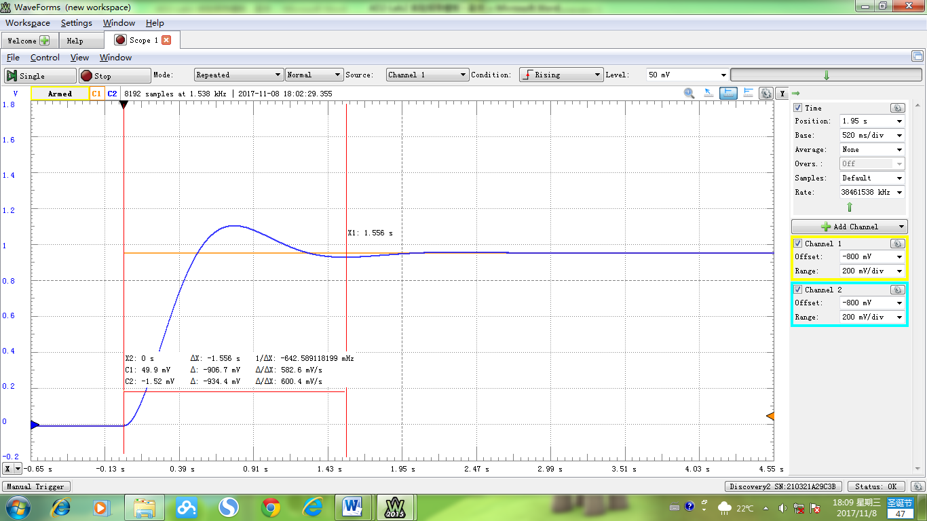

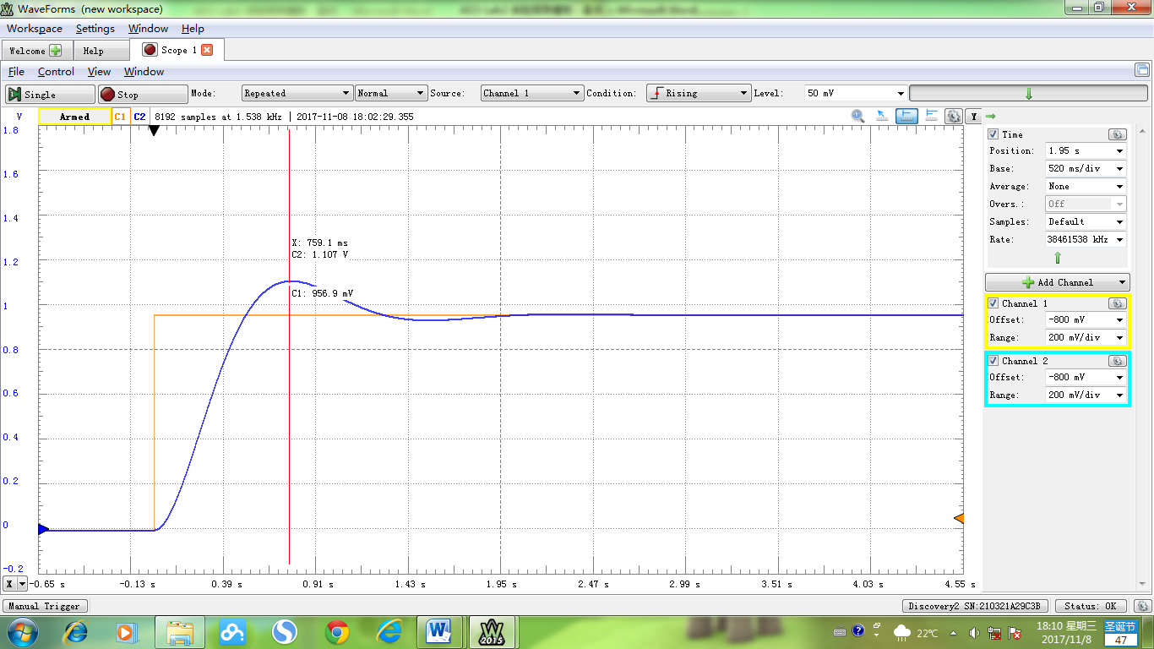

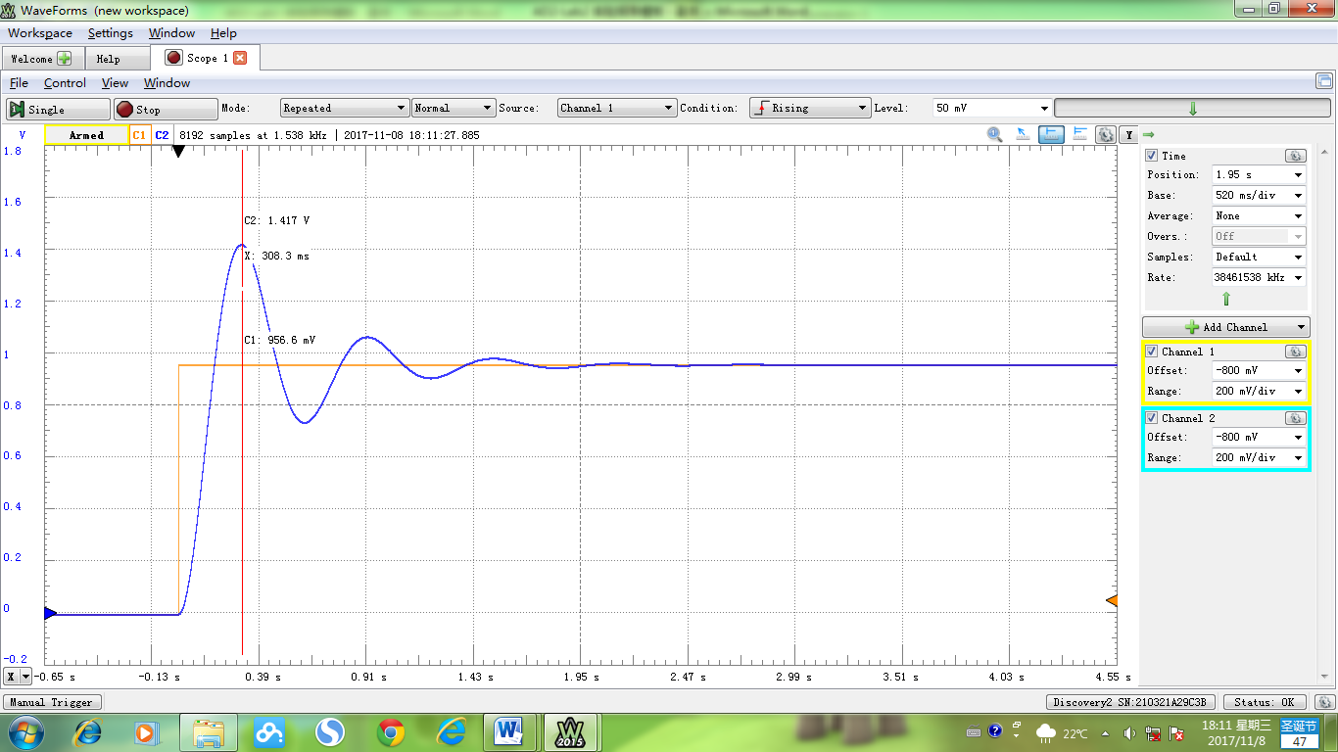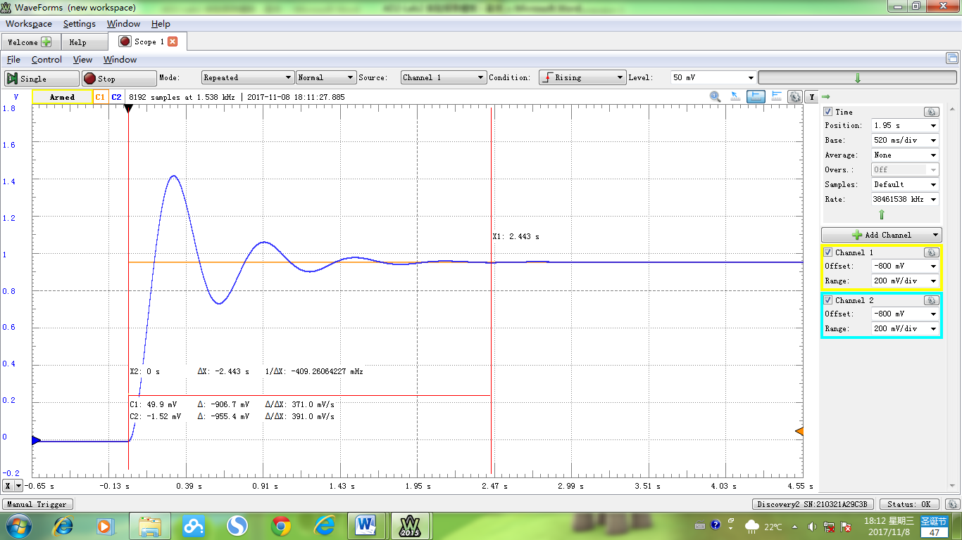

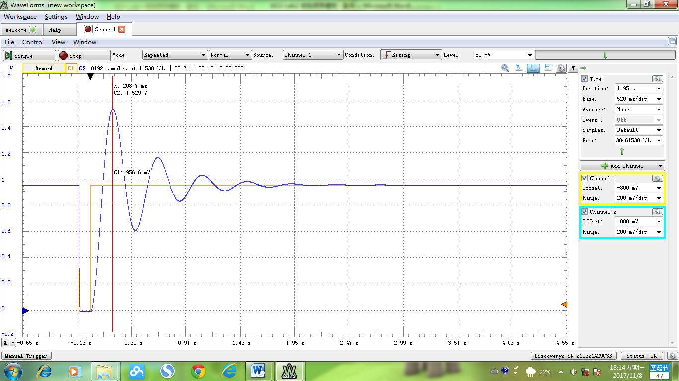

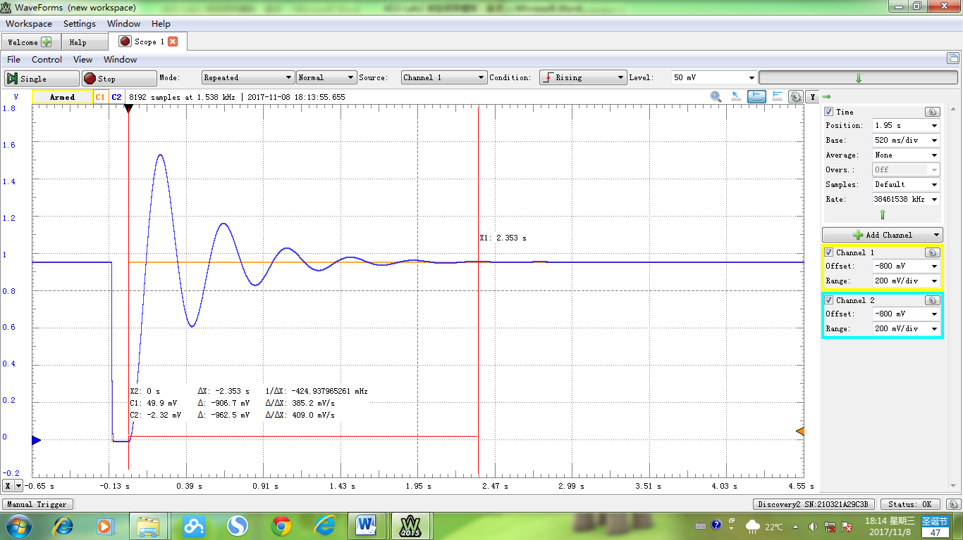

***RESULTS ANALYSIS***:

The transfer function is:

When RP4 pointing at #1, the approximation function is:

When RP4 pointing at #5, the function is:

When RP4 pointing at #10, the function is:

***DISCUSSION***:

The calculated settling time for all the three models are 1.2s with Δ=0.05 , but it’s quite difficult to measure the exact point from the graph. From the approximate results, the settling time increases with K.

In addition to changing parameter K, the parameter T in inertial element is also changeable, which may alter the value of *ξ*ωn .

When K goes to infinity, peak value approaches to 0, which means the output approaches to a step signal.

If the input signal is an acceleration, the second-order system will never settle.