***Lab3: Frequency Response and Series Compensation of a Linear System***

Name: Peng Jiahui Date: 2017-12-20

Student ID: 515021910446 Location: SEIEE 4-402/404

Team member: Feng Yifei Instructor: Wang Bing

***PRINCIPLES & OBJECTIVE***:

The performance of a feedback control system may not be satisfying if we only tune its stability properties. In this exercise, we are---apart from stability--- also interested in a compensation of the original feedback control system. In practice, we may design various types of compensators. Here, the purpose of introducing a compensator is to change the distribution of zeros and poles as well as the trajectory and the shape of the frequency characteristics of the system by adding poles and/or zeroes. The aim is to not only meet accuracy and stability requirements by designing open-loop gains, but also ensure ideal transient responses. The objective of this lab is to study the influence of the parameters on the performance of a given second order system by measuring the step response under different system parameters.

The objective of this lab is to study the frequency domain method to analyze the dynamic characteristics of feedback control systems, and study the compensation method using common compensation devices and learn about parameter tuning methods.

***EQUIPMENTS INVOLVED***:

1. Analog Discovery 2 (AD2), by DIGILENT from National Instruments (NI)
2. Waveforms, PC Virtual Instruments application by DIGILENT from NI

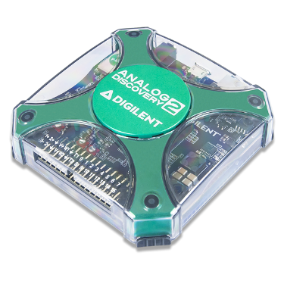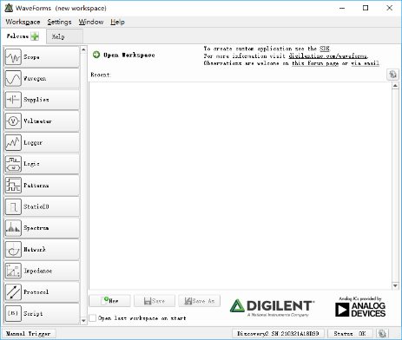

1. ACLab Experimental Kit

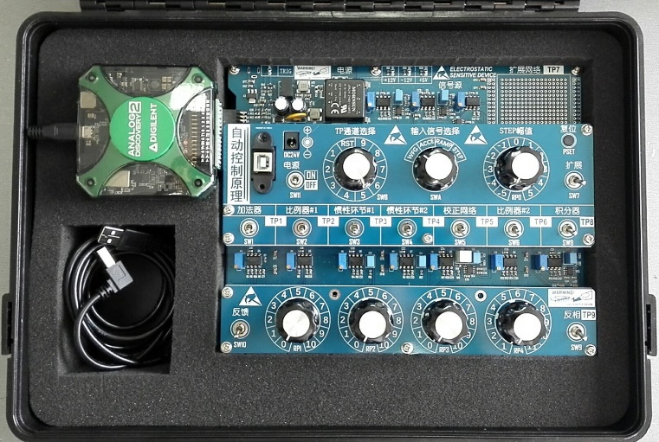

***PRE-LAB KNOWLEDGE***:

1. Understand the relationship between system performance and the bode diagram.
2. Familiar with the performance evaluation of a 2nd-order system from its step response.
3. Understand the transfer function computation of typical compensator circuit, e.g. the circuit shown below,



The corresponding transfer function is,

While , and in low frequency range, the TF can be simplified as,

Where,

***PROCEDURE***:

1. Obtain the frequency responses of the following 3 functional modules respectively, by using the virtual instrument ***WaveForms:Network****.*
   1. Inertial element #2 (SW4);

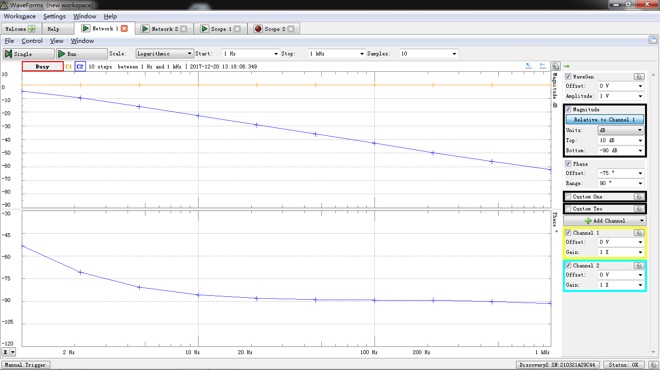

* 1. Integrator (SW8);

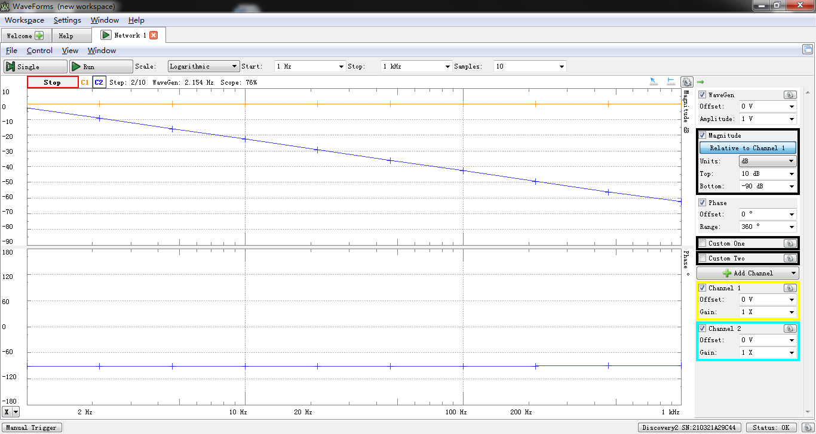

* 1. Series compensator (SW5).

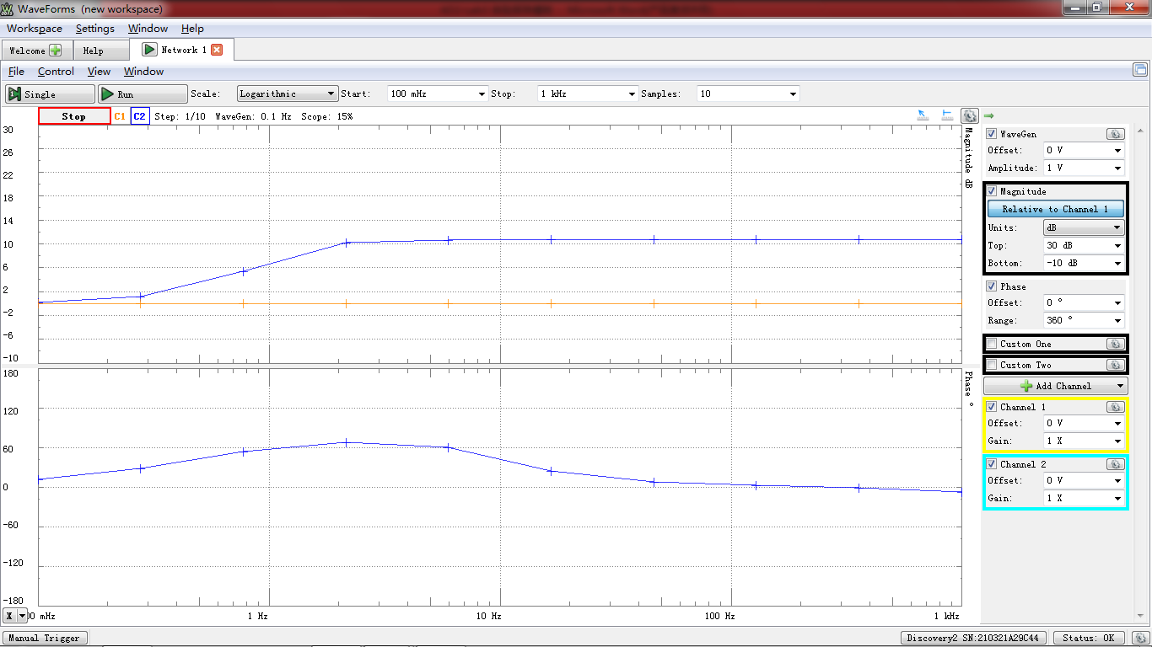

1. Build an uncompensated 2nd-order system as shown below, using inertial element #2 (SW4) and proportional amplifier #2 (SW6), with step input amplitude at 1V (scale of RP0 at 2), and scale of RP4 at 10. Capture the step transient response; measure and calculate *M*P and *t*s from scope display.



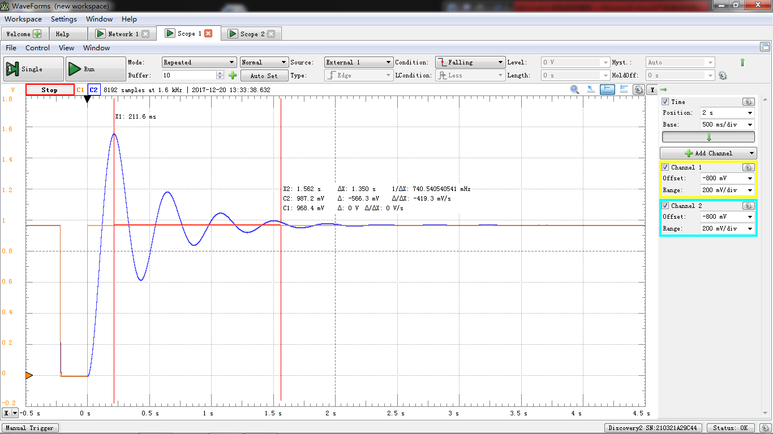

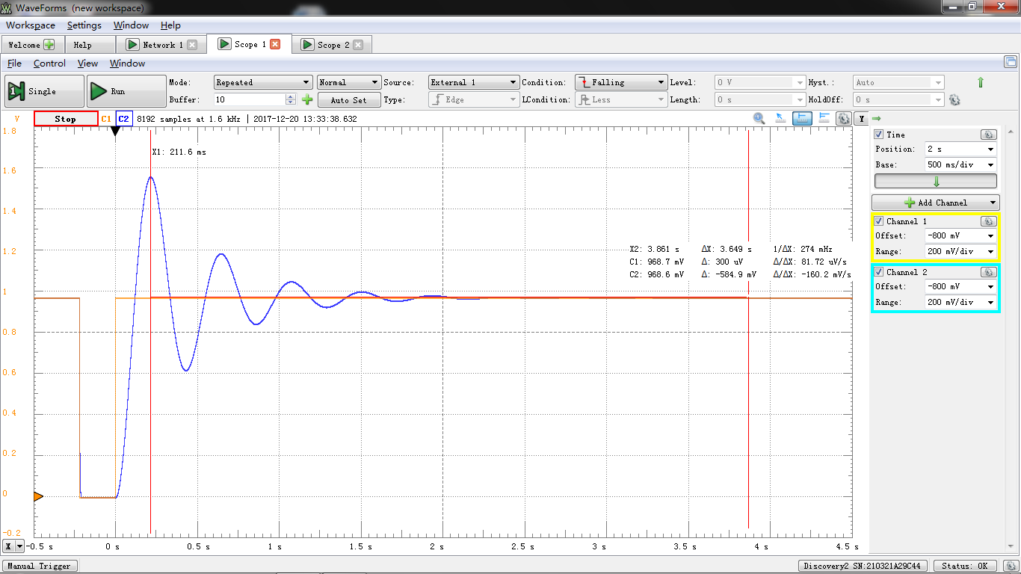

From the figure:

1. Insert the “series compensator (SW5)” into the 2nd-order system built above. Set the scale of RP3 at 10. Make sure that the circuit is been connected as negative feedback. Capture the step transient response of this compensated 2nd-order system; measure and calculate *M*P and *t*s from scope display.

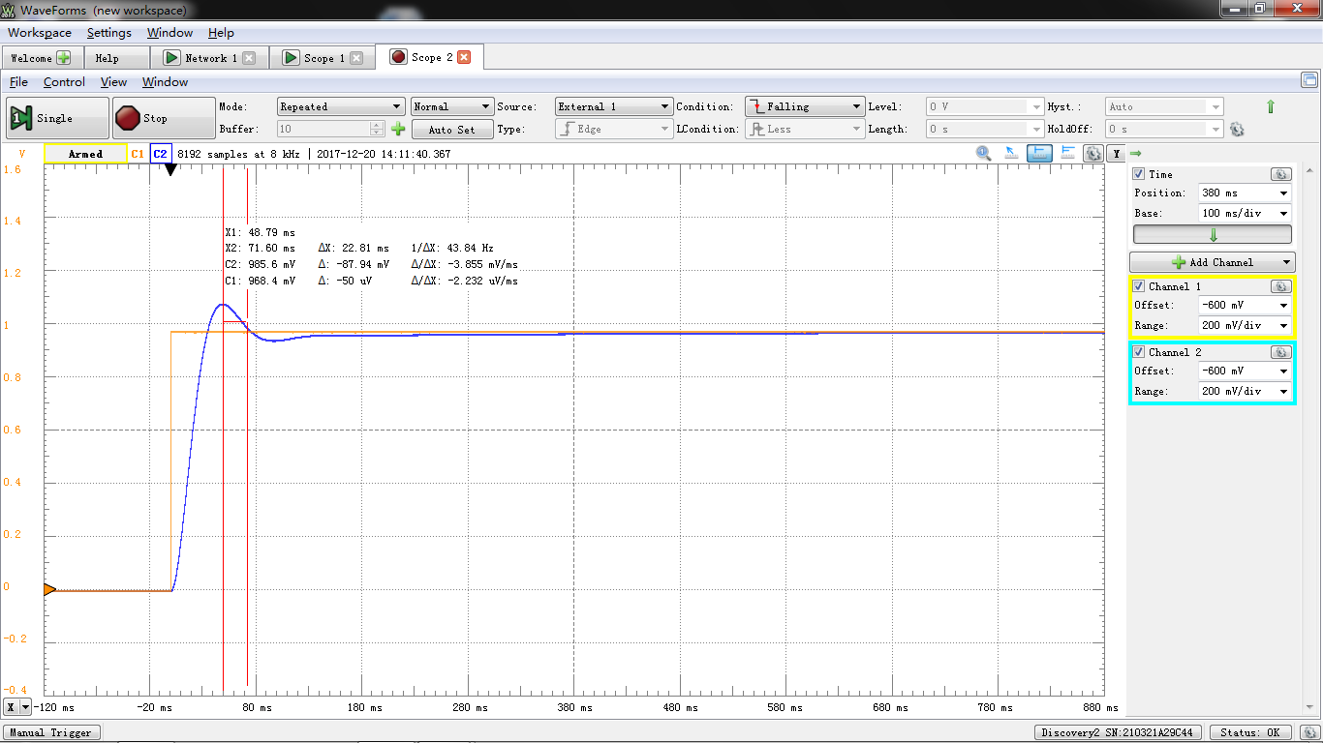

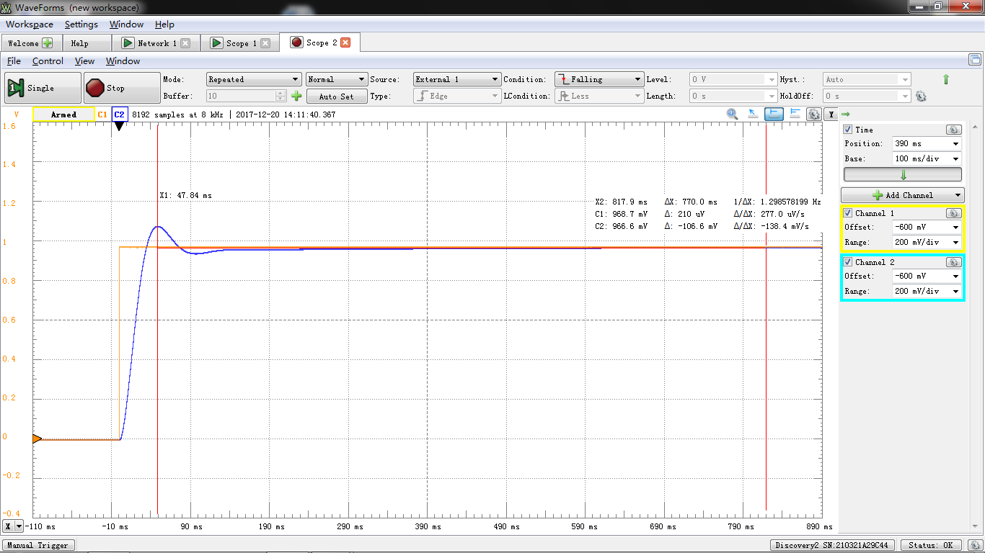

From the figure:

***RESULTS ANALYSIS***:

1. Theoretical analysis of the circuit targets in the experiment procedure described above.
2. Comparison and analysis between the theoretical and experimental results.

The transfer function of inertial element is

The break frequency is

, after which the log magnitude will decline at a speed of 20db/decade, and the phase magnitude should decline 180 degree.

And the function of integrator is

The log magnitude should decline at a speed of 20db/decade from the origin, and the phase magnitude should stay at -90 degree.

For series compensator,

The break frequency is

However, this function only works at a low frequency. Therefore, the figure is quite different from the theoretical one.

Without a compensator, the open-loop transfer function is

And the closed-loop function is

Compare with the experiment result, for , ; for , .

With a compensator, the open-loop transfer function at a very low frequency is

And the closed-loop function is

With the analysis of MATLAB[1], , no overshoot. This is also different from the experiment result, because the transfer function of compensator only works at a very low frequency. However, from the figure of ideal case, the settling time can be shorten enormously.

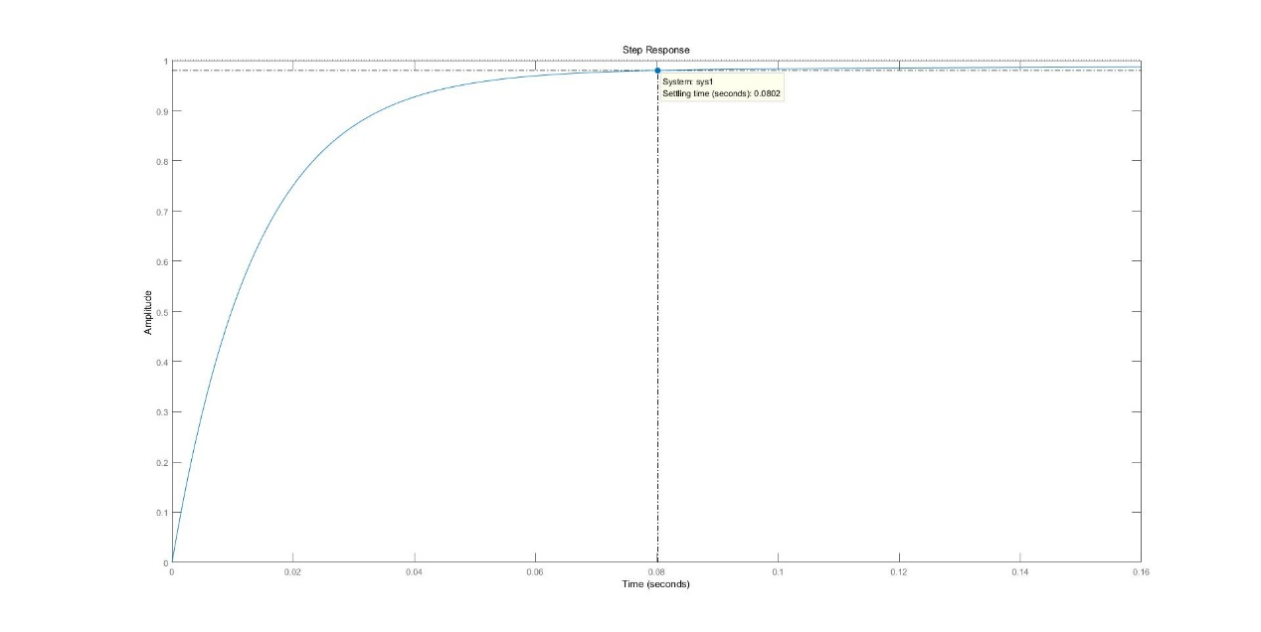

***DISCUSSION***:

1. What are the characteristics of differential compensator, integral compensator and the differential-integral compensator?

A differential compensator can add a new zero to the original transfer function, which can increase the value of as well as the stability of the system.

An integral compensator add a pole, which will improve the steady-state performance of the system, but also decrease the value of and the stability.

A differential-integral compensator can make use of the advantages of both compensators.

1. What are the advantages of active compensator and passive compensator, respectively?

An active compensator is composed of amplifier, so the gain of the system is adjustable, which is flexible during an experiment. But the characteristic of the system may be easy to drift.

A passive compensator is more stable because it only contains RC circuit. But there is no amplification gain in the system.

1. How to ensure the closed-loop systems built in this lab, uncompensated and compensated ones, have negative feedback?

It can be judged by the output of the system that whether there is a negative feedback in it. If the output cannot settle after a curtain time, there is no negative feedback. Vice versa.

***REFERENCES***:

[1] The code of MATLAB :

clear;

close all

clc;

%%

num1 = [14.25 50];

den1 = [0.2 15.25 50];

sys1 = tf(num1, den1);

figure(2);

step(sys1);

%%