BDRPC187

DANANG SOFTWARE CORPORATION

SOFTECH APTECH

− 🙣🕮🙡 −



**PROJECT**

**LANDSOFT MANAGEMENT**

**APPLICATION**

**Instructor : Mr. Nguyen Duc Thao**

**Group : 1**

**Members : Đỗ Hữu Tài**

**Huỳnh Thanh Chức**

**Nguyễn Thành Đạt**

**Nguyễn Sơn Trà**

**Danang, June 25th, 2020**

Landsoft Management

|  |  |
| --- | --- |
| Group 1 | |
| Group Member | Đỗ Hữu Tài  Huỳnh Thanh Chức  Nguyễn Thành Đạt  Nguyễn Sơn Trà |
| Instructor | Mr. Nguyen Duc Thao |

**TEACHER’S EVALUATION**

………………………………………………………………………………………………………………………………………………………………………………………………………………………………………………………………………………………………………………………………………………………………………………………………………………………………………………………………………………………………………………………………………………………………………………………………………………………………………………………………………………………………………………………………………………………………………………………………………………………………………………………………………………………………………………………………………………………………………………………………………………………………………………………………………………………………………………………………………………………………………………………………………………………………………………………………………………………………………………………………………………………………………………………………………………………………………………………………………………………………………………………………………………………………………………………………………………………………………………………………………………………………………………………………………………………………………………………………………………………………………………………………………………………………………………………………………………………………………………………………………………………………………………………………………………………………………………………………………………………………………………………………………………………………………………………………………………………………………………………………………………………………………………………………………………………………………………………………………………………………………………………………………………………………………………………………

**Table of Contents**

I. ACKNOWLEDGEMENTS 7

II. RATIONALE 7

In recent years, the real estate market in Vietnam in general and Da Nang in particular has grown rapidly. In addition to helping people own the dream land or house, real estate also helps many people become rich quickly. 7

LandSoft management application helps real estate brokers and investors to easily manage and trade their real estate properties. 7

III. INTRODUCTION 7

IV. TARGETS AND OBJECTS OF THE RESEARCH 8

1. Research Targets 8

2. Research Objects 8

V. PROBLEM DEFINITION 8

VI. THE TECHNOLOGY USED 9

1. Tools used 9

2. Language Used 9

VII. REQUIREMENT ATTRIBUTES 9

1.Critical Use Case Specification 9

2. Entity Relationship Diagram 15

4. Table 16

4.1 Properties Table 16

4.2 Properties Type Table 16

4.3 Customer Table 17

4.5 Owners Table 17

4.5 Transactions Table 18

4.6 Image Table 18

VIII. IMAGE OF THE SOFTWARE 19

VIII. CONCLUSION 27

**1. Conclude** 27

I. ACKNOWLEDGEMENTS

First, we would like to thank the teachers who helped us make a successful project. Especially Mr. Nguyen Duc Thao was very enthusiastic to help us complete software projects.

Although we have made many attempts, because of the limited time, the practice could not be able to avoid the mistakes and deficiencies. We hope teachers can consider and ignore our errors or deficiencies. And finally, we would like to offer many thanks to all our friends for their valuable suggestions and constructive feedbacks.

II. RATIONALE

In recent years, the real estate market in Vietnam in general and Da Nang in particular has grown rapidly. In addition to helping people own the dream land or house, real estate also helps many people become rich quickly.

LandSoft management application helps real estate brokers and investors to easily manage and trade their real estate properties.

III. INTRODUCTION

LandSoft management software helps real estate companies, brokers and real estate owners to provide information about their real estate. In contrast, customers and brokers in need can easily find a suitable property.

The management of real estate, customers, and owners is done strictly through linking with Microsoft SQL database management software.

IV. TARGETS AND OBJECTS OF THE RESEARCH

1. Research Targets

The main objective of the project is to create a real estate management system to solve the difficulties in the management activities for the purpose of minimizing the use of human resources in management, increasing efficiency, saving costs, time and effort.

2. Research Objects

Our main objects are the owners, customers and the real estate managers.

V. PROBLEM DEFINITION

1. Login

2. Account Management

3. Properties Management

4. Owers Management

5. Customer Management

6. Property type Management

7. Property Image Management

8. Transactions Management

9. Change and Recovery Password

VI. THE TECHNOLOGY USED

1. Tools used

NetBeans IDE 8.2 , SQL Server 2016

2. Language Used

Java, SQL

VII. REQUIREMENT ATTRIBUTES

1.Critical Use Case Specification

|  |  |
| --- | --- |
| USE CASE SPECIFICATION | |
| Use-case Name | Login |
| Purpose:  To manage account allows users to log into the management system  Descriptions:  User login to the management system by entering the required fields and push button “Login”.  User who log on to the system successfully, it will show up the Admin Frame if account role is admin, Main Frame if account role is member. | |

|  |  |
| --- | --- |
| USE CASE SPECIFICATION | |
| Use-case Name | Account Management |
| Purpose:  Allow users to add, edit, delete the user of system.  Descriptions:  User will add a customer by entering the required fields, select admin or user and push button “Add”  User will delete a customer by choose user in the list and push button “Delete”  User will edit information of a customer by choosing the user, then entering the required fields and push button “Update” | |

|  |  |
| --- | --- |
| USE CASE SPECIFICATION | |
| Use-case Name | Properties Management |
| Purpose:  To manage existing properties on the system.  Descriptions:  Users can add properties by filling in information and clicking the "add" button.  Users can modify properties by filling in information and clicking the "update" button.  Users can delete properties by clicking the "delete" button.  Users can find by filling in information and clicking the "find" button. | |

|  |  |
| --- | --- |
| USE CASE SPECIFICATION | |
| Use-case Name | Owers Management |
| Purpose:  To manage the owners of properties on the system.  Description:  Users can add owner by filling in information and clicking the "add" button.  Users can modify owner by filling in information and clicking the "update" button.  Users can delete owner by clicking the "delete" button.  Users can find by filling in information and clicking the "find" button. | |

|  |  |
| --- | --- |
| USE CASE SPECIFICATION | |
| Use-case Name | Customer Management |
| Purpose:  Allow users to add, delete, edit information of customer.  Description:  Users can add Customer by filling in information and clicking the "add" button.  Users can modify Customer by filling in information and clicking the "update" button.  Users can delete Customer by clicking the "delete" button.  Users can find by filling in information and clicking the "find" button. | |

|  |  |
| --- | --- |
| USE CASE SPECIFICATION | |
| Use-case Name | Property type Management |
| Purpose:  Allow users to add, delete, edit propertis type.  Description:  Users can add a property type by filling in information and clicking the "add" button.  Users can modify property type by filling in information and clicking the "update" button.  Users can delete property type by clicking the "delete" button.  Users can find by filling in information and clicking the "find" button. | |

|  |  |
| --- | --- |
| USE CASE SPECIFICATION | |
| Use-case Name | Property Image Management |
| Purpose:  Allow users to add, delete, edit the pictures of the properties.  Description:  Users can add a property image by filling in information and clicking the "add" button.  Users can modify a property image by filling in information and clicking the "update" button.  Users can delete a property image by clicking the "delete" button.  Users can find by filling in information and clicking the "find" button. | |

|  |  |
| --- | --- |
| USE CASE SPECIFICATION | |
| Use-case Name | Transactions Management |
| Purpose:  To manage information about real estate transactions  Description:  Users can add a transaction by filling in information and clicking the "add" button.  Users can modify a transaction by filling in information and clicking the "update" button.  Users can delete a transaction by clicking the "delete" button.  Users can find by filling in information and clicking the "find" button. | |

|  |  |
| --- | --- |
| USE CASE SPECIFICATION | |
| Use-case Name | Change Password |
| Purpose:  Allow users change password  Input:  User change password by entering the required fields include: user name, current password,new password and push button “Change”  Output:  System will notify the user that has changed successfully or not. | |

|  |  |
| --- | --- |
| USE CASE SPECIFICATION | |
| Use-case Name | Change and Recovery Password |
| Purpose:  Allow users Change recovery password.  Description:  Users can recovery password by entering the required fields include: user name, email, new password and push button “OK”.  Users can change password by entering the required fields include: user name, email, new password and push button “OK”. | |

2. Entity Relationship Diagram

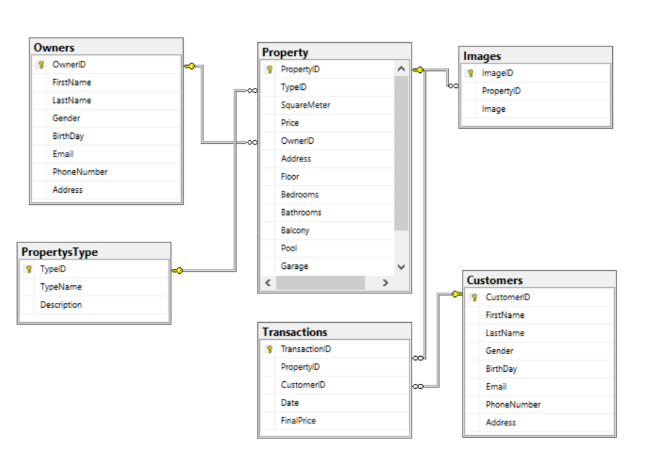

4. Table

4.1 Properties Table

|  |  |  |  |
| --- | --- | --- | --- |
| **Key** | **Field Name** | **Data Type** | **Null** |
| PK | PropertyID | int | Not |
| FK | TypeID | int | Not |
|  | SquareMeter | varchar(10) | Not |
|  | Price | varchar(20) | Not |
|  | OwnerID | int | Not |
|  | Address | nvarchar(50) | Not |
|  | Floor | int |  |
|  | Bedrooms | int |  |
|  | Barthrooms | int |  |
|  | Balcony | bit |  |
|  | Pool | bit |  |
|  | Garage | bit |  |
|  | Description | nvarchar(MAX) | Not |

4.2 Properties Type Table

|  |  |  |  |
| --- | --- | --- | --- |
| **Key** | **Field Name** | **Data Type** | **Null** |
| PK | TypeID | int | Not |
|  | TypeName | nvarchar(30) | Not |
|  | Description | nvarchar(50) |  |

4.3 Customer Table

|  |  |  |  |
| --- | --- | --- | --- |
| **Key** | **Field Name** | **Data Type** | **Null** |
| PK | CustomerID | int | Not |
|  | FirstName | nvarchar(20) | Not |
|  | LastName | nvarchar(20) | Not |
|  | Gender | bit |  |
|  | BirthDay | date |  |
|  | Email | varchar(30) | Not |
|  | PhoneNumber | char(10) | Not |
|  | Address | nvarchar(50) |  |

4.5 Owners Table

|  |  |  |  |
| --- | --- | --- | --- |
| **Key** | **Field Name** | **Data Type** | **Null** |
| PK | OwnerID | int | Not |
|  | FirstName | nvarchar(20) | Not |
|  | LastName | nvarchar(20) | Not |
|  | Gender | bit |  |
|  | BirthDay | date |  |
|  | Email | varchar(30) | Not |
|  | PhoneNumber | char(10) | Not |
|  | Address | nvarchar(50) |  |

4.5 Transactions Table

|  |  |  |  |
| --- | --- | --- | --- |
| **Key** | **Field Name** | **Data Type** | **Null** |
| PK | TransactionID | int | Not |
| FK | PropertyID | int | Not |
| FK | CustomerID | int | Not |
|  | Date | date | Not |
|  | FinalPrice | varchar(50) | Not |

4.6 Image Table

|  |  |  |  |
| --- | --- | --- | --- |
| **Key** | **Field Name** | **Data Type** | **Null** |
| PK | ImageID | int | Not |
|  | PropertyID | int | Not |
|  | Image | image | Not |

VIII. IMAGE OF THE SOFTWARE

1. **Login form**

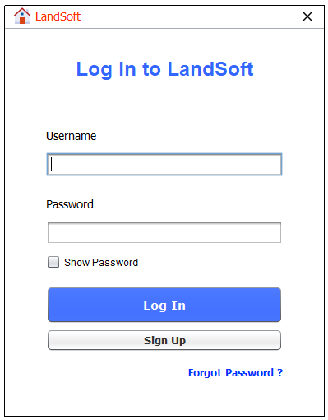

1. **Sign Up form**

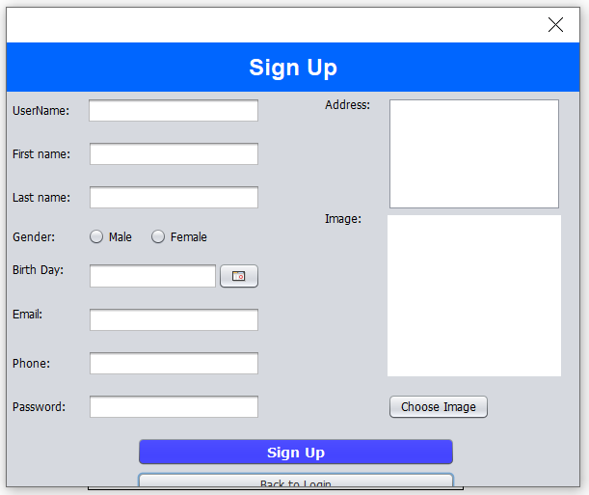

1. **Recover Password form**

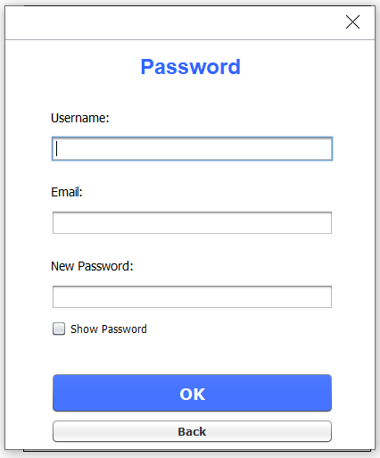

1. **The main software interface**

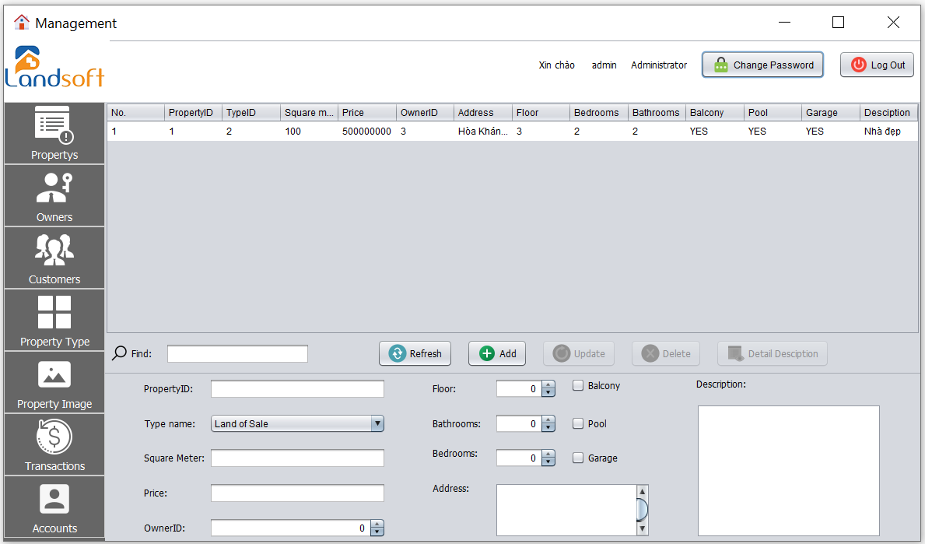

1. **Change password form**

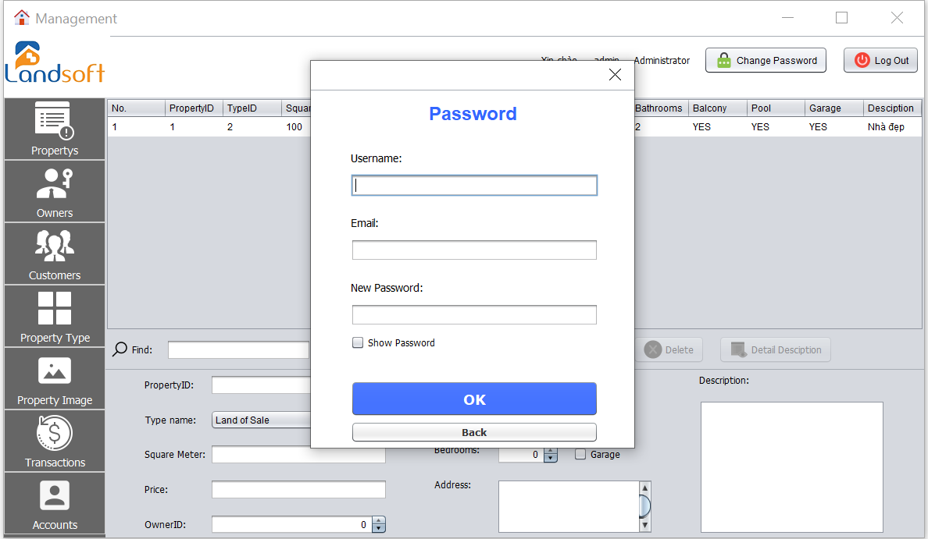

1. **Properties Managerment Interface**

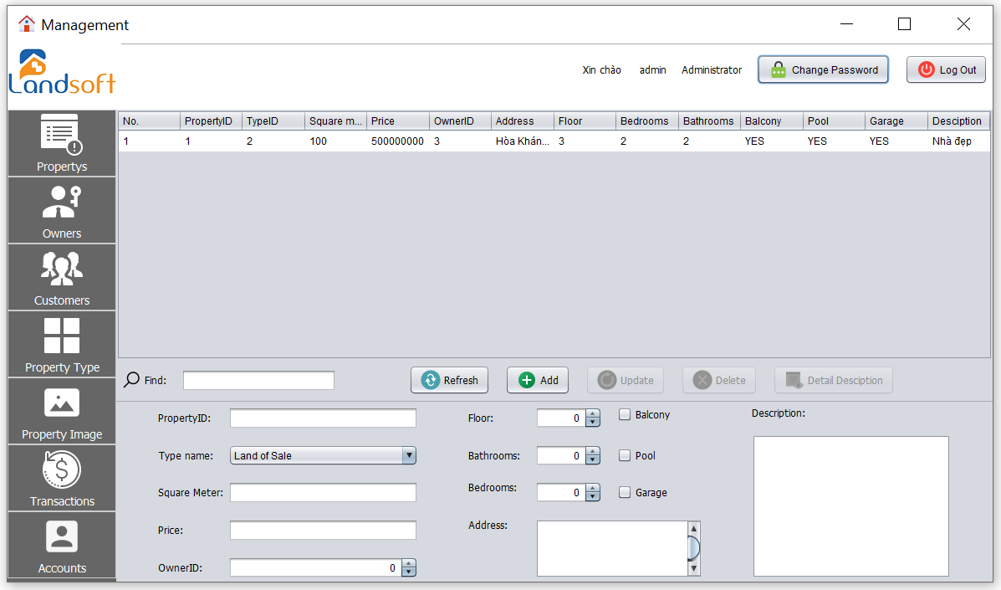

1. **Owners Managerment Interface**

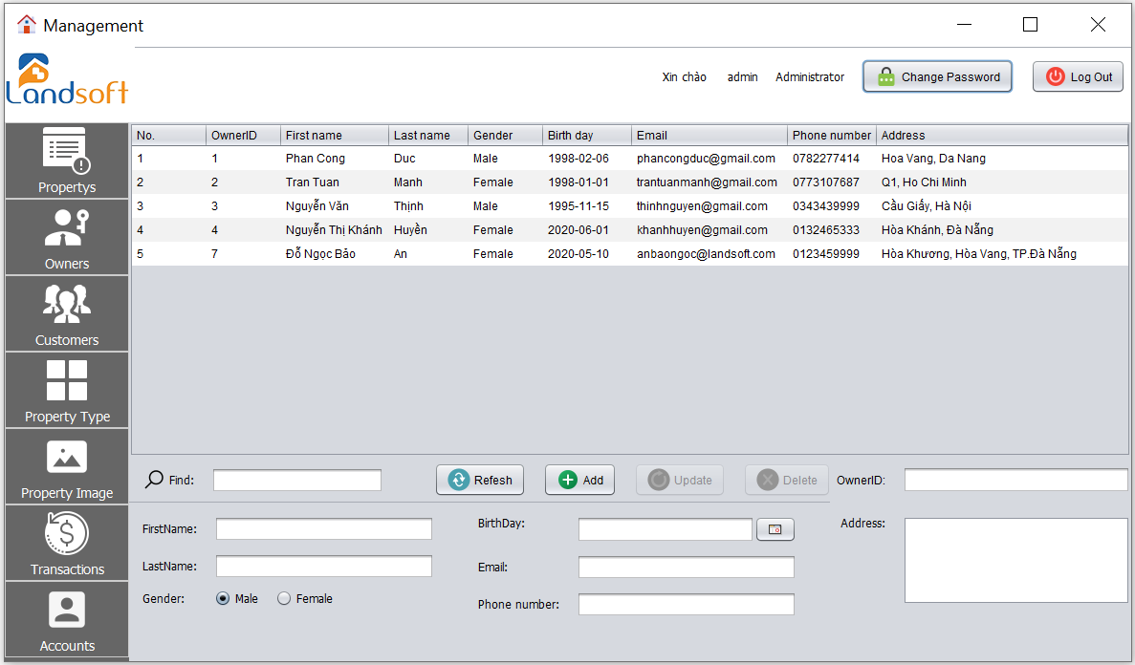

1. **Customers Management Interface**

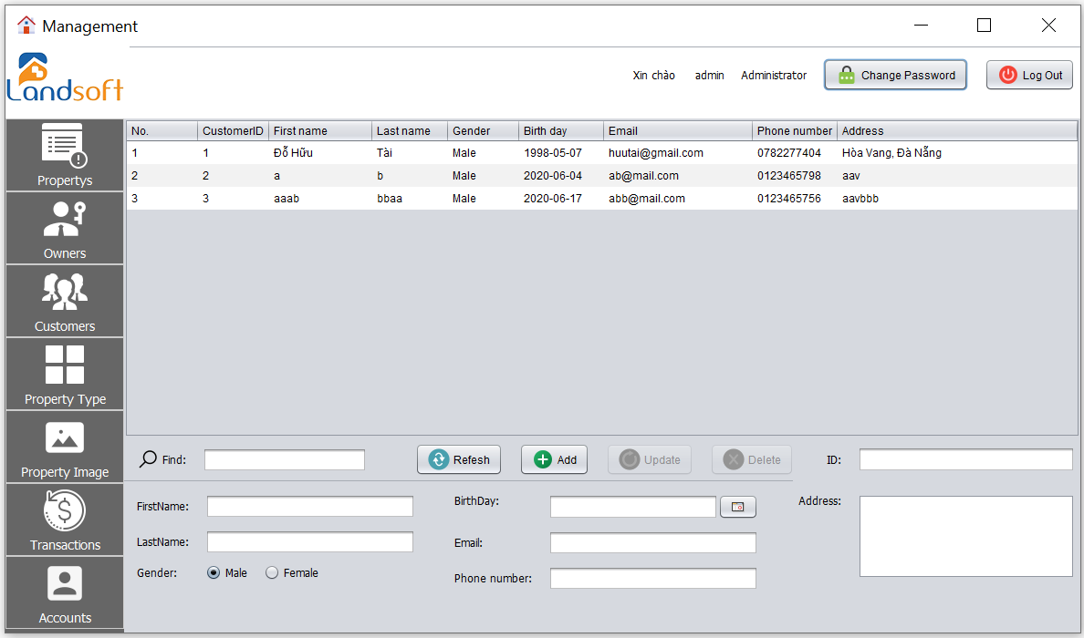

1. **Property Type Management Interface**

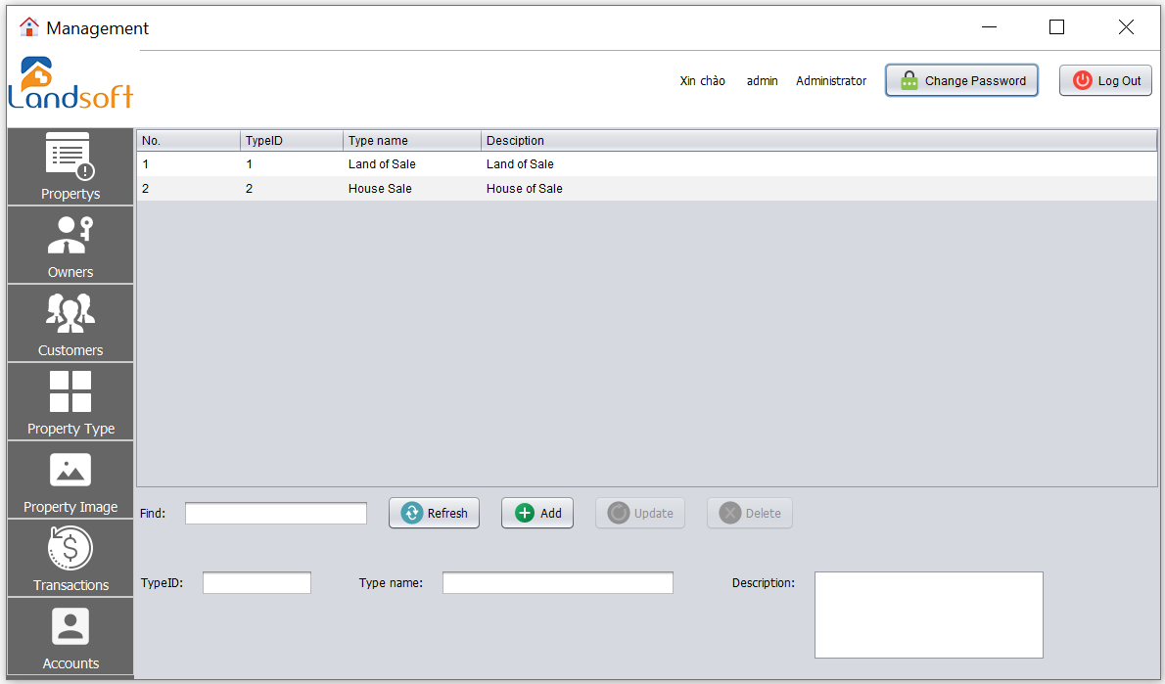

1. **Properties Image Management Interface**

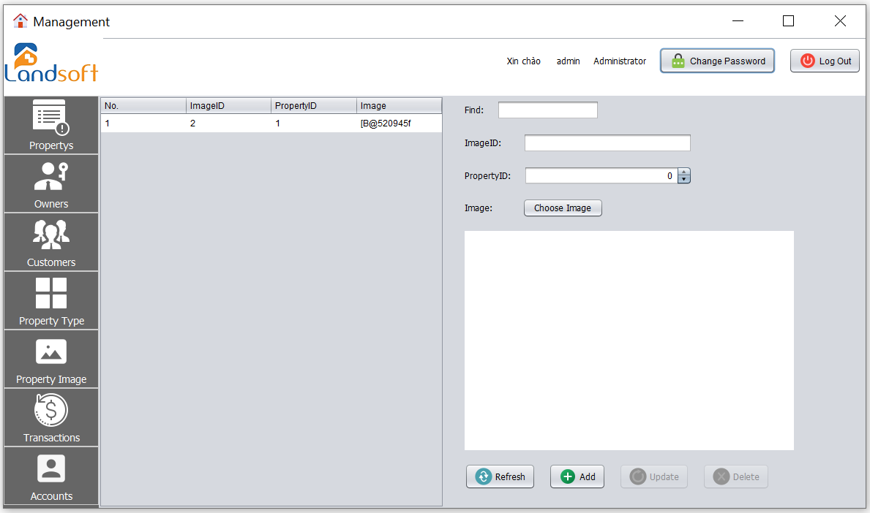

1. **Transactions Management Interface**

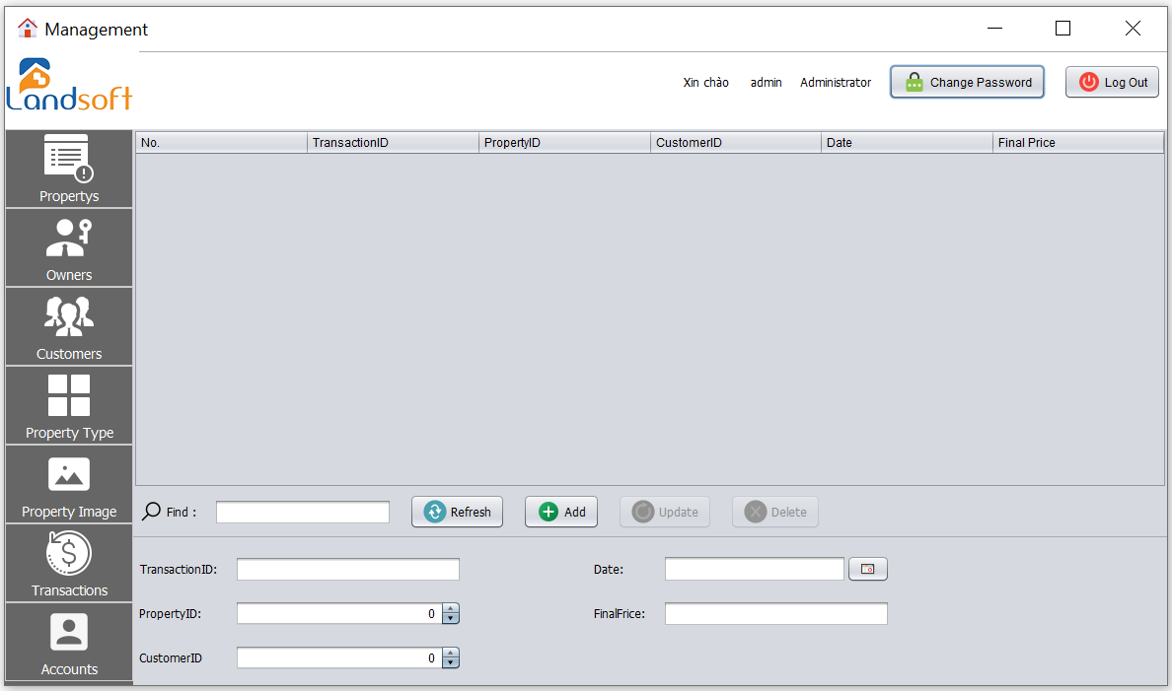

1. **Accounts Management Interface**

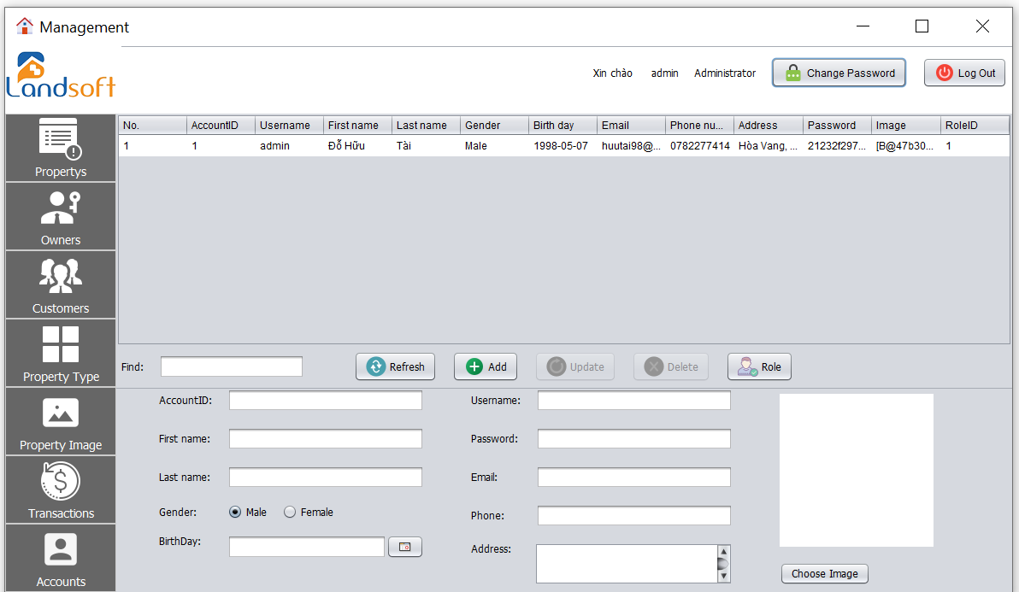

VIII. CONCLUSION

**1. Conclude**

To complete the 2st semester project, deliver the results as well as the products, our team has divided the specific tasks, as well as always trying to work and learn to develop and complete the products. good. However, due to lack of knowledge as well as work and completion, there are still some errors that cannot be completed correctly. The team will continue to complete the product to perfect and improve the components of the gym management software.

**PROS:**

* Have all basic function as the requirement
* Know how to develop a java application

**CONS:**

* Need more functions.
* Interface need to improves.

**TABLE OF DIVISION WORKING FROM THE MEMBERS OF THE GROUP**

|  |  |
| --- | --- |
| Member’s name | Mission |
| Do Huu Tai | * Up ideas for management * Division of work in groups * Database design for the application * Interface design for the application * Implement the functions of the program * Perform text file presentation |
| Huynh Thanh Chuc | * Up ideas for management * Perform text file presentation * Implement some code in the program |
| Nguyen Thanh Dat | * Up ideas for management * Implement some code in the program |
| Nguyen Son Tra | * Up ideas for management * Implement some code in the program |

**REFERENCES**

**A. REFERENCES VIETNAMESE**

**B. REFERENCES ENGLISH**

**C. REFERENCES WEBSITE**

[1] https://www.w3schools.com/

[2] https://viettuts.vn/

[3] https:// v1study.com/