Casual Gateway
Design and technical discussions

Table of Contents
Introduction 3
Logical design 3
Overview 3
Gateway Server 3
Gateway Master 3
Listening State machine 3
Gateway Client 4
Connection State machine 4
Protocol 5
Presentation layer 5
Application layer 6
Gateway specific 6
Casual specific 6

Introduction
This document contains the high level design of the casual gateway.

Logical design

Overview
The gateway consist of three high level components. The Gateway Server which is the startup component that launches the Gateway Master and one Gateway Client for each remote gateway in the configuration.
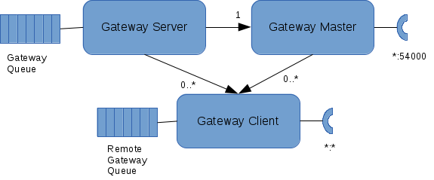Illustration 1: High level gateway design
The Gateway Servers high level function is to respond on service lookup requests from any local process that needs to find out where the service is located.
The Gateway Masters high level function is to respond to connection requests from remote gateways that wants to connect to this gateway. When the request arrives the Gateway Master launches a Gateway Client that takes control of the connection to the remote gateway.
The Gateway Clients high level function is to handle all requests to and from a remote gateway to a local proces.

Gateway Server
Bla bla

Gateway Master
Bla bla bla

Listening State machine
Bla bla
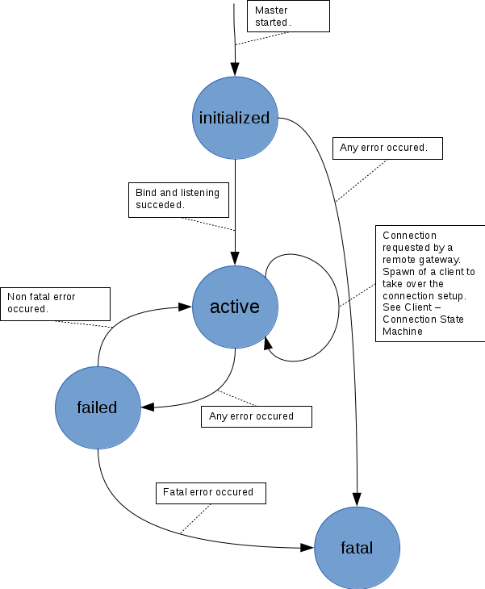Illustration 2: Master Listening State Machine
Bla bla

Gateway Client
Bla bla bla

Connection State machine
Bla bla
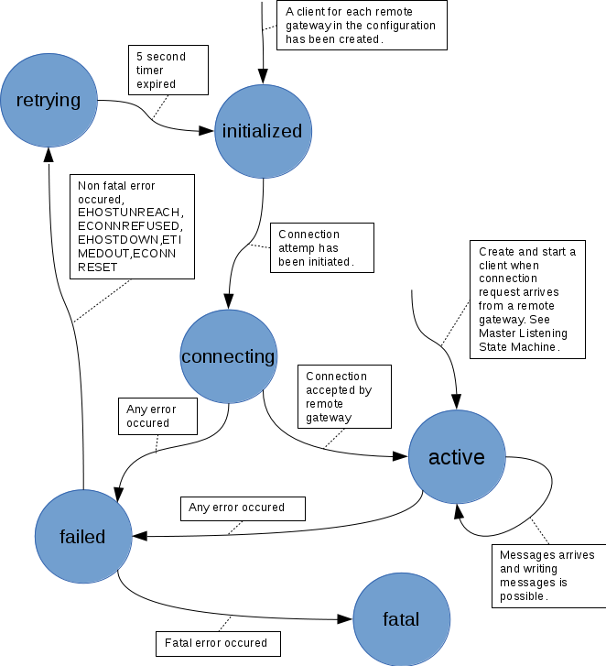Illustration 3: Client Connection State Machine

Bla bla

Protocol

Presentation layer
Each Casual message when sent over TCP/IP, presentation layer, begins with a four letter word ”CASL” followed by the size of the message body contained in 8 bytes, a 64 bit unsigned integer, and then the message body.

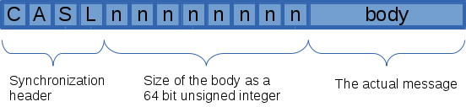Illustration 4: TCP/IP message
The header ”CASL” is used for synchronization of the TCP/IP-stream to find the message boundaries.
Any conversations containing sequences of multiple messages are defined on the application layer..

Application layer

Gateway specific
Remote gateway registration
Remote gateway shutdown
Remote gateway heartbeat

Casual specific
Bla bla bla

