Sewage treatment works

Proposal for the project

Shanxi blower (group)co.,LTD

August 2013

List of figures

**1. Overview** ........................................................................................ ...................................... 1

**1.1 Regional Overview** ..................................................................................... ........ .......... 1

**1.2 Basis of compilation**.................................................................................. ........ .......... 2

**1.3 Project overview** ....................................................................... ................................... 2

**2 Necessary of the construction**........................................................... .................................... 6

**3 Technology solutions**......................................................................... ...................................... 6

**3.1 treatment processes** .................................................................. ...................................... 6

**3.2 Construction site**........................................................................ ...................................... 7

**3.3 Construction of pipeline network**............................................. ...................................... 8

**3.4 Emissions pathways and discharge way and purposes**.......... ...................................... .. 8

**3.5 Staffing** ........................................................................................ ...................................... 8

**4 construction plan**............................................................................... ...................................... 9

**4.1 Business negotiation and technical preparation phase** ........... .................................... 9

**4.2 Project implementation phase**................................................... .................................. 9

**4.3 Project commissioning** ............................................................. ...................................... 9

**5 economic benefit analysis** ............................................................. ...................................... 9

**5.1 Investment estimate** ............................................................. ...................................... 9

**5.2 Operating cost estimates**...................................................... ...................................... 10

**5.3 Sales revenue** ............................................................... .......................................... 10

**5.4 Project financial analysis………………………………………………………………………………………. 11**

**6 Risk analysis and avoidance measures………………………………………………………………………. 12**

**6.1 Water Vloume………………………………………..………………………………………………………….. 12**

**6.2 water quality……………………………………………………………………………………………………… 12**

**6.3 Inflation risk………………………………………………………………………………………………………. 12**

**7 Social assessment ……………………………………………………………………………………………………. 13**

**7.1 Environmental benefit ……………………………………………………………………………………. 13**

**7.2 social benefit ……………………………………………………………………………………………………. 13**

**7.3 economic benefit……………………………………………………………………………………………. 13**

**8 conclusion and suggestions…………………………………………………………………………………… 14**

**Overview**

**Regional Overview**

Xi'an Lintong modern industrial group Weibei industrial zone located in north of the Weihe River, is the important implementation of Lintong District "Guanzhong - Tianshui" Economic Zone Development Plan.The planning area 51.03 square kilometers. Recent construction land size of 13 square kilometers, which can accommodate 13.3 million. Land areas: north to the north of Maling village, south to Weihe River levee, east of Eastern Wei East Village, west of North Town. Recent construction area includes part of the central area of ​​the park land for ancillary services and common special equipment manufacturing industrial park, noble style communities and Part of the riparian ecological residential area. east, west, south and north,four traffic road of the zone have been completed,namely qinwang yi raod,qinwang er road,weishui yi road and weishui er road. Recent construction area adjacent to the south of the Weihe River, Planning amount of recreational land in riparian ecological functions greenery; Central of the zone is given priority to residential and commercial land,which Is the center of the park development;planning of north areas is a class of industrial,which is use for fledgling industry. According to the concept of integration of construction and timing, The park will give priority to the construction of industrial zones, the effects of industrial aggregation will given impetus to the development of local business and Improve living facilities.

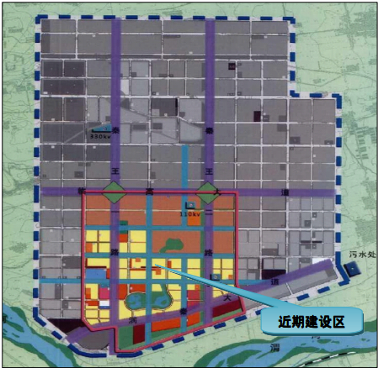

1. **Basis of compilation**

(1)policy

<Energy saving "Twelfth Five”Plan>

< Provisional Regulations on the development of private water utilities>

< State Council on promoting the reform of water prices to promote water conservation and protection of water resources>

< Water-saving society Development Program of shanxi province>

< Twelve Five comprehensive energy reduction program of shanxi province>

< Water Conservation Measures of shanxi province>

< Xi'an urban sewage treatment and recycled water use regulations>

(2) Park Planning

< Xi'an Weibei (Lintong) Modern Industrial City Plan>

< Weibei Industrial Zone, Xi'an Lintong modern industrial group controlled detailed planning>

<Xi'an Environmental Protection" Twelfth Five-Year Plan "and the 2020 Plan>  
<Weibei Industrial Zone of Xi'an Lintong modern industrial group Drainage Plan>  
<Detailed planning Weibei Industrial Zone of Xi'an controlling - Lintong modern industrial groups (review draft)> in the use of renewable water resources planning

(3) Industry standards and specifications

"PRC Water Pollution Prevention Law"  
"Surface Water Quality Standard" (GB3838-2002)  
"Urban sewage treatment plant pollutant discharge standard" (GB18918-2002)  
"Sewage discharged into the city sewer water quality standards" (CJ3082-1999)  
"Integrated Wastewater Discharge Standard" (GB8978-1996)  
"Outdoor drainage design specifications" (GBJ14-87)  
"City sewage treatment plant sewage sludge discharge standard" (CJ3025-93)  
"Urban sewage treatment project construction standards" (2001)  
"Urban Water Supply Engineering Planning" (GB50282-98)

**3 Project Overview**

(1) Project Name

Lintong modern industrial group Energy Island Ⅰ Sewage treatment works

(2) the proposed location  
The site is located Qinwang er road and Weshui sii Road intersection with the southeast corner, covering 20 acres.

(3) Scale  
"Detailed planning Weibei Industrial Zone of Xi'an controlling - Lintong modern industrial groups (review draft)" in the total size of the park sewage treatment 113,000 m³ / d, the scale of the recent construction of a sewage treatment plant for the 10,000 m³ / d.

4) sewage sources  
According to the plan the park sewage treatment plant will serve industrial and domestic sewage, "a nucleus, area, three-, four groups" region, the energy Island sewage treatment plant will cover services from the west side of the park west, north to Weishui Qi Road, south to Weishui si road, east to east of Qinwang Dong Road area, according to the starting area contracted corporate nature, the discharge of sewage will be machining manufacturing-based.

(5) Water Quality Indicators  
a raw water:  
According to "Lintong modern industrial group controlled detailed planning" within the scope of the sewage treatment plant water distribution received a large number of machinery, equipment and processing enterprises and some residential areas. Recommended water park based on the same type of effluent quality conditions and "Drainage Design Manual" (Volume V) moderate concentrations of sewage, effluent quality estimates shown in Table 1:

Table 1 Energy Island Ⅰsewage treatment plant influent water quality valuation (mg / L)



B effluent:  
Energy Island I a sewage treatment plant effluent A standard, its main water quality indicators in Table 2:

Table 2 Energy Island Ⅰ water reuse project water quality valuation (mg / L)



(6) Construction Period  
construction period: 1 year  
(7) investment budget

Energy Island Ⅰsewage treatment plant with a total investment of 25,742,500 yuan, as shown in Table 3:

Table 3 sewage treatment project investment estimate table (unit: wanyuan)

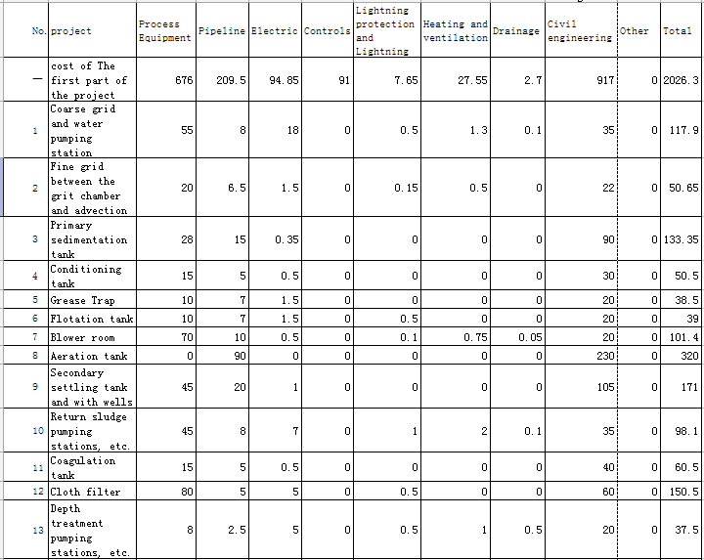

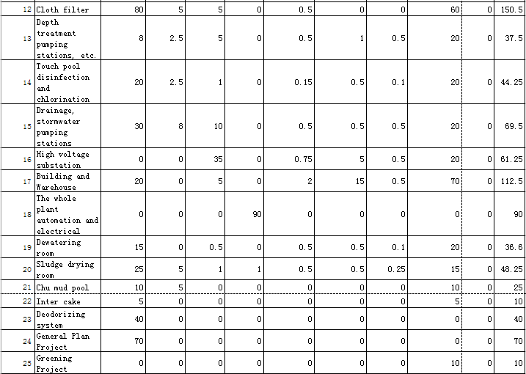

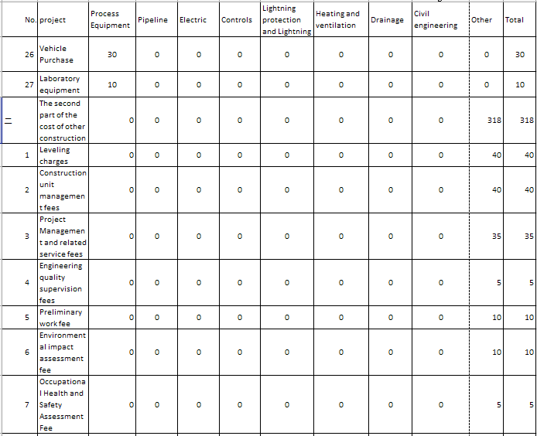

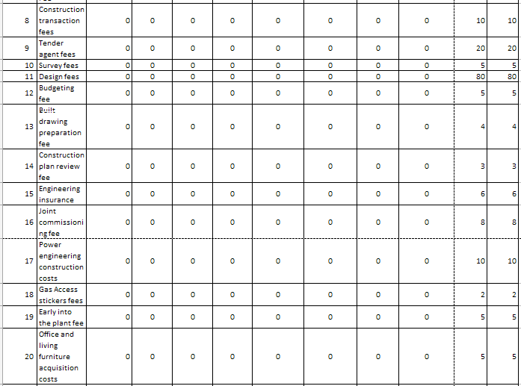

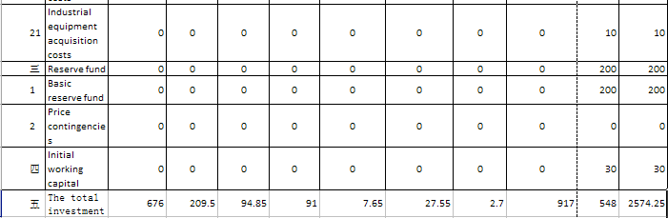

Note: does not include loan interest during construction

Second the necessity of the construction project

Urban water pollution is a major obstacle to the sustainable use of water resources for sustainable cities and urban economic development. Therefore, comprehensive treatment of urban sewage, the sewage discharge standards and implementations water reuse to minimize pollution of the local municipal sewage water environment is essential.

With the development of lintong modern industry groups, industrial enterprises continuously settled and put into production, the amount of sewage and pollutants will be a substantial increase, due to the Weihe River is a modern industrial group Lintong sewage water storage, the energy island I water reuse project is the Weihe River water an important part of pollution control. Thus, the full implementation of the Weihe River Basin Management Plan focuses on the promotion - sustainable development "Guanzhong-Tianshui Economic Zone," the economic and social development and the Weihe River has great significance.

Lintong modern industrial group in the transition zone of arid areas and wet areas, local water resources are not abundant, so the construction of this project will become an inherent requirement of sustainable development. Wastewater treatment, water reuse is to encourage water-saving behavior of Shaanxi Province, Lintong water use requirements are clearly modern industrial group planning raised. A "phased subdivision" ideological guidance in the construction industry started nearby sewage treatment plant, can effectively reduce the investment in water supply network, to meet enterprise requirements under the premise of the government to achieve the water economy, reduce municipal investment companies and financial pressure water users, is conducive to the promotion of water-saving policy for the region's economic and environmental pressure.

Third the process technology program  
1, the treatment process  
 Considering the energy Island Ⅰsewage treatment plant effluent quality within close range of a moderate concentration of water containing sewage water, many other considerations of safety and security from the sewage treatment, plant investment and operating costs, such as body mass, preliminary recommendations for the design of the sewage treatment process A2O Process II coagulation + treatment + grade cloth filter processing.  
Energy Island Sewage Treatment Plant Ⅰ major structures are shown in Table 4:

Table 4 main sewage treatment plant structures

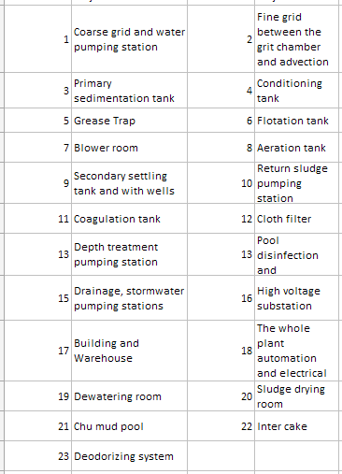

2, the construction site  
(1) siting principles:  
a line with the overall urban planning and water supply planning requirements.  
b good engineering geological conditions.  
c gravity flow to meet the requirements of the terrain.  
d facilitate the collection of sewage.  
e easy to use in the water;  
f ease with other sub-island energy coupling energy systems;  
g pipeline construction economy.  
(2) the project site:  
Ⅰ Energy Island sewage treatment plant construction site in the Wei Qin Road intersection with the southeast corner of four plots in Figure 2.

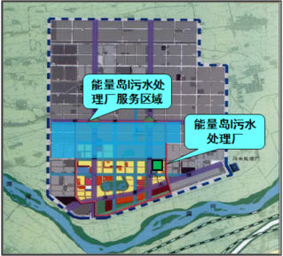

Figure 2 Energy Island Ⅰ Sewage Treatment Plant service area schematic

3, the pipeline construction  
Point-to-energy park island I drain the sewage treatment plant pipe network construction subject to the park management committee, the sewage plant output  
Construction of the main water supply network for the wastewater treatment plant construction side.  
4, the treated water discharge channels and uses  
(1) Energy Island I sewage treatment plant effluent discharge to attain the level A  
①You can use the drainage pumping stations treated effluent discharged into the main stormwater pipeline of Qinwang Er road. Transported to the south side of the Weihe River Pumping Station, into the Weihe River.

②along south ofQinwang er Road add sewers, solve the promble-- recent drainage issue of the development of the park.

(2) Based on the current development and construction of the actual situation in the park, the water can be used for construction projects in the water reuse project:  
5 Staffing  
Institutional settings and staffing situation Table 5:

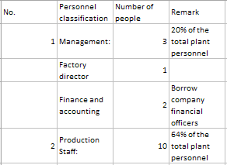

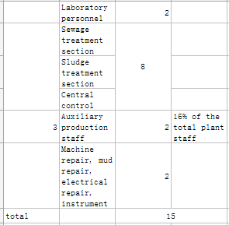

Four the construction plan

Depending on the circumstances prevailing norms and construction period of the project, the whole project cycle from September 2013 to June 2015, including pre-business negotiations, technical preparation, project implementation and project commissioning phase of the three phases. The work program as follows:  
 1, business negotiations, technical preparation phaseSeptember 2013 - November 2013: project approval, preliminary project plan, environmental surveying, investment is estimated to start the project contract negotiationsNovember 2013 - January 2014: Planning Review, land-use pre-review, Environmental assessment preparation, preparation of feasibility studies, safety assessment, signed a franchise contract.  
 2, the project implementation phase  
November 2013 - February 2014: Implementation of design units and contracts, while mapping and geological survey, equipment selection research to determine the general plan approval, construction design, peripheral large municipal programs (on the power supply, water supply, drainage , roads, etc.).

February 2014 - December 2014: civil construction, equipment installation.  
 3, project commissioning  
 December 2014 - June 2015: Project test run.

June 2015 to the future: the project put into formal operation.

Fifth, economic analysis  
1. Investment Estimation  
(1) Investment estimates are based on  
"Water Supply and Drainage Design Manual" (second edition)  
"Water Engineer's Handbook"

"Sewage treatment plant design and operation" (2001)  
"National unity municipal engineering budget quota tariff of Shaanxi Province" (2001)  
"Municipal Engineering Investment Estimation indicators" (HGZ-47-104-2009)  
"Project in Shaanxi province other fixed costs" (1999)  
"Shaanxi Provincial Project Cost Management Information Materials Information price" (2008.6)  
Wage labor costs by Shan Jian Fa [2007] No. 232 issued by the implementation of the text  
(2) Estimated Investment Description  
Including the handling process equipment and civil engineering and plant construction and other projects.  
(3) Investment Budget

Table 6 Investment Estimation of sewage treatment project

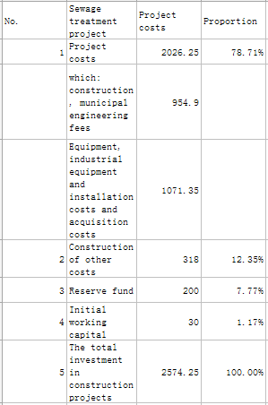

2 operating cost estimates  
(1) purchased raw materials fee: including production water, pharmaceutical consumption fees;  
(2) power costs including electricity and so on.  
Operating costs are shown in Table 7

Table 7 operating costs of sewage treatment

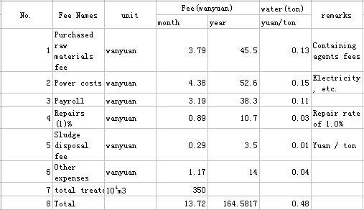

1. Sales  
   (1) Conditions of Sale:  
   ① sewage treatment plant construction in a similar situation to consider BOO model concession period of 30 years.  
   ② park shall be the project of sewage treatment capacity be guaranteed at the end, when the lack of actual water park, the park should be guaranteed at the end, Paul bottom water is: to 12 months after completion of the project Paul at the end of water to 6000m ³ / d, the first 13 months to 24 month minimum guarantee amount of water 8000m ³ / d, the first 25 months to 36 months and the end of each operating year warranty after water is 10000m ³ / d, running at full capacity.  
   (2) Sales revenue:

Table 8 project sales revenue

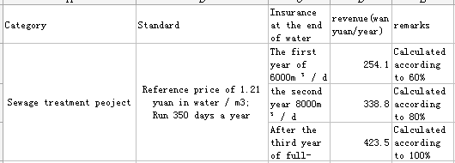

Note: The amount of revenue under the tariff reference has provided land resources.  
4 Project Financial Analysis  
(1) Measurement conditions:  
① handling capacity: the first year of 6000m ³ / d, the second year of 8000m ³ / d, in the third year 10000m ³ / d  
② running in a few days: 350 days  
③ Project Investment Estimation: Table 6  
④ operating costs of sewage treatment facilities: Table 7  
(2) The project is estimated by a professional financial staff, the results are shown in Table 9.

Table 9 Financial estimates

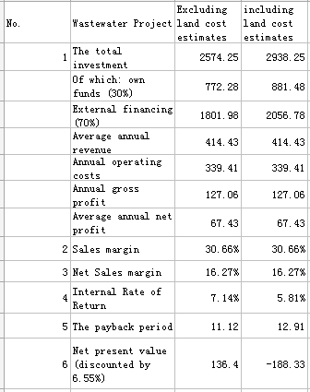

Note: The amount of revenue land resources under the premise of reference have 1.21 yuan / m3   
Sixth, risk analysis and avoidance measures  
1, water  
 Risk: With the construction and development of sewage water park will be gradually increased over a period of time, the early completion of the wastewater treatment plant in the presence of water can not reach sewage water risk estimates. Avoidance: recommended basic water clear in the agreement, and agreed under water shortage water, sewage services fee paid in accordance with the basic water. Meanwhile, the basic agreement as accurately as possible the amount of water, avoid long-term water quantity is less than the actual amount of water caused the government to pay the basic square default risk and risk of damage to equipment operation.  
2, water  
 Risk: The park generates effluent quality exceeded due to large number of industrial enterprises in the energy Ⅰ Island sewage treatment plant services, water and sewage discharge its general urban municipal sewage water are very different. During the wastewater treatment plant operators, long-term water quality, especially the excessive water will be mixed with an excess of toxic and hazardous substances in the process cause varying degrees of damage, leading to the sewage treatment plant is not normal production, which led to affect water quality.

Avoidance:  
① sewage treatment plant designed to leave enough margin  
 Design process, leave enough margin for the sewage plant project has a certain impact resistance , thereby reducing the risk of the project due to changes in water quality .  
② get the park each enterprise or sewage into the water close custody rights  
 Obtain custody or sewage polluting industries co-management rights from the park management committee , when the discharge of sewage meter business park , park assist the relevant authorities the right to shut down its drain valve , refuse sewage discharged into the city sewer . Ruoyin enterprises in the park when discharges contained poisonous substances overdose , resulting in sewage treatment plants and water reuse project processes, structures and equipment subject to appropriate levels of damage , the operator to obtain the corresponding compensation. To avoid the industrial park does not discharge water pretreatment effect on sewage treatment plant system may also recommend obtaining industrial piping straight row right .  
3 , inflation risk  
 Electrical , pharmaceutical , and other artificial rise will directly lead to an increase in operating costs , while the inflation rate ( CPI as an indicator ) will also affect the rate of return during the franchise . Suggested in the project agreement set a reasonable price adjustment formula to shielding and filtering effects of inflation.

Seven, social evaluation  
1, the environmental benefits  
Through the implementation of this project, further to the ecological environment and water environment throughout the region to play an active role in the construction of the wastewater treatment plant will serve the basis of environmental benefits . In the wastewater treatment plant on the basis of emission reduction benefits : COD reduction in the amount of 1,225 tons increase , BOD reduction in the amount of 525 tons increase , SS reduction in the amount of 840 tons increase , NH3-N reduction in the amount of 70 tons increase , while reducing sludge treatment quantization process will also reduce the negative impact on the environment , and further acts of Weihe River water quality protection and improvement , and improve the overall investment environment in the park .  
2 , social  
Construction of sewage treatment works , can greatly reduce the potential risk of disease outbreaks or epidemics , help to improve the quality of the urban environment , improve the city's image , will provide benefits to health and the environment on residents. Sewage treatment works are social welfare infrastructure can expand domestic demand , increasing employment, improving the people's living standards and living conditions will have significant social benefits.  
3 , economic  
Implementation of the project will have a wide range of local environmental impact , so that the development of industrial and residential sectors from the environment , resource constraints , the socio-economic development and environmental protection goals and coordinate for the park to provide quality play a positive investment environment effect.

CONCLUSIONS and recommendations  
1 , the total size of the park sewage treatment 113,000 m³ / d, the recent construction of a sewage treatment plant scale to 10,000 m³ / d.  
2 , Energy Island sewage treatment projects Ⅰ treatment process using A2O + + cloth filter coagulation and sedimentation processes, to achieve an A effluent discharge standards .  
3 , the estimated energy Ⅰ Island sewage treatment projects with a total investment of about 25,742,500 yuan excluding land , internal rate of return of 7.14% , static investment payback period of 11.12 years ; including land investment of about 29.3825 million yuan , 5.81% internal rate of return , investment static payback period of 12.91 years .  
4 , considering the uncertainty of the water park , clear water in the basic agreement , and agreed under water shortage water , sewage services fee paid in accordance with the basic water . Meanwhile, the basic agreement as accurately as possible the amount of water , avoid long-term water quantity is less than the actual amount of water caused by the basic political , government party payment default risk.  
5 , effluent monitoring of industrial enterprises the right to control wastewater treatment service agreement clearly out of the main indicators of water quality , water quality in the case of exceeding the agreed water , the sewage treatment plant effluent quality is not up to exemption , and has refused to discharge wastewater enterprises into the power of the municipal pipe network. Shall be specified in the agreement when the excess water contained toxic and hazardous substances , leading technology , structures and equipment subject to appropriate levels of damage , the operator access to appropriate compensation.