Fall
14
08
Fall
CS174 – Server Side Web Programming
Group Project – Milestone 1 A - Aikido

group 7 validate group 8
Group 7 members:
Avi Dey, Tom Croft,Robert Lee, Johan Hestenes

Contribution:
Name | Contribution
Alex Wilman | Worked on all of part A (data corruption and preparation), helped on part B (modified login to better fit the website), helped on part C (implemented the check box and debugged the cookie to store for one minute), and helped on part D (set up an additional table, implemented a favorite button based on session and developed a retrieval module to view favorite videos), as well as website debugging.
Andrew AcMoody | Created session for favorite video (Part D) and worked in tandem with Alex to configure checking whether video is a favorite for that particular user. Website debugging as well
Sokthea Moy | Created login/logout modules and registration page, worked on cookie and helped debug user login and general debugging. Helped comment code and setup tiering for user authority. Print screen for the report.
Jace Rose | created cookies and sessions, login page, debugging, and commenting code. Powerpoint slides

Domain used: Alex Wilman
http://www.sjsu-cs.org/classes/cs174/sec1/wilman/bonushw/
Username: admin Password: welcome123
Username: user Password: welcome123
Powerpoint presentation location
http://www.sjsu-cs.org/classes/cs174/sec1/wilman/milestone1/PresentationOutline4partA.ppt

Table of Contents
A. Data correction and preparation 4
Insert all the videos into a blank fun_video database table and recover all rows of data. 4
Remove all duplicated videos from the given data 4
Correct and/or add tags to better characterize videos 4
Provide script(s) to allow users to retrieve and correct video information. Make a link to this script on your startup homepage and require user login to access such a link. 4
B. Login/Registration module 6
Add a registration that takes on user id (email) and password for user to sign up accounts. 6
An authentication (login) page needs to be built to sync with the registration module to allow registered users to login. 6
Password check has to be enforced to ensure a minimal of 8 characters and at least one number and one letter are in the password entered. 7
C. Cookies for login info 9
Provide a checkbox for users to opt in or opt out for system to store user login info with PhP Cookies. Cookies need to be valid for a minute since created. 9
D. Favorite videos 10
1) For videos shown to the user, allow user to select and mark them as a favorite video. 10
2) Session should be used for this personalized feature. It should require login so different user can have different favorite video list 11
3) Display 3-4 favorite videos on user’s homepage upon login. It should be similar to the following. Each of the favorite video icon image should open up and play the Youtube video upon selection. 12
E. Validation.......................................................................................................................................13

A. Data correction and preparation

Insert all the videos into a blank fun_video database table and recover all rows of data.

Remove all duplicated videos from the given data
I found two duplicate sets of videos and deleted one video from each set, so there were zero duplicates. Corrected any discrepancy I noticed in any of the videos. This was done by querying to see if there were any duplicates, first in name and second in url.

Correct and/or add tags to better characterize videos

Provide script(s) to allow users to retrieve and correct video information. Make a link to this script on your startup homepage and require user login to access such a link.

Sessions were created to give users tiering, this way if the user didn’t have high enough authority they could not see the links to allow users to modify pages. Then From the modify page users could enter in the title of the video they wish to modify and it would return all the information about that user. The difficult part on this section was the check boxes, each checkbox will be ticked if the information in the database is related to it.
What a user sees if they aren’t logged in
What a user sees if logged in and have sufficient privileges

What a user sees once the title has been entered and information returned
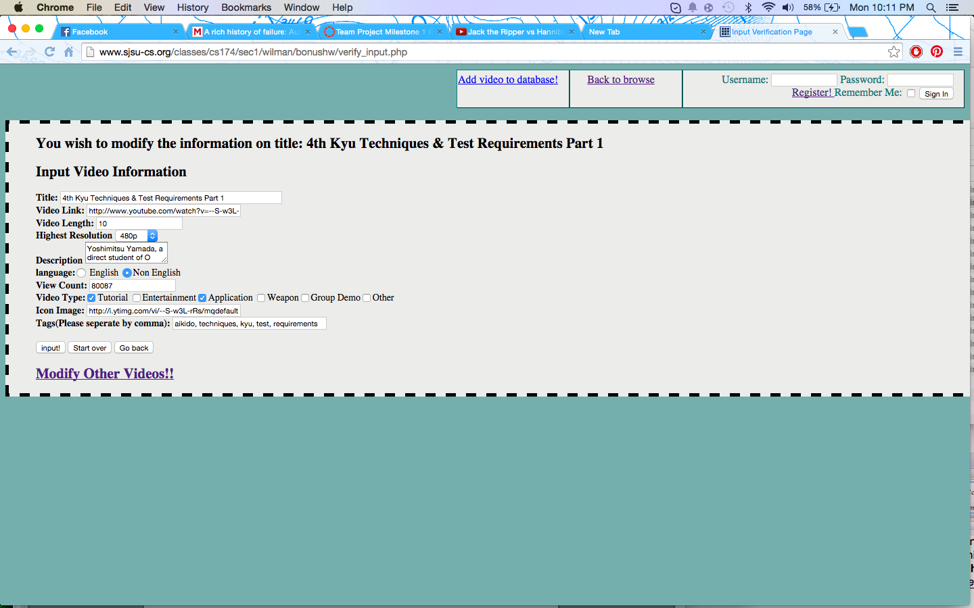

An example of the code used to set the checkboxes, verifying the database and getting the box ticked accordingly

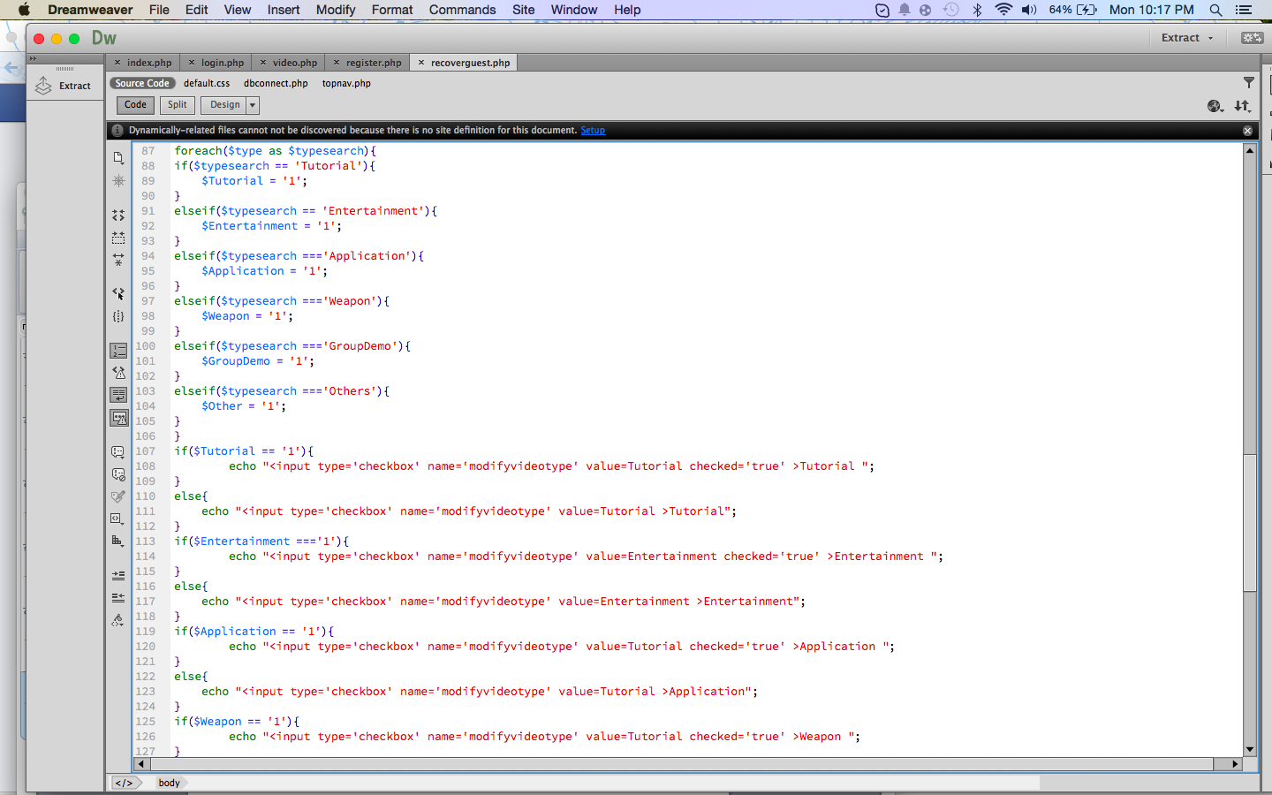

B. Login/Registration module

Add a registration that takes on user id (email) and password for user to sign up accounts.
This is what a user sees when they go to register an account.

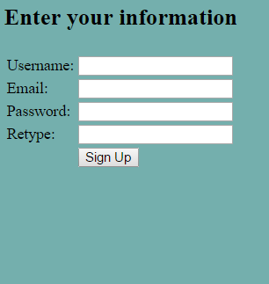

An authentication (login) page needs to be built to sync with the registration module to allow registered users to login.

If the information is incorrect then the site will display an error.
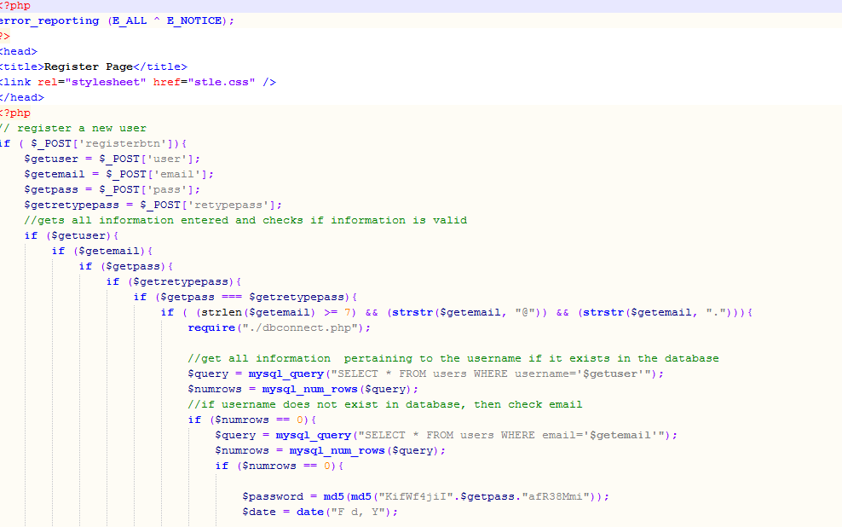

Password check has to be enforced to ensure a minimal of 8 characters and at least one number and one letter are in the password entered.
The code is enforced via a regex string in the entry.

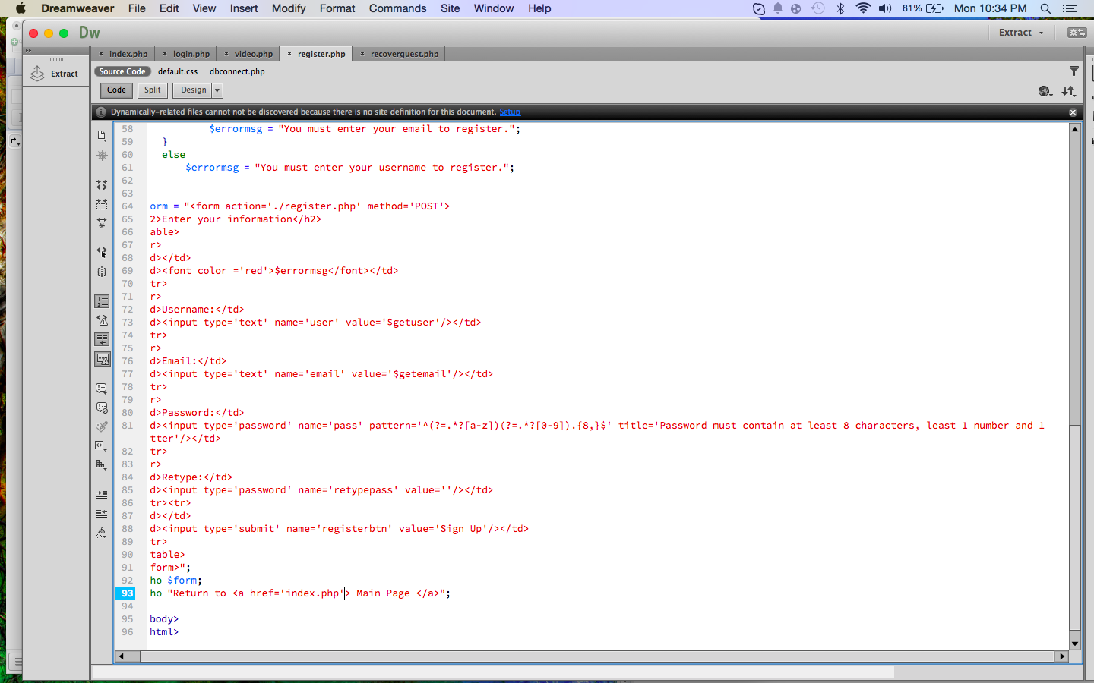

C. Cookies for login info

Provide a checkbox for users to opt in or opt out for system to store user login info with PhP Cookies. Cookies need to be valid for a minute since created.

If the check box is checked then the site will set the cookie and if the box is left unchecked, it will not set the cookie.

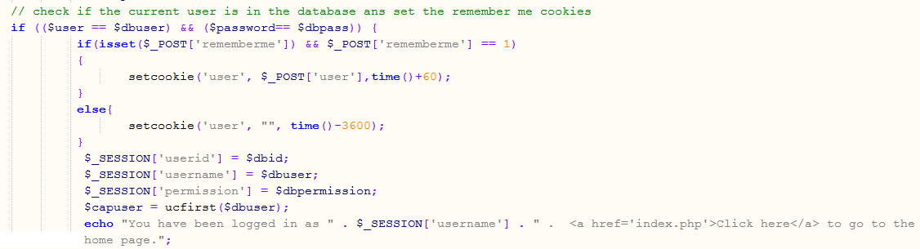

An example of the checkbox that is ticked

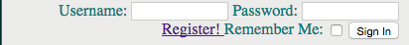

D. Favorite videos

1) For videos shown to the user, allow user to select and mark them as a favorite video.
Once the user has selected a video it is displayed on the main page using the following bit of code
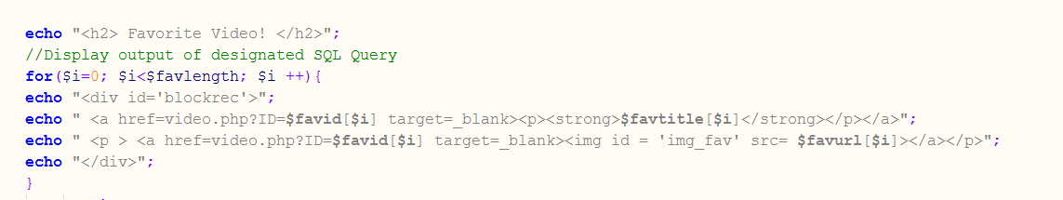
On the video page, if the user is logged in, they can see an option to favorite the video, this adds information from their session into a database to be recalled. It can only be recalled correctly if the session is set.
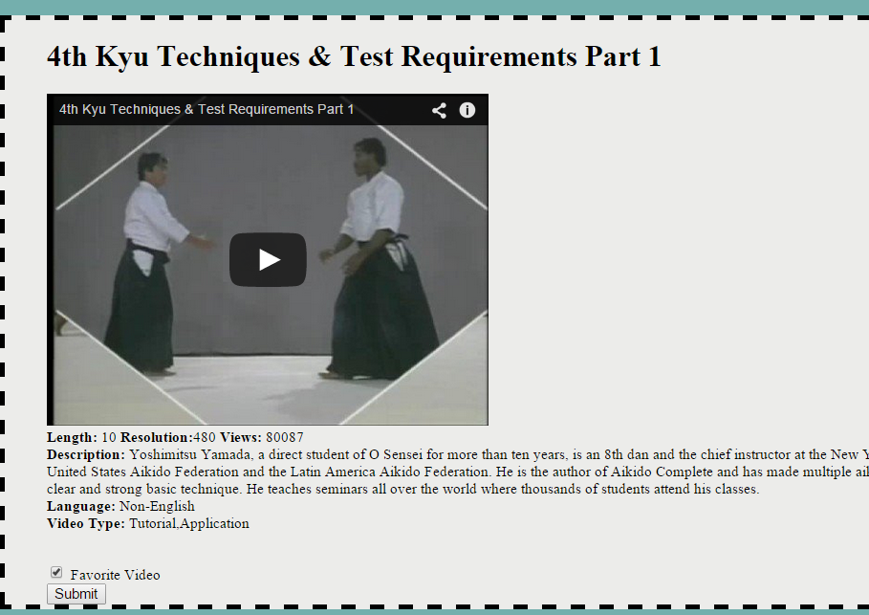

This is performed by the code first checking if there is a logged favorite for the video in the database and if not, adding it. If the video is unfavorited it will remove it as well
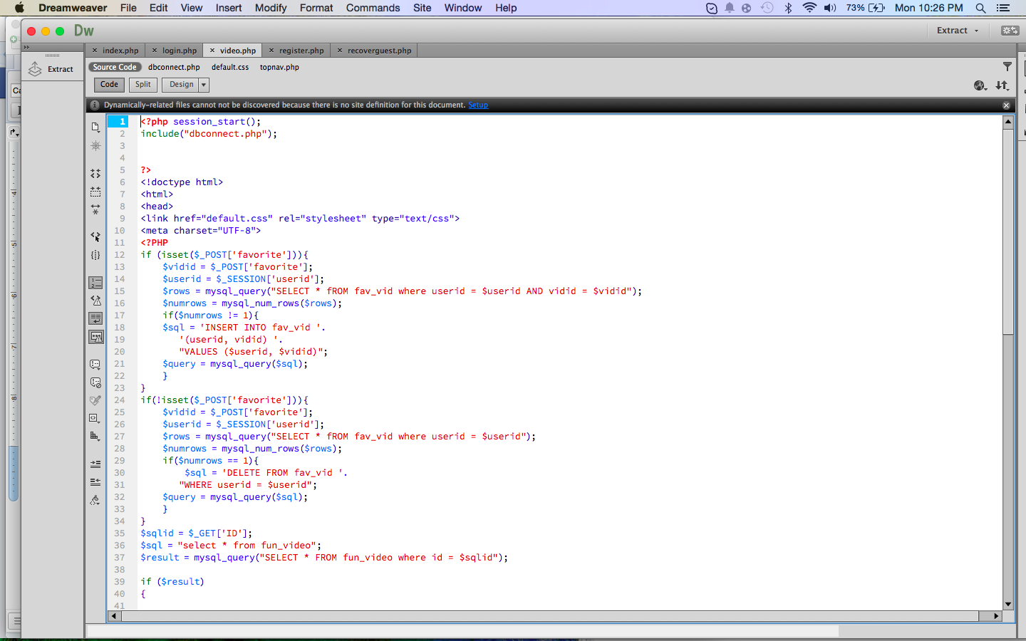

2) Session should be used for this personalized feature. It should require login so different user can have different favorite video list
This creating of the database allows different users to have different favorite videos associated with them.
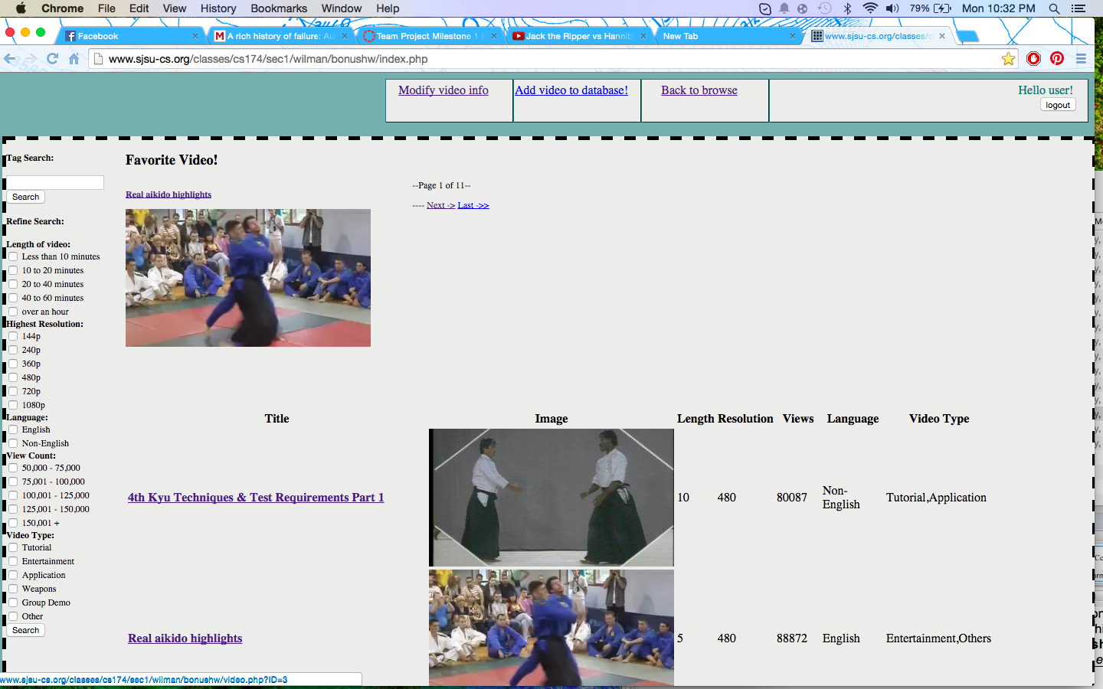

3) Display 3-4 favorite videos on user’s homepage upon login. It should be similar to the following. Each of the favorite video icon image should open up and play the Youtube video upon selection.

The favorite videos function the same way that the rest of the videos do, if the video is clicked, it opens up a new page and displays the video.

Validation
A. Data preparation(20%)
A.1 Are you able to load their exported sql file and recover all the data? If so, how it can be corrected.
You can edit video info by logging in and navigating to the edit info menu link
A.2 Do you see any data that is either duplicated, with lower than 50,000 view counts, or not in the assigned domain?
None
A.3 Are you able search and find videos matching your keywords?
Yes
A.4 Are you able to edit the video info after you login as an admin? How would you suggest them to improve the editing feature?
Yes, none

B. Login/Registration(20%)
B.1 Are you able to register an account and subsequently login?
Yes
B.2 Does the system enforce on minimal of 8 characters and at least one number and one letter in the password field? If not, what constraint(s) is not in place?
Yes

C. Cookies for login(20%)
C.1 Do you see a checkbox or similar for user to turn on and off the cookie function?
C.2 Is login info stored and valid when Cookies are turned in C.1? What problem did you see and how would you suggest them to improve it?

D. Favorite videos(20%)
D.1 Are you able to select your favorite videos? Can you select more than one?
D.2 Do you see personalized favorite videos when you login under different accounts?
D.3 Upon login, do you see your favorite videos displayed as icon images that is hylinkable to the original Youtube videos
D.4 What problem did you see and how would you suggest them to improve it?
E. Report (20%)
E.1 Is the report template used in their report?
E.2 Do you find workflow describing each features with matching screenshots
E.3 Do you find anything missing or poorly presented in this report? If so, how can they improve it?
E.3 Do you find their design user friendly or difficult to navigate? What suggestion do you have for them to improve on their user interface and workflow?
Contributor | Contributions

