**JumpCloud**

**Interview Assignment**

**Software Requirements:**

1. Java SE 13 JDK, download and install from <https://www.oracle.com/java/technologies/javase-downloads.html>.
2. Eclipse IDE for Enterprise Java Developers (e.g. Windows 64-bit for Windows 7/10), download and install from <https://www.eclipse.org/downloads/packages/release/neon/2/eclipse-ide-java-developers>.
3. gson-2.6.2.jar file, download from <https://repo1.maven.org/maven2/com/google/code/gson/gson/2.6.2/> or GitHub (<https://github.com/tomreeck/JumpCloud>).

**Assumptions:**

1. Developer has experience with java development in Eclipse.
2. User interface (UI) or external calls for the addAction and getStats methods will be implemented with assistance from a developer with that experience and knowledge.

**Development Environment Setup:**

1. After installing the Java SDK and Eclipse, edit the Windows system PATH variable to add the bin directory where the Java JDK was installed (Figure 1). Specific steps are located at <https://www.java.com/en/download/help/path.xml>.

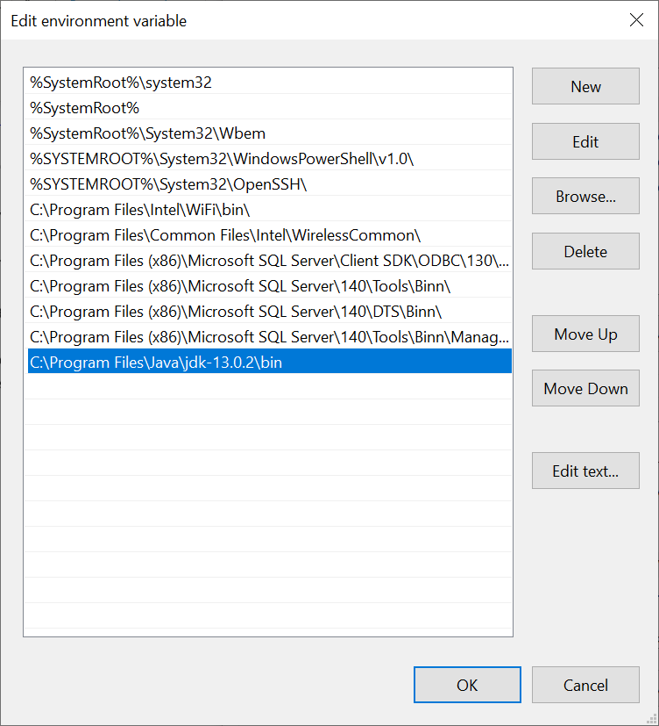

Figure 1: Edit system environment variable for PATH to add Java SDK bin directory.

1. Open Eclipse and create a new Java Project (e.g. JumpCloud).
2. Create src and lib directories under the new project.
3. In Windows Explorer, copy the gson-2.6.2.jar file to the lib directory (Figure 2). Select the project in Eclipse, right click and select Refresh to view the file in the directory.

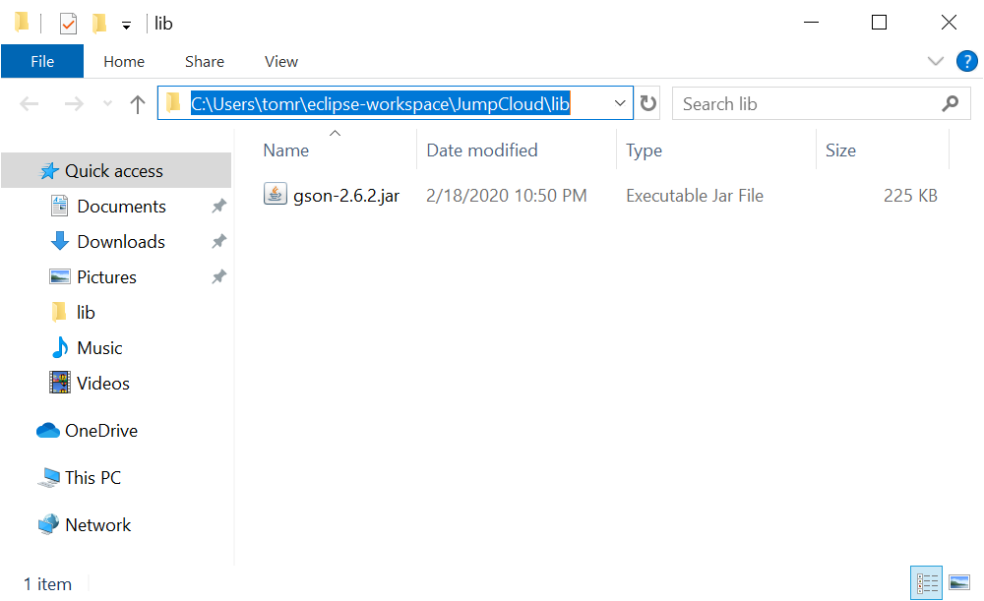

Figure 2: Copy gson-2.6.2 to the lib directory.

1. Create a new package (e.g. com.jumpcloud.backendassignment) under the src directory.
2. Download Action.java and BackendAssignment.java from <https://github.com/tomreeck/JumpCloud> and save to the package directory under src. Select the project in Eclipse, right click and select Refresh to view the files in the directory.

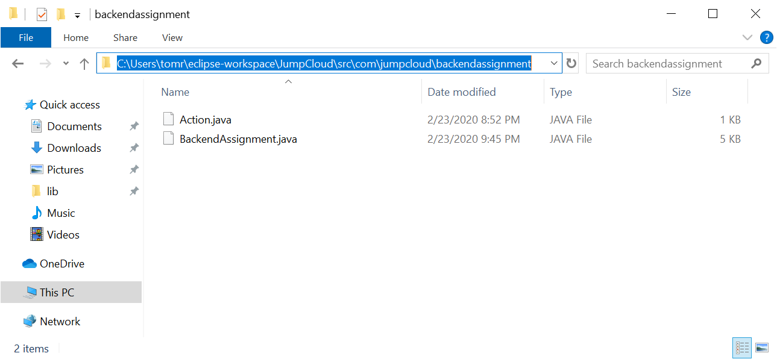

Figure 3: Java class files in package under src directory.

1. Select and right click on the gson-2.6.2.jar file in the lib directory and select Build Path 🡪 Add to Build Path to add the jar to the class path (Figure 4).

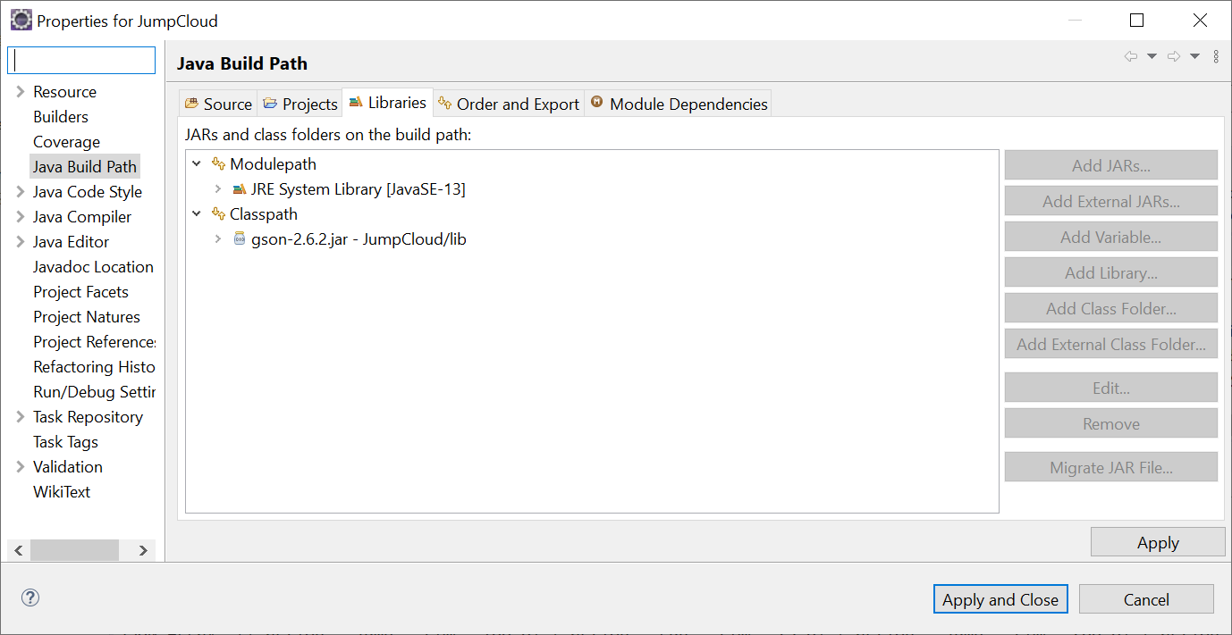

Figure 4: Add gson-2.6.2.jar to class path.

1. Project setup is complete (Figure 5).

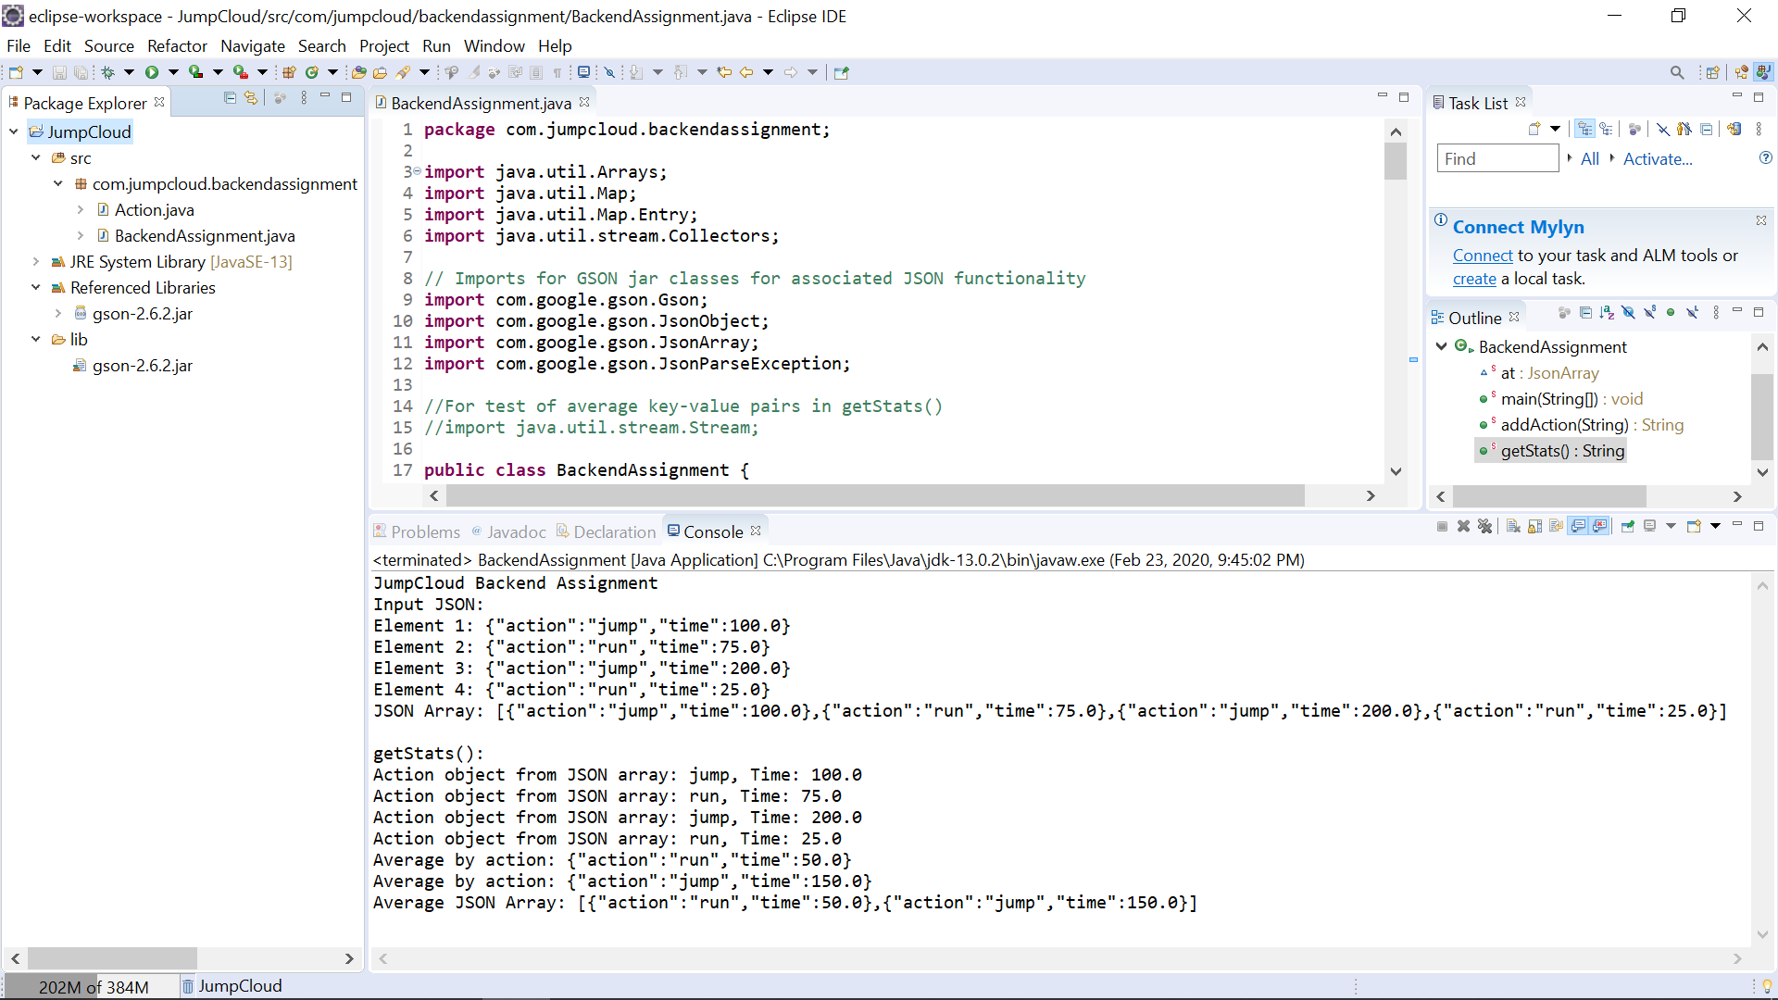

Figure 5: Completed project setup with console output after execution.

**Execution and Output:**

To run the project, select the project and click run. The following is the output with “JSON Array” displaying the final JSON after calling the addAction method for each Action object converted to a JSON string. The “Average JSON Array” displays the JSON for the average of the times for each unique action after calling the getStats method.

JumpCloud Backend Assignment

Input JSON:

Element 1: {"action":"jump","time":100.0}

Element 2: {"action":"run","time":75.0}

Element 3: {"action":"jump","time":200.0}

Element 4: {"action":"run","time":25.0}

**JSON Array: [{"action":"jump","time":100.0},{"action":"run","time":75.0},{"action":"jump","time":200.0},{"action":"run","time":25.0}]**

getStats():

Action object from JSON array: jump, Time: 100.0

Action object from JSON array: run, Time: 75.0

Action object from JSON array: jump, Time: 200.0

Action object from JSON array: run, Time: 25.0

Average by action: {"action":"run","time":50.0}

Average by action: {"action":"jump","time":150.0}

**Average JSON Array: [{"action":"run","time":50.0},{"action":"jump","time":150.0}]**