Testing examples:

* Modifying data normally
* Inserting perfectly normal data
* An insert with a null field where one isn’t allowed
* Modifying a field with data of the incorrect data type
* Deleting data

**Modifying data normally**

Before:

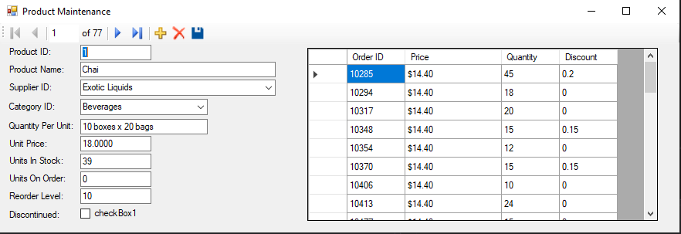

After changing most fields and clicking save:

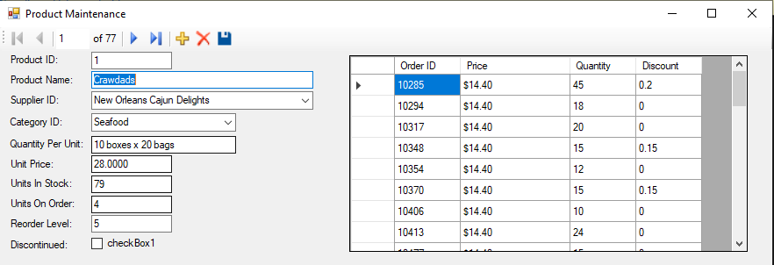

Confirmation in the database:

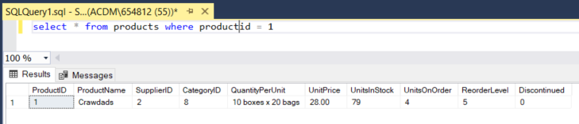

**Inserting perfectly normal data**

Before clicking:

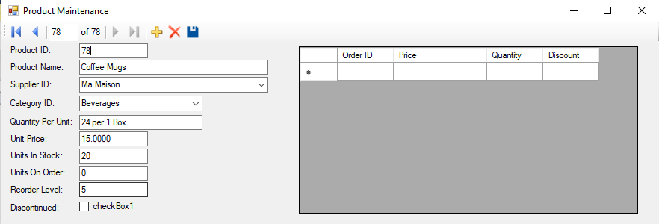

After clicking save and returning to the record:

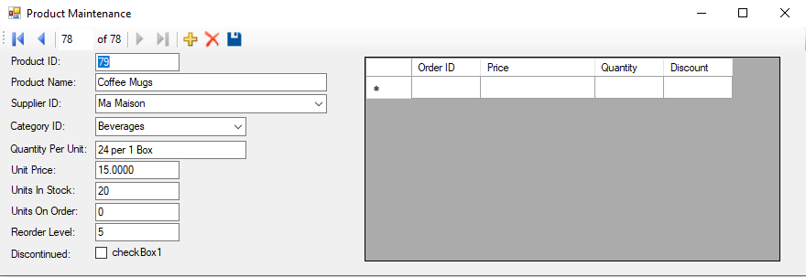

(ID 78 was ignored and replaced with 79 since 78 had already been used in a previous test)

**An insert with a null field where one isn’t allowed**

Record to try inserting:

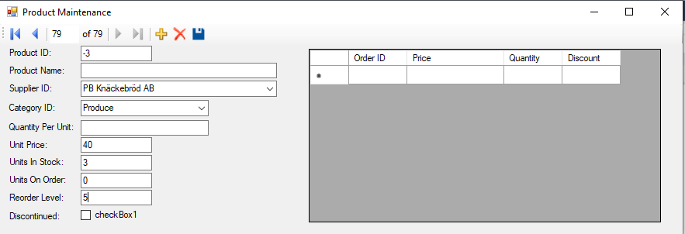

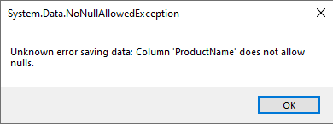

**Modifying a field with data of the incorrect data type**

Trying to put text in a numeric field:

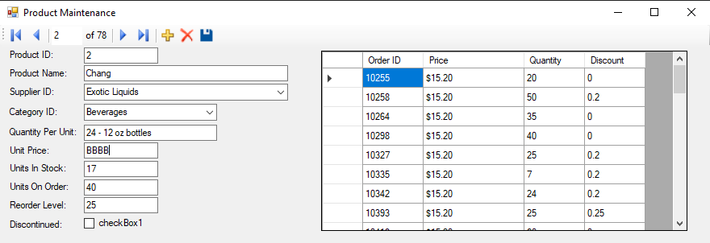

Nothing happens, click away and come back and the data is unchanged:

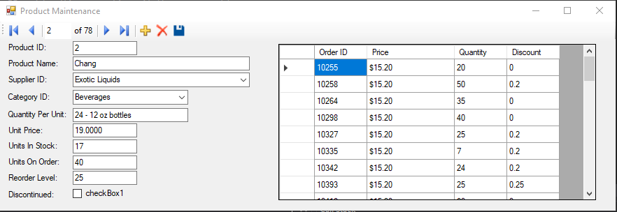

**Deleting data**

Record to delete:

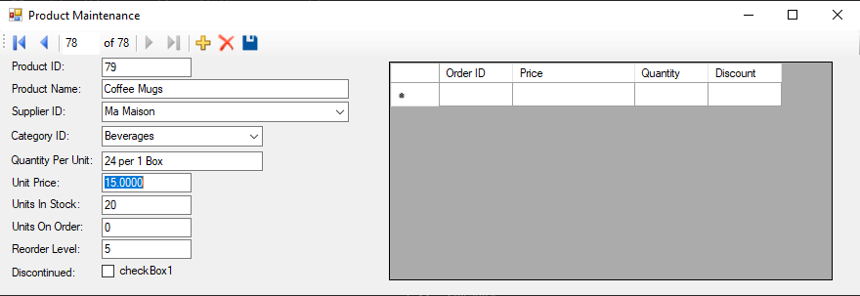

After delete button, no ID #79:

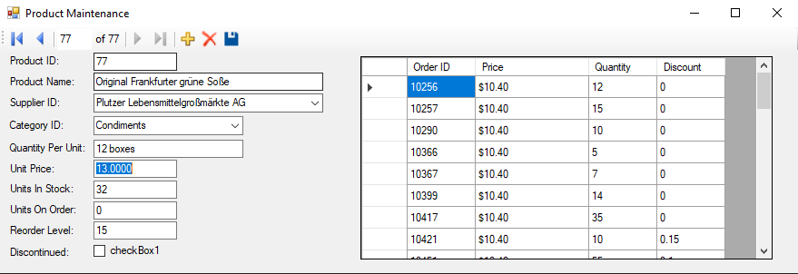

But it’s still in the DB:

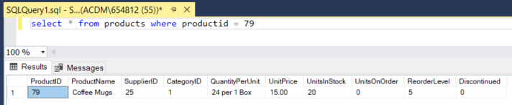

Until hitting the save button too:

