**PHASE 3 : DEVELOPMENT PART – 1**

In this part we will begin building our project.

**Database setup :**

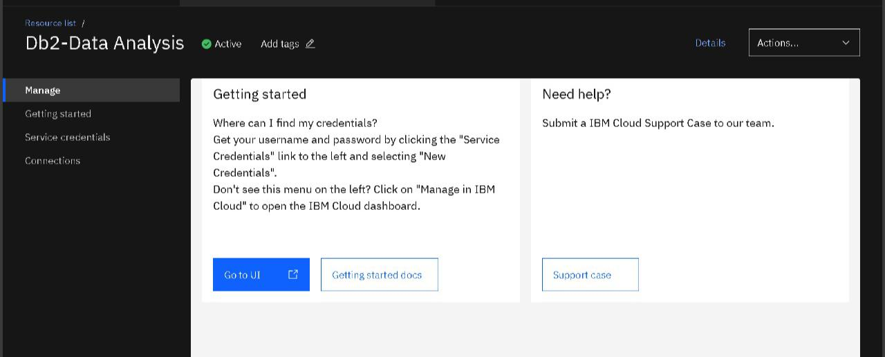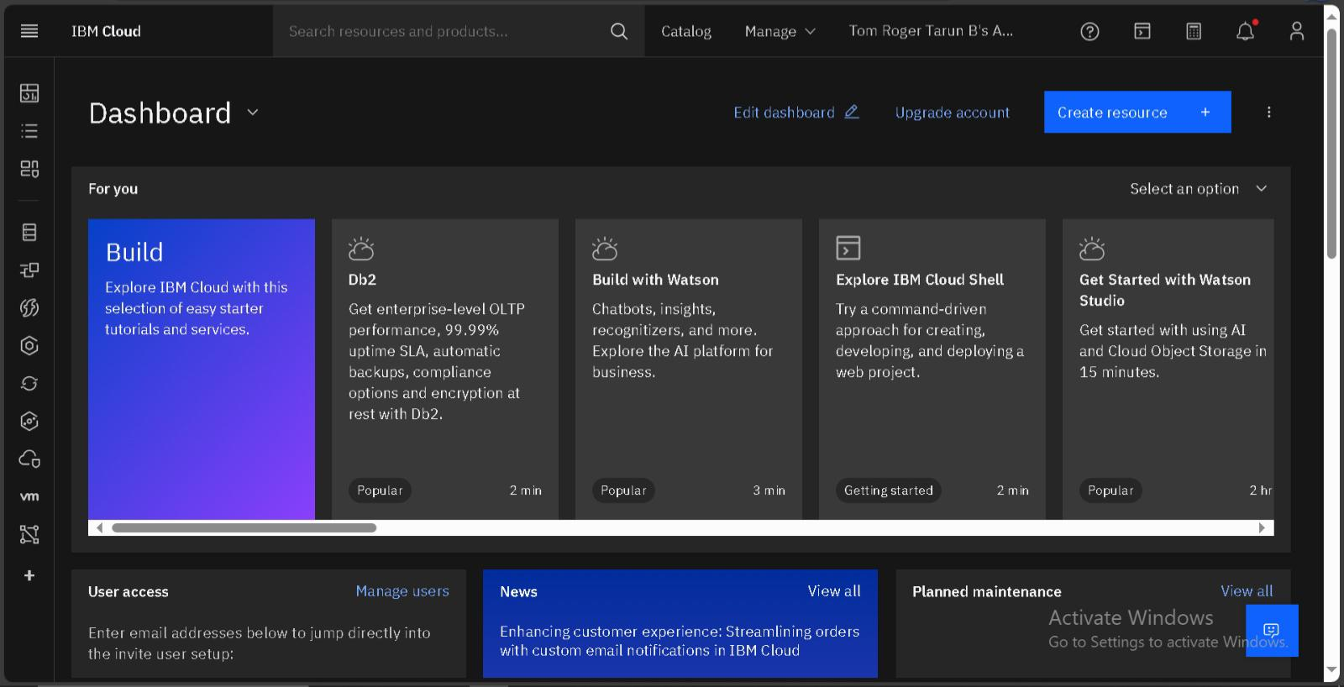An IBM Cloud account is created and then the DB2 database service is chosen and is activ

**Uploading Data :**

Let us upload the CSV file with data about social media trends and patterns into the IBM DB2 database by selecting the Schema and creating a New Table in the DB2 database.

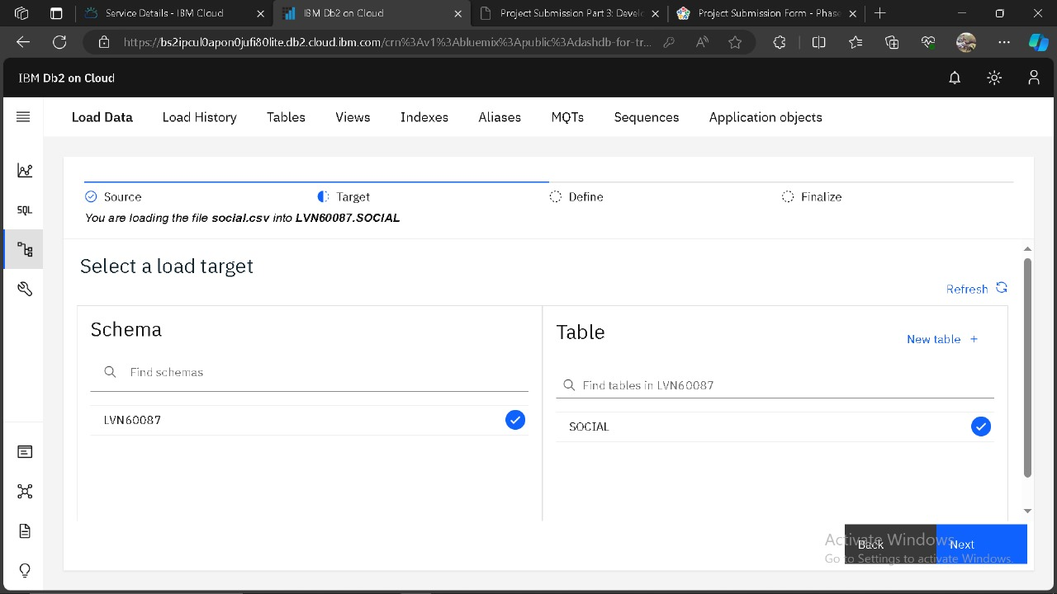

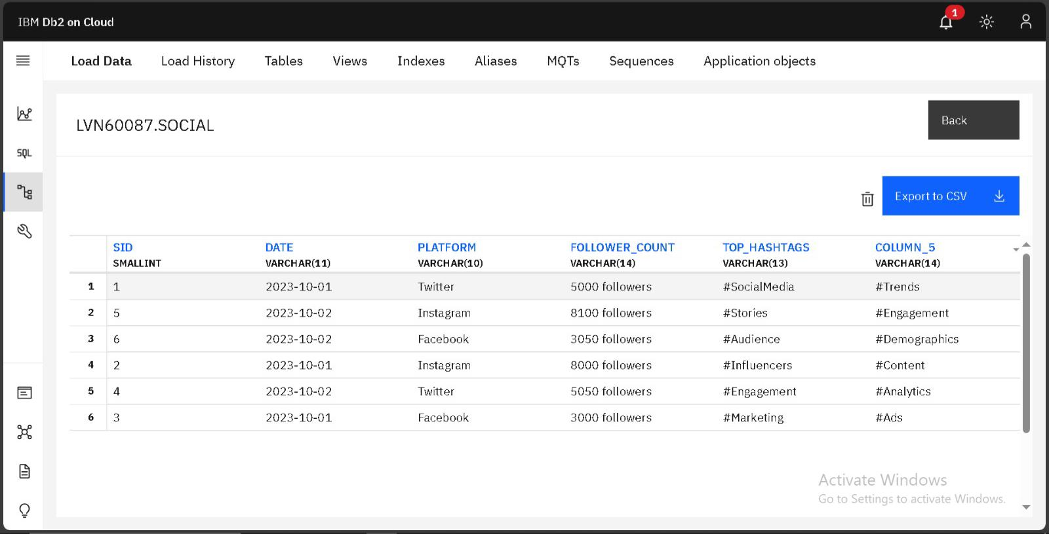Now the Data is uploaded.

**Developing Queries to explore data :**

Now we can start developing queries or scripts to explore and analyze the selected dataset about social media trends and patterns using SQl in IBM DB2 on Cloud.

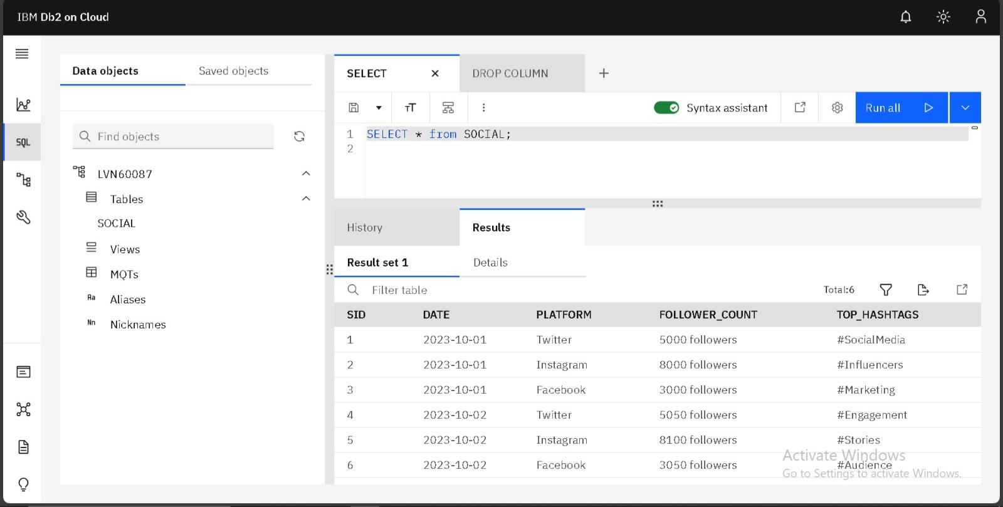

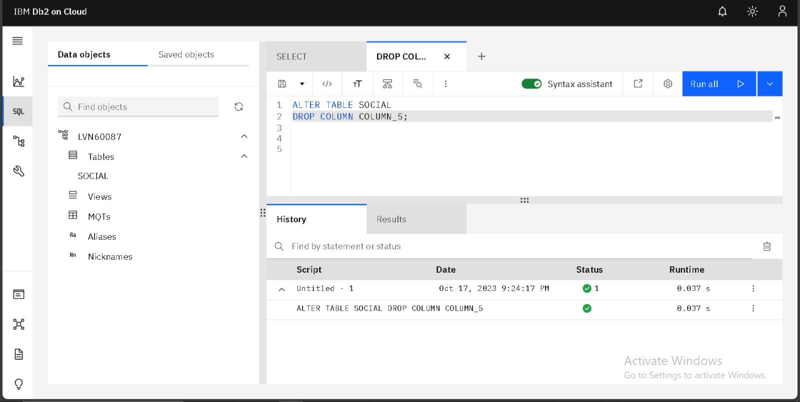

Basic data cleaning and tranformation is done as needed for this data about social media trends and patterns in IBM DB2 database.

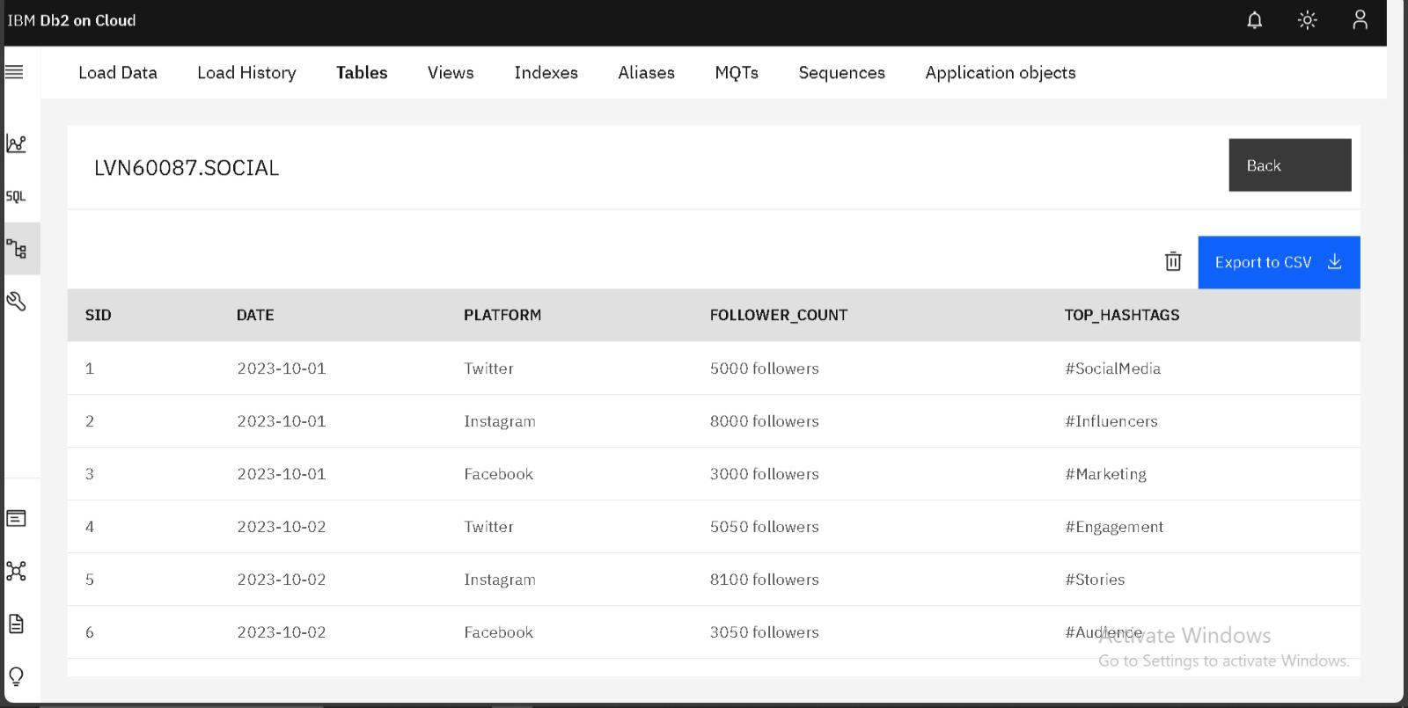

Done by

Tom Roger Tarun B

au412721104054