Proj_225005_Team_1

**Big Data Analysis in IBM Cloud Databases**

**STUDENT NAME :** TOM ROGER TARUN B

**NM ID :** au412721104054

**PHASE 4 : DEVELOPMENT PART 2**

After the social media trends, let us now upload the CSV file of climate trends into the IBM Watson Studio and IBM Watson Machine Learning to create visualizations to showcase the analysis result.

**IBM Watson Studio :**

Upload the CSV file of climate trends about minimum daily temperatures into the IBM Watson Studio which is the IBM Cloud Pak for Data by creating a new project and new asset of model associated with IBM Watson Machine Learning.

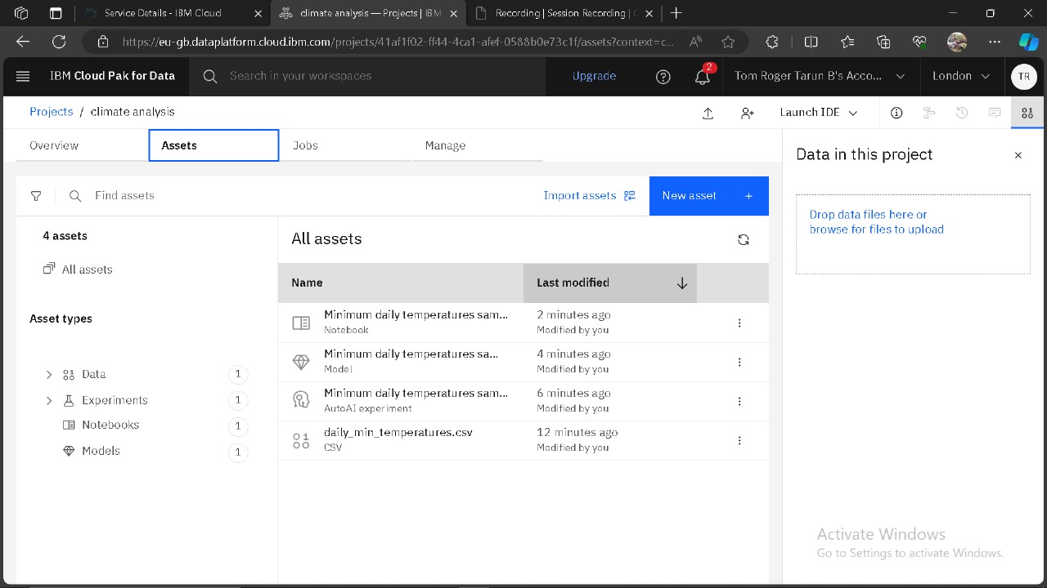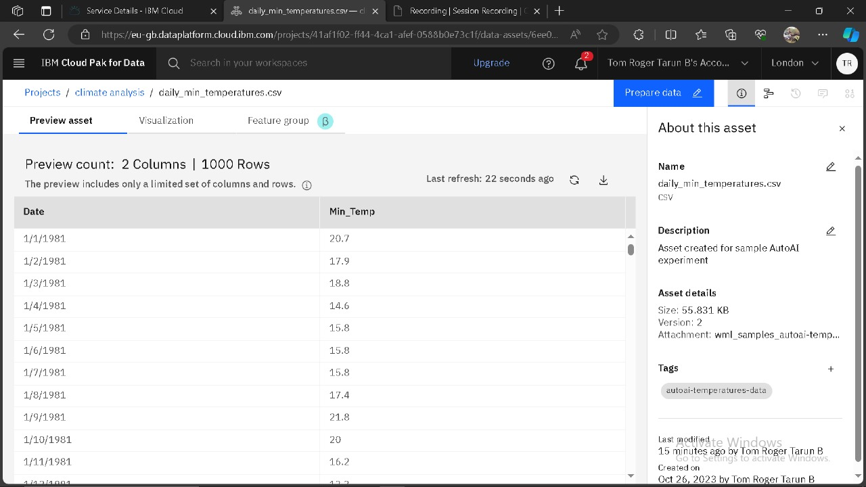

**Deployment Space :**

A new Deployment Space is created and our Climate Mode is promoted and deployed successfully to analyse.

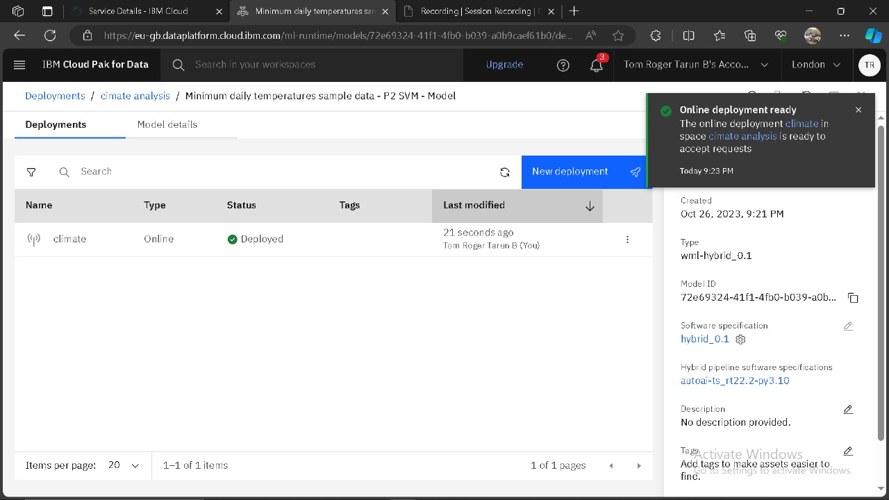

**Time Series Analysis :**

To analyse the data, Time Series Analysis is used associated with IBM Watson Machine Learning.

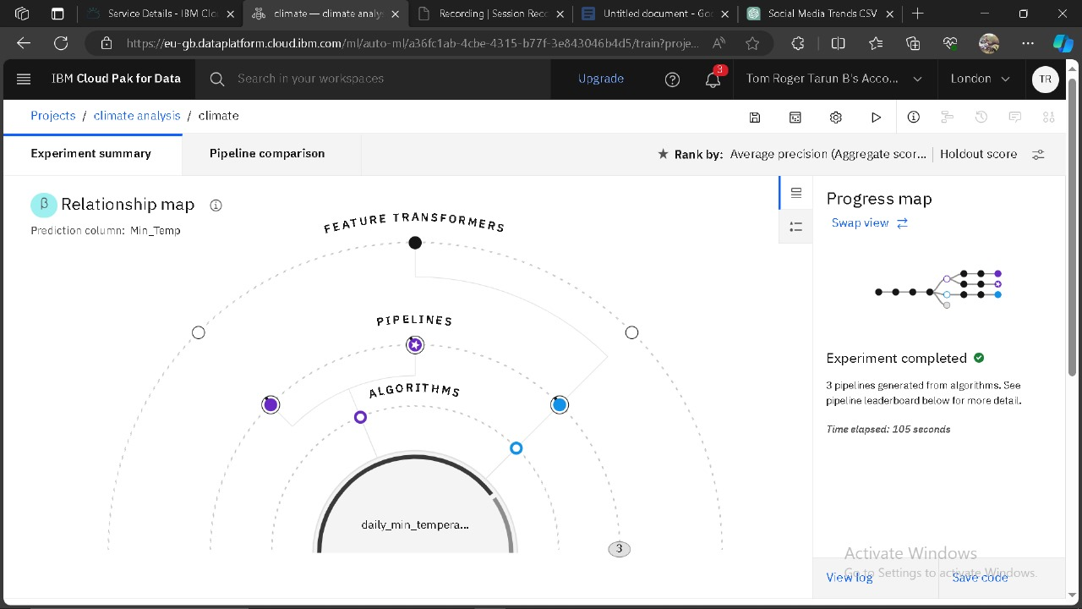

**Analysis Result :**

We got the result of Time Series Analysis once completed.

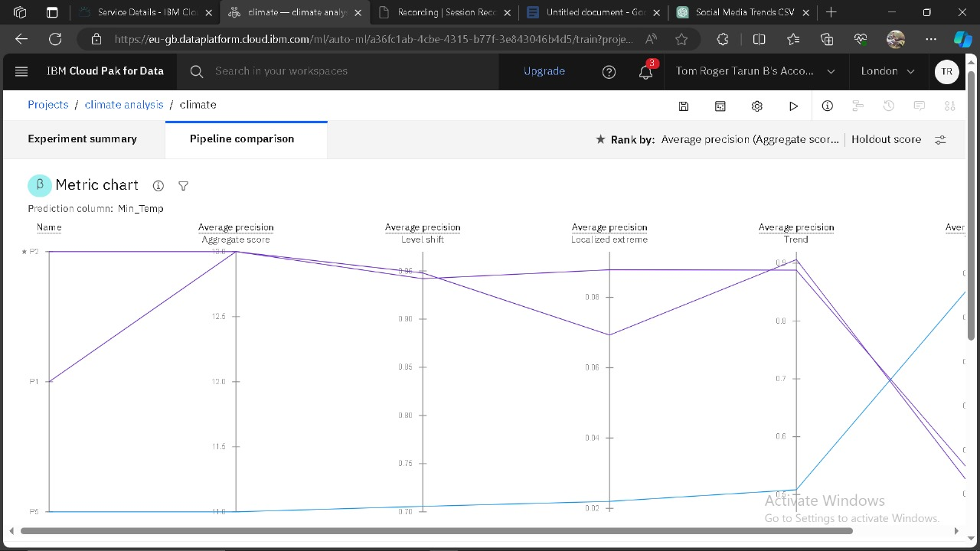

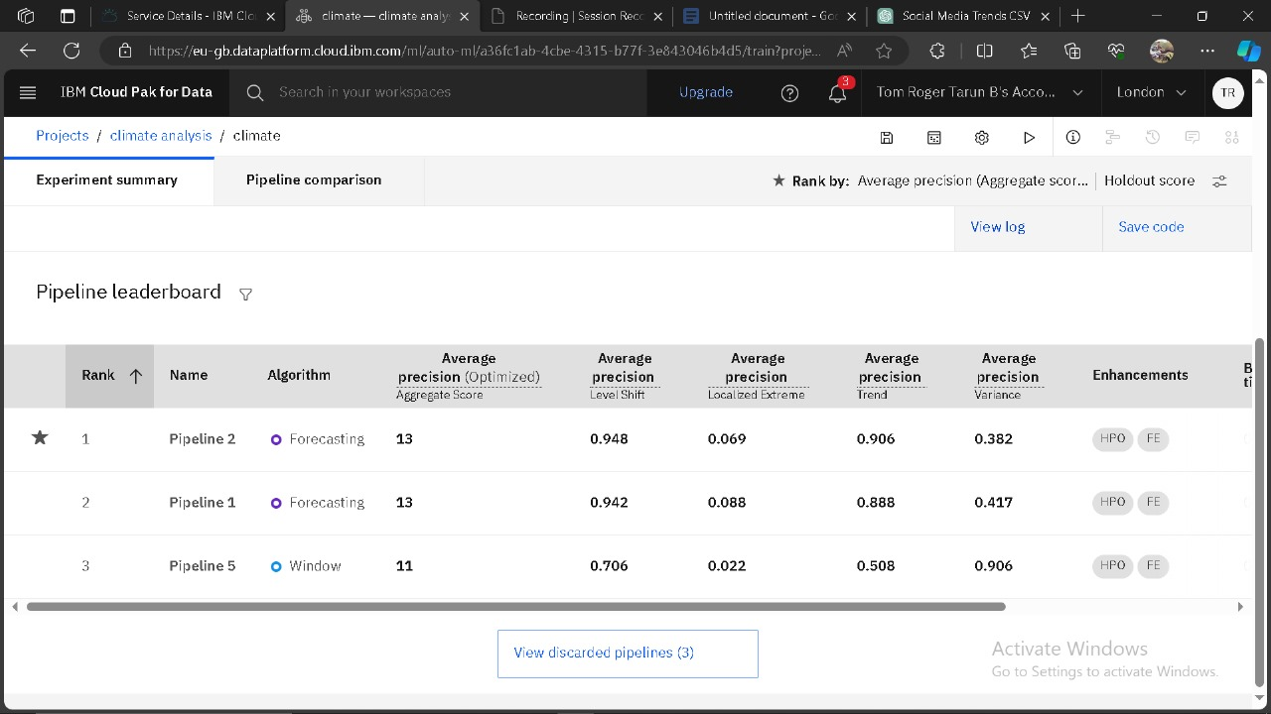

**Data visualization :**

Hence, we visualize our climate model asset in the IBM Cloud pak for Data associated with IBM Watson Machine Learning by creating Scatter plot and Multi-series graph with Date in X-axis and Min_Temp in Y-axis.

