Proj_225005_Team_1

**PHASE 5**

**Big Data Analysis in IBM Cloud Databases**

**STUDENT NAME :** TOM ROGER TARUN B

**NM ID :** au412721104054

**Project Objective :**

We're tasked with an Objective of analyzing large datasets using IBM Cloud Databases to find valuable information. The data covers diverse areas, from climate trends to social patterns. Our goal is to create a clear process for analysis, set up the necessary databases, perform data analysis, and present the findings in a way that helps businesses make informed decisions.

**Design Thinking Process :**

**Step 1: Choose the Right Data**

**Data Selection:** We need to pick the datasets we'll work with. These could be data about the climate, like temperature and rainfall, or data about social media trends, such as tweets or posts.

**Step 2: Set Up the Database**

**Database Setup:** To store and manage our large datasets, we'll use IBM DB2 Cloud Databases. This step involves configuring these databases for security and efficiency.

**Step 3: Dive into the Data**

**Data Exploration:** We'll create special queries and scripts to explore our datasets. Think of this like looking through a massive library to find specific books. We'll extract the information we need and identify any interesting patterns or trends.

**Step 4: Uncover Insights**

**Analysis Techniques:** This is where we use different methods, like IBM Watson Studio and IBM Watson Machine learning, to dig deep into the data. It's like solving puzzles – we want to find valuable pieces of information hidden within the data.

**Step 5: Make It Understandable**

**Visualization:** We'll turn our findings into easy-to-understand visuals. Imagine creating charts, graphs, and colorful diagrams that tell a story. These visuals will make it clear what the data is saying in the IBM Watson Studio.

**Step 6: Find the Business Value**

**Business Insights:** Finally, we'll interpret what our analysis means for businesses. It's like translating our data discoveries into actionable advice. If we find, for example, that certain climate trends affect product sales, we'll provide recommendations based on that.

**Development Phases :**

**Dataset :**

We will use the CSV file dataset of Climate trends which has the data about Minimum daily temperatures in the IBM Watson Studio in which is the IBM Cloud Pak for Data by creating a new project and new asset of model associated with IBM Watson Machine Learning.

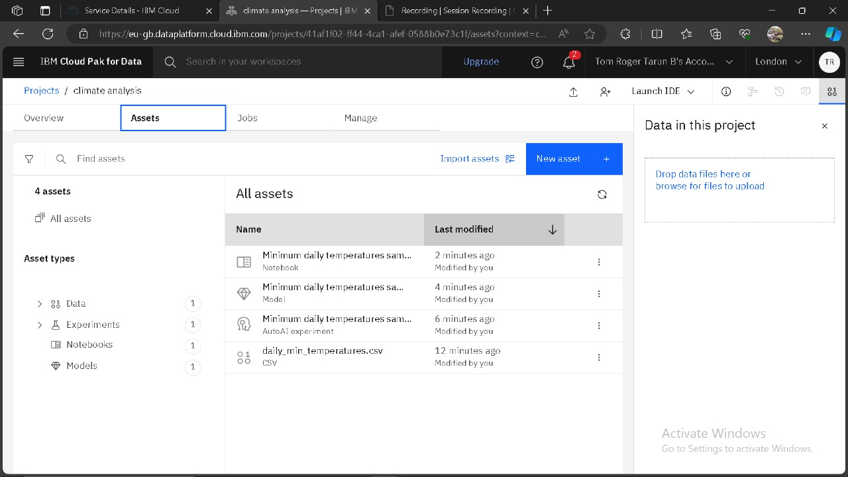

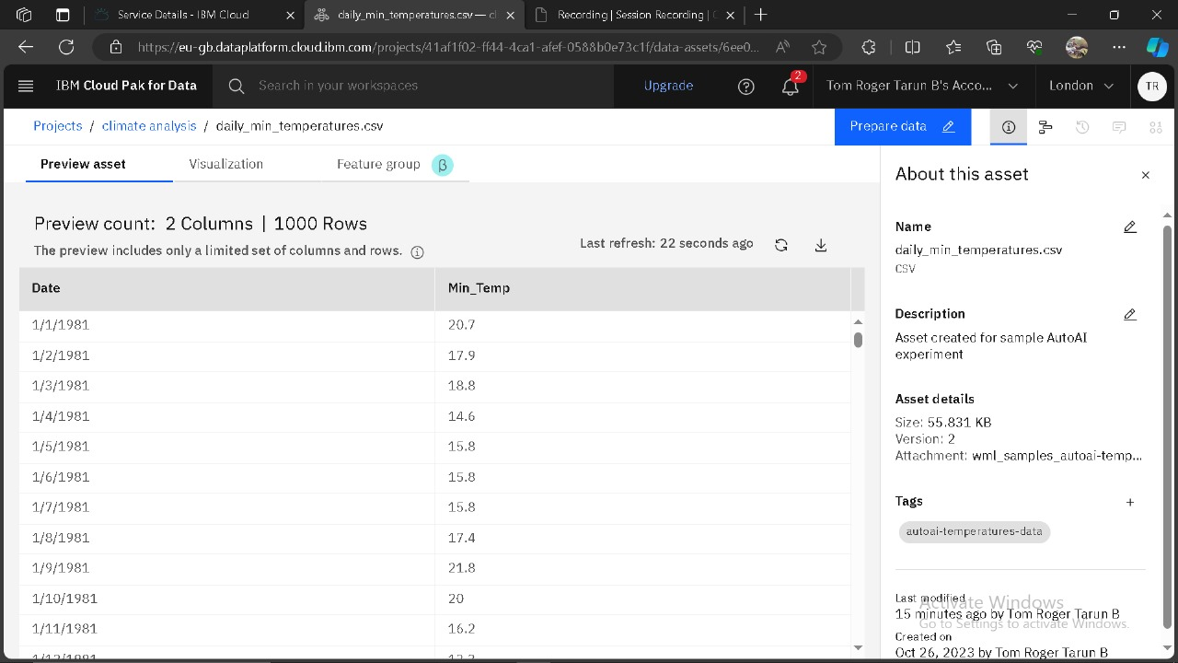

**Database Setup :**

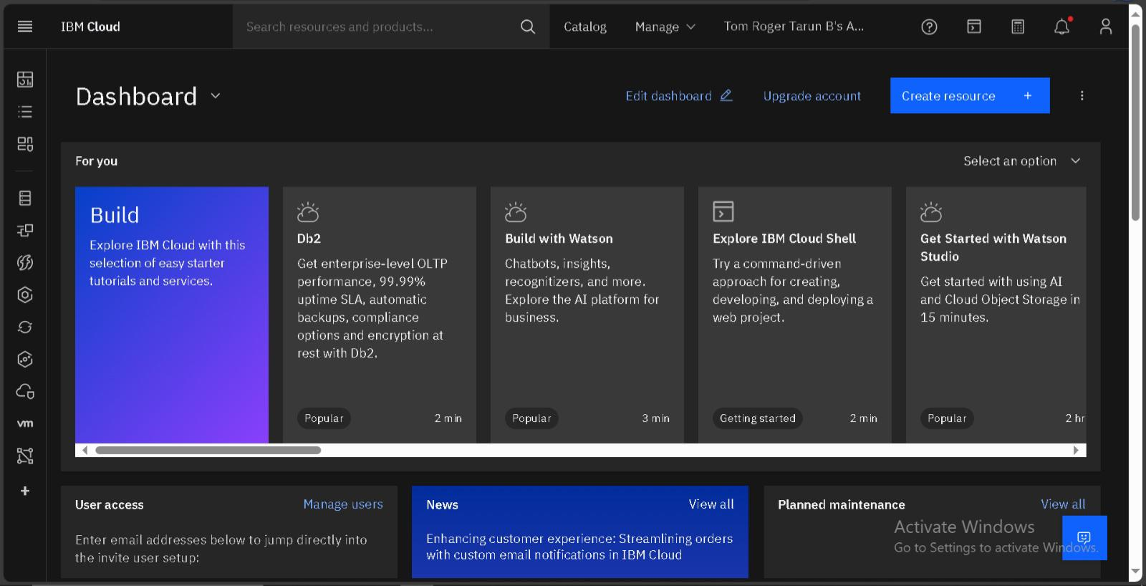An IBM Cloud account is created and then the DB2 database service is chosen and is active.

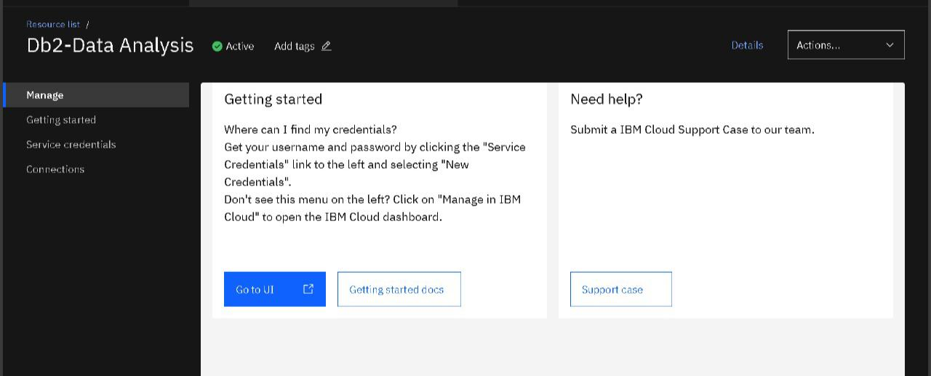

A new Deployment Space is created and our Climate Mode is promoted and deployed successfully to analyse.

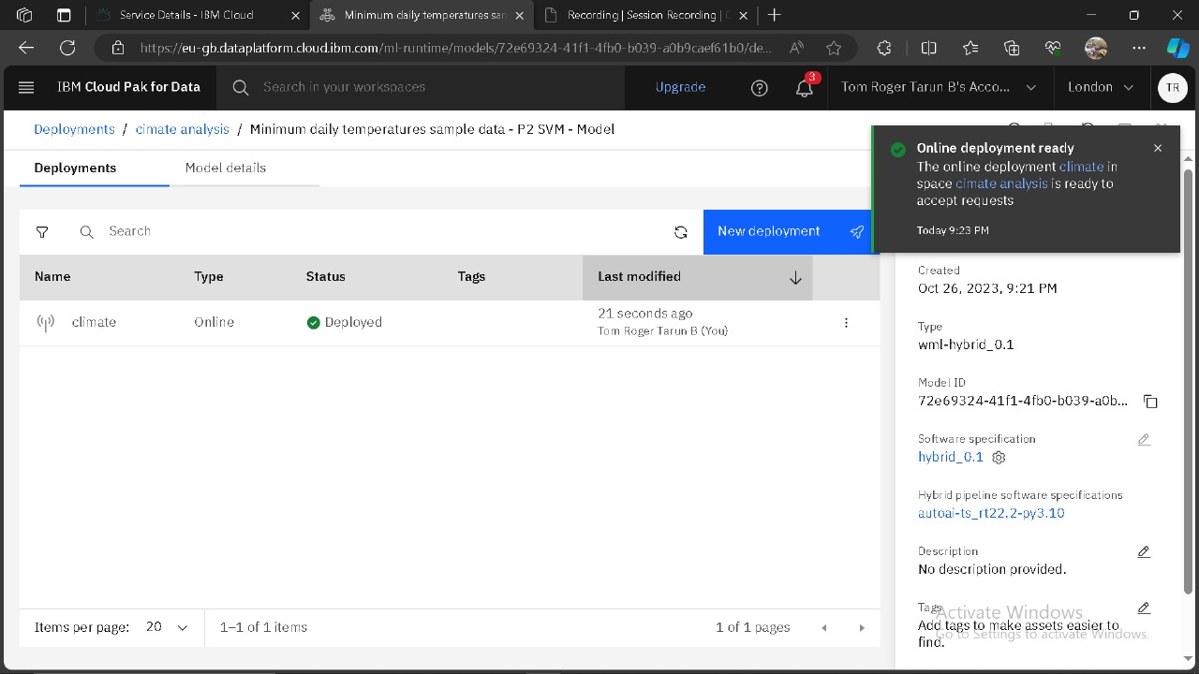

**Analysis technique :**

**Time Series Analysis :**

To analyse the data, Time Series Analysis is used associated with IBM Watson Machine Learning.

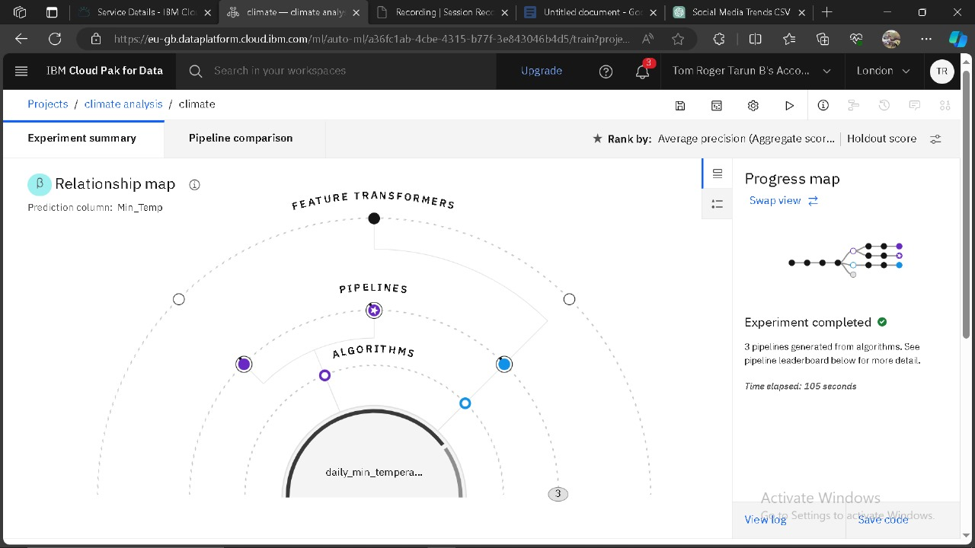

**Analysis findings :**

We got the result of Time Series Analysis once completed.

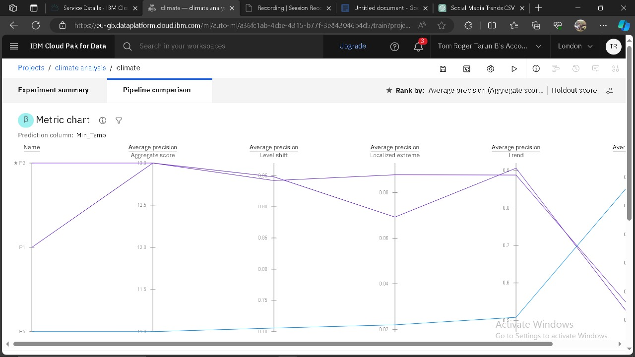

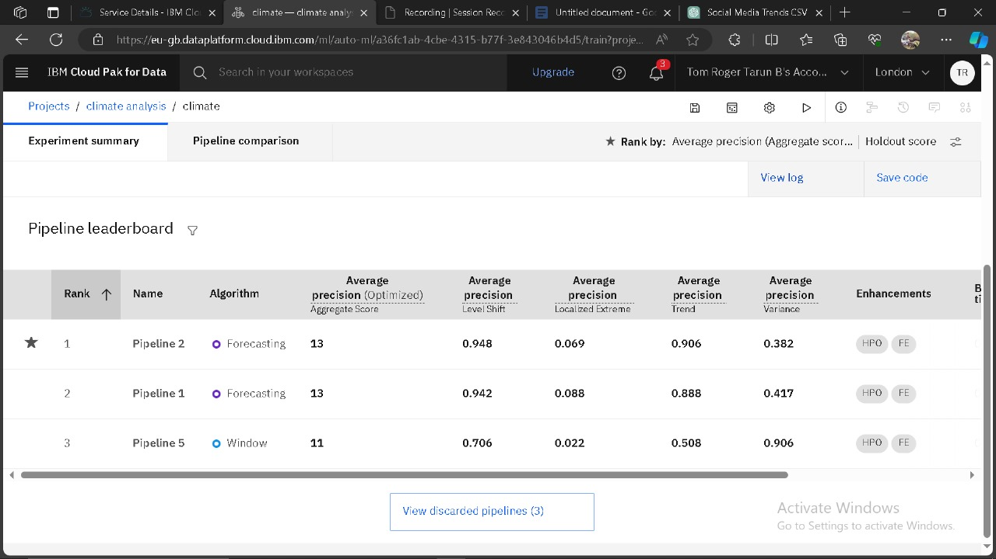

**Data visualization :**

Hence, we visualize our climate model asset in the IBM Cloud pak for Data associated with IBM Watson Machine Learning by creating Scatter plot and Multi-series graph with Date in X-axis and Min_Temp in Y-axis.

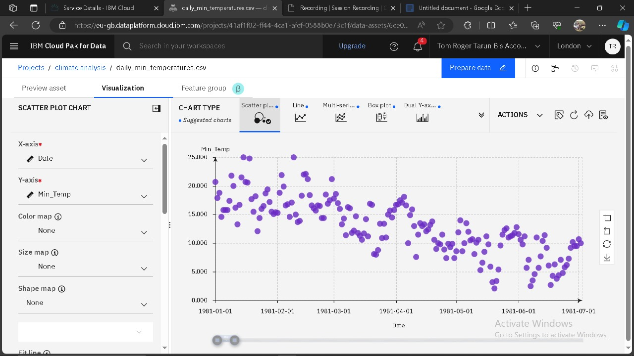

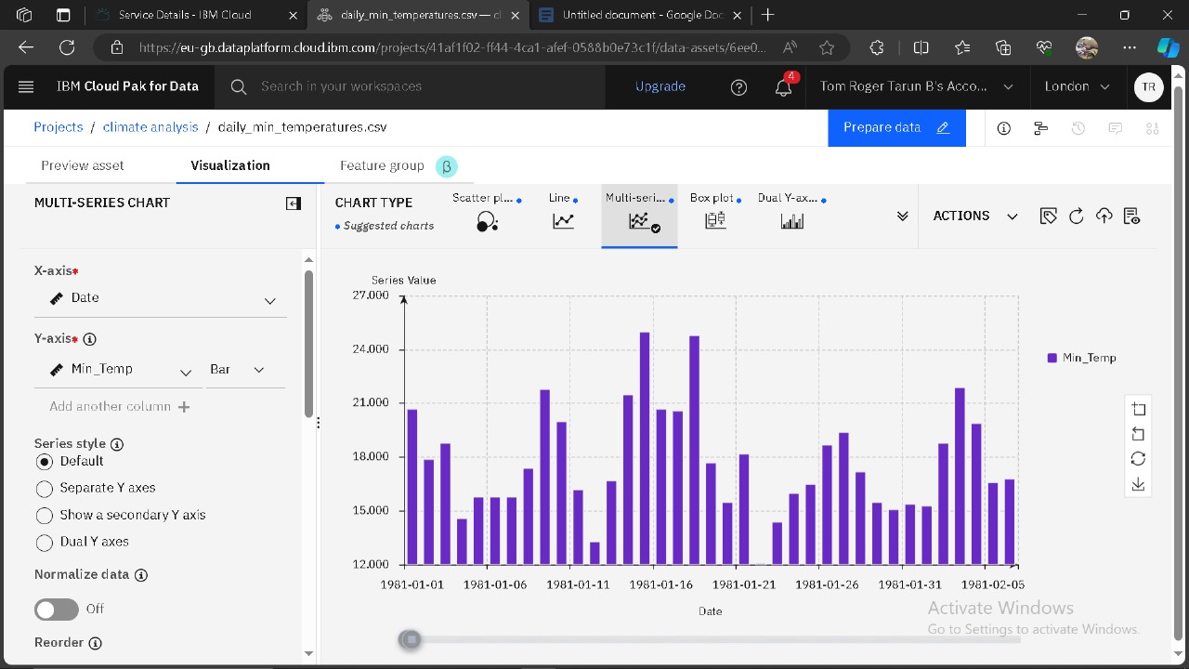

**Business Insights :**

When analyzing minimum daily temperatures climate data, we could consider the following business insights:

**Identify Seasonal Trends:** The student could leverage temperature data to identify seasonal trends in Chennai. This information can be valuable for planning businesses related to seasonal changes, such as clothing stores or outdoor activities.

**Energy Efficiency Solutions:** With a growing focus on sustainability and energy efficiency, the student might explore business opportunities related to optimizing heating and cooling systems in response to temperature fluctuations.

**Agricultural Decision Support:** Chennai's climate data could be used to develop solutions for local farmers, providing insights into planting and harvesting times based on temperature trends, helping improve agricultural yields.

**Weather-Dependent Services:** Services like event planning, tourism, or outdoor entertainment can benefit from historical temperature data to make informed decisions about scheduling and resource allocation.

**Environmental Initiatives:** As an aspiring entrepreneur, the student could consider launching an eco-friendly venture, taking into account climate data to address climate change-related challenges.

These insights can serve as a starting point for entrepreneurial endeavors that are both informed by climate data and aligned with the IBM Cloud.