WESTERN INSTITUTE OF TECHNOLOGY
WIT Barcode Student Information System
System Analysis, Design, and Implementation Documentation
Version 1.0.0 | 22 October 2026
Python 3.14.4 · PySide6 6.12 · MySQL 8.4 · YOLOv8n · Ubuntu 26.04

Table of Contents

CHAPTER I — INTRODUCTION

1.1 Background
The WIT Barcode Student Information System replaces manual verification of printed identification panels with a desktop application that holds student, enrolment, assessment, and payment records in a relational database and verifies a physical panel automatically by detecting its Code 39 barcode, decoding it, and resolving the decoded payload to exactly one student row before any identity claim is presented to the operator.

1.2 Objectives
O1 — Analyse the manual workflow. O2 — Design a normalised relational schema. O3 — Implement the desktop application (10 pages). O4 — Develop the detection and verification pipeline (YOLOv8n + CODE39 decode + exact SQL lookup). O5 — Implement detector training and promotion lifecycle. O6 — Verify functional correctness and scanner against real panels. O7 — Document with models and figure catalogue. O8 — Identify limitations and discrepancies.

1.3 Scope
Covers: desktop app, MySQL schema (19 tables), service layer, UI (10 pages + 4 dialogs), detector training tooling, and automated test suite (557 tests). Excludes: authentication, logout, multi-campus, web/mobile, independent accuracy audit.

1.4 Conceptual Framework
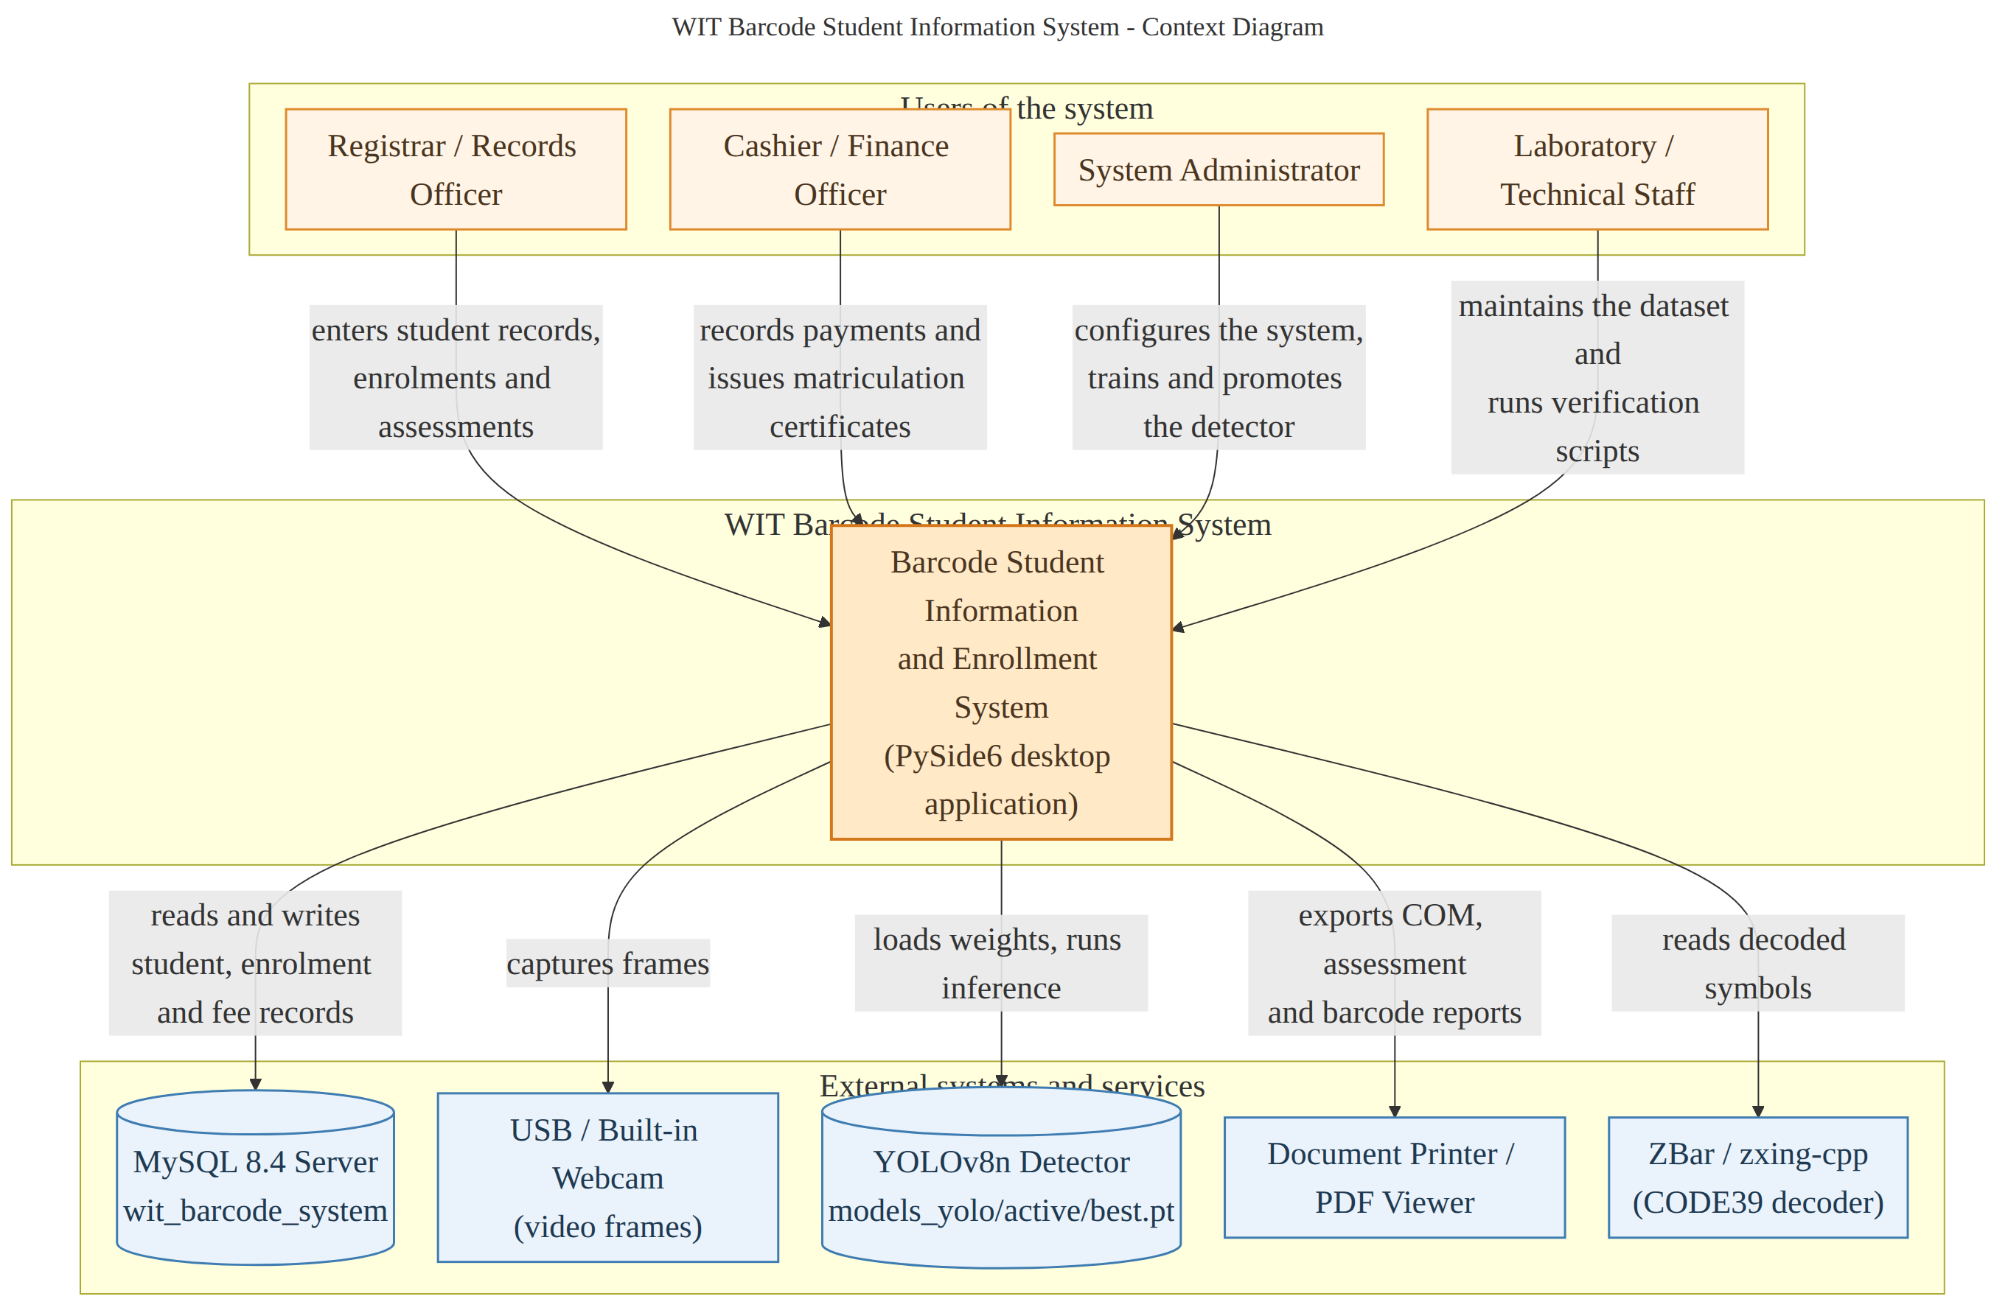
Figure 1. System context diagram — actors, system, and external systems.

CHAPTER II — METHODS

2.1 Development Environment
Python 3.14.4 · PySide6 6.12 · MySQL 8.4.11 · Ultralytics 8.4.177 (YOLOv8n) · PyTorch 2.14 · OpenCV 5.0 · NumPy 2.5 · Pillow 12.3 · zxing-cpp 3.1 · pyzbar 0.1.9 · ReportLab 5.0 · matplotlib 3.11 · python-dotenv 1.2.4 · pytest 9.1.1 · Ubuntu 26.04.1 LTS · NVIDIA RTX 2050 (4 GB).

2.2 Architecture
Three-tier layered architecture: Presentation (PySide6 widgets) → Services (pure Python, Qt-free) → Data Access (mysql.connector pool of 10, raw SQL, no ORM). No widget writes SQL; no service imports a widget.

2.3 Data Model
19 InnoDB tables with declared foreign keys: users, students, student_contacts, courses, subjects, enrollments, enrollment_subjects, barcodes, barcode_scans, assessment_categories, assessments, assessment_items, payments, payment_schedules, audit_logs, system_settings, yolo_models, id_cards, dataset_images. The Certificate of Matriculation is a view over these rows; totals are recomputed and cross-checked, not trusted.

2.4 Barcode Detection Pipeline
YOLOv8n at 0.75 confidence (raised from 0.35 on measured gap: highest false box 0.606, lowest true box 0.897) → geometric gate (80×24 px minimum, 88% gate ratio) → 30% margin crop → multi-strategy decode (zxing-cpp then pyzbar, ~15 transforms) → CODE39 reconstruction from module-width voting → exact SQL lookup → session latch → history row → success cue → Scan Result panel.

2.5 Verification
Full automated test suite: 557 passed, 2 warnings, 185.29 s (24 test modules). Scanner verified against real institute panels — every decoded payload resolves to exactly one student row. Detector: 22.49 ms mean GPU, 74.46 fps live, 9.82× faster than CPU.

CHAPTER III — RESULTS

3.1 Dashboard
Aggregate counts (Total/Active/Registered/Missing), searchable & filterable student table, detail panel with personal/academic/ID info. Payload 000065xxx shown per student. Defect: "Oktubre" renders under en_PH locale (DEF-02).
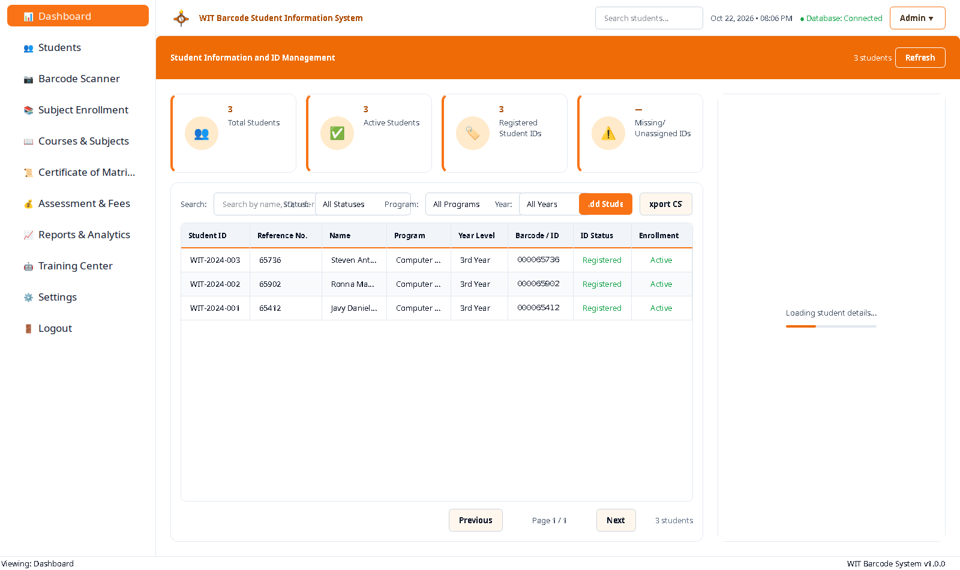
Figure 9. Dashboard — overview and student directory.
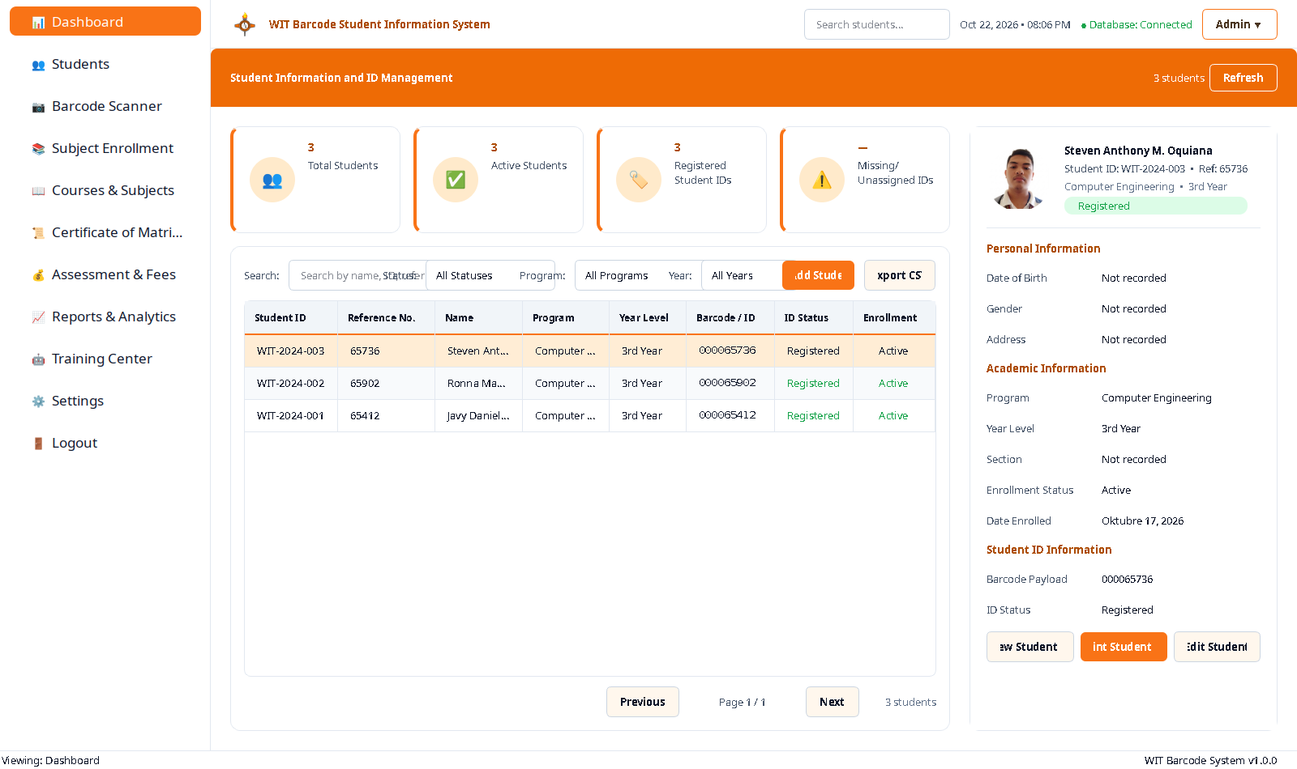
Figure 10. Dashboard — student detail panel.

3.2 Student Management
Directory with per-row View/Edit/Delete, Add/Edit dialogs with photo & contacts, mandatory-field validation, audit log for mapping changes.
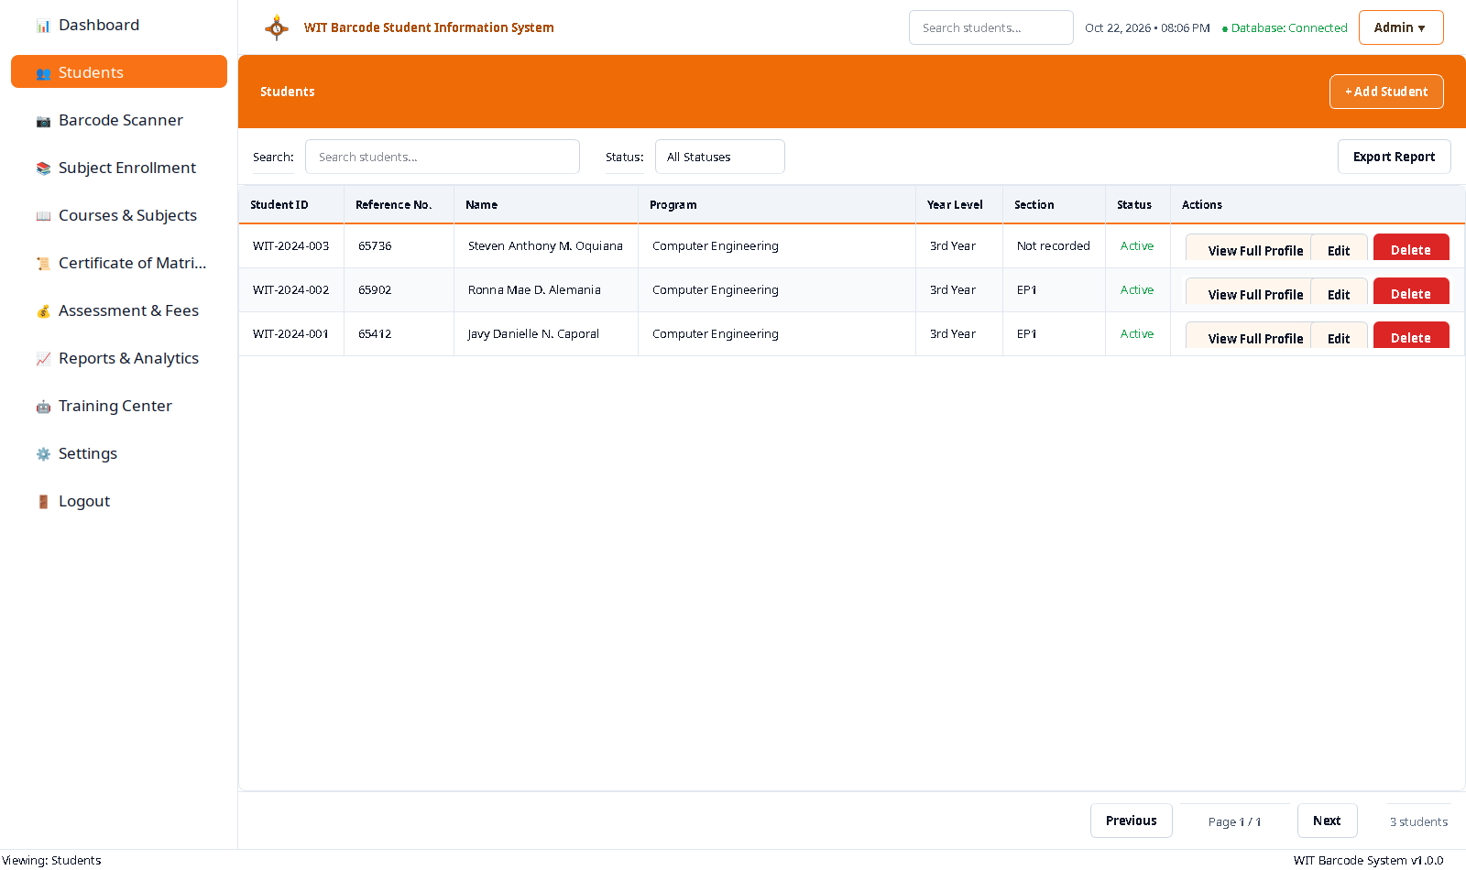
Figure 11. Students — searchable directory.
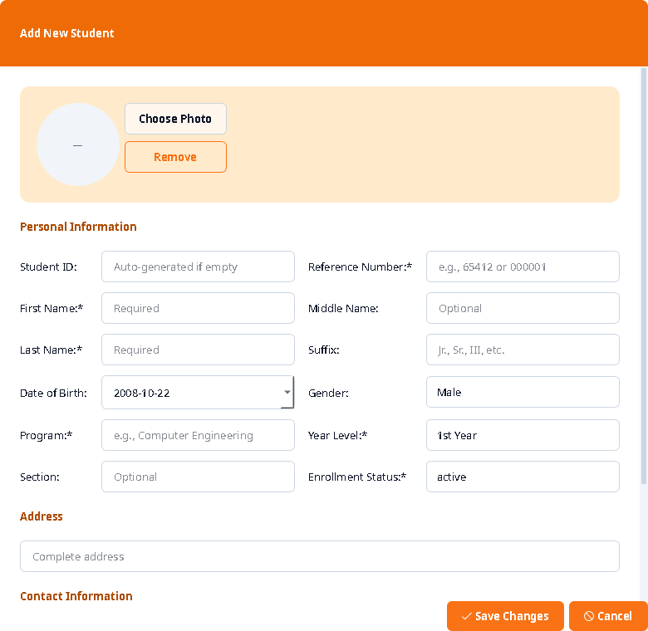
Figure 13. Add Student dialog.

3.3 Enrolment
Student picker → enrolment header (status, credits, date) → subject table with schedule, room, period, fees. Add Subject dialog captures section, time, days, room, period, lab/other fee.
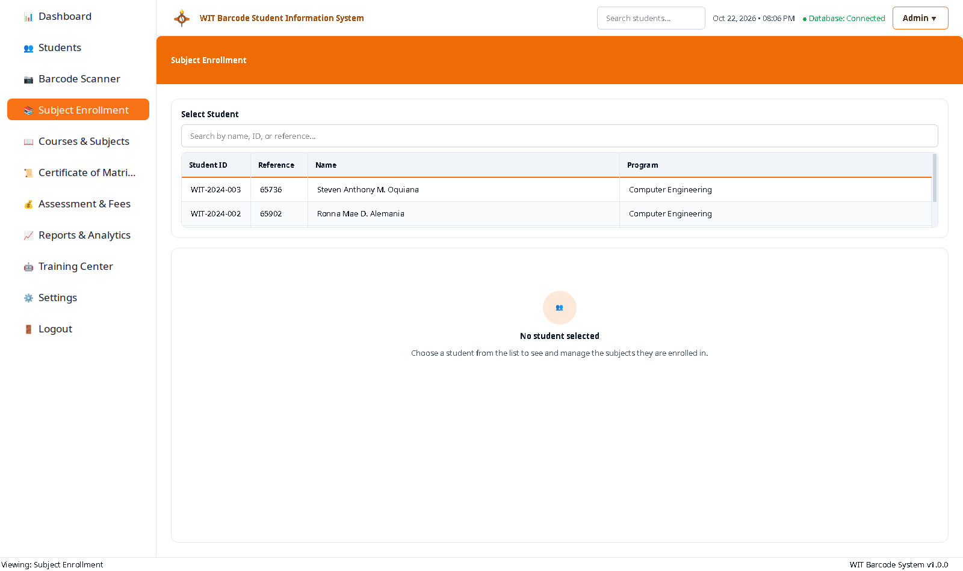
Figure 15. Enrolment — student picker.
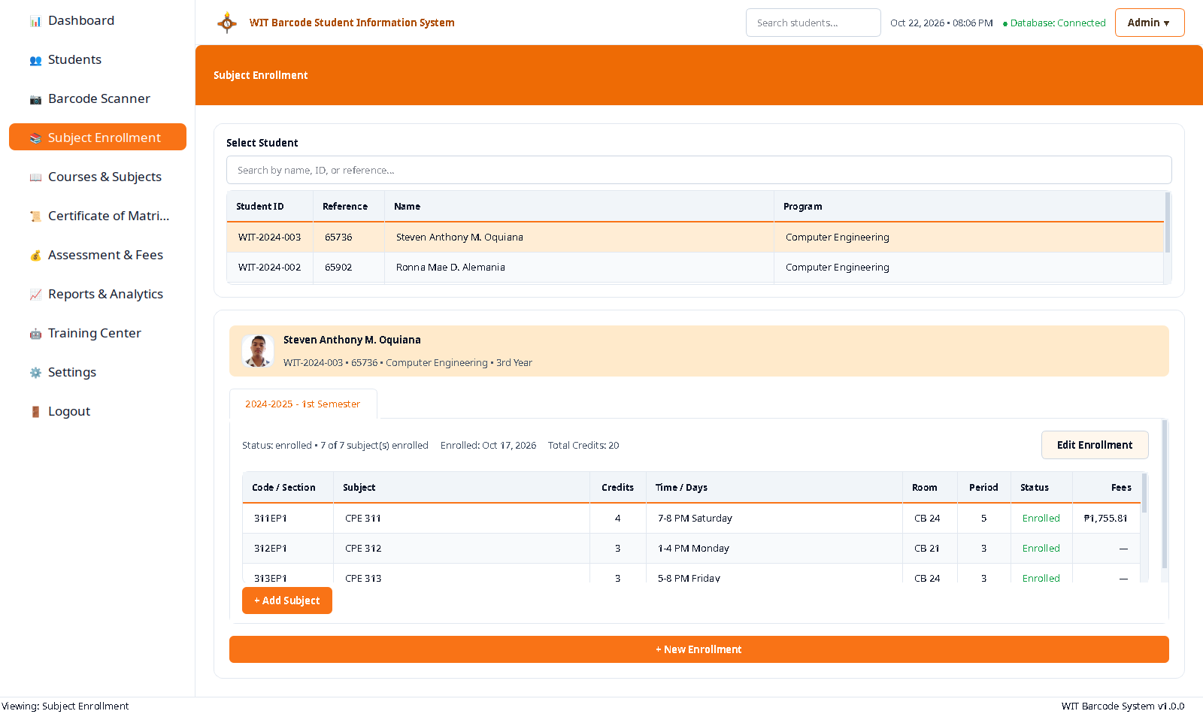
Figure 16. Enrolled subjects for the selected student.

3.4 Certificate of Matriculation
Composed from enrolment rows + assessment items + payment schedule + payments. Shows student profile, courses (7 subjects, 20 units), assessment breakdown (tuition ₱13,340.00, misc ₱8,674.72, lab ₱5,618.59), discounts, instalments (4), and totals. Unresolved totals notice: instalment sum ₱28,122.82 ≠ assessed ₱27,633.31 (gap ₱489.51).
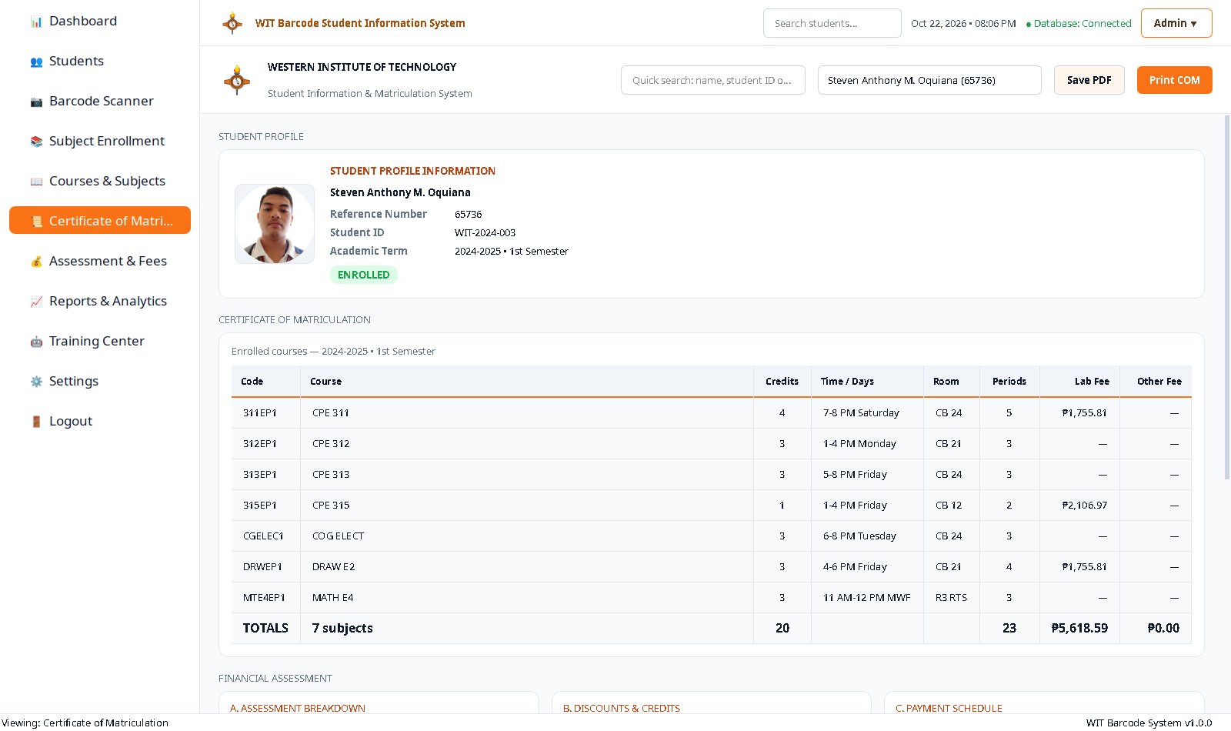
Figure 19. Certificate of Matriculation.

3.5 Assessment & Fees
Charges by category (Tuition, Misc, Lab, CDA), instalment schedule with due dates/status, payment recording (amount, date, method, reference, notes), balance recomputation. All 4 instalments overdue (no payments recorded).
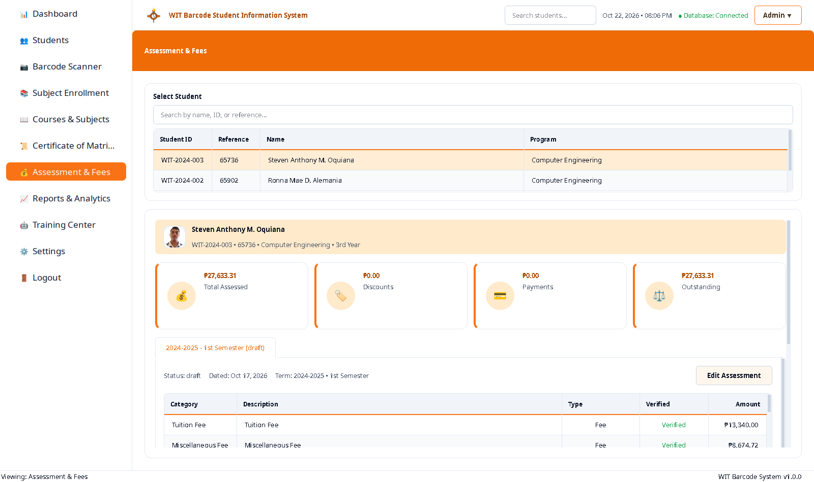
Figure 20. Assessment and Fees — charges, schedule, payments.

3.6 Reports
5 reports: Certificate of Matriculation, Enrollment Summary, Student Barcode Report, Assessment Report, Barcode Scan Log. Reports read from the same rows as the UI.
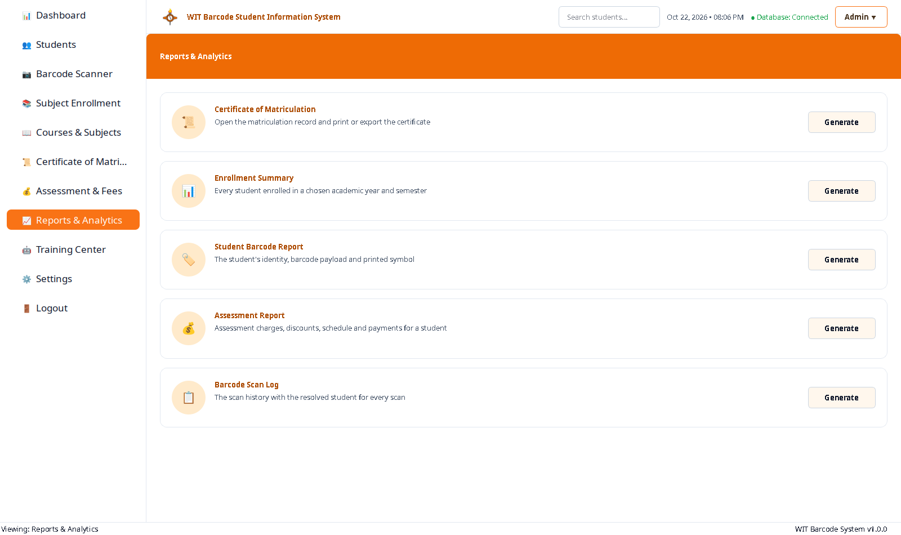
Figure 22. Reports and Analytics catalogue.

3.7 Barcode Scanner
Camera (1280×720) or uploaded card image → YOLO detection → gate → crop → decode → exact SQL lookup → session latch → history row → success cue → Scan Result panel (identity + subjects + fees). Tested on real panel: payload 000065412 → Javy Danielle N. Caporal (WIT-2024-001). 49 success / 24 not-found scans in barcode_scans table.
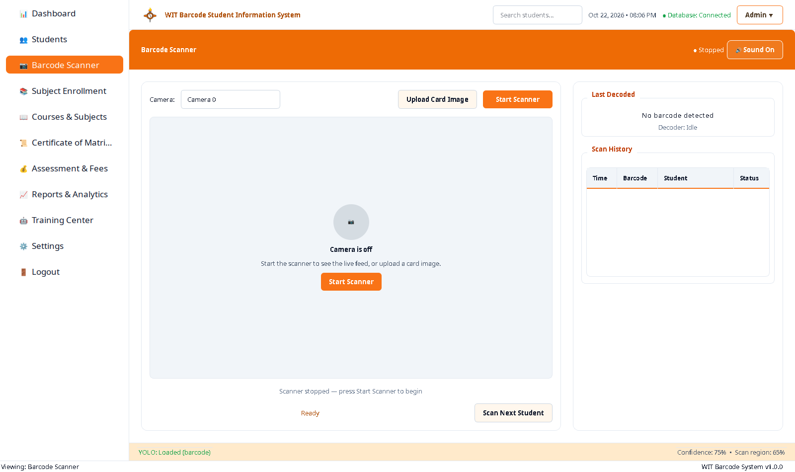
Figure 24. Scanner — idle state.
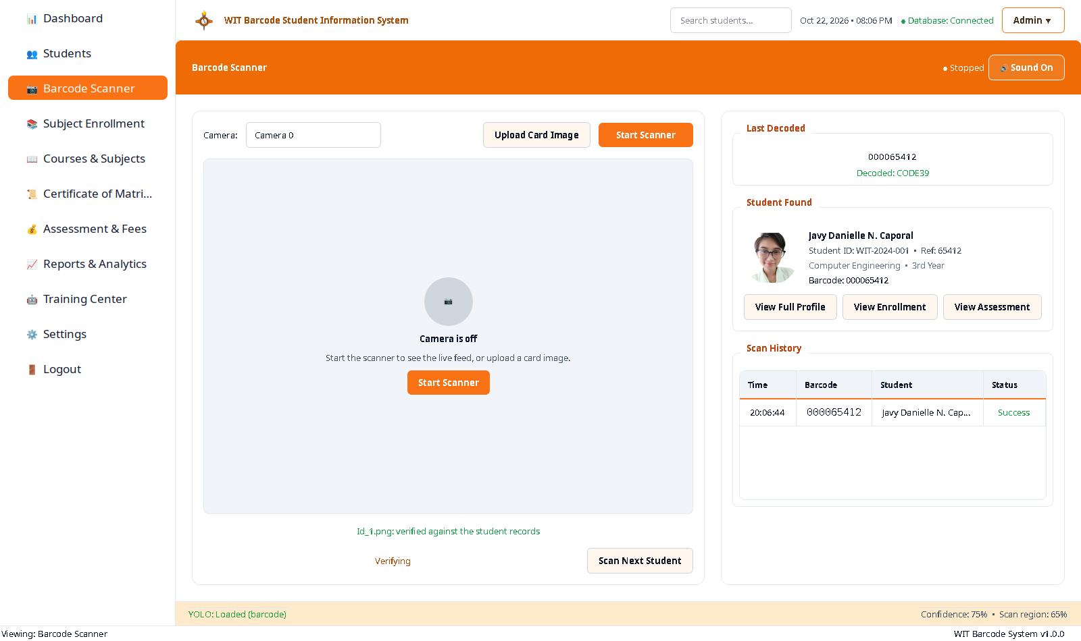
Figure 25. Scanner — real card decoded and verified.
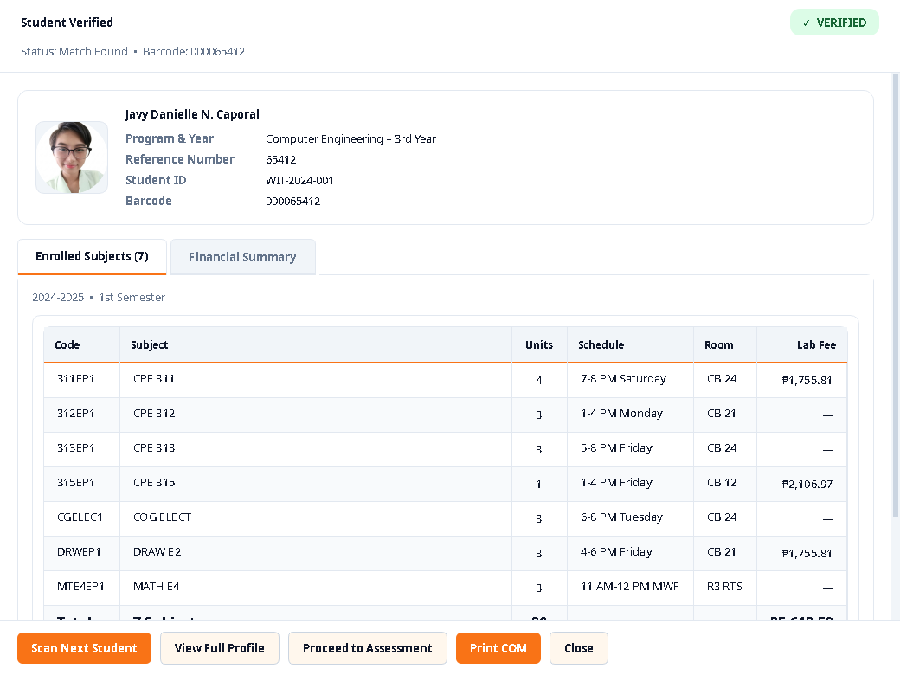
Figure 26. Scan Result panel — identity, subjects, fees.
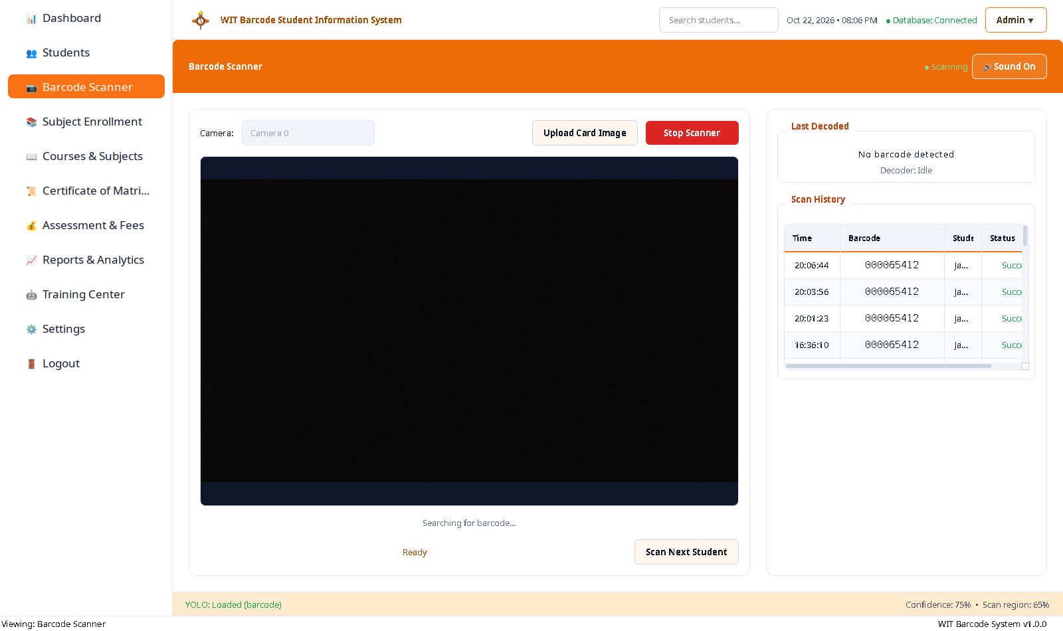
Figure 27. Scanner — live camera running.

3.8 Training Center
Dataset import/annotation/validation, training (epochs, imgsz, batch, device) with promotion gate (zero false positives on barcode-free docs + ≥ held-out decode rate), model registry (activate/deactivate). Note: dataset_images and yolo_models tables empty despite working corpus and best.pt on disk (DEF-04).

3.9 Settings
App name, version, default academic year/semester. No authentication exists (users table empty, DEFAULT_USER_ID=1; logout reports "to be implemented").
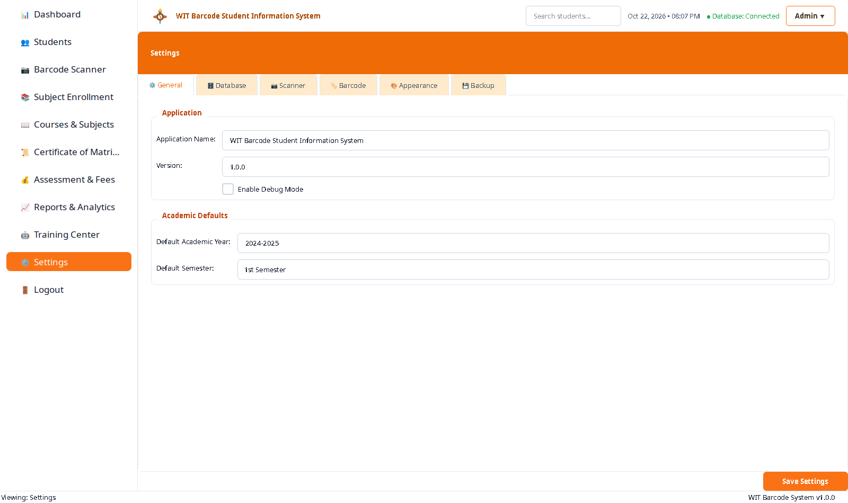
Figure 31. Settings page.

CHAPTER III — DATA VISUALIZATIONS

Assessment Breakdown
The assessment for each student consists of tuition, miscellaneous, laboratory, and CDA fees. The laboratory fee is computed from the enrolled subjects with lab components.
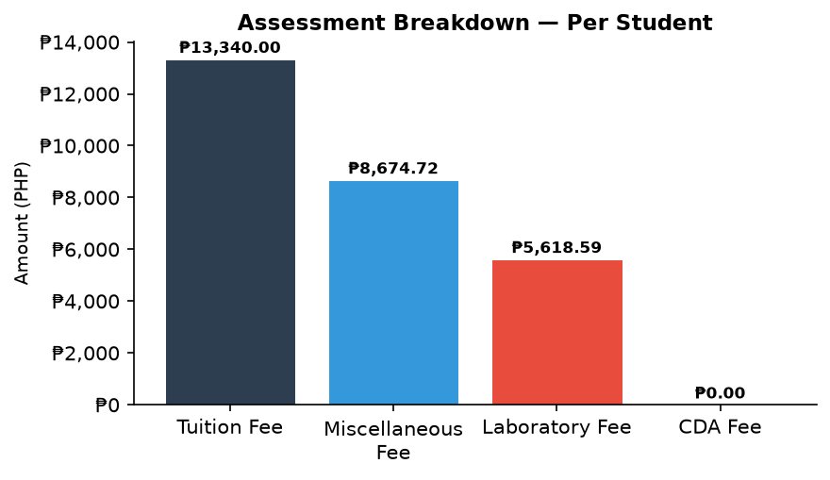
Chart 1. Assessment breakdown per student (PHP).

Payment Schedule
Four instalments: Down Payment, Midterm, Prefinal, and Final. All are currently overdue as no payments have been recorded against any assessment.
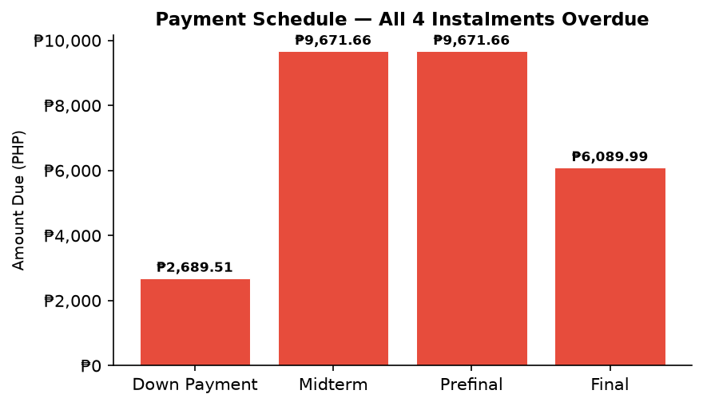
Chart 2. Payment schedule — instalment amounts (PHP).

Detector Performance: GPU vs CPU
The RTX 2050 GPU provides 9.82× speedup over CPU for YOLOv8n inference, enabling real-time scanning at 74.46 fps on GPU versus 8.59 fps on CPU.
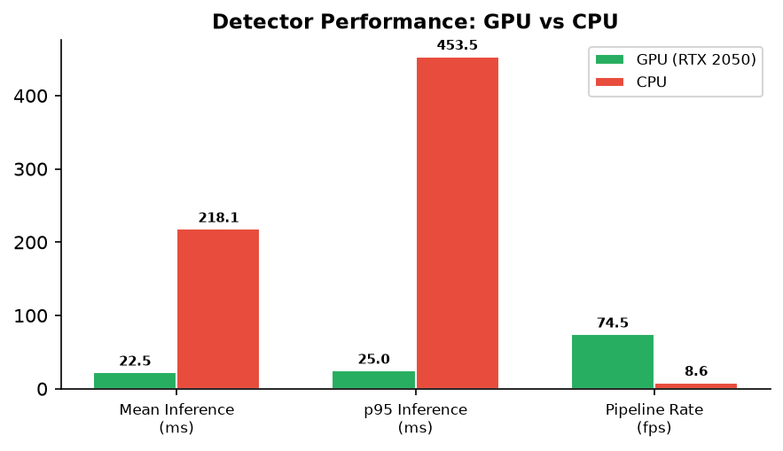
Chart 3. Detector inference latency and pipeline rate.

CHAPTER IV — DISCUSSION

4.1 Summary
The system is built and running against a live MySQL database. The core mechanism — decode a printed CODE39 symbol and resolve it to one student row by exact match — was demonstrated on a real institute asset. 557 tests pass. The normalised schema makes inconsistencies detectable: the ₱489.51 instalment/assessed-total gap is surfaced, not hidden.

4.2 Key Limitations
Self-reported verification (no independent audit). Only 3 students in the database. Camera tested under indoor lighting on a built-in webcam. Financial data is seeded, not verified (registrar must confirm). Barcode Generator page is broken (AttributeError). No authentication, no logout, no multi-user support.

4.3 Recommendations
R1 Add authentication & role separation. R2 Fix the 2 code defects (barcode generator page, locale month). R3 Registrar reconciles ₱489.51 gap. R4 Reissue 2 defective ID panels. R5 Populate model registry & dataset table. R6 Institutionalise threshold re-measurement. R7 Broaden the corpus. R8 Populate subject catalogue fields.

4.4 Known Defects
DEF-01: Barcode Generator page crash (ui/barcode_generator_page.py:536). DEF-02: "Oktubre" locale bug (ui/dashboard.py:847,858). DEF-03: ₱489.51 discrepancy (all 3 students). DEF-04: Empty yolo_models/dataset_images tables. DEF-05: No authentication or logout. DEF-06: Printed reference 000001 ≠ DB 65902 on 2 panels. DEF-07: Subject hours/department empty. DEF-08: WIT-2024-003 assessment seeded from another student.

