Australian International Trade, 2016 to 2025
What ten years of trade data say about Australian fuel security
32146 Visual Analytics, Assessment Task 3. Student 24503993. Dashboard and storyboard: https://toms55.github.io/DataVisA3/
1. Executive summary
Australian export grew from $258,469m in 2016 to $523,098m in 2025. Import grew from $254,345m to $460,866m. The trade balance looks healthy at first sight, but it peaked at $176,863m in 2022 and then fell 65% to $62,232m by 2025. The surplus of the last decade rested on a single price event and it is draining away.
Main category 3, mineral fuels, lubricants and related materials, is the largest mover in seven of the nine year transitions in the dataset. It sets the direction of the decade in both directions of trade. Inside it sits the finding this report is built around.
Subcategory 33, petroleum, is the only large part of Australian trade where the country buys far more than it sells. Export grew 104% across the decade and import grew 126%, so the deficit widened from $16,369m to $38,555m. Import and export move together at a correlation of 0.91, because both are priced off the same world oil market. Import is 3.72 times the size of export, so every oil price rise widens the deficit rather than closing it. Australia cannot export its way out of this gap.
The recommendation is a target, not a forecast. Cutting petroleum import 3% a year from 2025 reaches $45,291m by 2030. The straight line fit on ten years of data has an R squared of only 0.59, so no five year point forecast on this series deserves confidence. Section 12 shows an AI model, given the same ten numbers, forecasting the opposite direction.
2. Data collection and preparation
The data is the Australian International Trade dataset from the Australian Bureau of Statistics, supplied as 2026-Spring-Ass3-V20.xlsx. It holds two sheets, one for export and one for import, covering 2016 to 2025. Each sheet is wide: row 1 names the category, row 2 gives the unit, row 3 gives the ABS series identifier, and rows 4 to 13 hold the ten years. There are 10 main categories, 67 subcategories and one total column, which is 78 series in each direction.
The source file was never edited. A Python script reads it and writes a new workbook, 24503993_A3.xlsx. Four checks run on every build: the extract must produce 1,560 rows, all ten years must be present in both directions, every unit must read $ Millions, and the ten main categories must sum to the published total. That last check passes within 6 million dollars in the worst year, which is 0.0013% of the total and is consistent with ten independently rounded series. There are no blank cells anywhere in the source.
Every analytical and statistical result in this report lives in the workbook as a live Excel formula, not as a pasted number. A verification script recomputes growth, index, share, CAGR, the descriptive statistics, the trend fits, the z-scores, the correlation matrices, the change points and the forecasts independently, then compares them against the recalculated spreadsheet to six decimal places. The build fails if any cell disagrees or holds an error value.
3. Dataset characteristics and data types
The dataset mixes several data types and each one drives a different visual choice.
- Year is temporal and ordered. It drives a real axis on every time series in this report.
- Main category and subcategory are nominal, in a two level hierarchy. SITC codes with one digit are main categories and codes with two digits are their subcategories. The hierarchy is what sections 6 and 7 analyse.
- Direction is binary, import or export. Every criterion in this task asks for both, so direction is encoded by colour on every chart and never left implied.
- Value is continuous, in millions of Australian dollars. It is a value, not a volume, which is the single most important limit on what this dataset can prove.
- Derived measures add more types: growth and share are ratios, the index is a rebased ratio, the z-score is a standardised score and the correlation is a bounded coefficient.
The value limit deserves emphasis. The dataset records dollars, so it cannot separate a price change from a volume change. Where this report states a cause it says whether the evidence supports a price reading or a volume reading, and it does not claim a volume effect that the data cannot show.
4. The patterns built in Excel, and how they reach the dashboard
The workbook holds 24 sheets and 19 native Excel time series charts. Each chart carries a title and a label on both axes. The analysis sheets are these.
Sheet | Pattern it holds | Type
Main-Analytics | Growth, index, share, CAGR, contribution to growth | Analytical
Main-Stats | Mean, median, spread, coefficient of variation, trend fit, z-score | Statistical
Balance | Export minus import, and the cover ratio | Analytical
Correlation | Two 10 by 10 correlation matrices on growth | Statistical
ChangePoints | Largest rise and fall in each year, with a cause | Analytical
Cat3-SubAnalytics | Main category 3 against its subcategories | Analytical
Pet33-Focus | The focus subcategory, with an insight for each year | Analytical
Pet33-vs-Sub | Petroleum against coal and gas, with correlations | Statistical
Pet33-Forecast | Linear trend and CAGR forecasts, and the target path | Statistical
AI-Comparison | My forecast against the AI forecast | Analytical

Deployment into the application is literal rather than claimed. The dashboard and the storyboard do not recompute anything. A reader module opens the recalculated workbook and reads the finished values out of these sheets, so a marker who changes a cell in the spreadsheet and rebuilds will see the charts move. The spreadsheet is the single source of every number in this report and on both web pages.
One implementation note is worth recording. The openpyxl library writes modern Excel function names without the _xlfn prefix that the file format requires, so LibreOffice returns #NAME? for them. Every formula in the workbook therefore uses a legacy function name, such as FORECAST and STDEVP rather than FORECAST.LINEAR and STDEV.P. Both spellings are valid in current Excel, and the legacy names work in both applications.
5. All ten main categories: raw, analytical and statistical trends
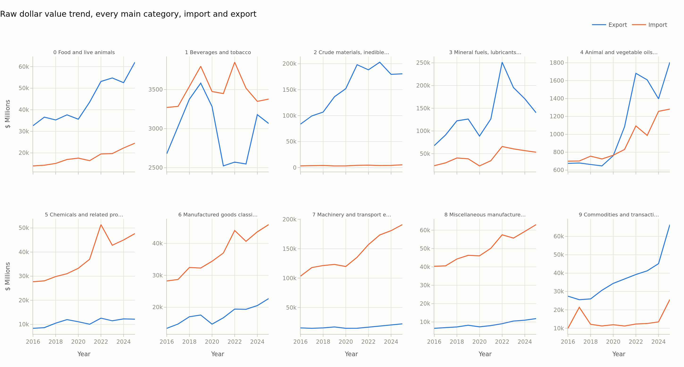
Figure 1. Raw dollar value trend for every main category, both directions, in $ Millions. One panel per category so that small categories stay readable next to large ones.
Ten categories cannot share one set of colours without becoming unreadable, so the raw view uses one panel per category and keeps colour for the one distinction that matters everywhere in this report, which is import against export. The export side is concentrated. Category 2 contributed $97,030m of export growth and category 3 contributed $72,479m. The import side is broader, and category 7 alone contributed $87,624m.
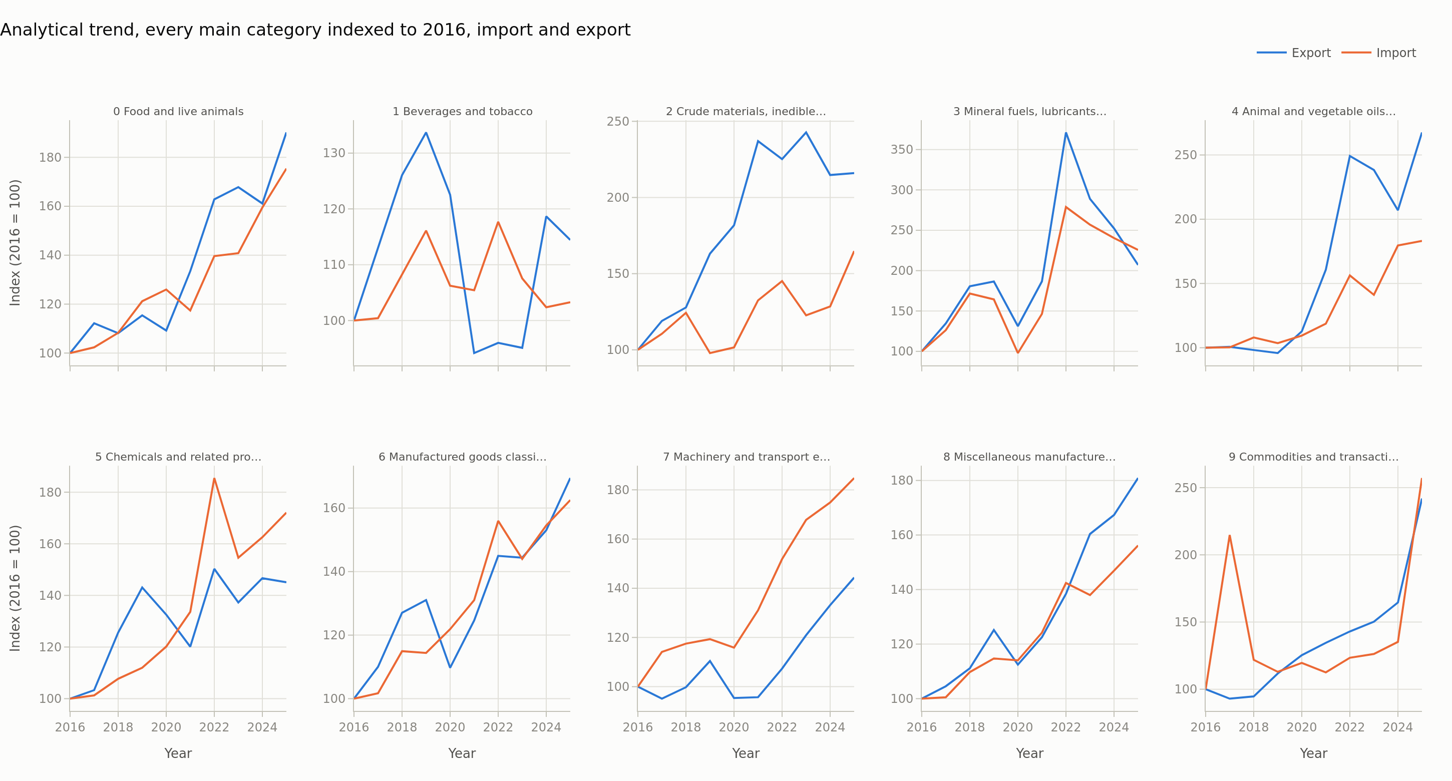
Figure 2. Analytical trend. The same ten categories with 2016 set to 100, which removes size and compares growth rate instead.
Indexing reorders the winners. Category 4 is the smallest category in dollars but grew fastest, at a CAGR of 11.6% on the export side. Category 1 is the laggard at 1.5%, and it is the only category whose export ends the decade near where it started. A raw chart hides both facts behind the scale of categories 2 and 3.
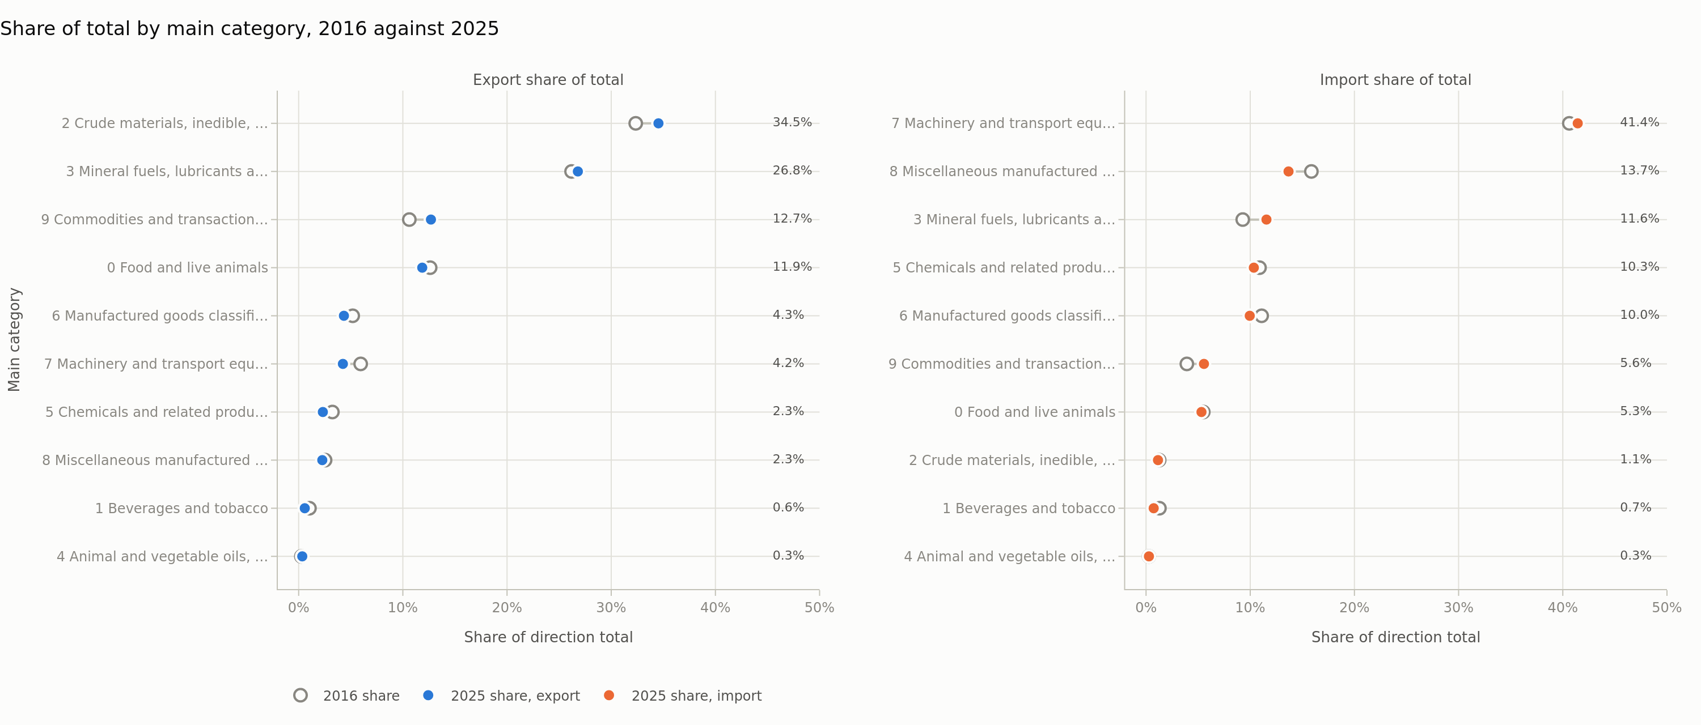
Figure 3. Each main category as a share of its own direction total, in 2016 and again in 2025.
The export mix shifted and the import mix did not. Category 2 rose to 34.5% of all export by 2025. On the import side category 7 moved only from 40.6% to 41.4%, inside a decade range of 37.6% to 42.0%. Australia changed what it sells and did not change what it buys.
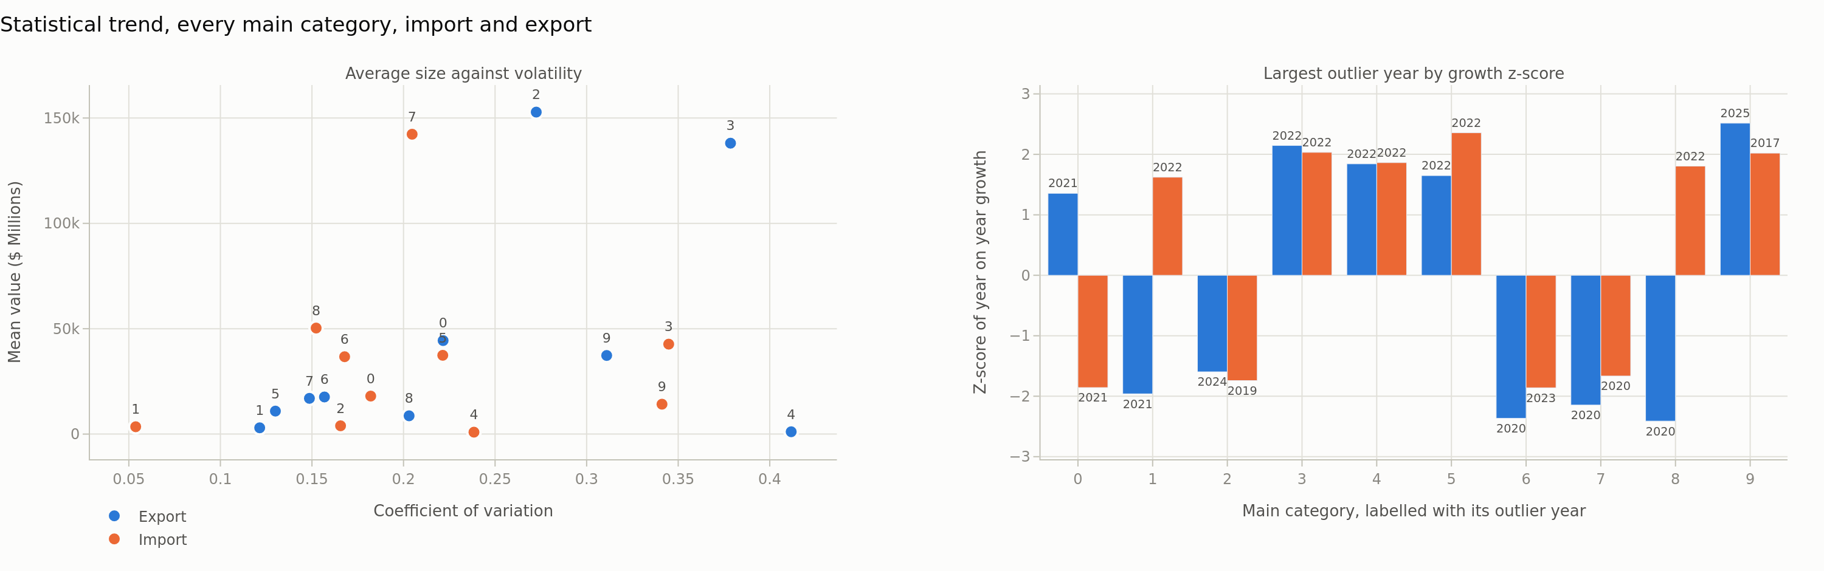
Figure 4. Statistical trend. Average size against the coefficient of variation on the left, and the single most unusual growth year for each category on the right, measured as a z-score.
The left panel separates the steady categories from the volatile ones. Category 3 has the highest export volatility at a coefficient of variation of 0.38, while its trend fit explains only 44% of the variance. A category this volatile cannot be forecast with a straight line, and section 11 returns to that point. The right panel shows that the outlier years cluster: 2020 for the manufacturing categories and 2022 for energy.
6. How the main categories relate, and the change point in each year
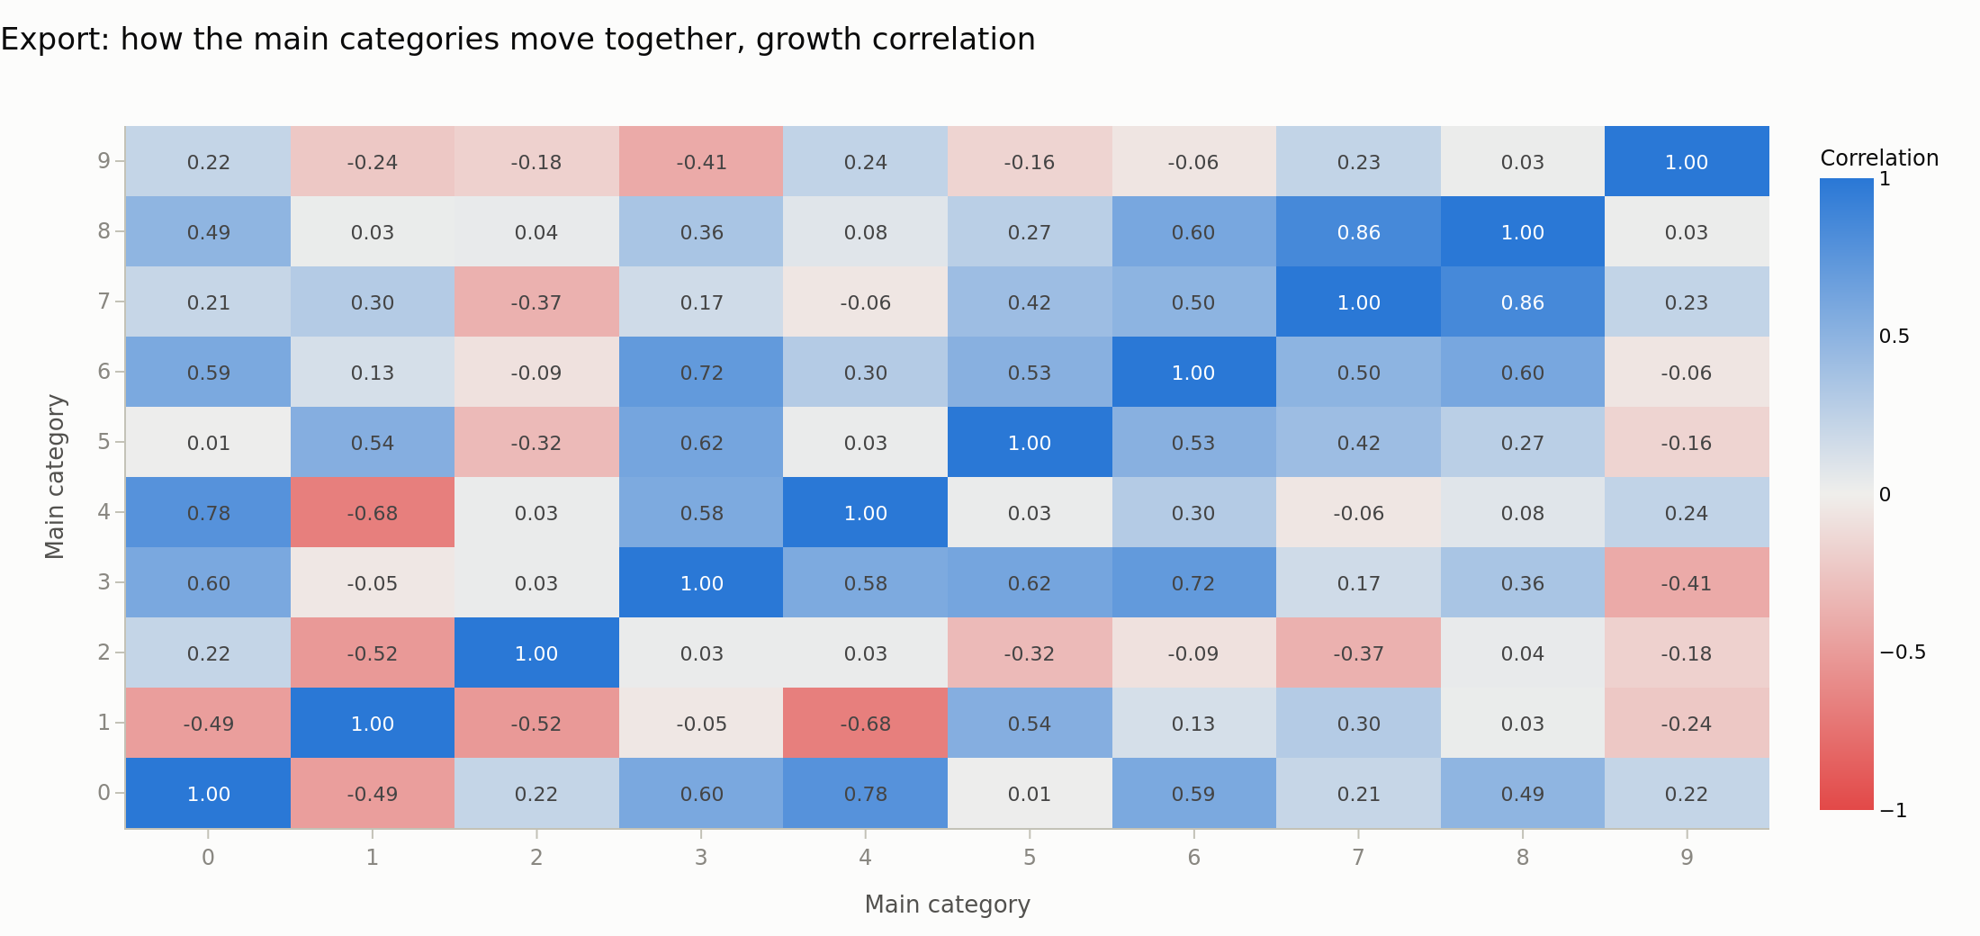
Figure 5. Correlation of year on year growth between every pair of main categories, export side. Blue means the pair moves together and red means it moves apart.
The two largest export categories are unrelated. Category 3 against category 2 is r = 0.03, which is effectively zero across nine growth years. Category 3 instead moves with category 6 at r = 0.72 and with category 5 at r = 0.62, because all three follow the same world price cycle. On the import side category 3 against category 7 is r = 0.76. This matters for policy: the two pillars of Australian export do not hedge each other, because they are driven by separate cycles that happen to overlap.
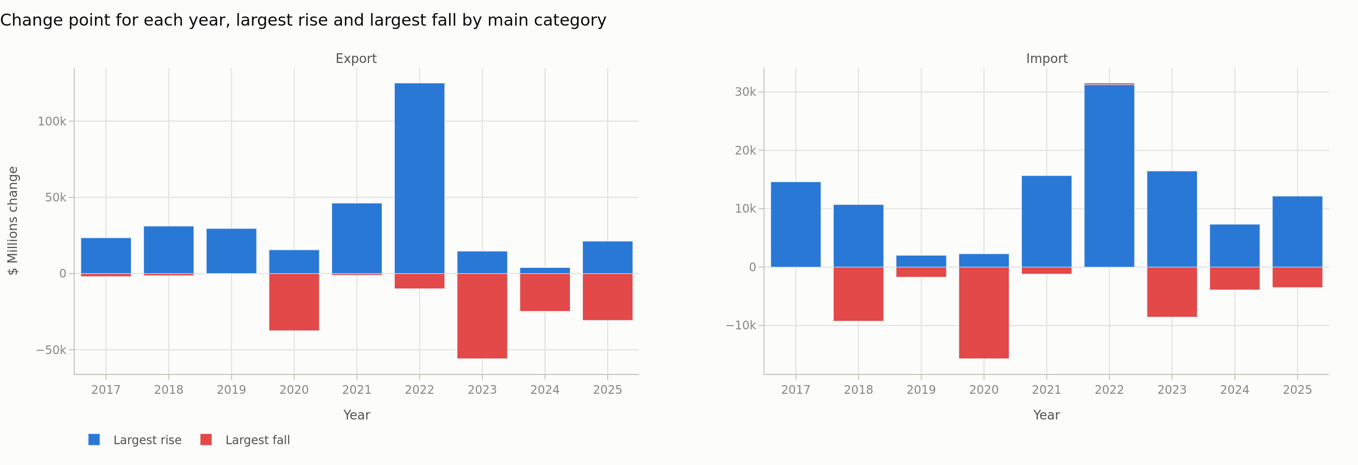
Figure 6. The main category that rose most and the one that fell most in each year, both directions, in $ Millions of change.
Requirement 3 asks for the change point in every year, so the workbook records all nine transitions rather than only the dramatic ones. The table below gives the largest export mover and the cause. Causes drawn from outside the data cite a sourced research note.
Year | Largest export mover | Change | Cause
2017 | Mineral fuels | 23,447 | Higher coal and LNG prices, and new LNG capacity.
2018 | Mineral fuels | 31,120 | LNG output reaches full capacity.
2019 | Crude materials | 29,536 | Iron ore rises 32,099 million after a supply shock cut Brazilian output.
2020 | Mineral fuels | -37,467 | COVID cuts demand.
2021 | Crude materials | 46,211 | The iron ore price peaks.
2022 | Mineral fuels | 124,939 | The invasion of Ukraine.
2023 | Mineral fuels | -55,785 | Energy prices retreat from the 2022 peak.
2024 | Mineral fuels | -24,707 | Energy and iron ore prices both ease.
2025 | Mineral fuels | -30,661 | Category 9 rises 21,245 million, and gold alone accounts for 23,854 million of that.

Two findings in that table correct a reading that the headline numbers invite. First, China restricted Australian coal from late 2020 until March 2023, yet coal export value rose 124% in 2022, in the middle of the restriction, and fell for three years after it ended. Price, not market access, drove the value, and Australia redirected volume to other buyers. Second, the 2022 fall in iron ore against the rise in coal is not a substitution. The iron ore price had already fallen from its April 2021 record to a low in November 2021, before energy prices spiked in 2022. These are two separate price cycles crossing.
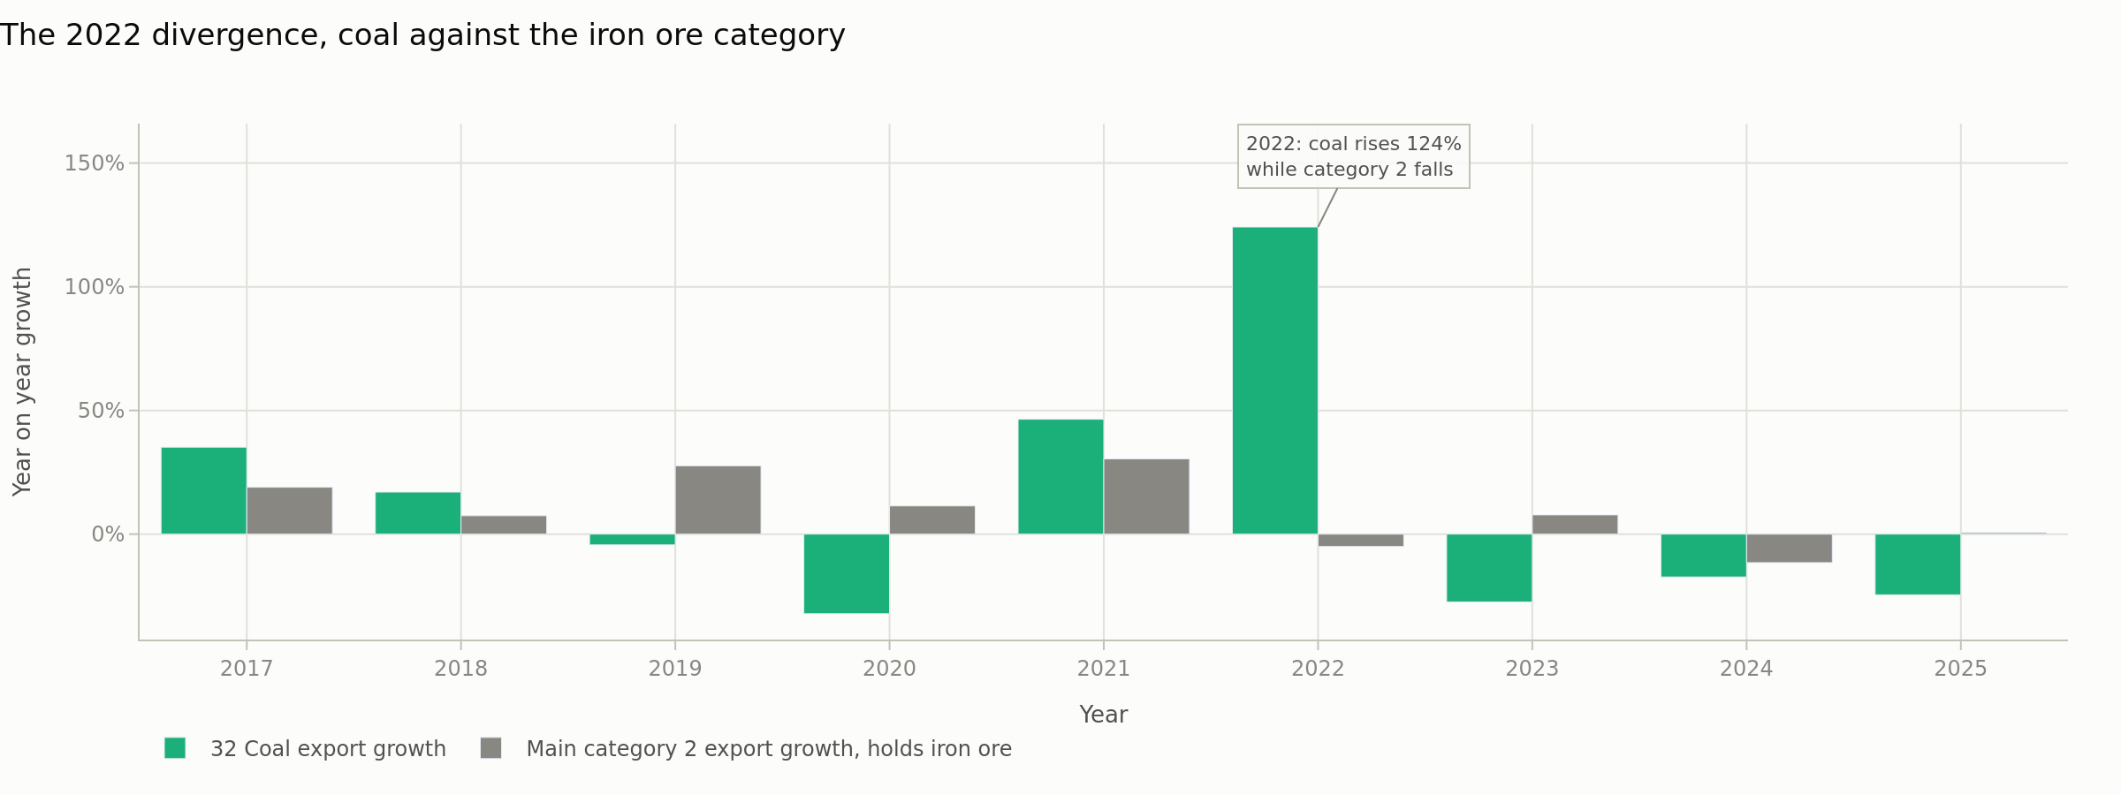
Figure 7. The 2022 divergence. Coal export growth against main category 2, which holds iron ore.
7. Main category against subcategory, inside category 3
The causes in this section are argued from inside the data, as requirement 4 asks. Main category 3 holds exactly three subcategories: 32 coal, 33 petroleum and 34 gas.
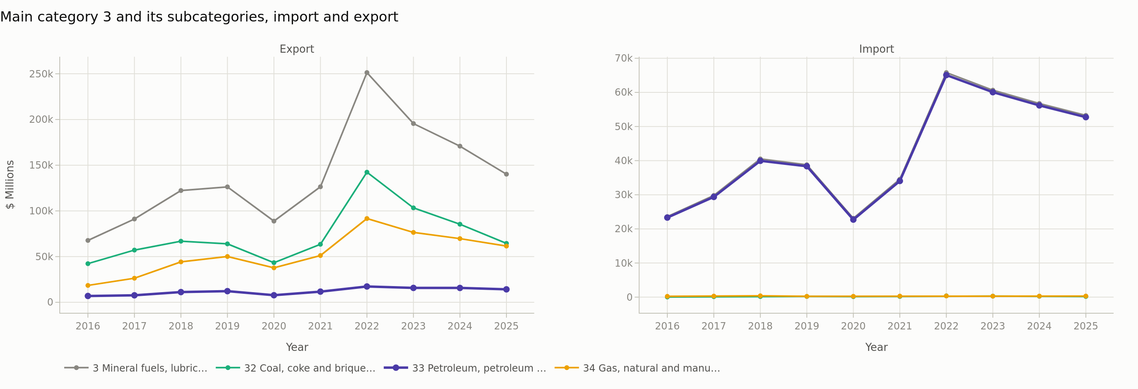
Figure 8. Main category 3 and its three subcategories, both directions, in $ Millions.
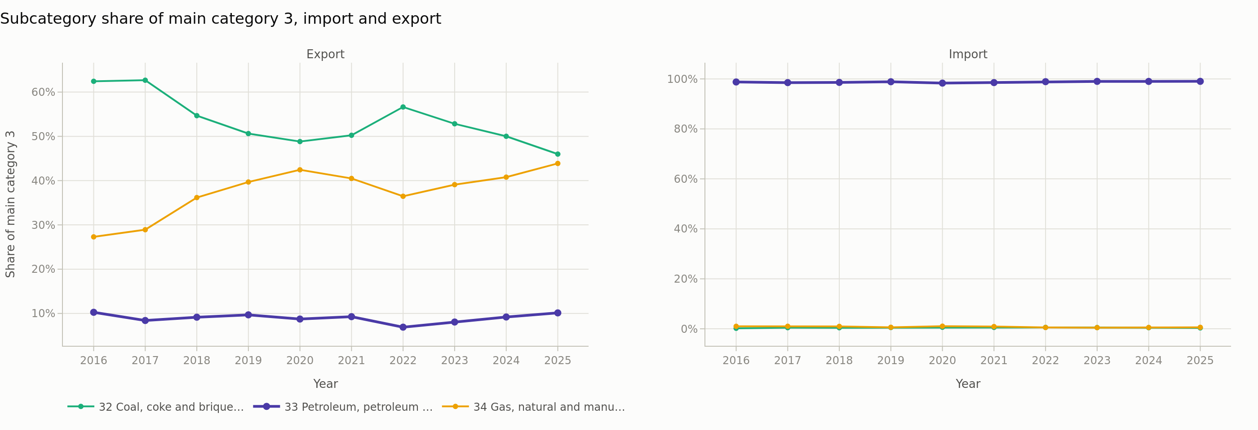
Figure 9. Each subcategory as a share of main category 3, both directions.
The export side and the import side are different categories in practice. On export, petroleum is only 10.1% of category 3 in 2025, behind both coal and gas. On import, petroleum is 99.0% of the category, against 0.4% for coal and 0.6% for gas. Any statement about "category 3 imports" is a statement about petroleum alone.
Each subcategory tracks its parent closely on growth: petroleum at r = 0.86, coal at r = 0.99 and gas at r = 0.94. The subcategories do not diversify the main category, they amplify it. The composition did shift, though. Gas rose from 27.3% to 43.9% of category 3 export while coal fell from 62.4% to 46.0%.
One change point can be read from inside the data alone. In 2025 category 3 export fell 18% while petroleum import fell only 6%. If a single demand collapse were driving both sides they would fall together. They do not, so the export fall is a price effect on what Australia sells, and not a fall in what Australia needs to buy.
8. The dashboard
The dashboard is at https://toms55.github.io/DataVisA3/dashboard.html and covers subcategory 33 in both directions on one screen. It carries a six tile summary row, five named comparisons, an insight for each of the ten years, and a year range control that re-scales every time chart at once. Each chart has a collapsible table of the numbers beneath it.
- Comparison 1, export against import on one scale, with the 2020 and 2022 change points annotated on the plot rather than left to the caption.
- Comparison 2, the trade balance as columns, every one of them negative.
- Comparison 3, petroleum against its own main category, which exposes the asymmetry between the two directions.
- Comparison 4, petroleum against coal and gas on a common index.
- Comparison 5, import against export as a scatter with the fitted line, which is where the central finding of this report becomes visible.
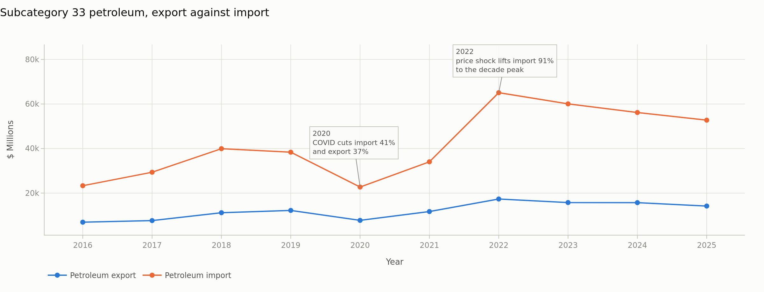
Figure 10. The dashboard anchor chart. Subcategory 33 petroleum, export against import, in $ Millions.
Import exceeds export in every year of the decade. The 2020 dip and the 2022 peak appear on both lines at once, which is the first visual clue that a shared price drives both sides. Import fell 6% in 2025 to $52,742m, which is still 2.3 times the 2016 level.
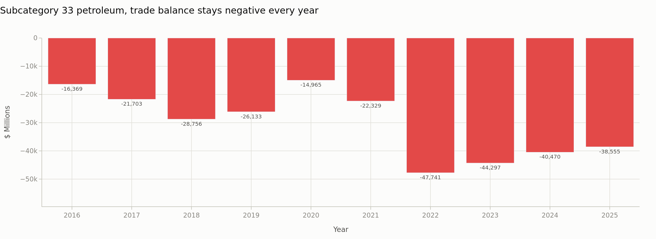
Figure 11. The petroleum trade balance for each year, in $ Millions. Every column points down.
The deficit widened from $16,369m in 2016 to $38,555m in 2025, and reached its worst point of $47,741m in 2022. The cover ratio in 2025 is 0.27, which means each dollar of petroleum import is matched by 27 cents of petroleum export.
9. The storyboard
The storyboard is at https://toms55.github.io/DataVisA3/storyboard.html. Where the dashboard answers questions in any order, the storyboard makes one argument in a fixed order across thirteen panels. It starts with total Australian trade, moves through the ten main categories in their raw, indexed and statistical forms, works through the change point of each year, descends into main category 3, then into subcategory 33, and closes with the forecast and the AI comparison. Every panel carries both trade directions and ends with a stated takeaway, so a reader cannot reach the end without having been told what each chart is for.
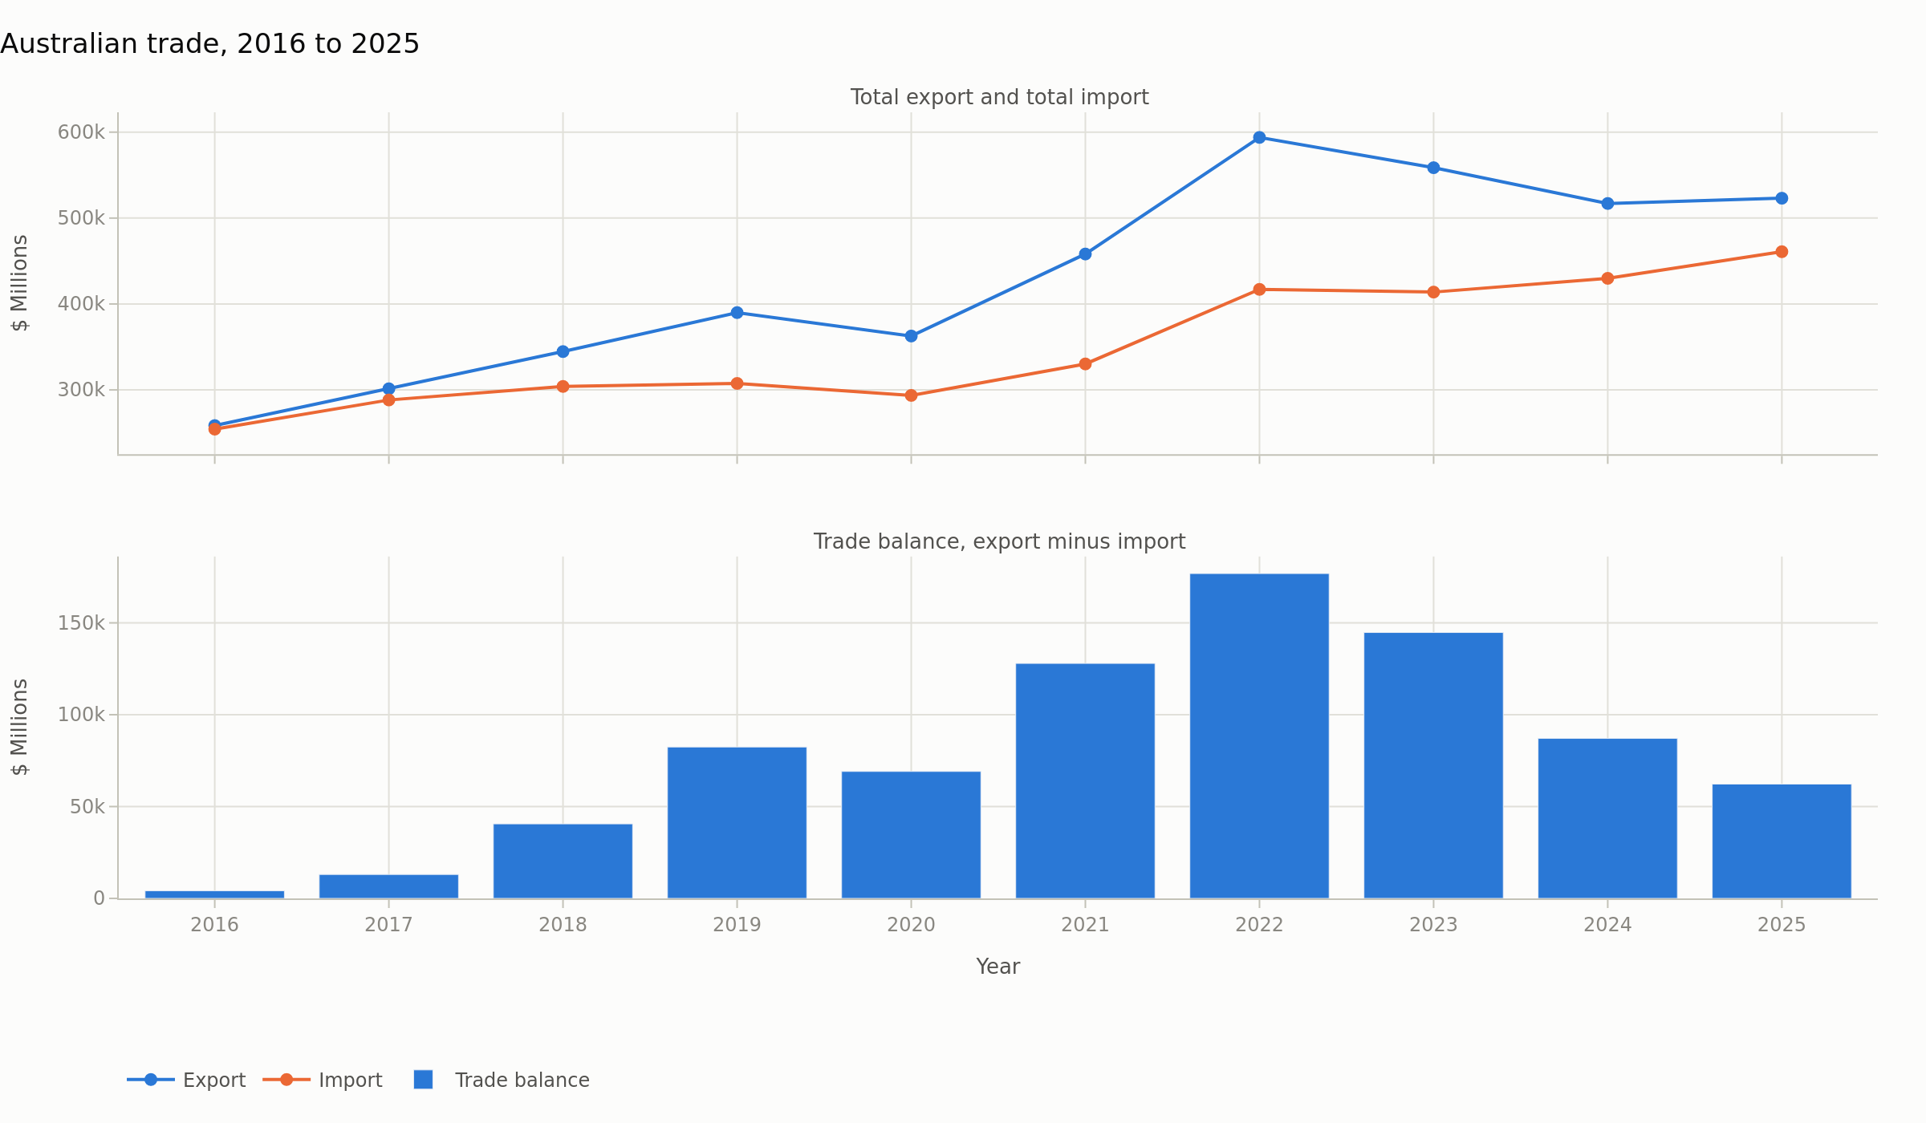
Figure 12. The storyboard opening. Total export, total import and the balance between them, in $ Millions.
This panel sets up every panel after it. Export fell 12% from its 2022 peak while import reached its decade high of $460,866m in the same year, rising in 7 of the nine transitions. The surplus quoted in section 1 narrows from both ends at once, which no single series on the chart shows on its own.
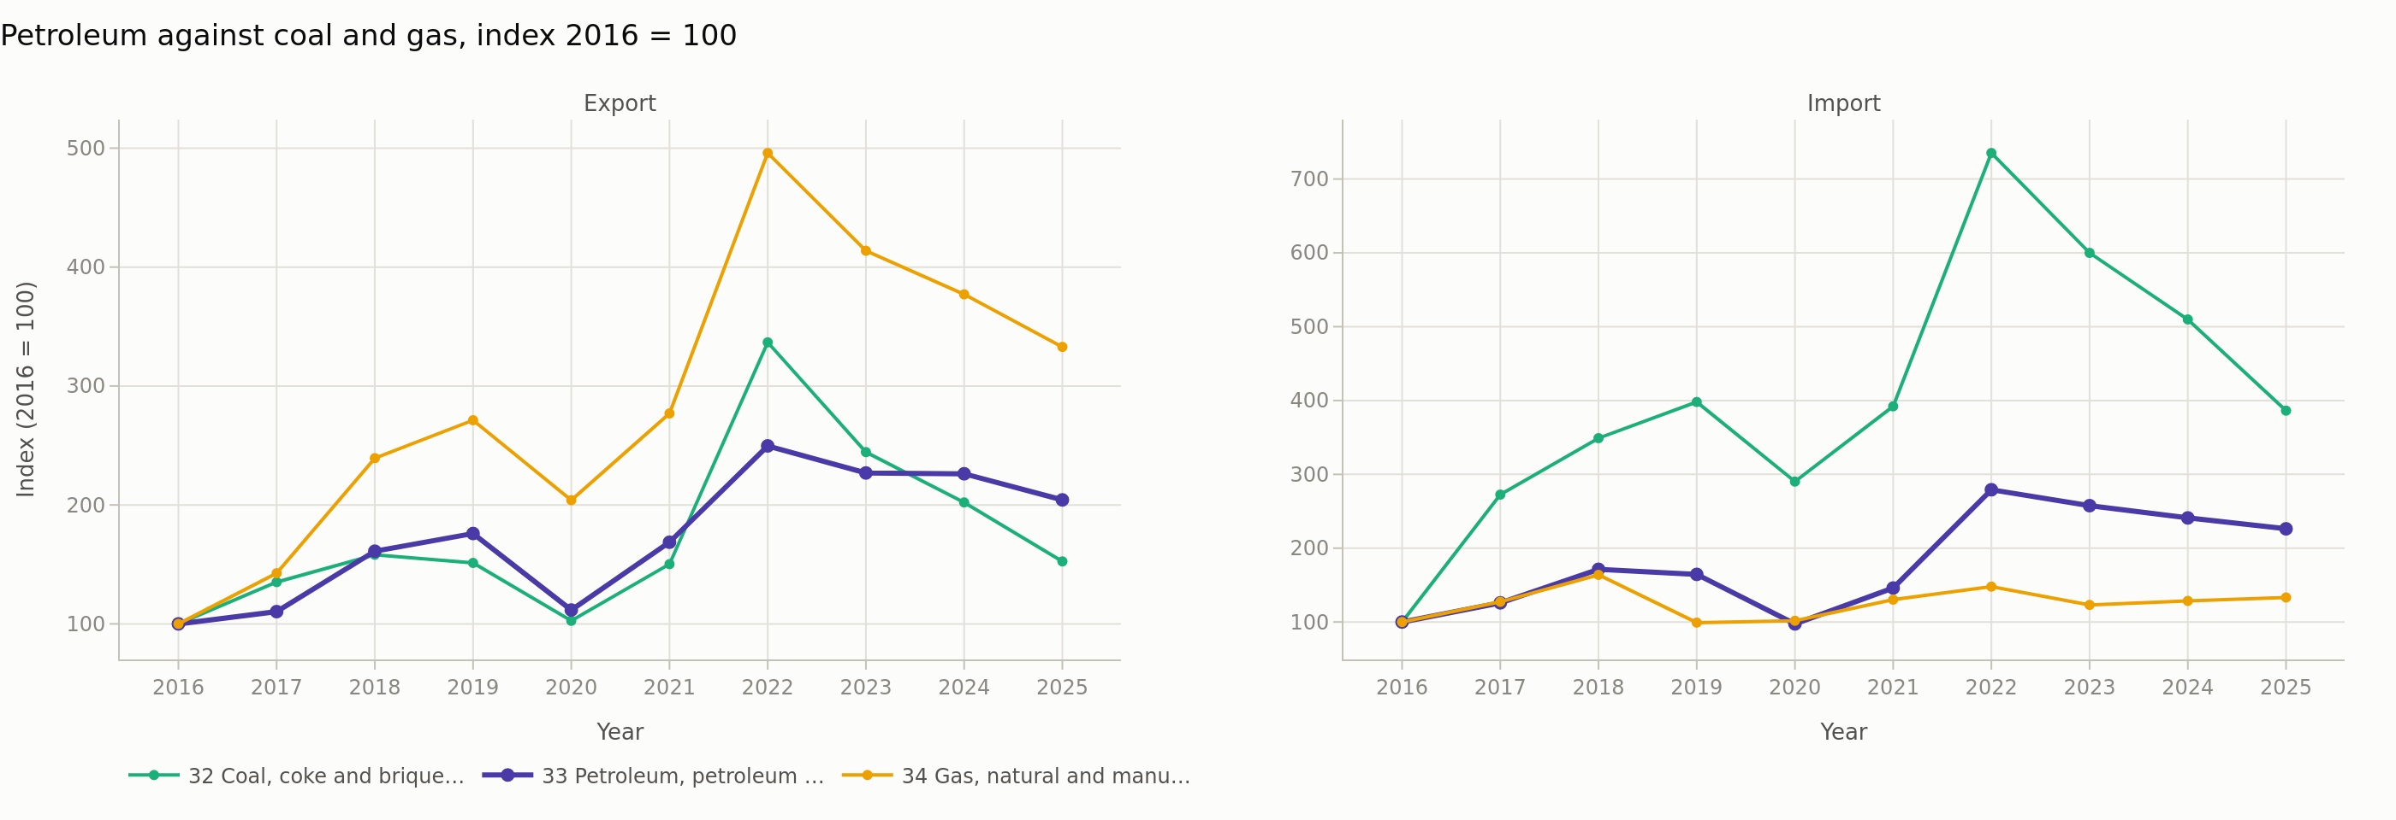
Figure 13. Petroleum against coal and gas, indexed to 2016, both directions.
Petroleum growth tracks coal at r = 0.79 and gas at r = 0.89 on the export side. On the import side those fall to 0.62 and 0.52, because the coal and gas import series are tiny and noisy. The export side of category 3 is one coherent energy story and the import side is a petroleum story with two rounding errors attached.
10. Trends and outliers compared
An outlier here is defined, not asserted. The workbook computes a z-score for each year of growth against that category's own mean growth, so a value above 2 marks a year that is unusual for that category rather than merely large.
Category | Outlier year | Growth that year | Z-score
8 Miscellaneous manufactured articles | 2020 | -10% | -2.41
6 Manufactured goods by material | 2020 | -16% | -2.37
7 Machinery and transport equipment | 2020 | -14% | -2.15
3 Mineral fuels | 2022 | +99% | 2.15
9 Commodities not classified elsewhere | 2025 | +47% | 2.52

The outliers fall into three groups and each has a different explanation. The 2020 group is the manufacturing categories, cut by the COVID demand collapse. The 2022 outlier is energy, lifted by the price shock after the invasion of Ukraine. The 2025 outlier is category 9, and that one is worth care. Category 9 rose $21,245m in 2025 while gold inside it rose $23,854m, so gold accounts for more than the whole category movement, offset by a $3,006m fall in confidential items. Gold rose 44% in price over 2025 against a 67% rise in Australian gold export value, so price explains most of the rise but not all of it. The remaining gap points to volume or refining throughput, which this dataset cannot separate.
11. Ten years of gain and loss, the target, and the forecast
The product chosen for this section is petroleum import, subcategory 33. It stood at $23,315m in 2016 against petroleum export of $6,946m, and by 2025 it had reached $52,742m against export of $14,187m. Across the ten years Australia lost ground on it. Import rose $29,427m, which is a rise of 126%, at a compound rate of 9.5% a year. The petroleum trade deficit widened by $22,186m over the same period. That is the loss, stated plainly: a larger bill every year for a product Australia increasingly does not refine for itself.
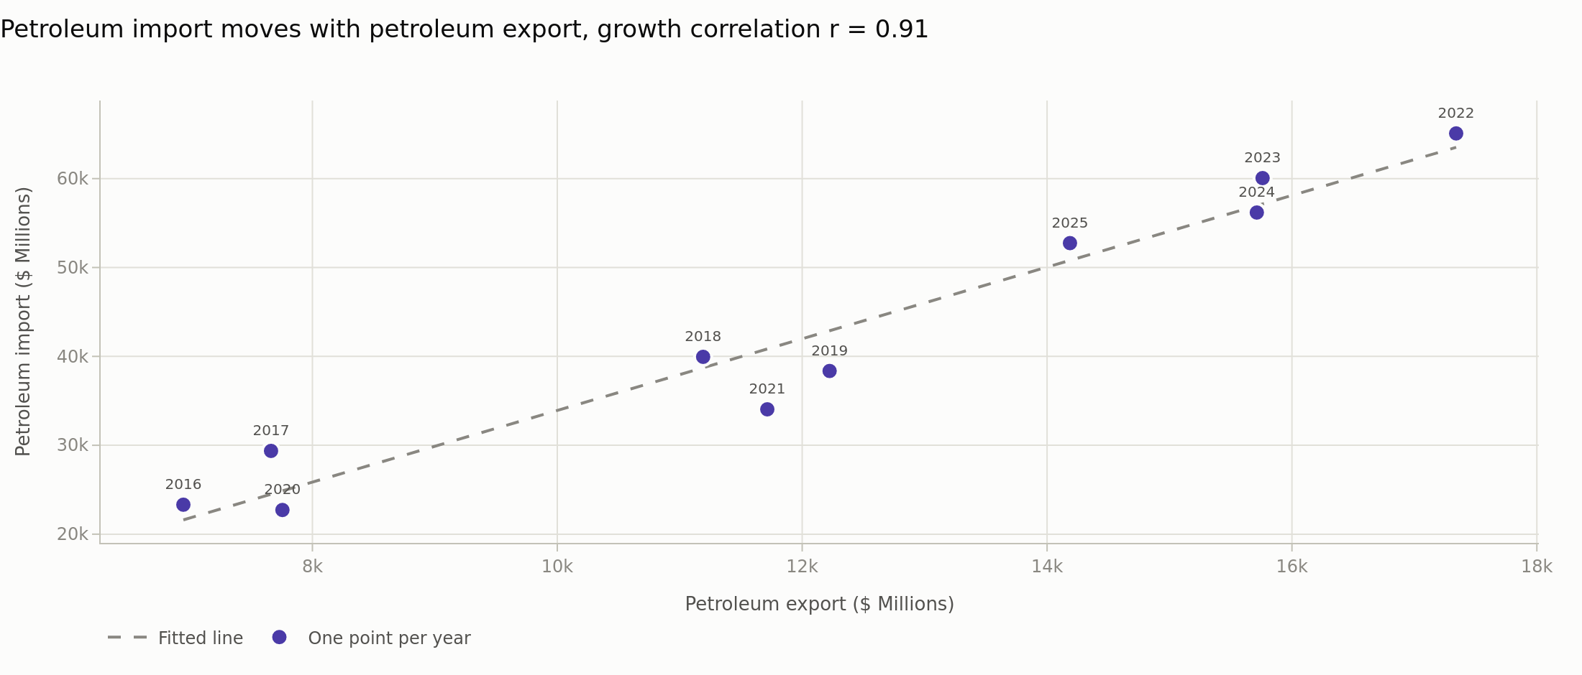
Figure 14. Petroleum import against petroleum export, one point per year, with the fitted line.
This chart carries the central finding. The two directions move together at r = 0.91. Both are priced off the same world oil market, so they rise and fall as one. Because import is 3.72 times the size of export, a price rise adds $3.72 to the import bill for every dollar it adds to export earnings. Growing petroleum export cannot close this gap. Only buying less, or refining more at home, can.
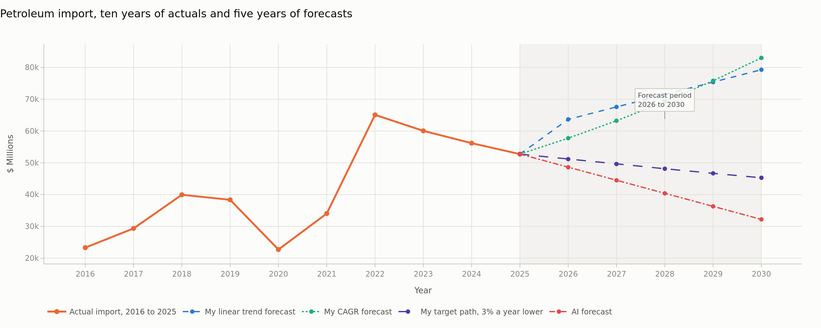
Figure 15. Petroleum import. Ten years of actual values, two forecast methods, the target path and the AI forecast, in $ Millions.
The workbook carries two forecast methods, both as live formulas. A straight line fitted to 2016 to 2025 gives $79,296m by 2030. Growing the 2025 value at the decade compound rate gives $83,007m. Both point upward and neither should be trusted far: the straight line explains only 59% of the variance, because this series follows a world price rather than a trend.
The target is therefore stated as a decision rather than a prediction. Cutting petroleum import 3% a year from the 2025 level reaches $45,291m in 2030, which is $34,004m below where the straight line would otherwise land.
Year | Linear trend | CAGR method | Target path | AI forecast
2026 | 63,668 | 57,749 | 51,160 | 48,600
2027 | 67,575 | 63,232 | 49,625 | 44,500
2028 | 71,482 | 69,236 | 48,136 | 40,400
2029 | 75,389 | 75,809 | 46,692 | 36,300
2030 | 79,296 | 83,007 | 45,291 | 32,200

12. Comparison against the AI forecast
An AI model was given the ten annual petroleum import values and the unit, and nothing else. It received none of this analysis, no change point notes, no refinery history, no export side and no target. The run used Claude Sonnet 5, model id claude-sonnet-5, at low effort on 16 October 2026, with no tools available. The prompt and the reply are reproduced word for word in Appendix A so that the comparison can be audited.
12.1 What the AI produced
The AI did two things. It described the decade, and it forecast each year from 2026 to 2030. Its description was accurate. It found the 2022 peak of 65,082, the 2020 dip to 22,720, and the three year decline to 52,742 in 2025, and it noted that 2025 is still more than double the 2016 level. It also stated its method, which was to extrapolate the 2022 to 2025 fall of 4,113 million a year. A reader can therefore check it.
The forecast is where the two analyses part. The AI projects $32,200m for 2030, a fall of 39% from 2025. My linear trend projects $79,296m, a rise of 50%. The difference in 2030 is $47,096m, which is more than the entire 2016 import value of $23,315m. The gap widens every year of the forecast, from 24% in 2026 to 59% in 2030.
12.2 Why the two answers disagree
The disagreement is not arithmetic. Both methods are correctly executed. The whole difference comes from one unstated choice, which is how much history to fit. The AI used the last four years, which contain only the fall from the 2022 peak, so it had to project a fall. I used all ten years, which contain the climb to that peak, so I had to project a rise. Neither window is obviously right, and neither of us justified the choice from the data. That is the most useful thing this comparison exposed, and it is a criticism of my own method as much as of the AI.
12.3 Testing both methods on data they have not seen
A disagreement can be settled by a backtest. Each method was fitted to 2016 to 2021 only, then asked to predict 2022 to 2025, which it had not seen. The recent window method reproduces the AI approach, extrapolating the change over the last few years of the training period. The Pet33-Backtest sheet in the workbook holds this as live formulas.
Year | Actual | Linear trend | CAGR method | Recent window, the AI approach
2022 | 65,082 | 34,503 | 36,722 | 32,076
2023 | 60,057 | 35,421 | 39,610 | 30,109
2024 | 56,183 | 36,339 | 42,725 | 28,141
2025 | 52,742 | 37,256 | 46,086 | 26,173
Mean error |  | 38.2% | 28.5% | 50.2%

Every method failed, and badly. The best of the three was the CAGR method at 28.5% mean absolute error. My linear trend scored 38.2%. The recent window method, which is the one the AI chose, was the worst at 50.2%, predicting $26,173m for 2025 against an actual of $52,742m. On the evidence available, the AI picked the weakest of the three approaches.
The more important reading is that all three were wrong by a wide margin in the same direction. Every method under-forecast, because the 2022 price shock was not present in the training data and could not be inferred from it. No amount of curve fitting on ten annual points will anticipate an invasion. This is the strongest argument in the report for treating the 2026 to 2030 numbers as a planning range rather than a prediction, and for setting a target instead.
12.4 What the AI could not know
- That the 2020 dip and the 2022 peak are price events rather than demand events. That only becomes visible from the two way data, where import and export move together at r = 0.91. The AI was given the import side alone, so it could not see the mechanism at all.
- That two Australian refineries closed in 2021, which shifts the mix of imports from crude towards refined product and puts a floor under the bill. No amount of care with ten numbers recovers a fact that is not in them.
- That the series is too noisy to support a point forecast. The straight line fit explains only 59% of the variance. The AI returned five exact figures with no range and no caveat, which reads as far more certain than the data permits.
- That its own method had the worst backtest record of the three. It had no way to test itself, because testing needs a held out period and a second method to compare against, and it was given neither.
12.5 Advantages of using AI here
1. Speed. The reply returned in seconds and needed no spreadsheet, no chart and no build step.
2. Independence. The model had no stake in my conclusion and had not spent hours forming an opinion. It read the series cold, which is exactly why it chose a different window and exposed that my own window was an unexamined assumption.
3. A stated method. It said it was extrapolating the 2022 to 2025 fall at 4,113 a year. Because it said so, the method could be backtested and found wanting. An assistant that only returned numbers would have been useless here.
4. Pattern description. Its reading of the decade shape was correct and would be a reasonable first summary for a reader meeting the series for the first time.
12.6 Disadvantages of using AI here
1. No causal knowledge. It could not know why 2022 happened, so it could not judge whether to carry that movement forward. Every useful cause in this report came from outside the dataset.
2. Confidence without uncertainty. Five exact numbers, no error band, no warning that the series resists forecasting. A policy reader would take those figures at face value.
3. It answers only the question asked. Given the import column, it analysed the import column. It did not ask for the export side, which is where the actual finding of this report lives. A human analyst would have asked.
4. It cannot check itself against reality. It had no held out period, no second method and no way to measure its own error, so its weakest-performing method was presented with the same assurance as its strongest observation.
5. One run is not evidence. This comparison rests on a single response. A different phrasing, or the same prompt run again, could give different numbers, and nothing in the output would signal that.
12.7 What this means for using AI in visual analytics
The AI was useful here as an adversary, not as a forecaster. It made a different defensible choice of window, which forced me to backtest a choice I had not examined. A second opinion whose method is stated and then measured improves the analysis. The same output read at face value, as five confident numbers, would have made it worse than having no forecast at all.
13. Visualisation techniques, and the problems handled
The techniques were chosen per job: time series lines for trends, columns for a signed quantity such as the balance, small multiples where ten categories had to be compared at once, a dumbbell for a before and after comparison, a heatmap for the correlation matrix, and a scatter with a fitted line for the relationship between the two trade directions. Five problems came up and each needed a decision.
1. Ten categories, eight safe colours. Cycling hues past eight makes series indistinguishable, so the ten category charts became small multiples. Colour was then freed for the one distinction that matters everywhere, import against export.
2. Different magnitudes on one chart. Category 4 export is $1,806m against $180,651m for category 2, a ratio of 1 to 100. A second y axis was rejected, because two scales on one frame invite false comparison. Indexing to 2016 and small multiples solved it honestly.
3. Labels colliding. The first share chart put ten end of line labels on top of each other and was unreadable. It was rebuilt as a dumbbell on a category axis, with the values in a fixed column clear of the markers.
4. Grouped bars that did not group. The outlier chart first used a label of category and year, and because the outlier year differs by direction it produced twenty separate categories instead of ten pairs. The year moved to a bar label and the axis became the category alone.
5. Colour that fails for colourblind readers. The palette was not chosen by eye. Every set of colours that appears together was run through a contrast and colour vision checker, and two of the hues sit below the contrast floor on a light background, so every chart that uses them also ships a table of its numbers.
14. The dashboard against the storyboard
 | Dashboard | Storyboard
What it is for | Looking something up | Being walked through an argument
Order of reading | Any order the reader likes | Fixed, top to bottom
Strength | Density and comparison on one screen, with filters | Causation and sequence, each panel sets up the next
Weakness | Shows what, not why. A reader can misread it with no guard rail | Slow to scan, and cannot answer a question it was not built to answer
Best audience | An analyst who already knows the domain | A policy reader meeting the data for the first time

The two methods failed in opposite ways while this task was built, which is the clearest evidence for using both. The dashboard shows that the petroleum deficit widened, but a reader can look at it and conclude that Australia should export more petroleum, which the data says will not work. The storyboard forces the scatter in section 11 in front of the reader before it allows any recommendation. The storyboard cannot be filtered, though, so a reader who wants 2020 to 2023 alone has to go to the dashboard. Together they cover both needs. Separately each leaves a real gap.
15. Recommendations
These recommendations cover the industries this study touches: refining, fuel import logistics, and the energy export industries that fund them.
1. Set the petroleum import bill as a tracked target, not a forecast. The path in this report cuts it 3% a year to $45,291m by 2030. A forecast on this series is not reliable enough to steer by, but a target is a decision and can be measured against each year.
2. Do not pursue petroleum export growth as a fuel security measure. Import and export move together at r = 0.91 and import is 3.72 times larger, so a higher oil price widens the deficit no matter how much Australia sells. This is the single clearest policy finding in the data.
3. Treat the two remaining refineries as the variable that matters. Refining capacity is what decides whether Australia imports crude or finished product, and that mix is the part of the bill domestic policy can still influence.
4. Do not read the energy export surplus as durable cover for the fuel bill. Category 3 export has fallen three years in a row and has the highest volatility of any category, at a coefficient of variation of 0.38. The surplus that funded the import bill in 2022 has already shrunk 65%.
5. Diversify with care, because the two largest export categories do not hedge each other. Categories 2 and 3 correlate at r = 0.03, which looks like good diversification, but both are commodity price cycles. They were uncorrelated over this decade by timing, not by structure.
6. Collect volume alongside value. Every limit in this report comes from the dataset holding dollars only. Separating price from volume would settle several questions this analysis could only bound.
16. Conclusion
The decade surplus peaked on a price shock and has fallen 65% since. Subcategory 33 runs the other way, and section 11 shows why selling more petroleum cannot close it. One decision follows: track the import bill against a target, because the backtest in section 12.3 shows no method here forecasts this series. Every number above lives in the submitted workbook as a live formula, and the report, the dashboard and the storyboard all read that one file.
Appendix A. The AI prompt and the reply, word for word
Run on 16 October 2026 using Claude Sonnet 5, model id claude-sonnet-5, at low effort, with no tools available. The model was given the ten values below and no other information about this project.
The prompt
Australian imports of SITC subcategory 33, Petroleum, petroleum products and related
materials. Annual values in millions of Australian dollars.
2016 23315
2017 29365
2018 39947
2019 38357
2020 22720
2021 34044
2022 65082
2023 60057
2024 56183
2025 52742
Do two things. Keep the whole answer under 200 words. Answer directly from the numbers
given. Do not use any tools.
1. Describe the trend between 2016 and 2025.
2. Forecast the value for each year from 2026 to 2030. Give one number per year in
millions of Australian dollars.
The reply
1. Imports rose overall from 2016 to 2025. Values climbed from 23315 in 2016 to a peak
of 65082 in 2022, with a dip in 2020 to 22720, likely due to reduced demand that year.
After 2022, values fell each year to 52742 in 2025, though 2025 is still more than
double the 2016 level.
2. Forecast for 2026 to 2030, based on the recent downward trend from 2022 to 2025 (an
average fall of about 4113 per year):
2026: 48600
2027: 44500
2028: 40400
2029: 36300
2030: 32200
Appendix B. Sources
Data: Australian Bureau of Statistics, Australian International Trade, 2016 to 2025, supplied as 2026-Spring-Ass3-V20.xlsx. External causes cited in section 6 and section 10 are recorded with their sources in data/research_notes.md, submitted with the dashboard source. The notes cover the 2020 COVID demand collapse, the 2022 energy price shock, the Kwinana and Altona refinery closures, China's coal restrictions, the iron ore price cycle and the 2025 gold price rise.

