**Project working title: The influence of subjective preferences on perception during binocular rivalry**

**Authors: Liad Mudrik, Hilla Israeli, Keren Shoval, Rinat Kiperman, Tom Salomon, Tom Schonberg**

**Affiliation: Tel Aviv University**

1. **Hypotheses**

Binocular Rivalry (BR) is an intriguing perceptual phenomenon in which different images are presented to the two eyes, leading the observer to perceive only one image at a time. These perceptual alternations persist as long as the stimuli are viewed (Brascamp, Klink & Levelt, 2015) and are considered a stochastic process (Blake, 2001), whose mechanisms are still not clear (Blake & Wilson, 2011).

Several factors were found to affect stimuli dominance during rivalry. First and foremost, low level features of the rivaling stimuli, such as spatial frequency (Fahle, 1982), orientation (Pearson & Clifford, 2005) and contrast (Hollins, 1980). However, high level features, like familiarity/recognizability, contextual expectations or emotional content, can also affect dominance (Anderson, Siegael & Barrett, 2011; Mudrik, Deouell, Lamy, 2011; Yu & Blake, 1992). Can subjective preferences also bias BR dominance, and affect the content of perception?

In two previous unpublished experiments we conducted, high and low valued faces of famous people (celebrities in Experiment 1 or politicians in Experiment 2) were presented during BR, after being individually binary ranked. The dependent variables were: Predominance score (PDS), average dominance duration (ADD), Percepts after fusion (PAF) and the number of initial percepts (IP; see Mudrik, Deouell & Lamy, 2011). PAF and IP served as measures of attentional attraction and ADD – of attentional maintenance. In Experiment 1, we did not find an effect for any of the measures. In experiment 2, we reasoned that Israeli politicians’ faces might induce stronger reaction than celebrity faces, as they evoke greater differences in subjects’ preferences. Indeed, we found a significant or marginally significant effect for the PDS and IP measures, respectively. Notably, even for the measures which did not show a significant effect, low valued faces tended to be more predominant than high-values ones. A possible explanation for the results is the negativity bias (Anderson, 1965; Kahneman & Tversky, 1984) in which an evaluatively negative stimulus has a greater impact on the subject than a similarly intense positive one (Peeters & Czapinski, 1990).

In the current study, we aimed at replicating the results for the IP and PDS variables, from Experiment 2, and possibly find significant differences also in the PAF and ADD measure. A further goal of this study was to directly manipulate the arousal variable, to experimentally control for its effect and to rule out the possibility of arousal being confounded with the valance variable. Finally, we aim at extending our findings from faces to natural scenes that are either neutral or emotional (emotional content was used to evoke different subjective preferences of the images).

We hypothesize that the subjective value of the stimuli will affect BR dynamics; namely, that the PDS and IP measures, and possibly also the PAF and ADD ones, will show preference of low valued stimuli. If indeed arousal does not drive the effect, we expect not to find a main effect of arousal, nor an interaction between arousal and valance.

**B. Methods**

***Participants***

Sixty-eight healthy volunteers, with normal or corrected to normal vision, and no psychiatric or neurological history, from Tel Aviv University will participate in study for monetary compensation (~10$ per hour). The experiment was approved by the ethics committee of Tel Aviv University. Power analysis [α=0.05, β=0.8] was used to calculate the required sample size, bases on collected data from Experiment 2.

***Apparatus***

The Stimuli will be presented on a 23'' LCD monitor (ASUS SyncMaster) with 1920*1080 resolution and 120Hz refresh rate, using MATLAB and Psychtoolbox 3 (Brainard, 1997; Pelli, 1997). Participants will sit in a dimly lit room, and their heads will be stabilized using a chin rest located 100 cm from the screen.

***Stimuli***

Sixteen black and white pictures will be used in the experiment. All the pictures are taken from the International Affective Picture System (IAPS; Lang, Bradley & Cuthbert, 1997) stimuli bank, and portray unfamiliar people. The images were chosen according to two independent criteria, corresponding to the two variables manipulated in this experiment: high/low valence, and high/low arousal, defined as images that were rated at least one standard deviation above or below the valance and arousal averages (except for arousal standard deviation of LALV condition), leading to four experimental conditions: high arousal, high valance (HAHV; Marousal = 6.50, SDarousal = 0.30; Mvalence = 7.21, SDvalence = 0.28); high arousal, low valance (HALV; Marousal = 6.59, SDarousal = 0.39; Mvalence = 2.45, SDvalence =0.37); low arousal, high valance (LAHV; Marousal = 3.57, SDarousal = 0.45; Mvalence = 7.36, SDvalence = 0.37); low arousal, low valance (LALV; Marousal = 4.10, SDarousal = -0.99; Mvalence = 2.86, SDvalence = 0.29). The pictures' luminance levels were digitally modified to the average level of luminance, using SHINE toolbox. This was done to minimize low level features differences of pictures. To induce rivalry, the two pictures will be presented, superimposed, at two different colors. The red colored picture (RGB [0.8 0.0 0.0]) will be presented to the left eye only, while the blue colored picture (RGB [0.0 0.0 1.0]) will be presented to the right eye only. They were presented at a visual angle of 3.44˚ (height) and 3.44˚ (width).

***Procedure***

Our design will closely follow the one of our previous unpublished experiment (Figure 1). First, in a BR task, participants will be presented with two pictures at a time. Each picture will be randomly assigned with a button (Left Shift or Right Shift), and participants will be asked to continuously press each button when they exclusively see the picture to which the button was assigned, and to release the button when the other picture emerges to their awareness. Then, when this other image becomes fully dominant, they should press and hold the other button. Thus, when pressing each button, participants index full dominance of one of the images. When no button is pressed, participants index a fusion period, when both pictures are perceived at once.

After the BR task, participants will perform a subjective evaluation of value and arousal using a continuous scale from zero to 10 (Figure 1).

***Main Experiment***

The main experiment will include 64 rivalry trials, 16 trials for each experimental condition (HAHV, HALV, LAHV and LALV). Trials will pseudo-randomly intermixed, with the constraint that no picture will be repeated for more than one consecutive trial.

Each trial starts with a short practice, to get participants acquainted with the pictures and their assigned buttons (randomly determined). During the practice, each picture will be presented in isolation and in black and white, so it will be seen through both eyes, without rivalry.

Then, the rivalry session will begin with a 900-1100 ms fixation cross. It will be followed by an instructions screen, after which the rivalry will start and will continue for 30 seconds. To induce rivalry, the two pictures will be presented, superimposed, at two different colors (randomly chosen in each trial). Participants will be given red-blue goggles, so that given the different colors of the pictures, each eye will only be presented with one picture: the red colored picture will be presented to the left eye, while the blue colored picture will be presented to the right eye. A short verbal description of the two pictures will be presented on screen right and left to the stimuli, to remind subjects the button assignment and facilitate report.

***Subjective Value and Arousal Ranking Task***

In the subjective value and arousalranking task, participants are presented with one picture at a time, and are instructed to report (on a continuous scale, ranging from 0 to 10), how much they like the picture (10 = 'strongly like‘, 0=’strongly dislike’) and how much the picture makes them feel aroused (10 = 'makes me feel extremely aroused', 0='doesn't make me feel excited'), using the computer mouse (see Figure 1 below).

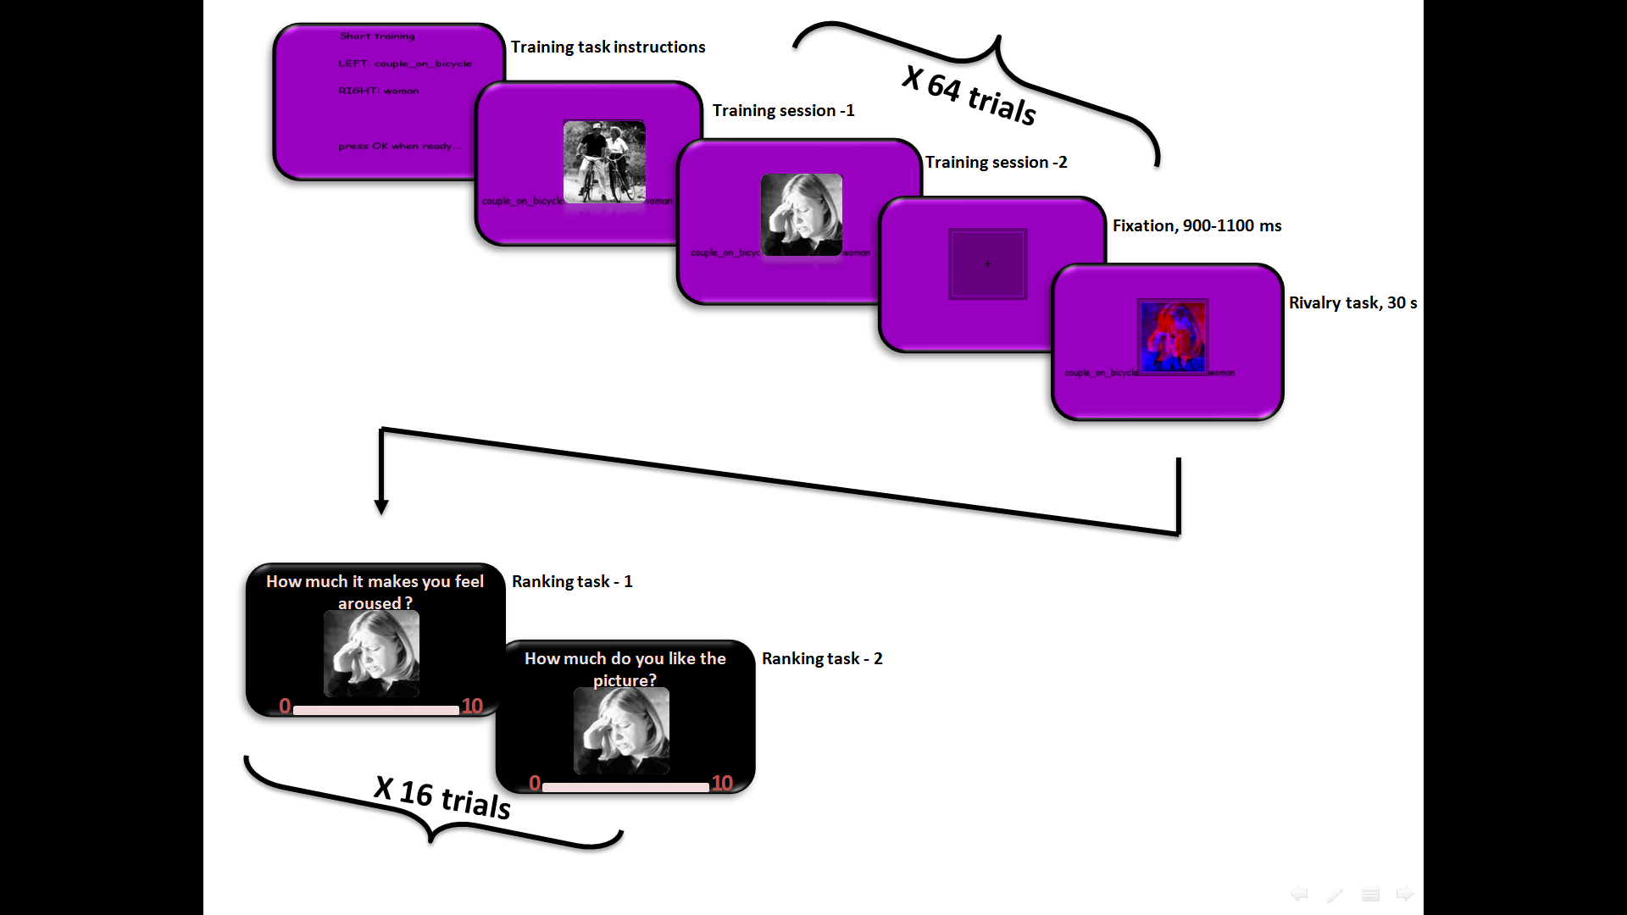

***Figure 1.*** Sequence of events in the main experiment and in the ranking tasks.

***Critical measures***

Independent variables:

stimulus valance (two categories - high and low valance; within subjects), stimulus arousal (two categories - high and low arousal; within subjects).

Dependent variables:

1. Predominance score - Arousal (PDS-A) - defined as the average of:

* The fraction of the HVHA stimulus percept duration out of the total duration in which any of HVHA or HVLA stimulus is perceived. And:
* The fraction of the LVHA stimulus percept duration out of the total duration in which any of LVHA or LVLA stimulus is perceived.

1. Predominance score - Valance (PDS-V) - defined as the average of:

* The fraction of the HVHA stimulus percept duration out of the total duration in which any of HVHA or LVHA stimulus is perceived. And:
* The fraction of the HVLA stimulus percept duration out of the total duration in which any of LVLA or HVLA stimulus is perceived.

1. Average dominance duration (ADD) – defined as the average duration of HVHA and LVHA percept ('ADD-A'), or: HVHA and HVLA percept ('ADD-V') among all relevant trials.
2. Percepts after fusion (PAF) - defined as the number of times the HVHA and LVHA ('PAF-A'), or: HVHA and HVLA percept ('PAF-V') follows a fusion percept out of the total number of times in which any stimulus follows a fusion percept, among all relevant trials.
3. The number of initial percepts (IP) - defined as the number of trials in which the HVHA and LVHA ('IP-A'), or: HVHA and HVLA percept ('IP-V') were the first percept, out of the total number of relevant trials in which any stimulus is perceived.

***Planned sample size***

Sixty-eight valid participants.

The data will be collected at Tel Aviv University, in the Mudrik lab experimental rooms, by Hilla Israeli. Participants will be TAU students, participating in the experiment for payment.

We will stop collecting data once reaching 68 valid participants. No other data analysis will be conducted prior to that.

***Exclusion criteria***

We will exclude from the analysis:

1. Participants who have less than 12 trials (75% of total trials) in every experimental condition, in the main experiment.
2. ~~Trials which contain pictures that in the subjective value and arousal ranking task were found to be at least two standard deviations above or below their average value, that are opposed to their expected direction. The average will be calculated using all participants' data.~~
3. ~~Trials which contain pictures that their average value in the subjective value and arousal ranking task was found to be higher than seven (when expected to be low), or lower than three (when expected to be high), on a scale from zero to ten.~~

*Update note (25.12.17)*

Before data collection was completed, we analyzed only the proportion of valid trials to assess the number of participants that are needed to complete the sample with a valid sample size of n = 68, as predetermined in the OSF preregistration. We performed changes to the exclusion criteria, before looking at the actual experimental results:

We add to the preregistration a clarification of two additional *technical* exclusion criteria for trials. We would exclude from analysis trials without valid experimental data due to either:

1. Trials in which the participant did not respond at all, and therefore did not report perceiving any one of the stimuli throughout the entire 30 seconds trial.
2. Trials in which the participant did not follow the instructions and responded by pressing both keys at the same time.

During the period between 3.9.17 – 24.12.17 we collected complete data from a total of 71 participants (6 were found at this point to have large proportion of invalid trials due to the technical issues).

When we tested the number of valid participants left after exclusion with the originally specified exclusion criteria, we found that over 50% of the sample do not fully meet the exclusion criteria (i.e. have less than 75% valid trials in all four experimental conditions), and should be excluded. We therefore decided to change the exclusion criteria before looking at the data. We decided to drop the exclusion criteria of trials and stimuli based on the subjective emotional rating (dropped criteria are marked with a strikethrough).

To account for the difference between the subjective perception of the stimuli and the manipulated category we would introduce additional regression analyses, in which we could model the subjective ratings as additional regressors (see section C - Analysis plan).

*End of update*

**C. Analysis plan**

**Confirmatory analyses**

Two-tailed permutation tests will be conducted to assess the significance of differences within subjects in each of the following variables: PDS, PAF, IP and ADD. For each subject, the data will be randomly shuffled between the results of both stimuli. We will repeat the randomization 1000 times, according to the null hypothesis that there is no difference between the stimuli.

As stated in the hypotheses, we expect to find a main effect for the valance variable, in each of the above-mentioned variables.

*Update note (25.12.17)*

Seeing that participants did not always perceive the affective stimuli as we intended them to (e.g. perceiving a low arousal stimulus as highly arousing or vice versa), we would include additional analyses which could take into account this deviance. In additional to the permutation tests, we would perform regression analyses (general linear model for continuous dependent variables, and logistic regression for dichotomous dependent variables), in which we could account for the subjective perception of valence and arousal by adding the subjective ratings as additional regressors in the model.

*End of update*