# Proxy voting skyrockets as Covid-19 rages

Labour’s Kier Starmer, along with the SNP’s Ian Blackford, has called for a return to remote voting in the wake of increasing travel restrictions across the country.

The SNP leader said: “With travel restrictions across the country and concerns for this new strain of Covid-19, it would be ludicrous for the Prime Minister not to allow remote electronic voting in the House of Commons.”

In light of the Tier 4 restrictions, the House of Commons did extend the options for remote participation offered to MPs. However, this did not include the option of remote voting which has been introduced successfully in the House of Lords.

Instead, MPs must participate in proxy voting where MPs that can’t attend Westminster entrust their vote to an MP who is able to attend the vote. The system was originally implemented to cover MPs on maternity leave but has been greatly expanded due to coronavirus.

This has led to certain MPs, often the party whips, being entrusted with an ever-rising number of votes. According to data analysed from the House of Commons, Stuart Andrew, the Conservative deputy whip, holds 269 votes and Patrick O’ Grady, the SNP whip, is responsible for the votes of 44 out of 47 his party’s MPs.

As the pandemic has escalated and restrictions on movement have been introduced across the country, the number of MPs who have requested proxy votes has increased rapidly. In particular, after a partial lockdown was announced on the 5th November, the number of MPs who applied for proxy votes shot up, especially among Conservative MPs, and continues to rise higher as further restrictions are introduced.

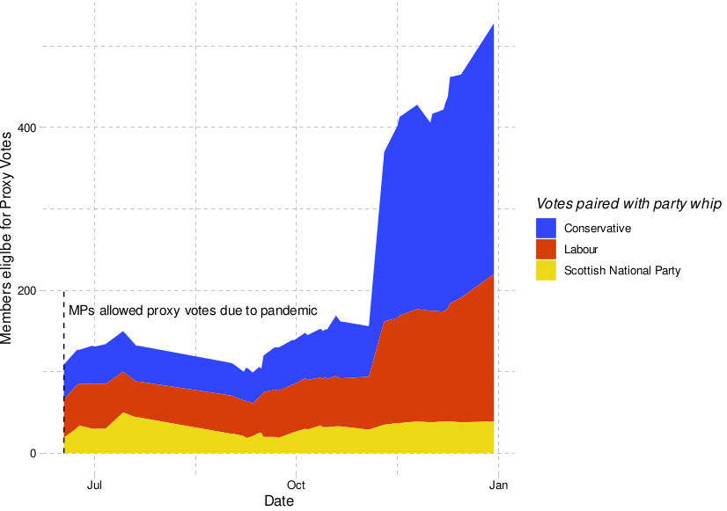

Some MPs have voiced their concern with the system which they say places too much power with party whips and still requires MPs to be present in the chamber to cast votes on behalf of those not present, creating unnecessary risk in the midst of a pandemic.

The Commons Procedure Committee recently called for remote voting to be extended to MPs. Karen Bradley MP, Chair of the Procedure Committee, said:

“The Government must think strategically, listen to reason, and heed MPs on all sides of the House. Virtual participation must be extended to those who need it, so the Government faces the full scrutiny of all Members of the House of Commons and not just those Members it wants to scrutinise it.”

**Word Count: 392**