# The Conservative sea-side towns on the brink

Exclusive analysis from The I shows that while Conservative “Red Wall” constituencies will be on balance more affected by the cut to Universal Credit, they are far from the only Conservative areas set to struggle under the cut to Universal Credit.

Among the worst affected Conservative areas are the constituencies of Great Yarmouth and Blackpool South. Blackpool South is a quintessentially “Red Wall” seat, held by Labour from 1997 until 2019 when the Conservatives took the seat and Labour saw its vote share fall by 12 per cent.

According to data from the Department of Work and Pensions, around a third of the constituency’s working-age residents are on Universal Credit, making it not only the most vulnerable Conservative constituency but the second-most vulnerable in the entire country.

Great Yarmouth, nestled between some of England’s wealthiest areas in the south-east of England, has consistently returned a Conservative MP since 2005. Around a quarter of its working-age population claims some form of Universal Credit.

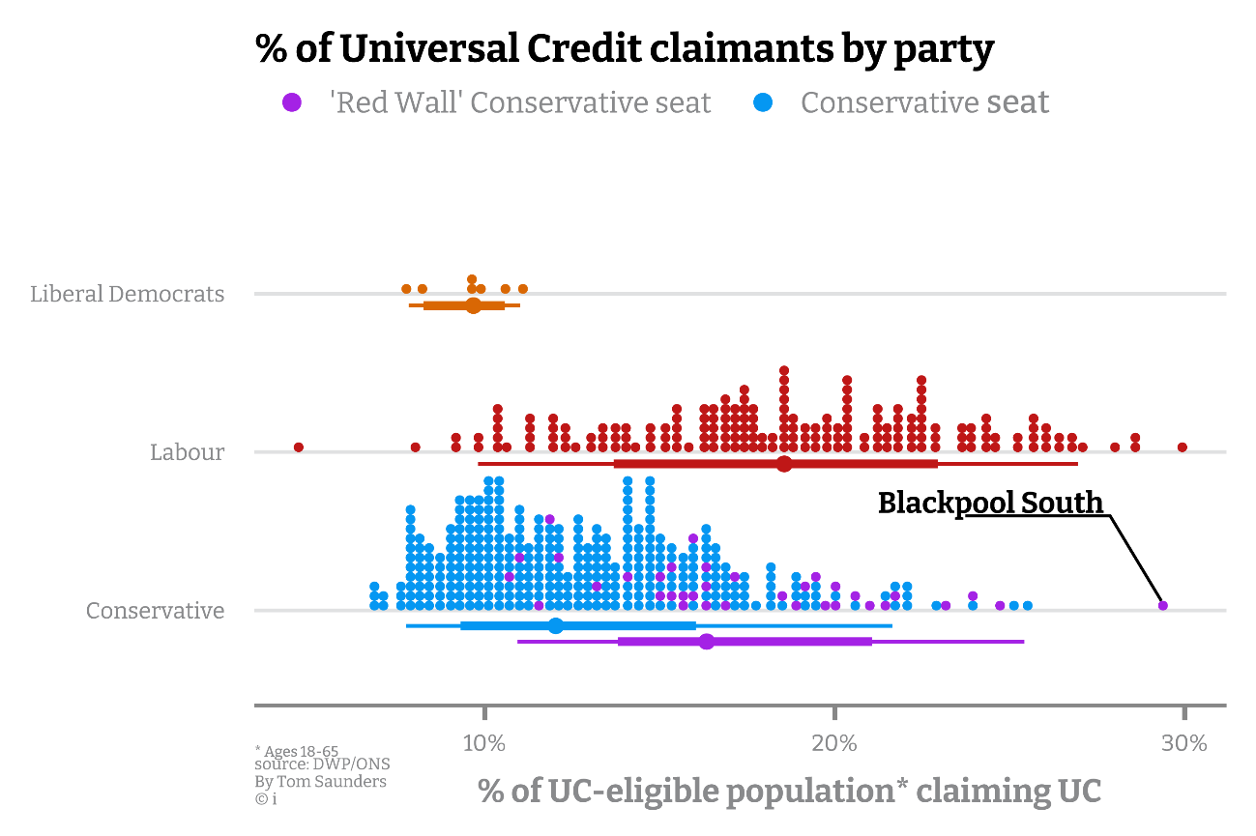

In Blackpool, community organisers expect this Christmas to be among the most difficult yet as their residents face rising costs of living and benefit cuts at the same time.

Chris Webb, a driver and fundraiser for Blackpool Food Bank, said: “We found that the majority of new people using the foodbank over the last 12 months are working people. A further cut of over £80 a month from their benefits, on top of utility bills going up and the insecure, seasonal work that covers most of Blackpool is a huge worry.”

The foodbank is expecting a busier Christmas than they’ve had before. They’re seeing the need increase week by week. They’ve had to move to bigger premises just to accommodate it.”

Dr John Clifton, a Captain at Salvation Army Blackpool South, said: “We are bracing ourselves. Since March, we’ve made over 3,000 interventions for people suffering from material poverty. That’s just in Blackpool. Given the scale of the issue at the moment, £20 a week off their income is staggering really.”

The cuts to universal credit may seem small, but for those who rely on it, it can account for around a 20 per cent fall in their income.

Those who claim UC are charged a marginal tax rate of 63 per cent on every pound they earn working which is taken out of their Universal Credit allowance This means to make up the cut, someone on Universal Credit would have to work around eight extra hours. In areas where jobs are seasonal and unstable, this can be particularly hard to find.

In Great Yarmouth, another seaside town on the other side of the country, the reality is rather similar.

Rev. Matthew Price, who operates a food bank from the St Mary Magdalene in Great Yarmouth, said: “I think £20 a week makes a significant difference, particularly when you combine that with food prices rising generally and the rising energy prices.

We always see higher demand for the food bank in the winter. With rising energy prices plus the reduction in UC, I think those two things coming together are going to have a significant impact on people living on Universal Credit.”

Experts on Universal Credit are also unconvinced that the temporary nature of the uplift has any real meaning to UC recipients in these areas.

Joe Norton, the project lead at Help to Claim, a UC advisory service run by Citizens Advice, said: “It was intended as a temporary uplift and that’s what it has always been called but after 18 months it has become something that families have got used to having. It does seem, particularly in areas like Yarmouth, that a lot of reasons that the uplift was brought in haven’t gone away.”

Dr John Clifton said: “On a very individual level it's really disheartening for families. I checked in with a family this morning, a single mother of three, who is in work but still receives UC and she said she just managed to get her budget to fit what’s there and now it’s like the goalposts are shifting again.”

Like many areas set to struggle under the cuts to Universal Credit, Great Yarmouth and Blackpool share some important characteristics. Namely, a short supply of stable, long-term employment that stretches back decades.

Earlier this month, the Labour party held a non-binding vote calling for the Government to cancel its planned cut to Universal Credit and Working Tax Credit. Just four Conservative MPs voted for the measure. The members for Great Yarmouth and Blackpool South both abstained from the vote.

The proposed cuts will severely affect the ‘Red Wall’ Conservative seats, as well as numerous poor Conservative seats in other areas of the country. Those that reply on UC in these areas, and the community organisations that support them, have little else to do but brace for an exceedingly harsh winter ahead.