Greenbelt borders most of England’s major cities, and accounts for more than ten per cent of all the land in England. In the Northwest of England, the green belt stretches unbroken from the North Sea to the very edges of Leeds and Sheffield.

Its supporters see the land as an essential resource that protects against urban sprawl and ensures that England retains green areas even as cities grow. Analysis by The I has shown that while this might hold for some of the green belt, it is not entirely true.

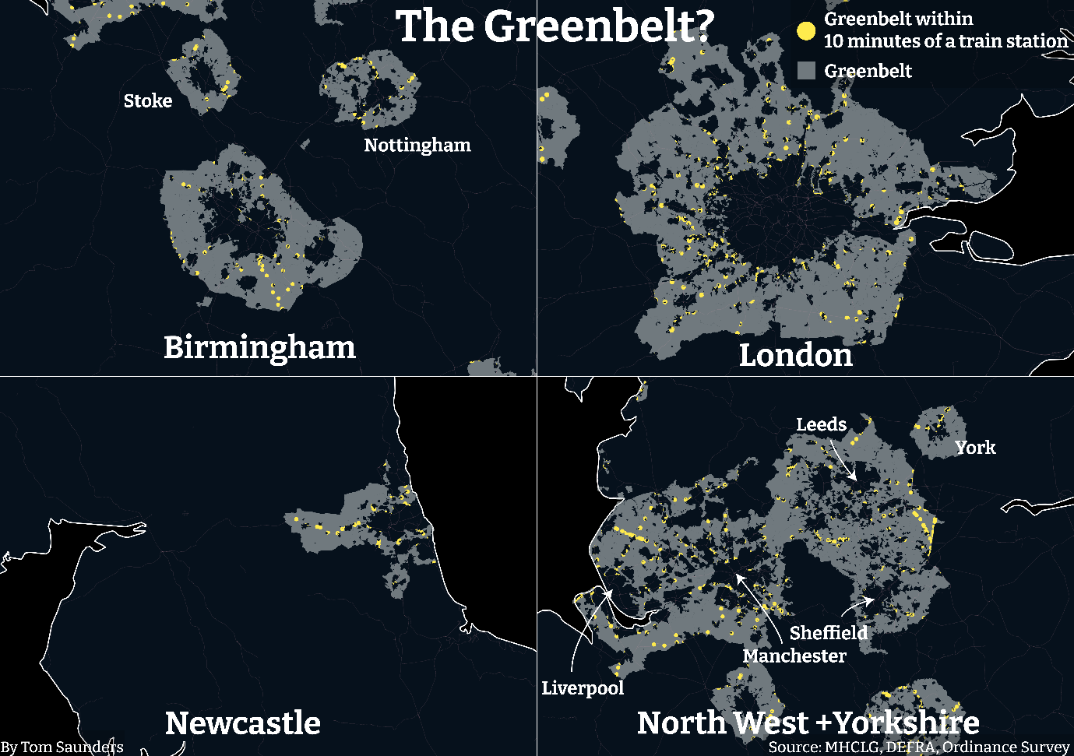

Within the greenbelt, there exists more than 650 km2 of land, or an area almost as big as Singapore, which is designated as green belt but is within a ten-minute walk of a train station.

Typically, land near public transport is an excellent place to build new homes, as it provides residents with cheap transport links into cities where houses are far less affordable. This is particularly important as the UK is experiencing an increasingly severe housing crisis.

In total, this land could potentially provide space over three million houses, well above the estimated 1.6-2.3 million house shortfall that already exists in England.

This land has no other special designation that might discourage building, such as containing ancient woodland or being of scientific interest, but its greenbelt designation means that it cannot be built on.

Much of this land is barely recognisable as greenbelt in the conventional sense. In 2018, greenbelt designation prevented a garage site near a few minutes’ walk from Tottenham Hale station being converted into affordable housing. The site had no greenery whatsoever in view, but its designation stopped the housing being built, badly needed in an area which is in the top 20 per cent for homelessness in the country.

/// Quote here from Paul

Some councils have a huge amount of land which is technically greenbelt but is within a stone’s throw of the nearest train station. Almost ten per cent of the land in Runnymede, in Surrey, fits this description, more than anywhere else in the country.

Runnymede councillors John Olorenshaw, Malcom Cressey and Carl Mann, all members of the Runnymede Independent Group, said: “We attach a great deal of importance to Green Belt. It is primarily there to prevent sprawl and coalescence, preserving the special characteristics of historic towns and villages and to promote urban regeneration.

That being said we do believe that there does exist exceptional circumstances that justify changes to the Green Belt boundaries thus allowing development.

As developable land is in short supply in Runnymede, the available land needs to be productive within reason, but also at a level of productivity that is acceptable to the local community.”

Many local councils which border major cities are running out of developable land which they can use to meet their nationally mandated housing targets. Building on the greenbelt is an option but is generally unpopular with local residents. However, as the housing crisis worsens it may one of the few options left.