Our Planes

I’m a wannabe pilot so I wanted to know all about the planes we flew (I’m sure I’m the only one…).

The little one:

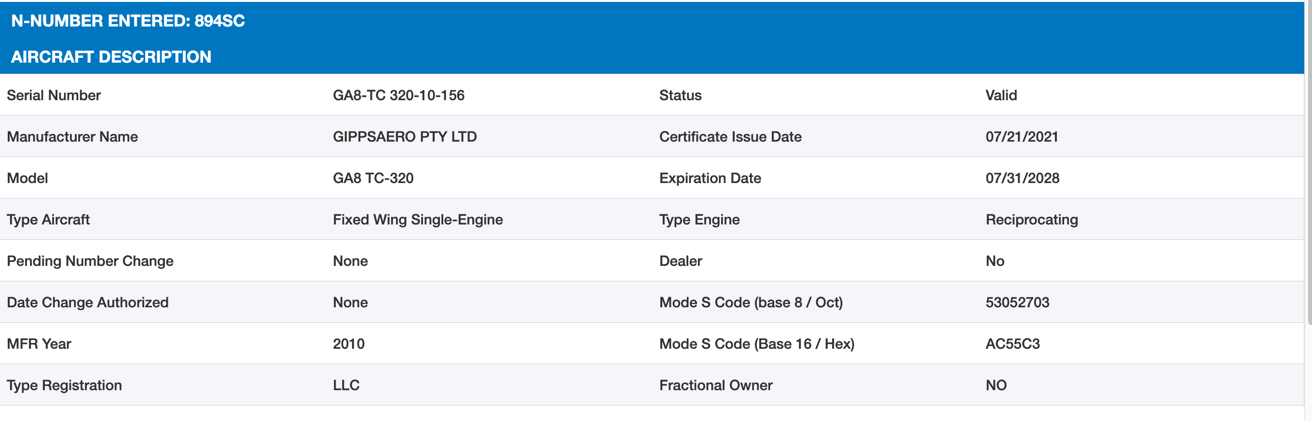

The big one:

