Database Architecture Documentation Shared Credit Card Reconciliation App

Purpose of this Document
This document defines the recommended database architecture for the Shared Credit Card Reconciliation App. It explains the data modelling principles, core tables, data flows, and refresh logic required to support supplementary cardholder attribution, payment reconciliation, and auditability. It also provides a final recommendation for the database technology to be used for the MVP.

Architectural Principles
The database architecture is designed around the following principles:
• Single source of truth for financial data
• Immutable raw data; interpretation layered on top
• Full auditability and traceability of user actions
• Support for ambiguous payments and bulk allocation
• Compatibility with CSV, PDF, and API-based ingestion
• Future-proofing for analytics and ML-assisted workflows

High-Level Data Model Overview
The data model is relational and accounting inspired. It separates bank-provided data from user-attributed meaning. All financial calculations are derived dynamically from base tables rather than stored directly.
Core entity groups:
• Accounts & Users
• Statements & Ingestions
• Transactions (Spend & Refunds)
• Payments
• Payment Allocations

Core Tables

Accounts
Stores a single credit card account (e.g. Amex UK account).
Fields:
• account_id (PK)
• provider (e.g. AMEX)
• provider_account_ref (masked or hashed)
• currency
• created_at

Users
Represents individuals linked to an account.
Fields:
• user_id (PK)
• account_id (FK)
• role (PRIMARY / SUPPLEMENTARY)
• display_name
• created_at

Statements
Statements represent immutable snapshots of account activity for a defined period.
Fields:
• statement_id (PK)
• account_id (FK)
• period_start
• period_end
• statement_date
• source_type (CSV / PDF / API)
• source_file_id
• hash
• created_at

Transactions
Stores all spend and refund transactions.
Fields:
• transaction_id (PK)
• account_id (FK)
• statement_id (FK)
• transaction_date
• posted_date
• description
• amount
• direction (DEBIT / CREDIT)
• raw_card_member_name
• attributed_user_id (nullable)
• attribution_source (SOURCE / USER / INFERRED)
• created_at

Payments
Payments are stored separately from transactions to allow explicit attribution.
Fields:
• payment_id (PK)
• account_id (FK)
• statement_id (FK)
• payment_date
• amount
• raw_description
• attributed_user_id
• attribution_status (AUTO / USER_CONFIRMED)
• created_at

Payment Allocations
Defines how payments are allocated across transactions.
Fields:
• allocation_id (PK)
• payment_id (FK)
• transaction_id (FK)
• allocated_amount
• created_at
This table enables bulk payments, partial repayments, and full auditability.

Database Entity Relationship Diagram

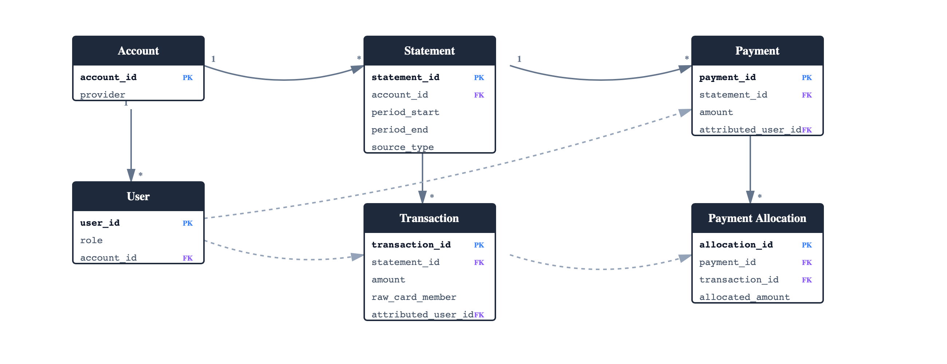

Statement Ingestion & Refresh Logging
Statement ingestion is treated as an event, not an update.
Ingestion tracking fields include:
• ingestion_id
• account_id
• statement_id
• source_type
• file_name
• file_hash
• status (SUCCESS / PARTIAL / FAILED)
• row_count
• created_at
This enables detection of missing periods, duplicate uploads, and data confidence scoring.

Data Refresh Strategy
Data refresh is user-driven:
• Users upload CSV or PDF statements periodically
• Each upload creates a new immutable statement
• Transactions and payments are appended
• KPIs are recalculated dynamically
Open Banking may be added later for convenience but is not relied upon for attribution

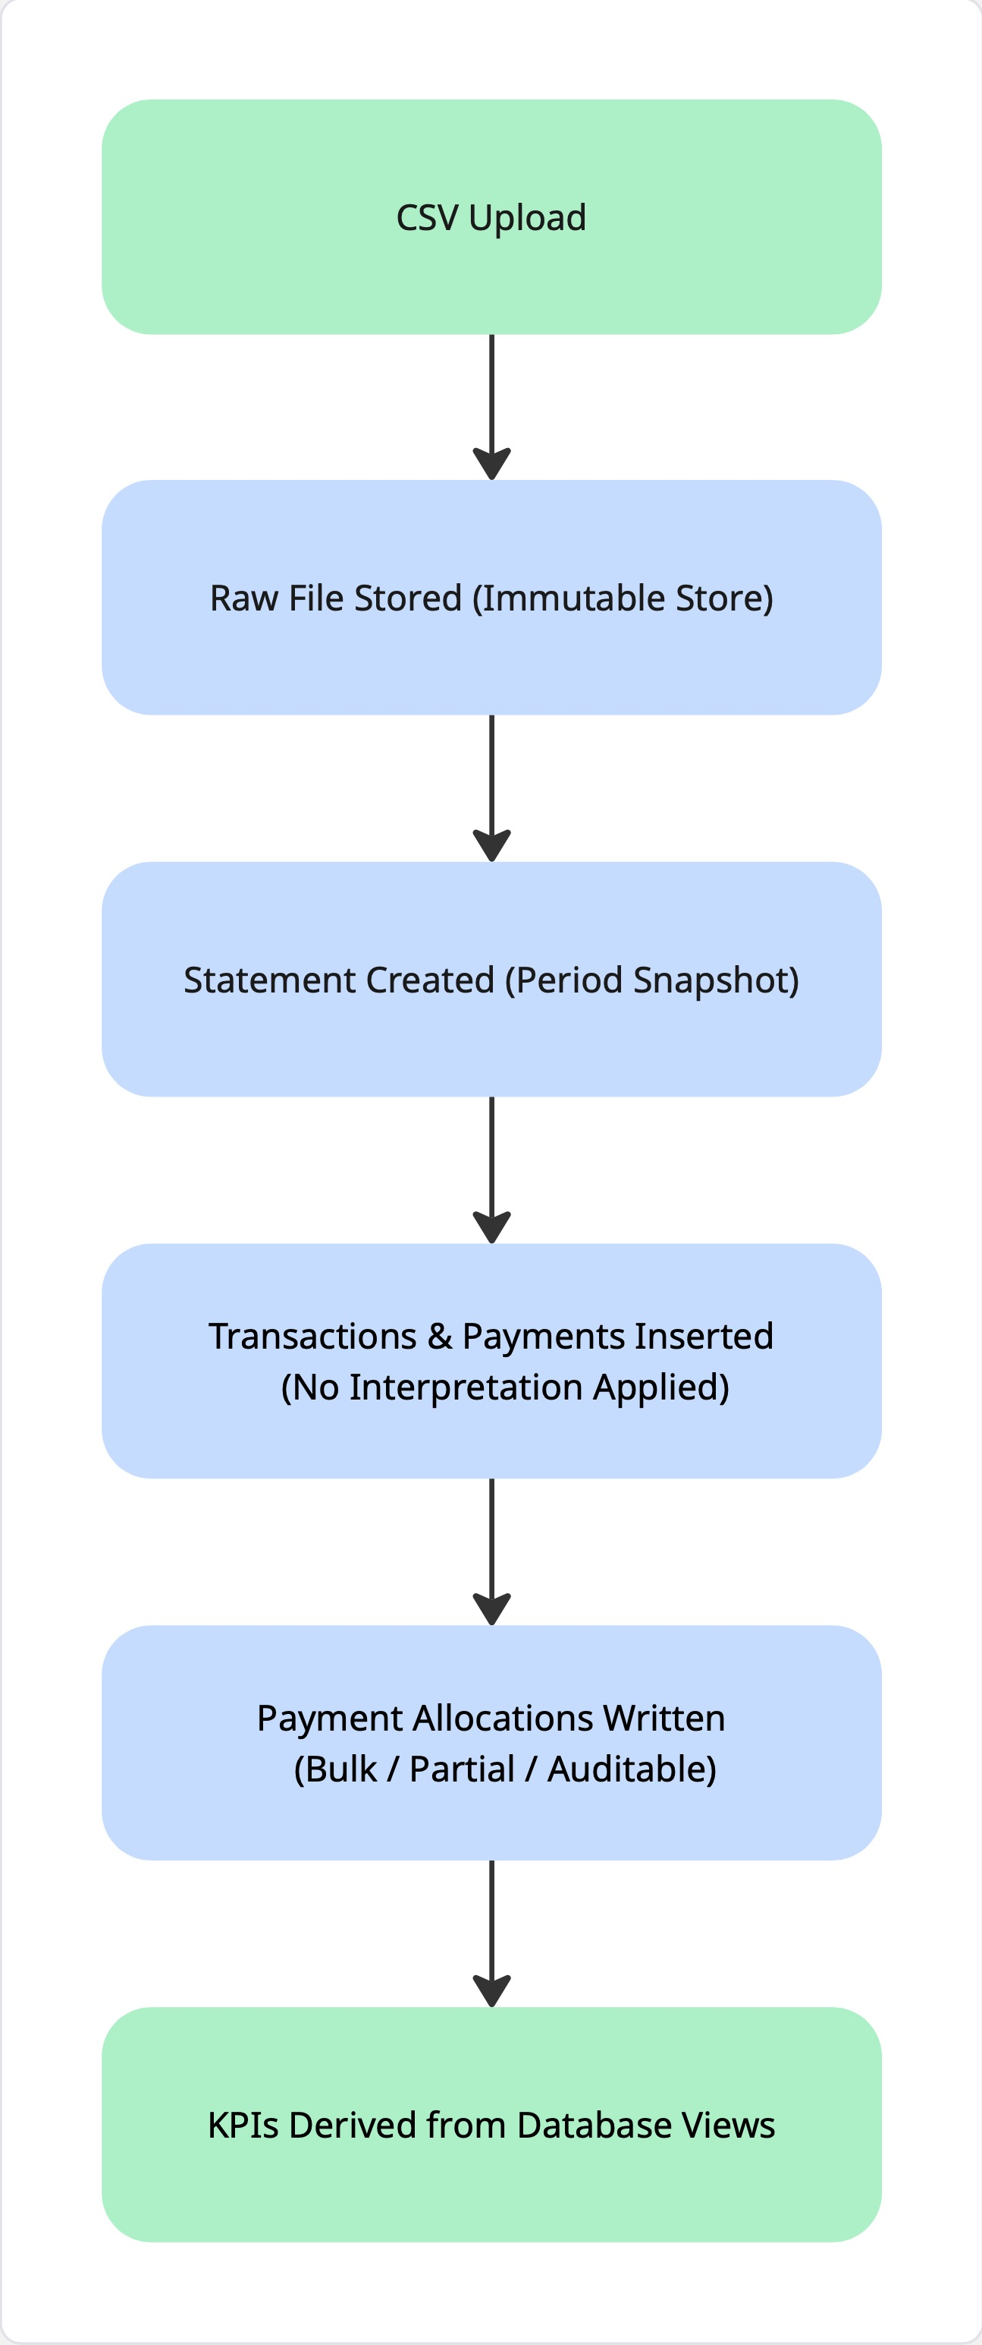
End-to-End Data Processing Flow
The diagram illustrates the complete lifecycle of how customer credit card data is ingested, processed, and transformed into accurate balances and KPIs within the application. Each stage is deliberately separated to ensure accuracy, auditability, and flexibility when handling shared credit card usage.

CSV Upload
The process begins when the user downloads a transaction activity CSV directly from their card provider (for example, American Express) and uploads it to the application.
This approach ensures:
- The user remains in control of their banking credentials
- The data originates directly from the provider
- Supplementary cardholder information (when available) is preserved
The CSV upload represents an explicit user-initiated refresh of account data.

Raw File Stored (Immutable Store)
Once uploaded, the raw CSV file is stored in an immutable file store. A unique file hash is generated to identify duplicates and prevent accidental reprocessing of the same data.
Key characteristics of this step:
- The original source file is never modified or overwritten
- The file can be reprocessed if parsing logic changes
- A permanent audit trail is maintained for compliance and debugging
This layer represents the system’s source-of-truth artifact.

Statement Created (Period Snapshot)
From the uploaded file, the system creates a statement record. A statement represents a snapshot of account activity over a defined date range (e.g. a billing period or activity window).
Statements are:
- Append-only
- Immutable once created
- Used to group transactions and payments logically
This abstraction allows the system to reason in terms of time-bound snapshots rather than an ever-changing transaction feed.

Transactions & Payments Inserted (No Interpretation Applied)
All transactions and payments contained within the statement are parsed and inserted into the database exactly as provided by the card issuer.
At this stage:
- No assumptions are made about who owes what
- No payments are matched to transactions
- All provider-supplied fields (including card member identifiers) are preserved as raw data
This ensures that the system faithfully reflects bank-reported reality, without introducing premature interpretation.

Payment Allocations Written (Bulk / Partial / Auditable)
Payments are inherently ambiguous in shared card setups. To resolve this, the application introduces an explicit payment allocation step.
Users can:
- Confirm whether a payment was made by the primary cardholder or on behalf of a supplementary cardholder
- Allocate a single payment across multiple transactions
- Partially allocate payments where appropriate
Each allocation is stored as its own database record, creating a clear, auditable link between payments and the transactions they settle. No original transaction or payment data is ever altered.
This step is where user-confirmed financial meaning is applied.

KPIs Derived from Database Views
Key metrics such as:
- Total supplementary spend
- Total repayments
- Outstanding balances
are not stored directly in the database. Instead, they are derived dynamically using database views that combine transactions, payments, and allocations.
This ensures:
- KPIs always reflect the latest confirmed data
- Corrections automatically flow through the system
- No risk of stale or inconsistent balances

KPI & Balance Computation
No KPIs or balances are stored directly. All values are derived using database views.
Example:
Outstanding balance (supplementary) = Total supplementary spend − Allocated supplementary payments

Recommended Database Technology (MVP)
PostgreSQL is the recommended primary database for the MVP.
Justification:
• Strong ACID guarantees for financial data
• Native support for relational integrity and constraints
• Excellent support for transactional workflows
• Compatible with all backend frameworks
• Ideal for analytics and future ML workloads
PostgreSQL should be accessed via a backend API layer. Mobile apps (iOS/Android) should never connect directly to the database.
SQLite may optionally be used on-device as a temporary cache or staging layer, but never as the system of record.

Conclusion
This database architecture supports the core goals of the application: fairness, clarity, and trust. By separating immutable source data from user interpretation and allocation, the system remains robust, explainable, and extensible as new data sources and intelligence layers are added.

