**Question1.**

**(i).**

(a). $p∧(q∨r)[⊨/⊢](p∧q)∨(p∧r)$

|  |  |  |  |  |
| --- | --- | --- | --- | --- |
| $$p$$ | $$q$$ | $$r$$ | $$p∧(q∨r)$$ | $$(p∧q)∨(p∧r)$$ |
| T | T | T | T | T |
| T | T | F | T | T |
| T | F | T | F | F |
| T | F | F | F | F |
| F | T | T | T | T |
| F | T | F | F | F |
| F | F | T | F | F |
| F | F | F | F | F |

Table a

Therefore, from Table a, it could be proved that $p∧(q∨r)⊨(p∧q)∨(p∧r)$.

(b). $[⊨/⊢]p→(q→p)$

|  |  |  |
| --- | --- | --- |
| $$p$$ | $$q$$ | $$p→(q→p)$$ |
| T | T | T |
| T | F | T |
| F | T | T |
| F | F | T |

Table b

Therefore, from Table b, it could be proved that $⊨p→(q→p)$.

(c). $¬p→¬q[⊨/⊢]p→q$

|  |  |  |  |
| --- | --- | --- | --- |
| $$p$$ | $$q$$ | $$¬p→¬q$$ | $$p→q$$ |
| T | T | T | T |
| T | F | T | F |
| F | T | F | T |
| F | F | T | T |

Table c

Therefore, from Table c, it could be proved that $¬p→¬q⊭p→q$. Since $¬p→¬q$ is True but $p→q$ is False in second row.

(d). $¬p→¬q, ¬q→¬p[⊨/⊢]p↔q$

|  |  |  |  |
| --- | --- | --- | --- |
| $$p$$ | $$q$$ | $$¬p→¬q,¬q→¬p$$ | $$p↔q$$ |
| T | T | T | T |
| T | F | F | F |
| F | T | F | F |
| F | F | T | T |

Table d

Therefore, from Table c, it could be proved that $¬p→¬q, ¬q→¬p⊨p↔q$.

(e). $p→q, q→r[⊨/⊢]¬r→¬q$

|  |  |  |  |  |
| --- | --- | --- | --- | --- |
| $$p$$ | $$q$$ | $$r$$ | $$p→q,q→r$$ | $$¬r→¬q$$ |
| T | T | T | T | T |
| T | T | F | F | F |
| T | F | T | F | T |
| T | F | F | F | T |
| F | T | T | T | T |
| F | T | F | F | F |
| F | F | T | T | T |
| F | F | F | T | T |

Table e

Therefore, from Table c, it could be proved that $p→q, q→r⊨¬r→¬q$.

**(ii).**

(a). $p∧(q∨r)[⊨/⊢](p∧q)∨(p∧r)$

$CNF[¬(\left(p∧q\right)∨\left(p∧r\right))]≡(¬p∨¬q)∧(¬p∨¬r)$

1. $p$ [Premise]
2. $q∨r$ [Premise]
3. $¬p∨¬q$ [$¬$ Conclusion]
4. $¬p∨¬r$ [$¬$ Conclusion]
5. $¬q$ [1, 3. Resolution]
6. $r$ [2, 5. Resolution]
7. $¬p$ [4, 6. Resolution]
8. □ [7,1. Resolution]

Therefore, it could be proved that $p∧(q∨r)⊢(p∧q)∨(p∧r)$.

(b). $[⊨/⊢]p→(q→p)$

$CNF\left[¬\left(p→\left(q→p\right)\right)\right]≡p∧q∧¬p$

1. $p$ [$¬$ Conclusion]
2. $q$ [$¬$ Conclusion]
3. $¬p$ [$¬$ Conclusion]
4. □ [1,3. Resolution]

Therefore, it could be proved that $⊢p→(q→p)$.

(c). $¬p→¬q[⊨/⊢]p→q$

$CNF\left[\left( ¬p→¬q\right)\right]≡(p∨¬q)$

$CNF\left[¬\left( p→q\right)\right]≡p∧¬q$

1. $p∨¬q$ [Premise]
2. $p$ [$¬$ Conclusion]
3. $¬q$ [$¬$ Conclusion]

cannot obtain empty clause using resolution so $¬p→¬q⊬p→q$.

(d). $¬p→¬q, ¬q→¬p[⊨/⊢]p↔q$

$CNF\left[\left( ¬p→¬q\right)\right]≡(p∨¬q)$

$CNF\left[\left( ¬q→¬p\right)\right]≡(q∨¬p)$

$CNF\left[¬\left( p↔q\right)\right]≡(p∨q)∧(¬p∨¬q)$

1. $p∨¬q$ [Premise]
2. $(q∨¬p)$ [Premise]
3. $(p∨q)$ [$¬$ Conclusion]
4. $(¬p∨¬q)$ [$¬$ Conclusion]
5. $p$ [1,3. Resolution]
6. $¬q$ [4,5. Resolution]
7. $¬p$ [2,6. Resolution]
8. □ [5,7. Resolution]

Therefore, it could be proved that $¬p→¬q, ¬q→¬p⊢p↔q$

(e). $p→q, q→r[⊨/⊢]¬r→¬q$

$CNF\left[\left( p→q\right)\right]≡(¬p∨q)$

$CNF\left[\left( q→r\right)\right]≡(¬q∨r)$

$CNF\left[¬\left( ¬r→¬q\right)\right]≡¬r∧q$

$1.¬p∨q$ [Premise]

$2.¬q∨r$ [Premise]

$3.¬r$ [$¬$ Conclusion]

1. $q$ [$¬$ Conclusion]
2. $¬q$ [2,3. Resolution]
3. □ [5,4. Resolution]

Therefore, it could be proved that $p→q, q→r⊢¬r→¬q$.

**Question2.**

**(a).**

“I never stole the jam!” pleaded the March Hare.

$¬Lying\left(marchHare\right)↔¬Stole(marchHare,jam)$

“One of us stole it, but it wasn’t me!” pleaded the madHatter.

$¬Lying\left(madHatter\right)↔(Stole\left(marchHare,jam\right)↔¬Stole\left( doormouse,jam\right))$

“At least one of them did,” replied the Doormouse.

$¬Lying\left(doormouse\right)↔(¬Lying\left(marchHare\right) ∨ ¬Lying\left(madHatter\right))$

The March Hare and the Doormouse were not both speaking the truth.

$\left(Lying\left(doormouse\right)∨Lying\left(marchHare\right)\right)$

**(b).**

$S=\{ ¬Lying\left(marchHare\right)↔¬Stole\left(marchHare,jam\right),$

$¬Lying\left(madHatter\right)↔\left(Stole\left(marchHare,jam\right)↔¬Stole\left( doormouse,jam\right)\right),$

$¬Lying\left(doormouse\right)↔\left(¬Lying\left(marchHare\right) ∨ ¬Lying\left(madHatter\right)\right),$

$Lying\left(doormouse\right)∨Lying\left(marchHare\right)\}$

Question: $α=∃x Stole\left(x,jam\right)$?

Proof:

Let I be any interpretation such that $I⊨S$

Case 1: $I⊨¬Lying\left(doormouse\right)∧Lying\left(marchHare\right)$.

$∴I⊨Lying\left(marchHare\right)↔Stole\left(marchHare,jam\right)$

$∴I⊨¬Lying\left(doormouse\right)↔\left(¬Lying\left(marchHare\right) ∨ ¬Lying\left(madHatter\right)\right)$

$∴I⊨¬Lying\left(doormouse\right)∧Lying\left(marchHare\right)→¬Lying\left(madHatter\right)$

$∴I⊨Stole\left(marchHare,jam\right)$

$∴I⊨α$

Case 2: $I⊨Lying\left(doormouse\right)∧¬Lying\left(marchHare\right)$.

$∴I⊨Lying\left(doormouse\right)↔\left(Lying\left(marchHare\right) ∧ Lying\left(madHatter\right)\right)$

This is contradictory for the interpretation of Case2 so $I⊭α$.

Case 3: $I⊨Lying\left(doormouse\right)∧Lying\left(marchHare\right)$.

$∴I⊨Lying\left(doormouse\right)↔\left(Lying\left(marchHare\right) ∧ Lying\left(madHatter\right)\right)$

$∴I⊨Lying\left(madHatter\right)↔¬\left(Stole\left(marchHare,jam\right)↔¬Stole\left( doormouse,jam\right)\right)$

$∴I⊨Lying\left(marchHare\right)↔Stole\left(marchHare,jam\right)$

$∴I⊨Stole\left(marchHare,jam\right)$

$∴I⊨α$

However, we do not know whether madHatter stole the jam since madHatter may lie due to two reasons. One reason is that more than one person stole the jam. This means it is possible that marchHare, madHatter and doormouse together stole the jam or both marchHare and doormouse stole the jam or marchHare and madHatter stole the jam. Another reason is that only madHatter stole the jam, but it is contradictory for the interpretation so we could exclude it.

Therefore, it is concluded that March Hare stole the jam according to case1 and case3.

**(c).**

In the above interpretations, from case1 and case3, we could judge that madHatter definitely stole the jam, but we do not know whether other two people participate in. Therefore, in order to precisely identify who stole the jam, we assume only one person stole the jam which is $∃!x Stole(x,jam)$.

**(d).**

Assume $S⊢Stole(marchHare,jam)$.

$1. Lying\left(marchHare\right)∨¬Stole(marchHare,jam)$ [Premise]

$2.¬ Lying\left(marchHare\right)∨Stole(marchHare,jam)$ [Premise]

$3.Lying\left(madHatter\right)∨Stole(marchHare,jam)∨Stole(doormouse,jam)$ [Premise]

$4.Lying\left(madHatter\right)∨¬Stole(marchHare,jam)∨¬Stole(doormouse,jam)$ [Premise]

$5.¬Lying\left(madHatter\right)∨¬Stole(marchHare,jam)∨Stole(doormouse,jam)$ [Premise]

$6.¬Lying\left(madHatter\right)∨Stole(marchHare,jam)∨¬Stole(doormouse,jam)$ [Premise]

$7.Lying\left(doormouse\right)∨¬ Lying\left(marchHare\right)∨¬Lying\left(madHatter\right)$ [Premise]

$8.Lying\left(marchHare\right)∨¬Lying\left(doormouse\right)$ [Premise]

1. $Lying\left(madHatter\right)∨¬Lying\left(doormouse\right)$ [Premise]
2. $∃!x Stole(x,jam)$ [Premise]

$11.Lying\left(marchHare\right)∨Lying\left(doormouse\right)$ [Premise]

$12.¬Stole(marchHare,jam)$ [$¬$ Conclusion]

$13.¬ Lying\left(marchHare\right)$ [2,12. Resolution]

$14.$ $Lying\left(doormouse\right)$ [10,13. Resolution]

$15.$ $Lying\left(marchHare\right)$ [8,14. Resolution]

□ [13,15. Resolution]

Therefore, it could be proved thatMarch Hare stole the jam.

When I assume $S⊢Stole(madHatter,jam)$ and $S⊢Stole(doormouse,jam)$, I found it is not possible to obtain empty clause using resolution, hence, It could be believed that madHatter and Doormouse did not steal jam.

In conclusion, March Hare stole the jam.

**Question3**

It is known that 3-SAT exhibits an easy-hard-easy computational pattern. Determining the satisfiability of sets of clauses is simple because there are fewer constraints in assigning truth values to the propositional variables. However, whether or not 4-SAT also exhibits an easy-hard-easy computational pattern, and if exists, what is the value of C which makes these satisfiability problems become difficult. This report shows that 4-SAT also exists an easy-hard-easy computational pattern and the value of C making 4-SAT hard to solve is around 10 by making three empirical experiments.

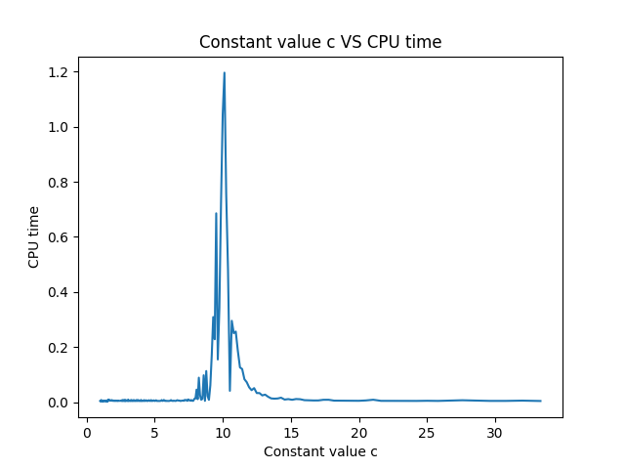

Figure1

In these empirical experiments, I assume the value of C*n clauses is a constant where I assume it is 800, 1000,1050 in three tests respectively. Then I could obtain different values for C by changing the value of variable n. For example, in the second experiment, I assume the clauses are 800 and variable n is number from 10 to 800, and so value of C is equal to clauses divided by n. For different n, I use python to generate a .cnf file which includes 800 rows clauses where each clause only contains 4 number and an end

number 0, and each number generated randomly in each row is not zero except the end number and the absolute value of each number is different. Next, I utilize these .cnf files obtained to generate the CPU time consumed by minisat. Finally, I could gain Figure1



Table f

and Table f by collecting different C values and their counterpart CPU time (The code is in assn1-q3-files). It is obvious that when C is around 10, the CPU time consumed reaches the peak from Figure1. Also, when the number of clauses is 1000 and 1050, their results are also similar to Figure1. Therefore, there is a constant value C for number of propositional variables n at which C*n clauses constitutes a hard satisfiability problem in 4 SAT.

In conclusion, an easy-hard-easy pattern exists in 4 SAT and the corresponding C value is around 10.

**Question4**

Probabilistic reasoning

**(a).** briefly describe how the method represents knowledge and include an example;

This method employs the form of Bayesian networks to represent knowledge. Bayesian networks is a directed graph where each node is assigned quantitative information. In this way, 1. each node represents a random variable. 2.A set of directed links or arrows connects pairs of nodes and if an arrow from node X to node Y, it is believed that X is the parent of Y. In other words, X is regarded as the direct reason of Y. 3. Each node has a conditional probability distribution $P(X_{i}|Parents(X_{i}))$ that quantifies the impact of the parent nodes on itself.

There is a classical example to explain how to establish a Bayesian network. Assume there is a burglar alarm installed at home. It is reliable, but also may be activated due to minor earthquake. John and Mary who are your neighbours promise you they would call you if they hear alarm. John always calls when he hears alarm but sometimes confuses the telephone rings with alarm and then calls you. Mary often misses the alarm because she is fond of loud music. Given the evidence of who has or has not called, we would like to estimate the probability of a burglary. The network is shown in Figure 2.

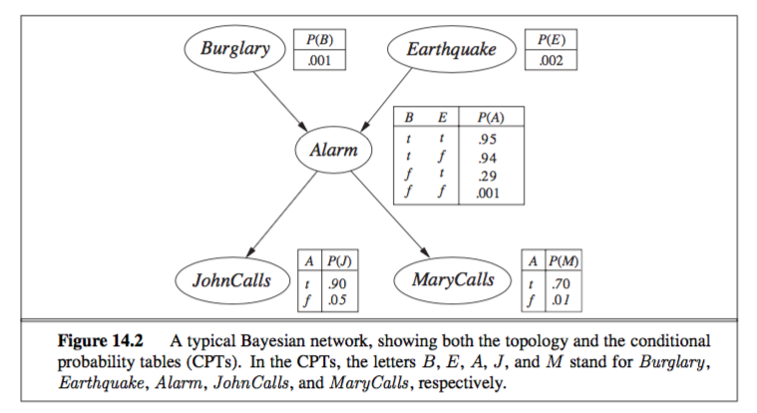

Figure2

From figure2, it is clear that Alarm only corresponds to the burglary and the earthquake, and Johncalls and Marycalls only rely on whether alarm. Moreover, probability also consider the laziness and uncertainty and if more information is introduced, the approximation would be increased further. Therefore, the method is complete.

**(b).** briefly describe the inference procedure(s) adopted by the method for reasoning;

In the probabilistic inference system, the main aim is to obtain the posterior distribution for a set of query variable such as $p(X|e)$ where e is an or several evidence variables. For example, in burglar Bayesian network, if we observed Johncall and Marycall are both True, we could predict the probability of burglary. In fact, there are a couple of algorithms to obtain the probability including inference by enumeration, the variable elimination algorithm, clustering algorithms, and Monte Carlo algorithms. In this report, the Inference by enumeration algorithm would be introduced . Let Burglary=b, Johncalls=J, Marycalls=M, Alarm = A, Earthquake = e. So, $P\left(b | j,m\right)=\frac{P(b,j,m)}{P(j,m)}=α*P\left(b,j,m\right)=α\sum_{e}{\sum_{a}{P\left(b,j,m,e,a\right)}}=α\sum_{e}{\sum_{a}{P\left(b\right)P(e)P(a|b,e)P(j|a)P(m|a)}}$. Because P(b) is constant, the formula could become $P\left(b | j,m\right)=αP(b)\sum_{e}{P(e)\sum_{a}{P\left(a | b,e\right)P\left(j | a\right)P\left(m | a\right)≈0.284}}$. Figure 14.8 shows the procedure of this algorithm. However, the time complexity of this algorithm is comparatively high which is $O(n2^{n})$.

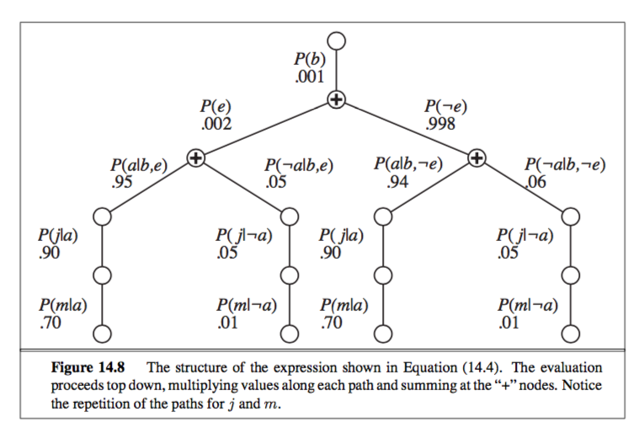

**(c).** identify some importance issues in using the method

In conclusion, Bayesian networks(BNs) is a method employing probability theory to worlds with objects and relations. The probabilistic representation of the interactions between objects is relative important for knowledge representation and it also involves the estimation of risks and uncertainties. Also, the probabilistic representation of knowledge also avoid overconfidence, which is an important improvement to deterministic models. However, BNs is computationally intractable in the worst case such as the time complexity of inference by enumeration is $O(n2^{n})$. Furthermore, several complicating scoring functions require reliable priors in order to gain a model closer to the actual model, nevertheless, it is still difficult for researchers.