**ISoP Technology Committee Charter\***

# Purpose and Goals

# Purpose: The international Society of Pharmacometrics Technology Committee supports the goals of the ISoP 5 year strategic plan through identification, highlight and support of the Pharmacometrics discipline specific tools, methodology, infrastructure, environments and technology training that enable the delivery of model informed drug discovery and development and quantitative systems pharmacology

# Goals:

* 1. Improve **Membership Engagement** and ensure Diversity Equity & Inclusion (DEI) within membership outreach
  2. Develop and publish Technology Environment/Infrastructure Best Practices Paper
  3. Finalize the previous ISoP Tools Survey; communicate results and actions resulting
  4. Refresh the ISoP Tools Survey on a regular periodic basis to ensure consistent understanding of member interests, needs and opportunities
  5. Develop and maintain a technology exchange resource for information about open source and commercial software tools for Pharmacometrics
     + Provide information hub for PMx resources and tools
       1. Prepare website/wiki with software compendium
       2. Catalog available tools
       3. SWOT - strengths, weaknesses, capabilities etc. for individual tools
       4. Include vignettes/descriptions solicited from tool creators or, optionally, subject matter experts
     + Option to provide Tool Application Notes
       1. code examples for specific use cases
     + Promote/Enable broad accessibility to tools & compute resources
       1. how to use NONMEM from central africa for example
     + pointers (cross-links) to educational material are available - (through Educational Committee? or generally?)
       1. for example, youtube tutorials
     + links to relevant mailing lists NMUsers, etc.
  6. Enable ISoP Discuss (or other venue) Platform/Channels to flourish/expand utilization
     + exchange of information for methodology/tools development
     + capabilities: archive/search/repurpose (and more) in choice of platform
  7. Platform for exchange of information for technology environment & process & infrastructure development/implementation
  8. Platform for opensource software/environments support
     + collaborate with a variety technology enabling organizations such as POSSC/Linux Foundation/R Foundation
     + Support for development of tools for new methodology
     + could be longer term goal and requires structure/method to pursue through ISoP 501(3c) framework

1. **Roles and Responsibilities**
2. **Committee Chair** [**(Link)**](https://drive.google.com/drive/folders/1NINansJX5D3NyO9OFOreBLnFPw1qBZQ4?usp=sharing)
   * Brief description of the Chair’s role. This may be specific to each committee; please list here only deviations from the Roles & Responsibilities document.
   * Chair/co-Chairs of committee are appointed and have responsibilities as per the Roles & Responsibilities document
3. **Committee Chair-Elect** [**(Link)**](https://drive.google.com/drive/folders/1NINansJX5D3NyO9OFOreBLnFPw1qBZQ4?usp=sharing)
   * Brief description of the Chair-Elect’s role. This may be specific to each committee; please list here only deviations from the Roles & Responsibilities document.
   * Committee Chair-Elect is/are appointed and have responsibilities as per the Roles & Responsibilities document
4. **Committee Members** [**(Link)**](https://drive.google.com/drive/folders/1NINansJX5D3NyO9OFOreBLnFPw1qBZQ4?usp=sharing)
   * Brief description of the committee members role. This may be specific to each committee; please list here only deviations from the Roles & Responsibilities document.
   * Committee members are appointed and have responsibilities as per the Roles & Responsibilities document
5. **Board Liaison** [**(Link)**](https://drive.google.com/drive/folders/1NINansJX5D3NyO9OFOreBLnFPw1qBZQ4?usp=sharing)
   * Board Liaison is appointed and have responsibilities as per the Roles & Responsibilities document
6. **Structure**
   * Please provide a brief description of the Committee structure (i.e working groups, sub-committees, leadership for each, members for each, terms for members … etc).
   * Graphical representations are desired
   * Committee currently exists with Co-Chairs. Membership recruitment and expansion is anticipated with the new committee structure and project plan and goals as described within.

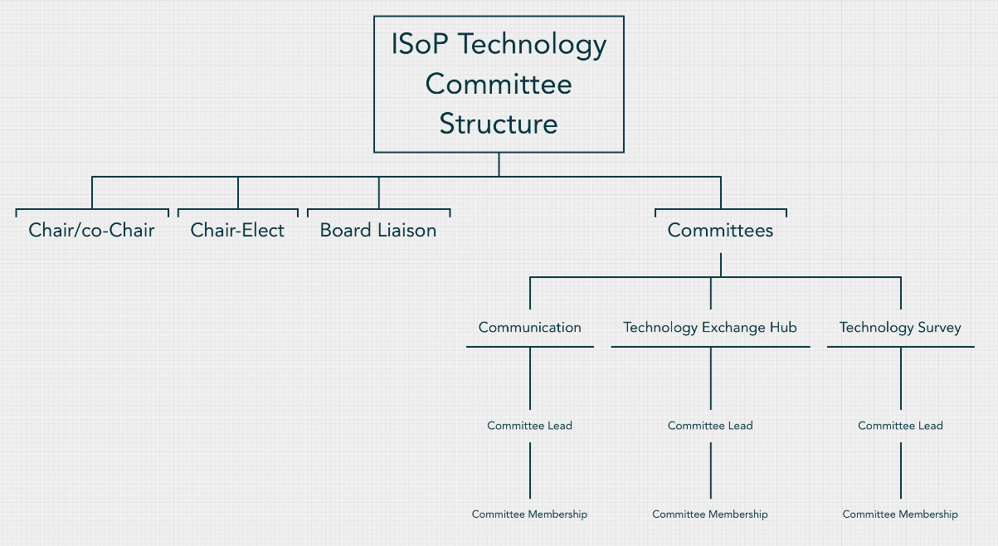

1. **High Level Project Plan**

|  |  |  |
| --- | --- | --- |
| **Steps / Milestones** | **Timeline** | |
| Month | Year |
| Member development & Inclusion Strategy | September | 2022 |
| Technology Paper | October | 2022 |
| 2020 Survey Results Summary | September | 2022 |
| 2022 Survey Refresh | announce with 2020 survey communication | 2022 |
| Technology Communications Hub Platform Choice | November-December | 2022 |
| Tools & Resources Hub /Communications Platform (resourcing budget) | January | 2023 |

Note: Please add as many rows as needed.

1. **Key Stakeholders and Dependencies**
   1. **DE&I Committee** for membership considerations
   2. **Education Committee** for interaction for tools/education
   3. **Communication Committee** for coordination of Technology Hub platform
   4. Technology support for “Communication and Technology Hub” platform
   5. Within Communications Hub, integration with or deviation from existing ISoP infrastructure (Wordpress Discuss channels for example) to maximize communications.
2. **Resources requested For This Year:** In this section the committee may request an approximate annual budget needed for some of its activities during the year. A budget justification must be provided.
   * None in 2022
   * Support and Budget Request for Technology Tools & Resources / Communication Hub in 2023 is anticipated
3. **Inventory of official Committee communication channels:** In this section the committee lists all document repositories and communications channels that have been used to communicate with their Committee members or ISoP membership. This includes but not limited to: ISoP Google Drive, non-ISoP document repository (e.g., DropBox, Google Drive, etc.), github, official ISoP email addresses, unofficial email addresses (e.g., gmail), Linked In account, YouTube Channel, websites, …etc.
   1. Github instance: <https://github.com/tomtensfeldt-isop/ISoP_Technology_Committee>
   2. Github instance: <https://github.com/tomtensfeldt-isop/isop_technology_white_paper>
   3. Github instance: <https://github.com/tomtensfeldt-isop/survey2020>
4. **Submitted by:**

**[William Denney & Thomas Tensfeldt], Chair**

**[TBD], Board Liaison**

1. **Reviewed and approved by:**

**[insert name], Secretary**

**[insert name], President**

**\*Blue text remains unchanged. It is reserved to ISoP administration**