Response to Task Order Request (TOR) RFQ 1333BJ22Q00280020  
Virtual DaaS (Data as a Service) Support

**Volume I, Technical**

Submitted February ##, 2022 11:00 AM EST  
to USPTO, Office of Procurement  
Contracting Officer (dennis.johnson@uspto.gov) and   
Contract Specialist (sora.jung@uspto.gov)

Submitted by—

**CSZNet, Inc.**  
100 M St SE, Suite 914,  
Washington, DC 20003

***Contents***

Technical Approach 1

* Understanding of the Government’s Need 1

C.4. 1 Task 1 – Provide Product Management Support 2

C.4.1.1 Subtask 1 – Coordinate A Kick-Off Meeting 2

C.4.1.2 Subtask 2 – Prepare a Weekly Status Report (WSR) 2

C.4.1.3 Subtask 3 – Monthly Status Report (MSR) 3

C.4.1.5 Subtask 5 – Transition-Out 3

C.4.2 Task 2 – Integration of Virtual DaaS in Product Development Across All Product Lines 3

C.4.3 Task 3 – Implementation And Integration of Virtual DaaS Replication Solution 5

C.4.4 Task 4 – Communication and Requirement 7

C.4.5 Task 5 – Implementation, Operation and Customer Services 7

C.4.6 Task 6 – Documentation and Compliance 8

C.4.7 Task 7 – Phased Adoption and Approach for DaaS & Disaster Recovery (DR) 8

C.4.8 Task 8 – Automated Testing 9

C.4.9 Task 9 – Design, Implementation, Operation And Customer Services 10

* Schedule and Deliverables 11
* Quality Assurance 11
* Knowledge Management Approach 12

Project Staffing Plan 13

Key Personnel Resumes 16

Project (Product) Manager 16

Subject Matter Expert 17

Senior Software Developer 1 18

Senior Software Developer 2 19

Senior Database Administrator 1 20

Senior Database Administrator 2 21

*This proposal is valid for a period of 240 calendar days from the date submitted.*

# Technical Approach

The Team CSZNet methodology addresses the goals, objectives, conditions, and task requirements with a three-step technical approach. With over ten years in the business of leveraging DevSecOps practices and CI/CD pipelines to enable federal agencies to respond to security and reliability events quickly and efficiently, Team SSZNet has been at the forefront of producing resilient and secure software on a predictable schedule and budget. Adoption of this methodology may be a “no brainer,” but Team CSZNet understands that ongoing improvement of the methodology can be challenging. Hiring Team CSZNet for this task order ensures the USPTO will have access to the institutional knowledge embodied in our framework for planning and implementing of a roadmap to functional CI/CD pipeline capabilities and the confidence of a DevSecOps toolchain. These processes are based on real experiences supporting on-premises development environments tailored to the missions of the sponsoring agencies, and our competitors don’t have the breadth of expertise Team CSZNet brings to this opportunity.

Our two-step technical approach starts with building a strong SaaS foundation for the DaaS, by building the physical infrastructure first. We must determine how your environment is going to be configured, connected, and interconnected to other sites. Start by examining the USPTO current setup — the “discovery” phase. For instance, what is the a physical infrastructure, either colocation or the government’s own facility? Then we start by matching this task order’s objectives what we need to engineer in the future environment. We ask, How will we plan to support applications in the cloud? Do we plan to support applications on site? How much conditional security do we want in the environment and how will we maintain consistent security practices across the board? What is your strategy for disaster recovery? The answers to these questions will help shape a physical infrastructure, logical architecture, and a cloud deployment.

With this information, we can then flesh out the hardware needed as well as the required software management overlay that controls it. Some examples of the latter include: Actifio Solution (DaaS), which is now part of Google; Cisco Application Centric Infrastructure (ACI); Cisco Data Center Network Manager (DCNM); VMware NSX-T, etc. Step two focuses on design for flexibility and growth, so Team CSZNet will make sure we’re architecting a data center and hybrid cloud with flexibility and growth in mind. Once a software overlay and orchestration tools are in place, we may want to add additional compute resources. For example, the government may want to integrate artificial intelligence (AI) measures to look at traffic patterns and improve infrastructure utilization through analytics. Furthermore, ensure we’re giving developers a DevSecOps environment that lets them actually leverage CDCI. With a multi-tenant setup, Team CSZNet will create logically separate “mini data centers” that mirror the appropriate cloud provider capabilities and ease integration. While we must plan for USPTO current business needs, and advantage of Team CSZNet is that we will also keep an eye on the future by standardizing USPTO practices and taking advantage of available commercial tools to optimize productivity and maintain focus as agency needs evolve.

## Understanding of the Government’s Need

The US Patent and Trademark Office (USPTO), headquartered in Alexandria, Virginia – with regional offices in Detroit, Michigan; Denver, Colorado; Dallas, Texas; and San Jose, California – is an independent operating agency within the Department of Commerce, subject to the policy direction of the Secretary of Commerce. Team CSZNet understands the US Patent and Trademark Office (USPTO) accomplishes its statutory requirements and mission through the production-oriented and corporate support work of almost 13,000 federal employees, located in Alexandria, Virginia – with regional offices in Detroit, Michigan; Denver, Colorado; Dallas, Texas; and San Jose, California. We understand time and resources spent on data preparation account up to 1/3 of the overall product development testing effort, due to limited capability of reusable test data, data interdependency, data inconsistency among environments, and lack of test data to validate the builds in the Continuous Integration Continuous Delivery (CICD) pipeline.

# C.4. 1 Task 1 – Provide Product Management Support

Team CSZNet proposes __________ as Product Manager (PM), who will also serve as the Government’s primary Point of Contact (POC) and the Project Manager. Our PM will provide top-level management for all the team’s personnel: assigning tasks to contractor personnel, supervising on-going technical efforts, and managing overall TO performance.

Our methodology is based on analytical techniques to be used to provide an organizational function that guides every step of a product’s lifecycle — from development to testing and deployment through CDCI — by focusing on DevSecOps with a “customer first” mindset. To build the best possible product, Team CSZNet product managers advocate for stakeholders within the organization and make sure their voices are heard. As evidenced by our success at _____, this focus on the stakeholder means Team CSZNet product teams routinely ship better-designed and higher-performing software.

Team CSZNet has appointed _____ as Product Manager (PM) to serve as the Government’s primary Point of Contact (POC). The PM provides overall management and guidance for all our personnel assigned to this contract, supervising on-going technical efforts, and managing overall task order performance. The Team CSZNet PM takes an iterative approach to project management that focuses the product and breaking down goals into smaller, manageable tasks. Our PM prioritizes speed, flexibility, cross-team collaboration, and seeks frequent feedback. Under their leadership, the technical teams continuously evaluate requirements, progress, and results, so we can respond to evolving needs, quickly.

## C.4.1.1 Subtask 1 – Coordinate A Kick-Off Meeting

Team CSZNet will convene within ten business days if contract date of award a kick-off meetings to provide an introduction between us and Government personnel who will be involved with this task order. We will circulate an agenda ahead of time, so that we are sure to discuss technical, management, and security requirements, and reporting procedures. On our side, the attendees will include all Team CSZNet Key Personnel, and we will invite the USPTO Contracting Officer’s Representative (COR), Product Owner/System Owner(s) and Task Order Manager (TOM). For this meeting and all subsequent, we will capture notes and action items, and issue a summary of meeting outcomes (in the form of meeting minutes) within one (1) workday after the meeting(s). All meeting notes will be archived in our web-based project and knowledge management portal. Circulated via email, we will provide inflation that includes attendance, issues discussed, decisions made, and action items assigned. The meeting agenda/deck will be available no later than two hours prior to any schedules meetings (Section F, Deliverable 05).

Upon request and by the direction of the TOM, we will provide meeting agendas and preparation material no later than two (2) hours prior to a scheduled meeting, capture meeting minutes and action items during the meeting, and within one (1) business day distribute the minutes and action item list to the meeting attendees (or appropriate distribution list as agreed to and directed by the Product Owner). Meeting requirements will be specified at a later date.

We will be available to meet with the TOM and COR upon request to present deliverables, discuss progress, exchange information and resolve emergent technical problems and issues. For meetings, USPTO will provide at least two hours advanced notice; however, we understand this timeline may be moved up in the event of an emergency.

## C.4.1.2 Subtask 2 – Prepare a Weekly Status Report (WSR)

Team CSZNet will provide a WSR (Section F, Deliverable 02) that includes: Progress updates; Task Order schedule updates; a list of required Government actions; and Other Administrative Reports, as needed. All meetings will follow the notification and reporting/followup format as established for the kick-off meeting.

## C.4.1.3 Subtask 3 – Monthly Status Report (MSR)

Team CSZNet will provide multiple reports as part of MSR (Section F, Deliverable 03), and will include all the information required on page C-5 of the TOR RFQ.

## C.4.1.5 Subtask 5 – Transition-Out

Contract transition is the most critical phase in the life cycle of a contract, in Team CSZNet’s experience. A transition that goes well sets the stage for smooth contractor/Government relations and efficient performance throughout the term of the contract. A transition that goes badly undermines relationships and confidence in the new contract team when cooperation between the Government and new contractor is most critical. It can take months to recover performance to acceptable levels. Team CSZNet understands that continued operations of the critical systems covered by this program are required to fulfill USPTO’s mission — and thus cannot be allowed to degrade as a result of contract transition.

We will compile, no less than 30 days prior to the end of this task order, a Transition-Out Plan to facilitate a seamless transition from us to an incoming contractor (if any) and Government personnel. We will provide a *draft* Transition-Out Plan within one month of Project Start (Section F, Deliverable 06) and work with the Government to finalize the Transition-Out Plan in accordance with Section F, Deliverable 06. Before the conclusion of this effort, we will provide a final version of the Transition-Out plan for government approval.

# C.4.2 Task 2 – Integration of Virtual DaaS in Product Development Across All Product Lines

Team CSZNet takes an agile approach to integrating and implementing a SaaS solution for USPTO across all product lines. If a new channel, trading partner, or application is added to the integration system, these integrations will also be duplicated from existing workflows, meaning less time and risk to get new connections up and running. To promote our Virtual DaaS solution usage at the enterprise level, Team CSZNet will build a self-service portal for software as a service — this portal will form the basis for a “Plug and play” integration like an app. Either from a stand-alone download or via API, users will be able to configure or an extension of the DaaS into other applications. To enable meeting the objectives of this task, when a user cannot change parameters or mold it to fit their exact needs, they will request a “custom” integration via support ticket. This portal will enable users with the correct permissions to modify and clone real-time integrations as mission needs evolves — without having to hit ‘pause’ on normal operations.

As experts at designing systems for provisioning the right data at the right time. Team CSZNet believes in testing early, often, and faster across all product lines. The DaaS solution that Team CSZNet proposes will provide USPTO with connected networks, supporting processes and a cloud-based system which protects against the loss of valuable data. Our approach helps meet the conditions required by the government by promoting efficiency as well as preventing delays in work through fast provisioning. Team CSZNet’s methodology promotes accessibility since users can check on their operations from anywhere, with appropriate two-factor authentication. This will also serve to integrate and automate the solution into the CICD pipeline, exceeding the requirements identified in Section C of the TOR.

Team CSZNet recommends the Actifio DaaS solution from Google; the role the Government in this task is to assess our recommendation and approve based on this toolset because Actifio is a Google Cloud based backup and disaster recovery solution. The complexity of this task is reduced because the tool can be configured for backup only or for backup with disaster recovery orchestration. Actifio as a DaaS is a SaaS service, composed of several components that together deliver:

* + A management plane that resides in the Actifio Cloud. Each tenant of the service gets a dedicated and isolated management plane that connects to the customer’s on premise/cloud Sky.
  + A data mover built with Actifio patented Virtual Data Pipeline (VDP) technology. Actifio Sky has the smarts to efficiently capture, move and manage the lifecycle of data within your enterprise.
  + Connectors — light pieces of software that call the application native APIs — efficiently capture data from production applications in an incremental forever fashion. Additionally, Actifio connectors also provide the application awareness at the time of recovery.
  + Actifio Resiliency Director (RD) enables creation of disaster recovery plans and execution of orchestrated recovery operations. Users will be able to perform one click DR test and recovery operations.

Team CSZNet recommends the Actifio DaaS solution because of its flexibility in configuring networks within the cloud. The most common architecture leverages shared VPC’s. In this architecture, the network setup is configured in a central project also known as the host project. Separate networks or subnets are shared with client projects also called Service projects.Our approach integrates into Agile teams so we can work with other teams, and vendors, within and across product lines to successfully; we will set metrics to provision virtual workloads in minutes for Test/Dev, Labs/Training and integrate with Orchestration / configuration management tools (including Chef, Puppet, and Ansible).

**Exhibit - One possible architectural layout showing steady-state** “**zero footprint” (i.e. no DR-specific cloud-based compute required) protection**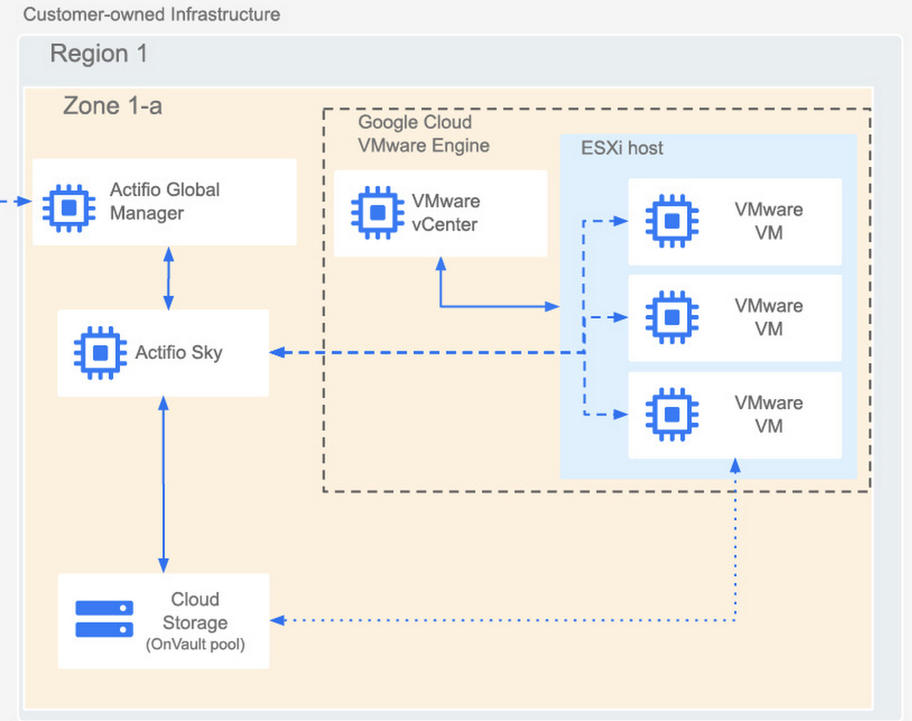

Team CSZNet understands many technologies, some with overlapping capabilities, so we a re the best choice for USPTO to avoid duplication of integration efforts. The Team CSZNet approach reduces support costs through the effectiveness of our center of excellence (COE) knowledge transfer approach.

The role the Government in this task is for USPTO to provide data so Team CSZNet can craft user-story personas for integration, including potentially the integration developer (application developer, specialist integration developer, Line of Business (LOB) integration developer and citizen integrator) might result in Point-to-point integration, the simplest form of integration. But we recommend against this model, as it can introduce technical debt with a complex spaghetti architecture that is hard to manage. We recognize different roles and projects require different technologies to be successful — so point-to-point makes sense when application developers can deliver integration as part of their application. Developers can quickly do the work and where the whole solution is easily redeployed when changes are required.

We will enable the Virtual DaaS system for use in multiple cloud providers as required. We support an Extract, Transform and Load (ETL) approach that automates the process of moving data between systems and keeping data synchronized with minimal human intervention. Extraction involves getting a copy of data from a source, which could be an application, database or text file. Team CSZNet experts will then craft transformation translations for the source data to match the format of the target system. This includes changing data types, combining or splitting fields and applying more complex formulas. We can do this via an Enterprise Service Bus (ESB) with appropriate plug-ins. Loading completes the process by putting the transformed data into a target system.

We will manage data on-premise and in multiple cloud providers via a single solution as required to make right data available and make data available for all aspects of development, testing and other cross-functional teams. We have the required skilled staff to handle this approach. Because frequency is an issue for USPTO, ETL moves data in batches, perhaps on an hourly or daily basis, so it works well for moving data behind a firewall inside an organization when the data is not time-sensitive. Team CSZNet haas the experience from ______ to use ETL software to load data from different systems into a data warehouse for reporting and data analytics. For cloud deployments, it requires an on-premises server to run the integration software. ETL is a great approach, in our expert opinion, when the agency has high-data volume, as ETL can handle very high-data volumes, into the millions of records.

As part of this task’s Deliverables (Section F, Deliverables 11,12, 13-32), we will draft a Corrective Action Plan based on our QA/QC approach. Ours outlines a set of steps for addressing issues and gaps in business operations and processes that could negatively impact the business. It describes the approach for resolving an issue that interferes with reaching company goals. The corrective action plan should be S.M.A.R.T. (Specific, Measurable, Attainable, Relevant, Time-bound) and includes timeframes, costs, and signatories.

# C.4.3 Task 3 – Implementation And Integration of Virtual DaaS Replication Solution

Implementing the replication solution for the Virtual DaaS that Team CSZNet proposes has specific , measurable benefits. Using our recommended Data Platform, we can deploy a single appliance (also called a block or rack unit), then scale up incrementally one node at a time. This approach provides the best of the world of vertical scaling and horizontal flexibility — the ability to start small and grow to massive scale without any impact on performance. Team CSZNet will analyze requirements or use cases as defined by Virtual DaaS team and convert them to Work Items (Epics, Features, or User Stories) in the system of record (Rally). This agile approach works well with the solution platform we recommend. For example, the following exhibit captures what happens when a client starts a job that uses a routine such as MapReduce; a DataNode writes to disk.

The complex process detailed in the above steps is practical because Team CSZNet provides context to the efficient of consumption of computational resources on bare metal. We assume, in step 1, a client submits a job. Step 2, Application Master responds with ApplicationID. Step 3, Containers launch context. Step 4, Start Application Coordinator. At Steps 5 and 6, Get capabilities and request and receive containers. Finally, at Steps 7 and 8, Containers launch requests and write data.

At the last step, we assume computational resources will be fully utilized. Node 1 writes to the local disk and creates remote copies. The HDFS replication factor is set to 3 by default, which means that the system creates three copies of every piece of data. This model provides for optimal Storage Consumption, as it uses data locality for performance and replication factor for availability and throughput. When the Node Manager negotiates link aggregation, multiple links to separate physical switches appear as a single layer-2 (L2) link. A traffic-hashing algorithm such as *balance-tcp* can split traffic between multiple links in an *active-active* fashion. Because the uplinks appear as a single L2 link, the algorithm can balance traffic among bond members without any regard for switch MAC address tables. In our experience, Team CSZNet recommends using *balance-tcp* when link aggregation is configured, because each TCP or UDP stream from a single VM can potentially use a different uplink in this configuration. The *balance-tcp* algorithm hashes traffic streams by source IP, destination IP, source port, and destination port for the most secure connectivity. With link aggregation and balance-tcp, a single user VM with multiple TCP or UDP streams could use up to 20 Gbps of bandwidth in a node with two 10 Gb adapters — incredible throughput for marginal cost.

**Exhibit - The Team CSZNet proposed solution deployed on “bare metal” VMs**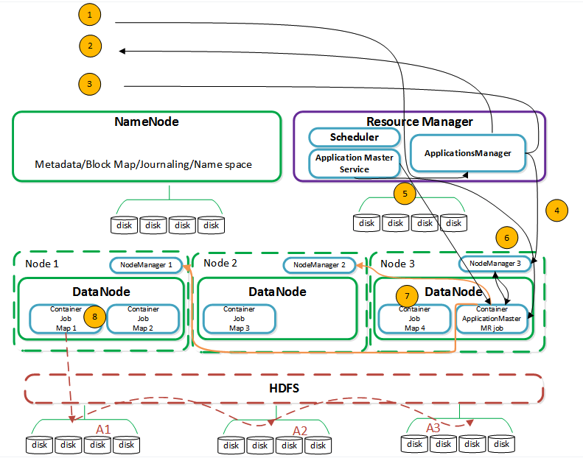

Team CSZNet will seek guidance and take proactive measures to investigate any issue resolution paths and carry through in compliance with USPTO policies, procedures according to organization structure in the New Ways of Working (NWOW). We will schedule deliverables: (Section F, Deliverables 11, 13-32) within the appropriate WBS line items for this task, and Team CSZNet will constantly communicate and collaborate with team members and stakeholders internal or external to the Virtual DaaS product team on all matters related to Virtual DaaS product team’s mission.

An advantage of the assumed Team CSZNet vendor-agnostic approach is that our solution is suitable for a different types of databases (RDBMS, NoSQL, cloud DBs), deploys in any public cloud or public/private hybrid cloud, and supports multiple USPTO product lines. To aid in knowledge transfer, we will develop technical documentation such as System Design Document (SDD), Operating Support Procedures (SOP) and any other type of documentation as required by Agile Delivery Office, Agile team, and OCIO standards.

# C.4.4 Task 4 – Communication and Requirement

Team CSZNet will seek guidance and take proactive measures to investigate any issue resolution paths and carry through in compliance with USPTO policies, procedures according to organization structure in the New Ways of Working (NWOW). The Team CSZNet approach to communication starts with a single, shared email inbox: this will funnel all of customer support emails into shared team inboxes where they are converted to tickets, ready to be assigned to a member of our team. Inboxes are accessible by all of our technologists, so nobody works in a vacuum. Centralizing the communications hub means better team collaboration and overall transparency. Team CSZNet will constantly communicate and collaborate with team members and stakeholders internal or external to the Virtual DaaS product team on all matters related to Virtual DaaS product team’s mission via our web-based portal.

Team CSZNet will analyze requirements or use cases as defined by Virtual DaaS team and convert them to Work Items (Epics, Features, or User Stories) in the system of record (Rally), to support the deliverables (Section F, Deliverables 11, 13-32) requested. We address two types of software requirements — functional and non-functional. As the name implies, Functional requirements describe the functionality of the product. Non-Functional requirements describe the look and feel of the system — in our case, most users will touch the DaaS via the provisioning portal.

# C.4.5 Task 5 – Implementation, Operation and Customer Services

Team CSZNet supports all phases of the software development lifecycle including Operations and Maintenance. Our expertise with legacy mainframe systems and Unix/Linux/Oracle or Microsoft/MS SQL or combinations, as many organizations have, allows us to provide support across the entire Enterprise. Because of our understanding goes from the database layer, through the middleware up through the application and presentation layers we have a thorough understanding of the interrelationships of DaaS. Following ITIL best practices, we provide support services that include: User guidance, standard issue fixing, systems monitoring; 24×7 on-call support for mission critical systems; and, utilizing the agency’s in-house service management tools to track and monitor incidents and service request, ensuring break-fix is performed within defined SLAs.

Team CSZNet will implement, maintain and enhance the capability of automated virtual data provisioning utilizing API (e.g., Actifio API) programmatically, with or without a self-service web portal or tools used in the CI/CD pipeline build process. Team CSZNet will contribute in the scoping and planning of Virtual DaaS self-service portal with the goal of providing the capability to virtual data users to manage all tasks of virtual data provisioning and user management for their won organizations (such as a product team). As discussed elsewhere, we will contribute in the scoping and planning of Virtual DaaS self-service portal with the goal of providing capabilities to virtual data users to manage all tasks of virtual data provisioning and user management for their won organizations (e.g., a product team).

Operations & Maintenance involves planning for, and executing, activities, such as operating production software applications, monitoring system performance, making defect repairs, testing the application after any changes are made, and tuning a releases software system.

Team CSZNet takes a proactive approach to monitoring production systems which results in early detection of potential issues. Issue identification early on allows us to quickly resolve potential problems before they proliferate so the user base. The Team CSZNet O&M services ensures deployed systems are maintained with optimal support because we triage potential issues and expedite assigning the right technical personnel to resolve them. Any issues that are deemed enhancements are categorized and logged in the appropriate tracking system for future development. Deliverables: (Section F, Deliverables 11, 13-32)

# C.4.6 Task 6 – Documentation and Compliance

Team CSZNet will provide customer knowledge and content management to support an enterprise collaborative culture as part of its web presence. Services should focus on end-user support to include tailoring front-end interfaces for intelligence mission and business applications as well as web/portal presentation and content customization (i.e., portlets, digital authoring, and web publishing, editorial review workflow). Team CSZNet will ensure that the content management system integrates effectively with existing enterprise systems and data stores with the goal of maintaining a well- connected, secured, and controlled enterprise of systems. Deliverables: (Section F, Deliverables 11, 13-32)

Team CSZNet will draft or assist in drafting or updating all Virtual DaaS related, and similar and related documents, for example, for the purposes of obtain and retain ATO, enterprise technology cataloging, system design, configuration management, standard operation procedure, implementation plan, test plan, etc. Team CSZNet will follow, document, and implement compliance dictated processes and procedures. We will assist USPTO in IT system architecture documentation, design and planning of current and future technical and functional / business systems by depicting technical, systems, and functional architecture views as required. Our team will work to facilitate and develop plans which will enable information sharing, integration, and interoperability while considering service-oriented architecture best practices by aligning architectures with overarching Federal (TOGAF) and agency architectures, and other related documentation activities as required. The architecture support provided to the Government will, naturally, consider the full life cycle, inclusive of initial planning through systems decommissioning.

# C.4.7 Task 7 – Phased Adoption and Approach for DaaS & Disaster Recovery (DR)

Disaster Recovery (DR) and Continuity of Operations (COOP) are two of the most critical elements in any organization’s infrastructure, and are often some of the most overlooked and underfunded elements. Each element has a specific role to play, and failing to plan for either could leave an enterprise crippled while mission critical services are brought back online, if that is even possible. We will support the DaaS strategy using a phased approach due to the complex interdependencies of process interactions, technical capabilities and support entities within the USPTO landscape. Team CSZNet understands the difference between DR and COOP. Disaster Recovery preparations should not be confused with COOP. Disaster Recovery plans are meant to provide a series of steps and tasks by which mission critical operations can be resumed in the event of a catastrophe, such as fire or flood, at a primary business location.

We will identify core stakeholders involved in end-to-end processes and review current process interactions, configuration of environments & data, to support team alignment, KPI & artifacts to interdependencies across processes. This means identifying the opportunities for improvements along with recommendations for Planning and Solution Design phase. Deliverables: (Section F, Deliverables 11, 13-32)

Team CSZNet will provide support for planning, execution and management of Enterprise data backup, disaster recovery (DR), and continuity of operations (COOP) operations and support. Services include, but are not limited to, ensuring Enterprise data backup, DR, and COOP requirements are considered early in the application or systems’ development lifecycle; verifying Enterprise data backup, DR, and COOP capabilities during installation; certifying Enterprise data backup, DR, and COOP compliant architectures; creating and executing recurring Enterprise data backup, DR, and COOP scenarios to test and verify continued capabilities; and reporting lessons learned and process improvements.

Virtualization helps reduce DR/COOP complexity and costs because it uses images, which can be easily manipulated and re-created. In many ways, the recovery process is similar to the way setting a restore point works in Microsoft Windows. If something goes wrong, it is possible to re-create an image off a last known image. Virtualization facilitates the restoration of corrupted files or systems as well as DR. It makes it easy to logically group and re-group images, test recovery plans, and make changes in a granular way, without impacting the production environment.

# C.4.8 Task 8 – Automated Testing

Team CSZNet provides independent testing and verification methods intended to provide an independent process that helps identify and mitigate development risk and use risk. Our staff uses a state-of-the-art automated testing methodology and tools to help us perform testing and evaluating if of any project at any point in the project life cycle. Team CSZNet will conduct all aspects of testing with a focus in the areas of functional, unit, integration, performance, load, stress, and resiliency, security, regression, usability, database testing, interface testing, software compatibility testing (SCT), end-to-end testing, testing in the cloud, mobile testing, cross-browser testing, Section 508 testing, user acceptance testing support and any other testing as needed. Scope of testing and approach may vary as defined by product teams in accordance with NWOW and DevSecOps model (Section F, Deliverable 09).

We take an approach to automated testing that strives for objectivity and reproducibility by consistently applying a reproducible approach to automated testing and through the use of industry best practices as crisply defined in the widely-accepted industry standards from the Institute of Electrical and Electronics Engineers (IEEE), the International Organization for Standardization (ISO), the International Electrotechnical Commission (IEC), the National Institute of Standards and Technology (NIST), and the Program Management Institute (PMI).

**Exhibit - Team CSZNet automated testing within the context of the full life cycle**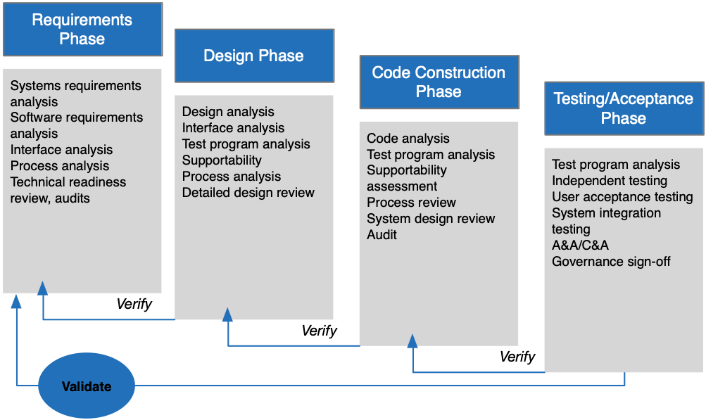

A benefit of the Team CSZNet approach is that testing is that the results of efforts that are both consistent (tested by the verification processes) and fit for the intended use (tested by the validation processes). Testing scenarios shall be developed in a collaborative Agile team environment to enable the most robust test cases needed to ensure quality, security, performance, usability and scalability of the delivered solution (Section F, Deliverable 10).

Team CSZNet will create automation of test cases required to reduce the number of test cases run manually, improve testing time, and increase test coverage. Automated testing shall support and enable USPTO’s goal of moving teams to DevSecOps (Section F, Deliverable 09). We will create test cases designed, defined, developed, updated and implemented by cross-skilled resources (Section F, Deliverable 10). The purpose of the test cases shall be to identify, document, track, mitigate, manage, and resolve all defects discovered during testing.That outcome will be testing to inform continuous improvement processes to reduce the overall defect rate and improve software development, as well as product usability, stability, and value delivery. Team CSZNet will also create manual test methods that are used in only rare and very limited circumstances when automation can’t be achieved. Deliverables: (Section F, Deliverables 7, 8, 9, 10, 11, 13-32)

Team CSZNet automated testing also increases objectivity by reducing process subjectivity, and its accompanying uncertainty, whenever possible and quantifying any uncertainty that cannot be reduced. At ___________, for example, we supplied automated testing services in an environment supporting the maintenance and operation of legacy systems historically consisted of multiple commercial vendors each performing discreet portions of work under decentralized (different offices) Government management.

Team CSZNet will provide management and operational support for enterprise independent testing activities for system, application and service-oriented IT functions in order to uncover operational software, hardware, and/or system flaws before fielding that might otherwise result in erroneous products or mission failure. Our team will be responsible for implementing a centrally managed test process, documenting testing requirements for evolving DaaS architectures, and participating in acceptance testing and beta tests. Team CSZNet will work with end users to ensure that requirements and “bug” issues are addressed by the test processes; and establish a library of widgets that link to documented test processes/plans/procedures for enhancement and reuse on various DaaS integrations.

In carrying out our approach to automated testing, we see the process as a completely independent entity to evaluate work products generated by a team that is designing or executing a particular project — a key advantage of the Team CSZNet QA/QC process. Often, an automated testing project is used to mitigate conflict of interest (OCI) issues with other contracts. As mentioned previously, our CMM Level 3-compliant automated testing methodologies are documented in the Team CSZNet “automated testing Methodology SOP,” and will be tailored to the customer. This methodology adheres to guidance published through standards bodies such as SEI (CMM), IEEE (std. 1012-2004), and PMS (PMBOK), and is flexible to incorporate specific agency standards and policies.

# C.4.9 Task 9 – Design, Implementation, Operation And Customer Services

Enterprise architecture, in the minds of the team at CSZNet, is an ongoing proactive that provides the context, resources, and environment to govern and enable service-oriented architecture delivery to the government. Team CSZNet strives to bring capability to the customer to work with business planning teams to provide direction for running the enterprise. We seek to assist with direction for portfolio and project management teams, after approval of resources. We will provide guidelines, reviews, and other aspect of architecture government during solutions development. Our staff will provide direction to deploy solutions and continuously monitor production assets in coordination with the O&M side of the house. Team CSZNet will support Virtual DaaS COTS product operation and maintenance activities, including issue investigation and resolution need occurred during these activities, such as upgrade or hot fixes.

We will assist USPTO in IT system architecture documentation, design and planning of current and future technical and functional / business systems by depicting technical, systems, and functional architecture views as required. Our team will work to facilitate and develop plans which will enable information sharing, integration, and interoperability while considering service-oriented architecture best practices by aligning architectures with overarching Federal (TOGAF), and agency architectures, and other related documentation activities as required. The architecture support provided to the Government will, naturally, consider the full life cycle, inclusive of initial planning through systems decommissioning. Team CSZNet will work independently or alongside Virtual DaaS team members to support all aspects of Virtual DaaS integration with USPTO product teams’ development, operation and maintenance activities. Team CSZNet will implement, maintain and enhance the capability of automated virtual data provisioning utilizing API (e.g. Actifio API) programmatically, with or without a self-service web portal or tools used in the CI/CD pipeline build process.

We will support an architecture board liaison for the DaaS, who should be made responsible and accountable for achieving consistency between detailed architectural modes, identifying re-usable components, and enforcing architectural compliance. Any frameworks — based on TOGAF, for example — will help USPTO define architecture vision, principles, and requirements. Our team will define business, information and technology domains to set up models for the realization of the architecture over the course of this effort. Team CSZNet will conduct research investigation to implement Virtual DaaS cloud migration and implementation in compliance with USPTO cloud implementation procedures and standards. Team CSZNet will apply industry best practices to deliver value during daily work in implementation, operation and customer services.

To support implementation and operation from a customer-centric view, Team CSZNet will contribute in the scoping and planning of Virtual DaaS self-service portal with the goal of providing the capability to virtual data users to manage all tasks of virtual data provisioning and user management for their own organizations (e.g. a product team). Team CSZNet will build the Virtual DaaS self-service web portal progressively to support manual, automated and CI/CD pipeline.

At Team CSZNet, we believe an enterprise-wide architecture should serve as an authoritative reference, source of standards for processes / resources, and provider of designs for future operating states. It should cover all elements and aspects of IT government, and be a single source of reference. Team CSZNet has found, at USPTO for example, this is essential to avoiding waste and duplication in large, complex organizations. It also resolves the “battle of best practices” and competition between sub-architectural domains which can be problematic for agencies that are aiming for efficiency. Deliverables: (Section F, Deliverables 11, 13-32)

## Schedule and Deliverables

Per page F-1 of the TOR RFQ, we will incorporate into the WBS of our PMP the schedule of milestones, to monitor timely progress of this effort. Deliverables identified in the table on pages F-1 through F-5 of the TOR RFQ will be submitted in electronic format for review, feedback, and acceptance from the government COR/TOM, and in a format that is compatible with Microsoft Office or other USPTO approved software and are subject to. Team CSZNet understands the frequency of submissions is subject to change. All deliverables will be sent to the Office of the Chief Information Officer, US Patent and Trademark Office, at 600 Dulany Street in Alexandria, Virginia.

## Quality Assurance

Inspection and acceptance of all work performance, reports, and other deliverables under this TO will be performed by the USPTO COR and USPTO TOM. Our Quality Management Process is based on our Total Quality Management Framework — the objective of which is to provide independent QA/QC assessments, standardization and implementation across all our work areas. We use CMMI L3 and ISO 900x processes to implement “Total Quality Management.”

## Knowledge Management Approach

The Team CSZNet methodology for institutionalizing experience is encapsulated in the following practices. This methodology ensures we capture knowledge, and institutionalize project experience so that we may providing reach-back support. We do this to master the customer’s mission objectives. To get started, Team CSZNet engineers chart the journey for every technical segment of a project. Our experts look through the customer lens and plot interactions across the varied stages of a project. Where do technologies intersect with end user experience, and, what’s this experience like? We do this for every step, and identify strategies for strengthening the low points, while replicating the high points.

Our methodology for maintaining the technical expertise of our personnel is based on an annual skills inventory and corresponding personalized training plan for each staff person. A training needs assessment identifies individuals' current level of competency, skill or knowledge in one or more areas and compares that competency level to the required competency standard established for their positions or other positions within the organization. The difference between the current and required competencies can help determine training needs.

Finally, Team CSZNet provides corporate reach-back in the form of reusable technology assets, lessons learned, talent bench support (a pool of vetted, experienced consultants ready at a moment’s notice), and continued knowledge transfer from projects in which we have gained firsthand experience, knowledge, and expertise. This experience comes from working through full life-cycle implementations and sustainment services for our government sector clients.

***Web-Based Project and Knowledge Management Portal*** — The team relies on a web-based project and knowledge management portal built with SharePoint. The platform, available to the Government CO/COR and other task order stakeholders, offers custom workflows enabling us to update our Project Management Plan (PMP) faster. This also provides access to a knowledge management section with collaboration capabilities so we have a user-friendly web-accessible location for collaboration, ensuring knowledge sharing and learning management.

A key advantage of the Team CSZNet technical approach is that we collect actionable data to improve our team’s performance and the customer experience. To do this, we measure specific variables, publishing the data on our web-based portal, and refine associated processes to improve. We also set customer satisfaction benchmarks like perceived quality (almost as important as error reduction and other quality metrics). We implement what we call the “Net Promoter Score,” a metric which we assume will help us ascertain overall customer satisfaction. Every time a Team CSZNet staff person closes out a task, work assignment, or action item, a single question survey is dispatched via email to the customer POC, and a NPS scores is measured with and reported with a number in the range of 0 to 10. A higher score is desirable. This is an example how we establish KPIs over the areas we are responsible for; we track these hard numbers to measure progress against both task deliverables and independently set customer experience goals. Most importantly, Team CSZNet then comprehensively implements these findings by making monthly, quarterly, and annual modifications to our SOPs.

# Project Staffing Plan

The Team CSZNet rationale for the proposed our staffing solution, labor mix, and level of effort for each of the TOR tasks is based on how each person will be involved in each task/subtask and how each person’s qualifications and experience uniquely qualify them for the positions described in Section H of the TOR RFQ. The process of assessing each staff person can be challenging, particularly when it comes to determining strengths and weaknesses. The factors that influenced this labor mix are ability to communication, team cohesion/mutual support, coordination of expertise, significant technical/engineering capabilities, and value diversity. Value diversity means being able to look at a technical problem from multiple perspectives. Such factors are sufficiently addressed with the Team CSZNet staffing solution, enabling us to meet the Government’s requirements at a reasonable cost.

Team CSZNet considers more than just general professional attributes; we also consider how both strengths and weaknesses work in the target government environment and to meet the needs of the specific project. As part of personnel reviews, we ask for feedback from other employees and managers who work with each team member and use the information gathered to help form one overall suitability determination. We also gauge consistency among team member roles, based on our matrix management approach — cross-trained individuals can fill in for missing teammates, and understand the “big picture” of client goals. The government’s role will be to provide the needed information to each member of Team CSZNet so they can fulfill their assigned duties. Finally, we look at each potential team member's performance outside of the project structure to determine where they are strongest on their own. Team CSZNet decision makers may see consistency among those strengths and weakness working in the team or out of it; or may discover that some staff have a different set of strengths when working in differing environments.

All Key Personnel proposed are identified in the Project Staffing Plan, following, and are available to begin work immediately upon contract award. A Letter of Commitment, signed by each proposed Key Personnel is included with this submission.

|  |  |  |  |  |  |
| --- | --- | --- | --- | --- | --- |
| Exhibit - Project Staffing Plan | | | | | |
| Role | Named Staff Persons(s) | FTEs, Base Period | FTEs, Option Period 1 | FTEs, Option Period 2 | FTEs, Option Period 3 |
| **Senior Software Developer** |  | 2 | 2 | 2 | 2 |
| **Senior Database Administrator** |  | 2 | 2 | 2 | 2 |
| **Subject Matter Expert** |  | 1 | 0 | 0 | 0 |
| **Project Manager (Product Manager)** |  | 1 | 1 | 1 | 1 |

**Responsibilities of the Senior Software Developers —**

**Responsibilities of the Senior Database Administrators —**

**Responsibilities of the Subject Matter Expert —**

**Responsibilities of the Project Manager (Product Manager) —**

***Staff Recruiting*** — Team CSZNet has successfully employed a resource pool support approach, whereby team members from the resource pool will be assigned to task orders depending on the scope and complexity. Upon completion of the task order, the team members will return to the resource pool or will be assigned to another task order. This approach allows us to maintain a constant team of key personnel with extensive project management as well as USPTO system and business experience adequately supported by qualified and experienced personnel on as needed basis. For staffing needs on any task order, Project Manager along with the implementation group leads will tap into the resource pool. If staffing needs cannot be accomplished with resources in the resource pool, then Team CSZNet’s Human Resource (HR) department will find resumes. Team CSZNet’s Management team will conduct phone interviews and detailed interviews to map candidate’s goals with project goals. Upon completion of screening and interviewing process, we will recommend the appropriate action to the HR.

***Staff Training*** — Team CSZNet includes experienced personnel and subject matter experts that possess with a decade or more of experience working with federal agency systems. We will utilize our institutional knowledge to continuously train and mentor new team members. We will develop project orientation materials, which will be used by our senior team members to train junior/new members. Our initial project staff training will involve project orientation training, ethics conduct, and training on any new technologies employed by the project at no additional cost to USPTO. In addition, we will ensure cross training of the staff on the various DaaS/SaaS systems modules and sub-modules to ensure that there is ample coverage for all TOR RFQ tasks as demonstrated in below demonstrates the distribution of all the TOR RFQ tasks among the personnel in the organization chart to ensure all the tasks are accomplished in the most efficient way. On this contract we will maintain a knowledge matrix that maps abilities of existing and new resources to the technical, management and business areas. This matrix is reviewed every few month and efforts are in the Integrated Team Meeting (ITM) to track the improvements in knowledge and technical abilities and also to revise the cross training efforts for each individual.

***Staffing Adjustments*** to surge levels of workload — We have proposed personnel with extensive IT and specifically USPTO systems experience to handle the TOR RFQ tasks. Due to our efficient cross training strategy and resource pool based staffing approach, we will be able to adjust the staff on task assignments in accordance with the fluctuating level of workload and in consultation with the government.

# Key Personnel Resumes

## Project (Product) Manager

## Subject Matter Expert

## Senior Software Developer 1

## Senior Software Developer 2

## Senior Database Administrator 1

## Senior Database Administrator 2