**VOLUME I – EXECUTIVE SUMMARY**

**DRAFT - Version 0.50 6-April-2022**

**Submitted by:**

Avening Management and Technica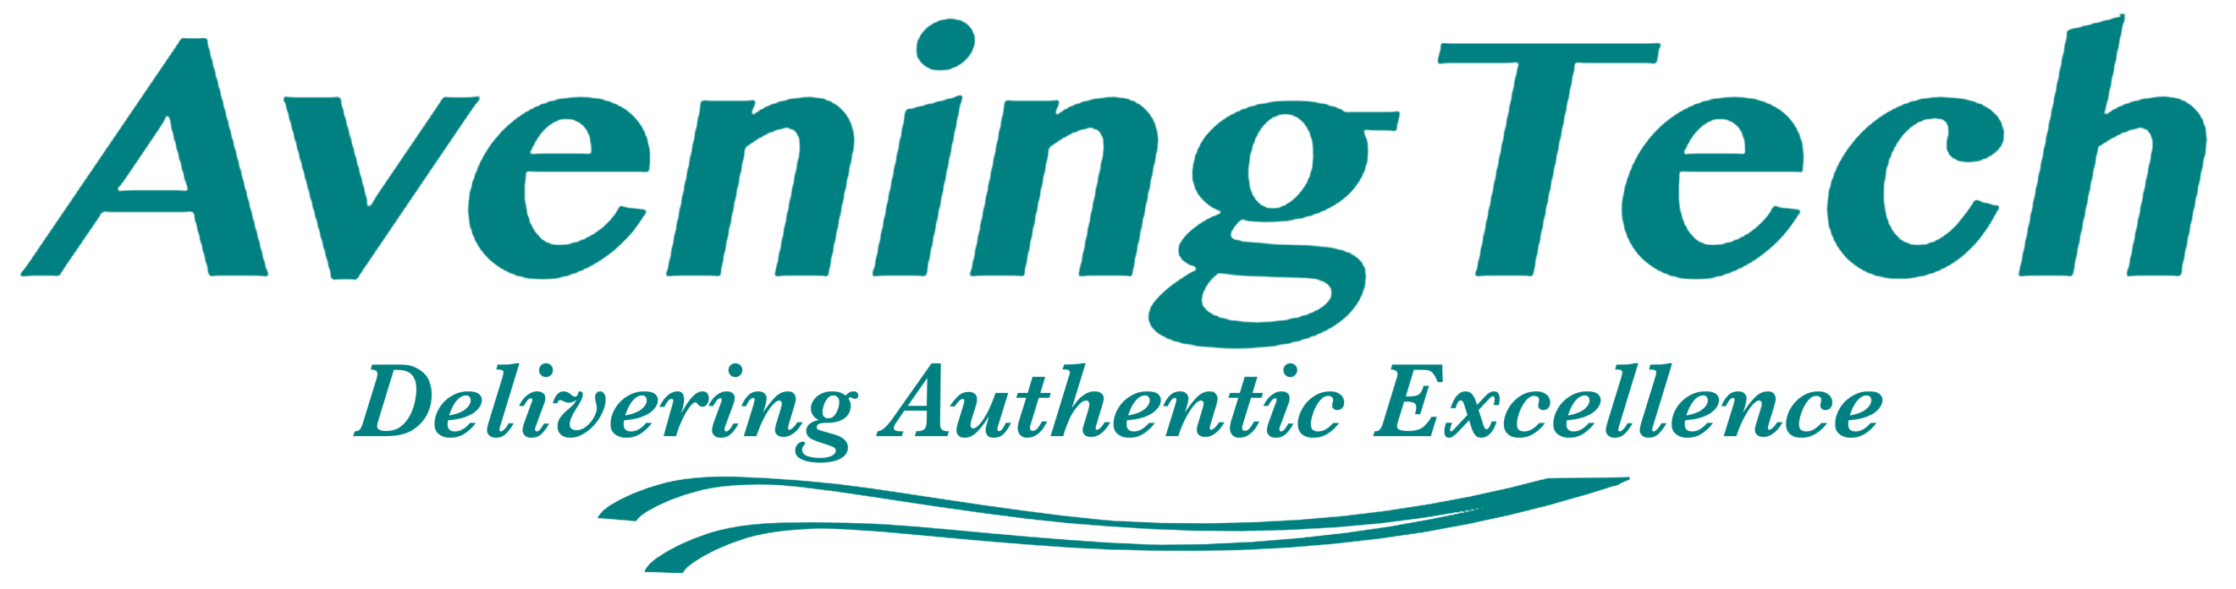l Services, LLC (AveningTech™)  
11 North Maple Avenue, Suite 101  
La Plata, Maryland 20646  
Tel: 301-848-2053

DUNS: 963340752

**Restrictions on Disclosure of Data**: This proposal includes data that will not be disclosed outside the Government and will not be duplicated, used, or disclosed -- in whole or in part -- for any purpose other than to evaluate this proposal. If, however, a contract is awarded to this offeror as a result of -- or in connection with -- the submission of this data, the Government will have the right to duplicate, use or disclose the data to the extent provided in the resulting order. This restriction does not limit the Government’s right to use information contained in this data if it is obtained from another source without restriction.

**Intro**

[TBD]

Leadership — AveningTech brings top-tier project management experience to this effort, drawing upon more than 25 years’ experience managing large, complex IDIQ contracts with multiple simultaneous Task Orders, numerous subcontractors, and distributed and remote technical and administrative staff. Managing geographically dispersed employees who are co-located on or travel to client sites relies on robust and consistent communication between staff, subcontractors, and management and client representatives. In cases where there are multiple employees in a single location, we often identify a site- or team-lead, who becomes the local supervisor and primary point of contact, interfacing with the local client organization and with AveningTech management. In cases where there is a single employee at a designated location, we put extra emphasis on evaluating candidates to ensure that those selected are able to work independently with remote supervision.

On other engagements, our PM is responsible for staffing, budgeting, scheduling, client interaction, reporting and issue resolution, and is the primary point of contact for the Contracting Officer. AveningTech takes great care in the selection of teaming partners for contract engagements to ensure that our team is fully capable of addressing the scope and level of effort of an engagement. The AveningTech senior management team has significant experience successfully operating as a prime contractor and have all assembled and managed teams comprising both large and small business subcontractors and teammates. Our relationships with service and product providers extend throughout industry and academia and enable us to assemble teams composed of the most effective mix of skills and experience for each specific program. We continuously develop and nurture positive relationships within industry, and frequently re-partner on subsequent and follow-on engagements.

We chose ActionNet as a team member because, for 24 years, ActioNet gets the job done by solving our customers’ most challenging and complex problems. ActioNet continues to grow with Large Business Capability and Small Business Agility. Given our expertise of Navy IT Infrastructure, DON Cybersecurity and RMF principles, along with our unique experience and in-depth knowledge of NMCI/NGEN systems and platforms, ActioNet is that partner! ActioNet provides 18+ years of experience implementing Cloud, Software, System, Cyber, IT Operations, and DevSecOps Engineering services for Outside the Continental United States (OCONUS) and Continental United States (CONUS) large-scale DOD programs. Our 10+ years managing projects in OCONUS is a key enabler to successfully managing a cleared workforce for CNFJ/CNRJ.

* Industry leading corporate certifications including ISO 9001, ISO 20000, ISO 27000, CMMI Level 4 SVC and DEV
* 18+ years of successful performance modernizing IT infrastructure based upon DON Cybersecurity and RMF principles.
* 10+ years of ITSM performance supporting highly relevant DoD programs in Japan, Okinawa, Korea, Guam, and Diego Garcia.

AveningTech chose Commdex as a team mate because, with 20 years of mission critical communications experience in all 50 states and in many countries across four continents globally, Commdex is a leading systems integrator in the mission critical telecommunications space. They have worked on hundreds of LMR systems, including: conventional and trunked, analog and digital, and P25 clear and secure operations. Commdex’s in-house technical expertise covers a broad range of communications technologies and platforms across 4G/5G networks, fiber optic, satellite, and microwave that are widely used across critical communications systems. With experience on over 300+ LMR communications systems including nine large LMR programs each with 100+ sites, Commdex understands what is involved in designing large tactical communications projects and provide the resources to bring exceptional expertise. The depth of experience and commitment of our team enables us to provide the customer with mature expertise and reliable quality on a standards-based management framework.

Commdex is an ISO 9001:2015 and TL 9000 certified organization that has developed extensive quality processes incorporated into every step of the design and deployment process to ensure the highest levels of quality for every one of our systems. Using Commdex’s proprietary [*i*Comm360o](https://commdex.com/about-us/implementation-methodology/) framework, they help customers navigate the maze of technologies and products to develop innovative solutions. Combining specialized skills and unmatched wireless communications experience, Commdex plans, designs, implements, and maintains customized technology solutions that help field operators expedite response, share information, and stay connected. Commdex provides: Land Mobile Radio Systems; DAS & BDA In-Building Coverage Solutions; Microwave and Fiber Optic Systems; Video Surveillance Systems; and, Systems Integration and Testing Support.

Our key project management personnel ensure efforts comply with all terms of our contracts, including ensuring staff training is up to date, security requirements are adhered to, and accurate invoices are submitted in a timely manner. Our business success on other programs has historically been the result of a combination of technical expertise and relationship management performed between our senior management and Government counterparts.

Our formal, well-established project management process address preliminary planning through closeout to develop the overall skill mix, level of effort, specific tasks, and define the overall performance objectives. Upon award, Our PM schedules a kickoff meeting with the project team and client stakeholders to review goals, objectives, roles, responsibilities, requirements, deliverables, milestones, schedule, budget, assignment parameters, and success factors for each engagement. Based on input from this initial meeting, the PM adjusts the overall staffing plan and tailors our tools to enable the optimal labor mix for the task. Projects undergo regular Internal Program Reviews to ensure quality of services, compliance with standards and instructions, and that efforts meet or exceed all performance standards and objectives.

To support effective contract and task order execution, the management team uses a common computing infrastructure and collaborative toolset, including an internal SharePoint portal, to share project planning tools, work products, action items and documents. Our clients have access to this portal, which provides visibility into task order performance and metrics associated with staffing, cost and schedule. The PM monitors workload requirements, and makes adjustments when necessary. Staff assigned to support our clients are provided with clear instructions and guidance that define the work to be accomplished and measures of success. We produce thorough, accurate, and timely status reports delivered in accordance with all contract requirements. Our PM ensures the COR, Contracting Officer, and other relevant government personnel are kept abreast of progress, plans, and issues in a timely manner. We coordinate training for project personnel IAW contractual requirements, which includes maintaining certifications for a compliant Information Assurance Work Force.

Technical Approach That is Fully Compliant — The team has drafted a fully responsive technical proposal that addresses all the subfactors, as well as details our approach on individual tasking.