Thomas Todaro
ME 456
HW #1
Practical Astrodynamics: Working with Two Line Element (TLE) Sets
- Provide the Satellite Catalog Number (SCN) number (a.k.a. NORAD number) that corresponds to the oldest object still in orbit. What is this object?
    - NORAD number: 1736
    - Rocket Body titled SL-6 R/B(2)
- Provide the SCN for the newest object. What is this object?
    - 62974, unknown- as of 2/14/2025, launched 2/11/2025
- Tell me about objects with an international designator beginning with the root “2024-149”
  - How many objects?
    - 113
  - When were they launched and from where?
    - 08/16/2024 from Cape Canaveral, USA
  - How many are positively identified?
    - 99- as of 2/14/2025
  - Import the TLEs into mod/sim software and show the class what it looks like.
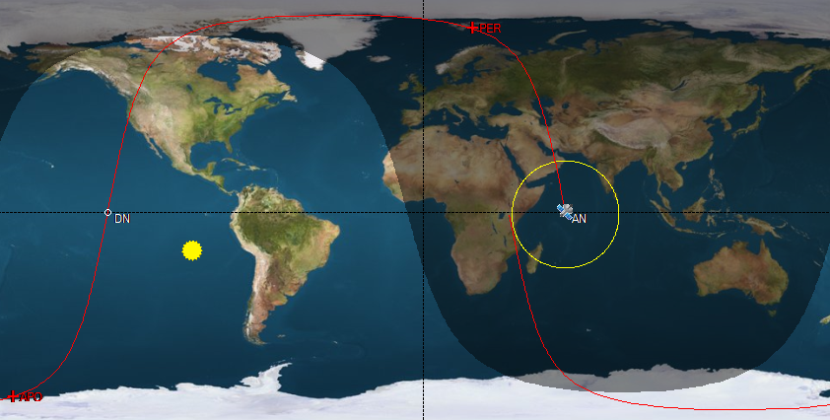
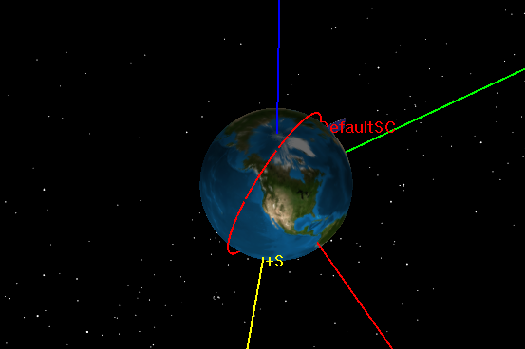
  - What do the TLEs look like on the launch date?
    - The TLE satellite path may look incorrect based on the launching location if the TLE file has been updated since the launch date. TLEs reflect a space objects approximate real position and therefore must be updated frequently in order to maintain loose trackability
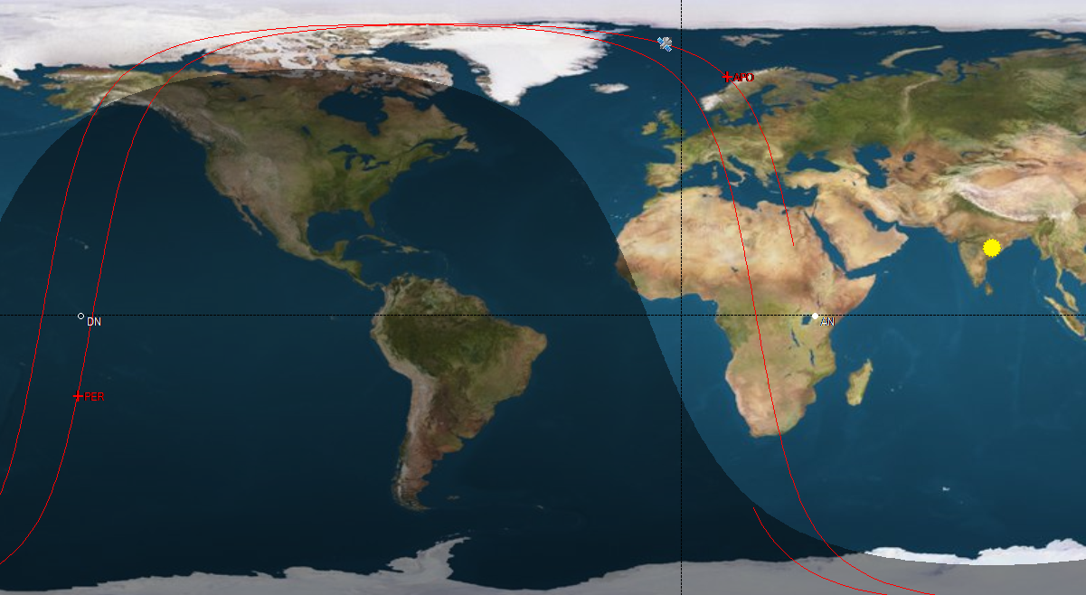

- Parse the TLE below and describe all the data contained therein
  - 1 25544U 98067A 25026.23381182 .00028165 00000-0 48961-3 0 9996
    - 1: Line number
    - Satellite NORAD Number: 25544
    - International Designator: 98067A, 67th launch of 1998, primary payload
    - Epoch Year: 2025
    - Julian Day: January 26 + 0.23381182 days (~6 am)
    - Ballistic Coefficient: 0.00028165
    - Second derivative of mean motion: 00000-0
    - Drag/radiation pressure: 48961E-3
    - Ephemeris Type: 0
    - Element Number: 999
    - Mod Check Number: 6
  - 2 25544 51.6394 290.1657 0002353 148.0201 356.6586 15.50579325 493141
    - 2: line number
    - Satellite Number: 25544
    - Inclination: 51.6394 Degrees
    - RAAN: 290.1657 Degrees
    - Eccentricity: 0.0002353
    - AP: 148.0201 Degrees
    - MA: 356.6586 Degrees
    - Mean Motion: 15.50579325
    - Revolution Number at Epoch 49314
    - Mod Sum Check 1
  - What is this object?
    - The internation space station, ISS(ZARYA)
  - Investigate the root of the international designator. What do you notice? Is this normal for an average space object?
    - International designator shows the ISS was the 67th launch of 1998 and was the primary payload of its launch. This international designator appears to be normal for a typical space object, however the irregularity can come in the fact that the ISS was assembled in pieces rather than the product of just one launch.

Laboratory: Grab the most recent TLE for object 25544 and import it into mod/sim software. Insert Bethlehem, PA into the software as well. Calculate times in the next two weeks where this space object will be above the horizon in Bethlehem. Calculate the azimuth and elevation for each opportunity. Go outside on those dates (at night) to see if you can observe this object based upon your prediction. Terminator conditions are ideal.
- .txt file containing Azimuth and Elevation angles for various times where the ISS is visible from Bethlehem PA for the next 2 weeks is included in the folder this assignment was sent in.

- Look up this object: 2022-074D.
  - Tell me similar info as above (don’t do the lab)
    - This object has already been degraded and reentered Earths atmosphere
    - Using its last used TLE the following times were generated:
DATE [UTC]: AZI[deg] ELE[deg]
11 Sep 2024 06:29:24.248 | 239.128 | 11.872
11 Sep 2024 06:30:24.248 | 219.105 | 44.551
11 Sep 2024 06:31:24.248 | 78.261 | 23.886
11 Sep 2024 08:01:24.248 | 315.896 | 12.203
11 Sep 2024 08:02:24.248 | 5.896 | 15.540
11 Sep 2024 09:33:24.248 | 350.155 | 16.229
11 Sep 2024 09:34:24.248 | 45.286 | 13.592
11 Sep 2024 11:04:24.248 | 263.441 | 22.348
11 Sep 2024 11:05:24.248 | 160.734 | 28.757
*Running this TLE in GMAT caused it to crash after only a short propagation, these were the remaining times. .txt file is also included in the folder

- When is the next Starlink satellite predicted to reenter?
  - Starlink-2308 Feb 14,2025 17:04 UTC+-6hours
    - Closest reentrance following class on 2/14/2025

