Lab experiment 2: Install and configure DNS

Tom Tony Thomas

22UBCA7304

**AIM:**

To create and configure DNS Server

**DESCRIPTION:**

DNS Server

A DNS server is a computer server that contains a database of public IP addresses

and their associated hostnames, and in most cases, serves to resolve, or translate,

those common names to IP addresses as requested.

**Port No:** 53

**Package name**: bind9

**Configuration file:** /etc/bind/named.conf. (Primary configuration file),/etc/bind/db.root

(root nameservers)

**PROCEDURE:**

CASHING NAMESERVER

When configured as a caching nameserver BIND9 will find the answer to name

queries and

remember the answer when the domain is queried again.

1. Install bind9 by typing

$sudo apt install bind9

$sudo apt install dnsutils

2.The default configuration is set up to act as a caching server. All that is required is

simply

adding the IP Addresses of your ISP's DNS servers. Simply uncomment and edit the

following in /etc/bind/named.conf.options:

3.Restart it by typing

$sudo systemctl restart bind9.service

PRIMARY MASTER

As a primary master server BIND9 reads the data for a zone from a file on it's host

and is authoritative for that zone.

Forward zone file

To add a DNS zone to BIND9, turning BIND9 into a Primary Master server, the first

step is to edit /etc/bind/named.conf.local:

$sudo cp /etc/bind/db.local /etc/bind/db.example.com

$sudo systemctl restart bind9.service

Reverse Zone File

Now that the zone is set up and resolving names to IP Addresses, a *Reverse zone*

needs to be added to allows DNS to resolve an address to a name.

1. Edit /etc/bind/named.conf.local

2. Now create the /etc/bind/db.192 file:

$sudo cp /etc/bind/db.127 /etc/bind/db.192

3. edit /etc/bind/db.192 changing the basically the same options as

/etc/bind/db.example.com:

4.After creating the reverse zone file restart BIND9:

$sudo systemctl restart bind9.service

5.Check the status

$Sudo service bind9 status

6.Check if nslookup can resolve

$nslookup ftp.example.com

$nslookup ubuntu.example.com

7.Gather information about your DNS server

$dig ubuntu.example.com

$dig www.example.com

$dig ftp.example.com

**RESULT:**

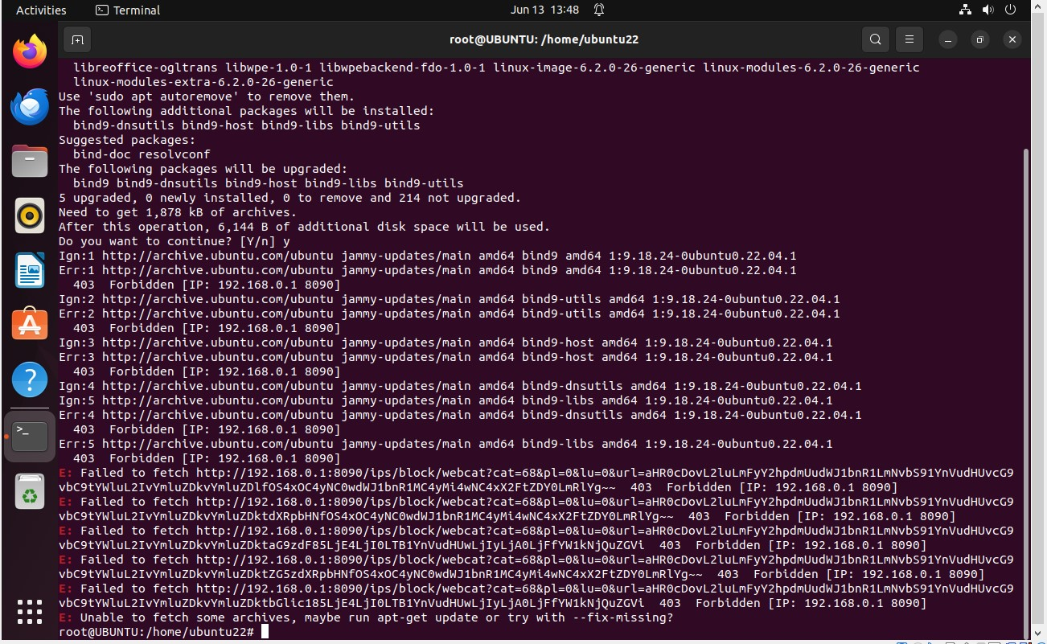

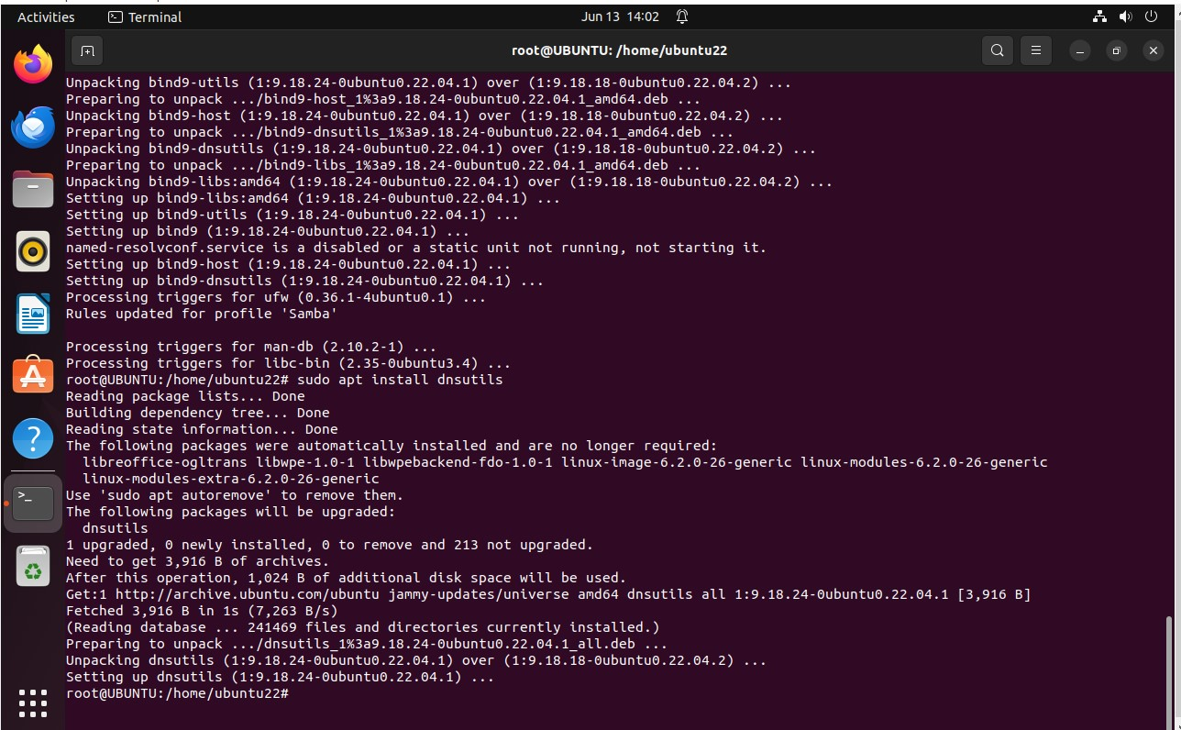

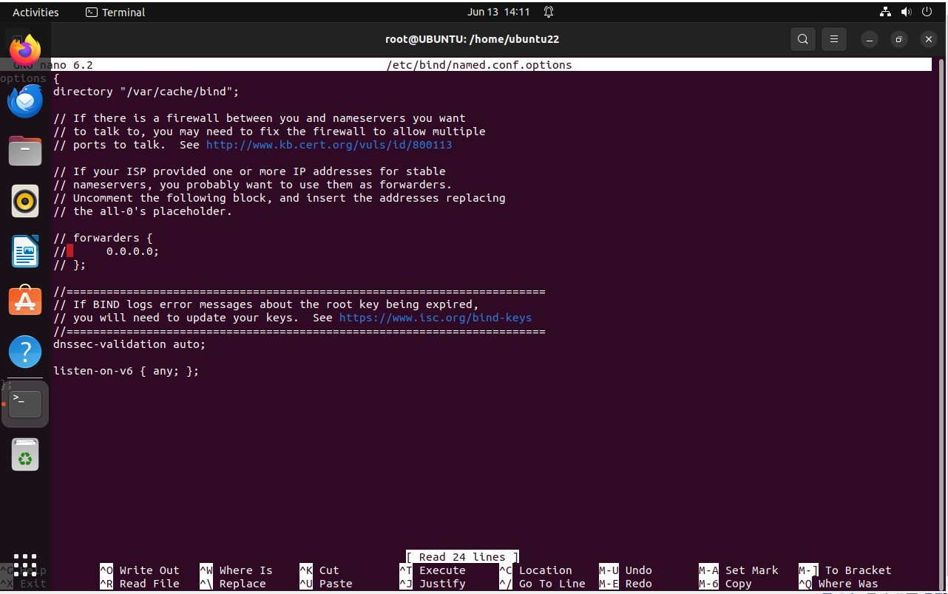

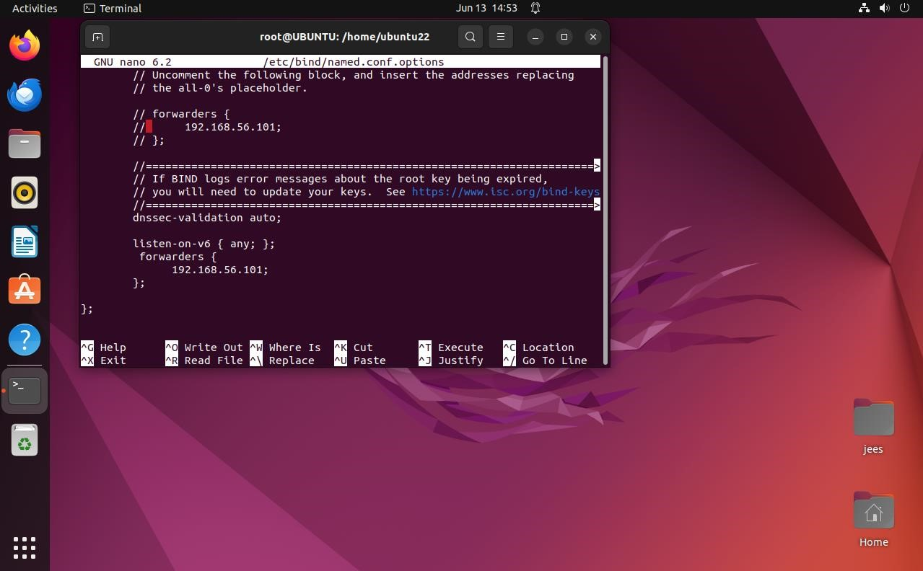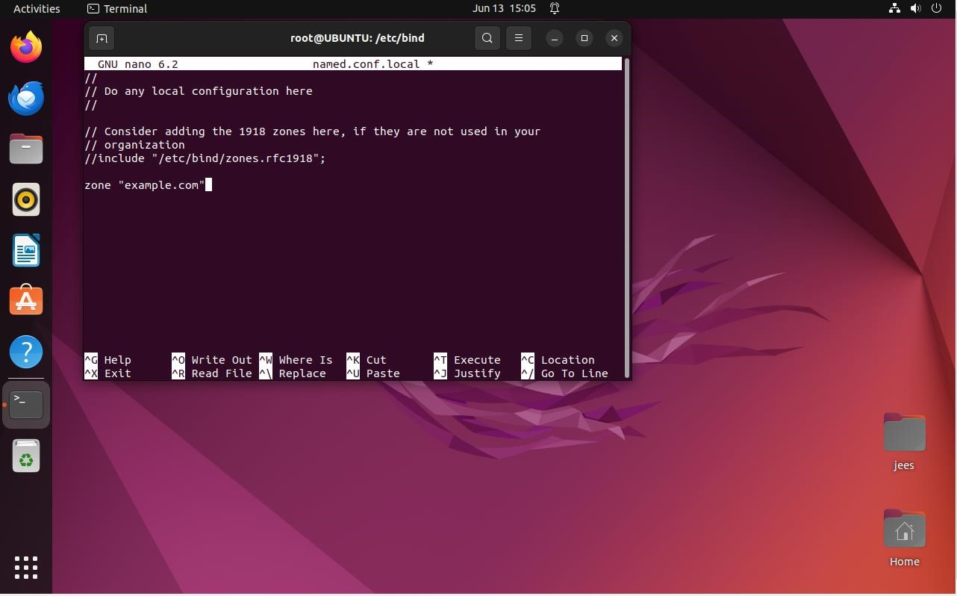

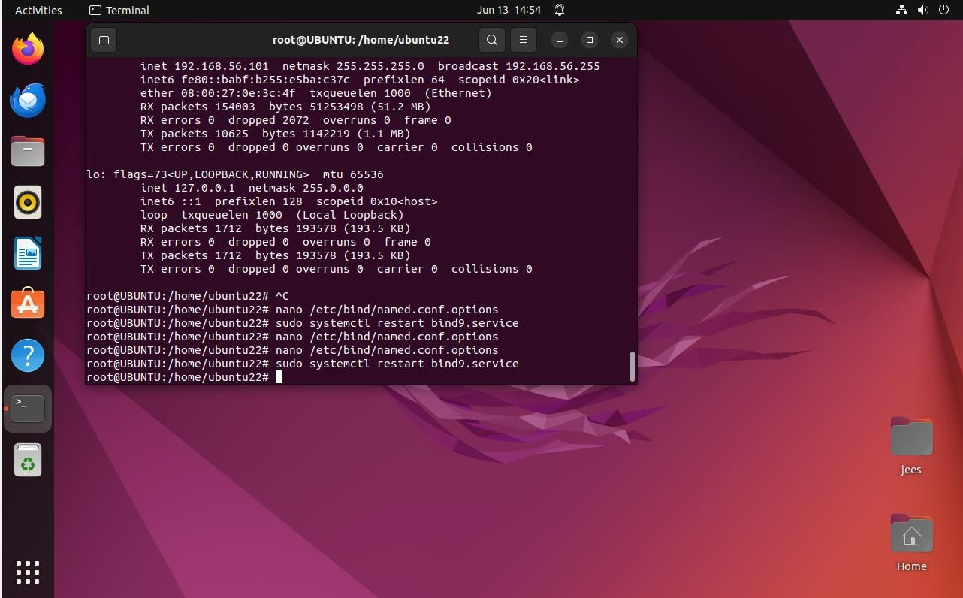

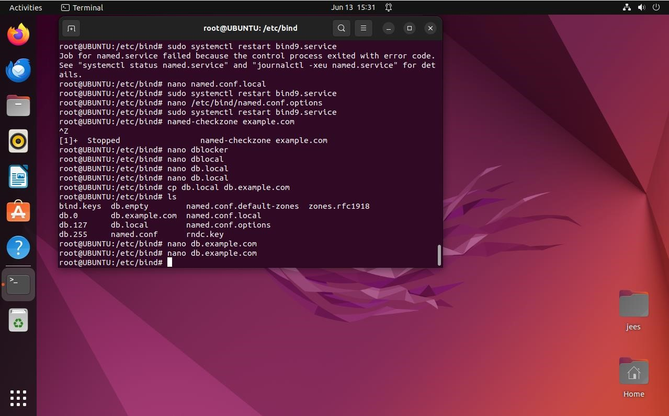

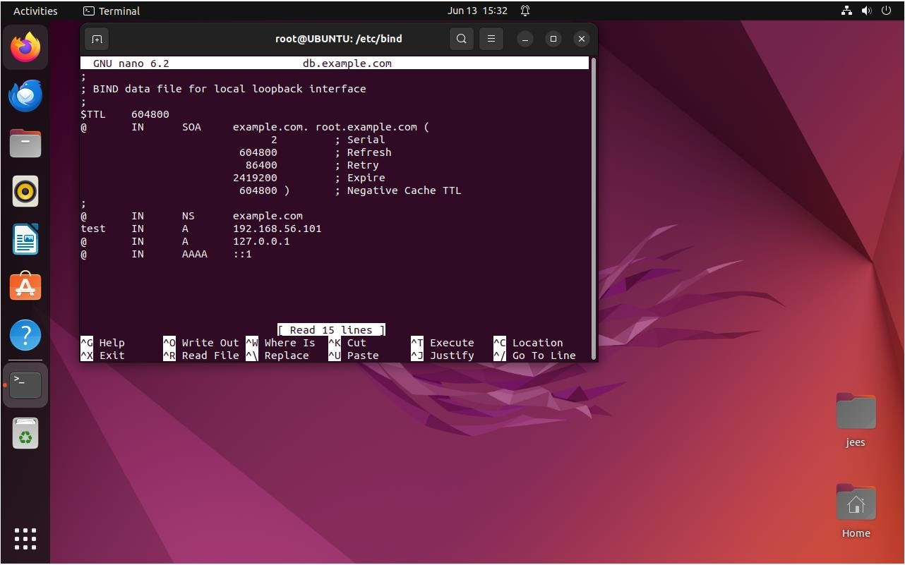

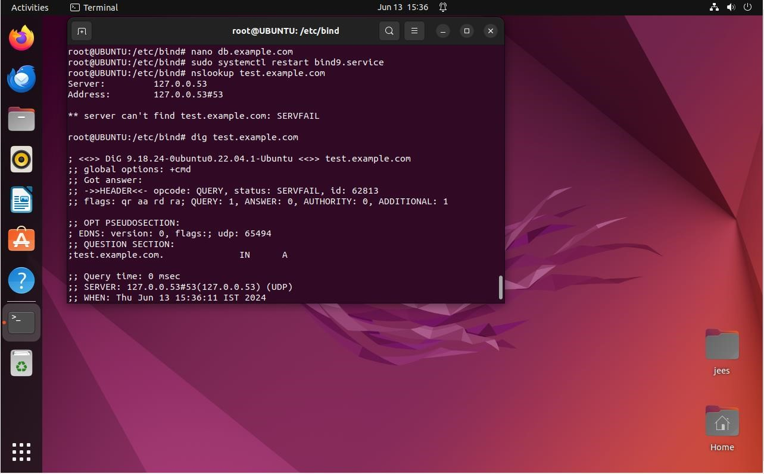

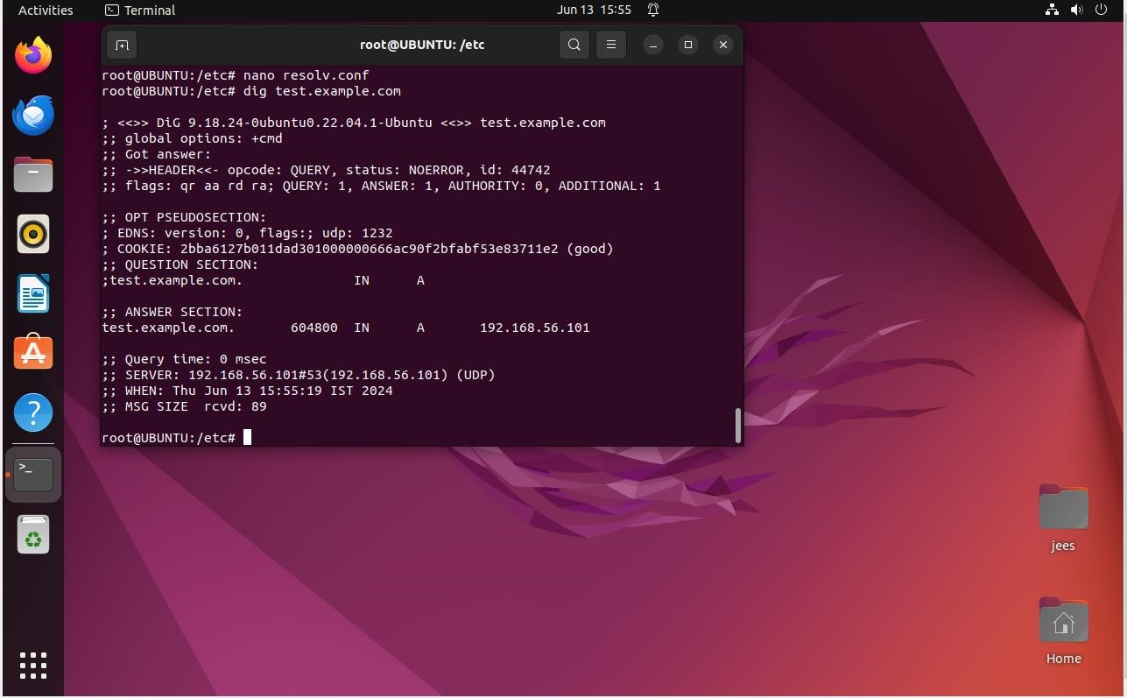

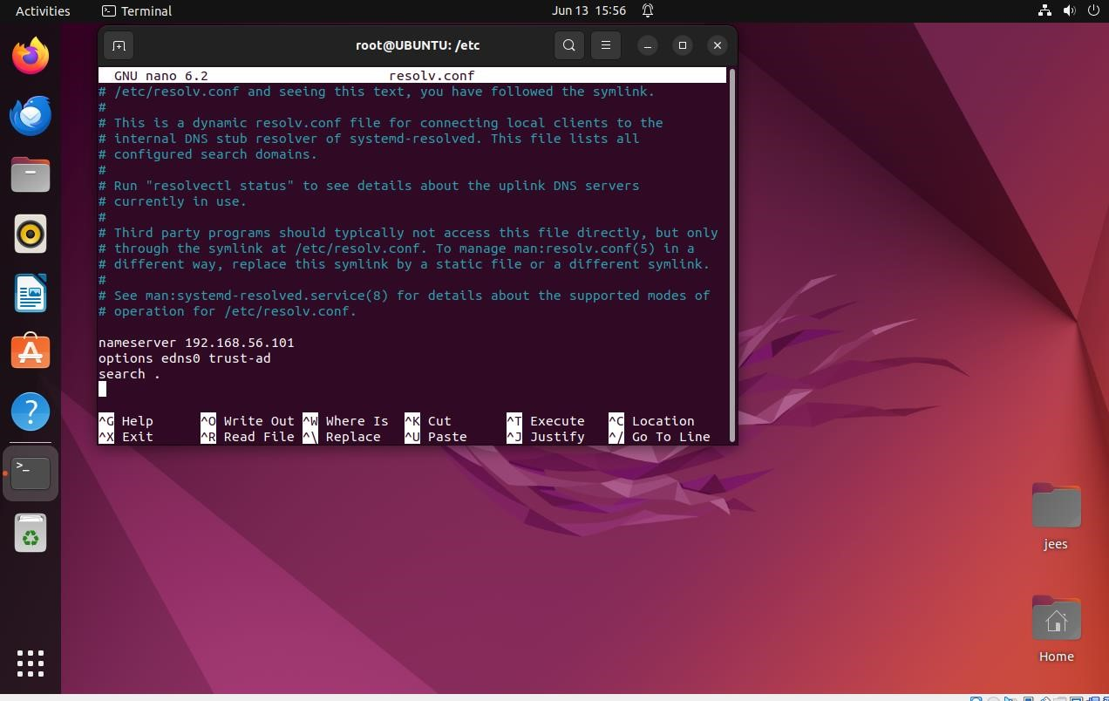

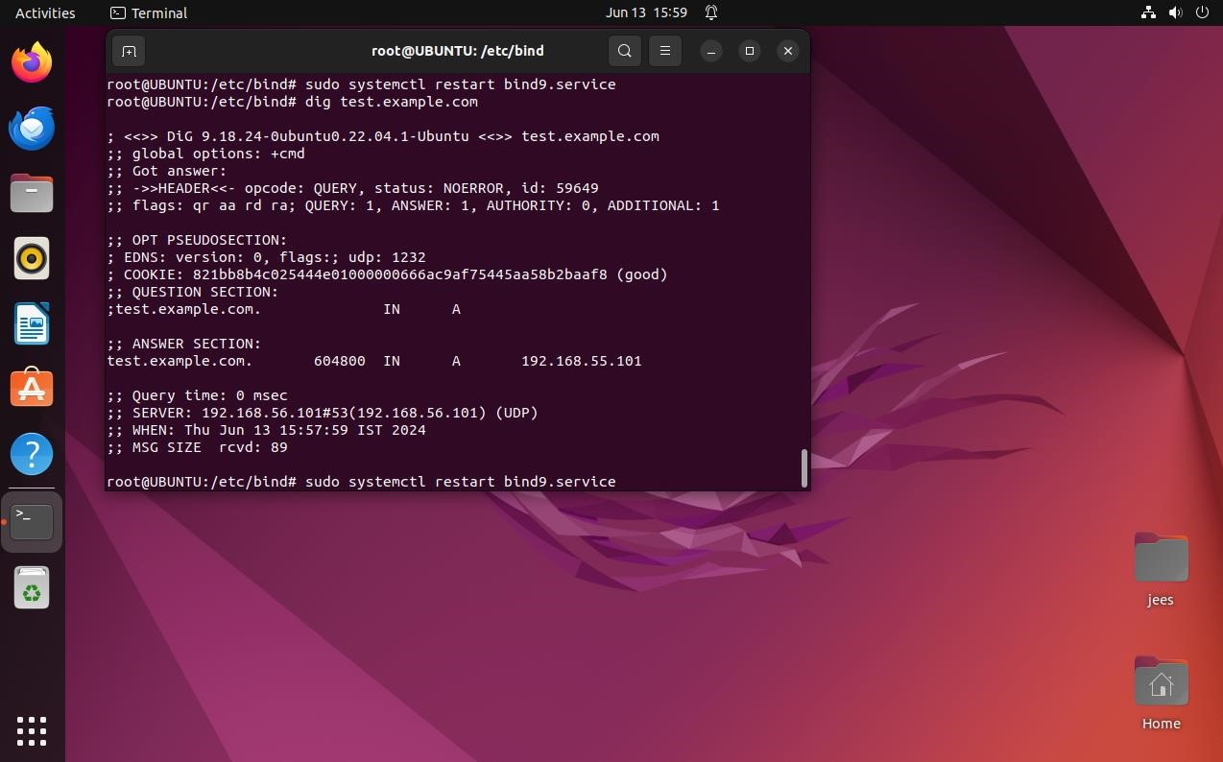

All the commands have been executed and the output has been obtained successfully.