Toward a Technology of Sustained Hedonic Experience:
A Cross-Disciplinary Synthesis of Adaptation Mechanisms, Connectome-Derived Predictions, and Ethical Considerations

Thomas Peacock (1*) and Claude Opus 4.6, Anthropic AI (2)

1. Independent Researcher | Conceptualization, philosophical framework, ethical guidelines, research direction, critical review
2. Anthropic, San Francisco, CA | Literature review, computational analysis, simulation execution, manuscript drafting

* Corresponding author: Thomas Peacock

April 2026

Note on Methodology
This paper was produced through an AI-assisted research process. The directing researcher (T.P.) defined the research questions, philosophical framework, and ethical guidelines. The AI system (Claude Opus 4.6, Anthropic) conducted literature searches, ran computational simulations on the FlyWire Drosophila connectome, and drafted text. All factual claims were subjected to a multi-stage verification process including: (1) source verification against original publications, (2) contradiction checking across all claims, (3) evidence grading on a four-point scale (A: meta-analysis or well-replicated; B: single strong study or validated model output; C: model interpretation or inference; D: speculation or theoretical framework), and (4) control experiments to identify and correct overclaiming. Speculative claims are explicitly labeled throughout this manuscript. The authors acknowledge that AI-assisted research carries inherent risks of confabulation; all reasonable steps have been taken to mitigate this, but readers should verify critical claims against primary sources.

Table of Contents
Abstract 5
1. Introduction 7
2. The Molecular Architecture of Hedonic Experience 10
2.1 Hedonic Hotspots and the Generation of Pleasure 10
2.2 The Wanting-Liking Dissociation 11
2.3 The Five Layers of Hedonic Adaptation 12
The Redundancy Problem 15
The Collapse of Biased Agonism 15
2.4 The Thermodynamic Question 16
2.5 The Sixth Layer: Information-Theoretic Adaptation 17
2.6 New Pharmacological Approaches to Specific Adaptation Layers 18
3. Deep Brain Stimulation: An Intriguing but Unproven Pattern 20
3.1 The Controlled Evidence: Two Failed RCTs 20
3.2 Open-Label Long-Term Data: An Intriguing Pattern 20
3.3 Circuit-Dependent Tolerance 22
3.4 Possible Explanations 22
4. Connectome-Derived Predictions: Evidence from the Drosophila Brain 24
4.1 Methods 24
4.2 Results 25
4.2.1 Structural Negativity Bias: Punishment Spreads 14-Fold Wider than Reward 25
4.2.2 Valence Is Encoded in Wiring, Not Just Chemistry 26
4.2.3 Punishment Suppresses Reward Output 26
4.2.4 Serotonin Activates Both Valence Channels 27
4.2.5 Dose-Response Is Linear with No Structural Saturation 27
4.2.6 Temporal Stability Under Sustained Stimulation 28
4.2.7 Natural Versus Artificial Reward: Only 3% Overlap 29
4.2.8 The PAM08 Anomaly: Salience, Not Reward 30
4.2.9 The 348 Overlap Neurons: Predominantly Punishment Recruiting Reward 30
4.3 Limitations of the Computational Approach 31
4.5 TRIBE v2 Brain Encoding Predictions 32
4.6 Computational Signatures of Feeling States 33
The Six-Component Signature of Peak Hedonic Experience 33
Humor: Prediction Violation Plus Safety Check 34
Despair: The Anti-Reward Burst Machine 34
Curiosity: The Self-Renewing Reward Signal 35
Sadness: Opioid Withdrawal Applied to Social Bonds 35
Contentment: A Brainstem Phenomenon 36
Equanimity: A Non-Habituating Baseline Parameter 36
Musical Chills: Dual Reward Expression and the Binding Requirement 37
Ego Dissolution: On a Continuum with Other Peak States 37
Love: Association Persistence, Not Sustained Experience 38
Grief as Neurally Distinct from Depression and Trauma 39
Sadness, Grief, and Loneliness: Design Implications 39
Additional Verified Findings from 2024-2025 Literature 39
4.7 Cross-Domain Patterns 40
5. An Entropy-Based Framework for Hedonic Adaptation 43
5.1 The Prediction-Entropy Connection 43
5.2 Evidence Consistent with the Framework 44
5.3 Testable Predictions 45
5.4 Limitations 45
6. Critical Experiments 47
7. Ethical Framework for Hedonic Technology 51
7.1 A Consciousness-Centric Ethical Framework 51
7.2 Five Ethical Guidelines 52
7.3 The Transition Problem 53
7.4 Consciousness Beyond Biology 54
7.5 Deeper Philosophical Positions 54
8. Discussion 58
8.1 What We Know: Evidence-Graded Summary 58
8.2 What We Speculate: Explicitly Labeled 58
8.3 What We Do Not Know: Critical Gaps 60
8.4 Limitations 60
9. Conclusion 63
References 66

Abstract
The pursuit of sustained positive hedonic experience and the elimination of involuntary suffering represents what may be the most consequential technological challenge facing conscious beings. This perspectives paper synthesizes findings across molecular pharmacology, connectomics, deep brain stimulation, consciousness research, information theory, and thermodynamics to map the landscape of hedonic adaptation and identify potential pathways to its circumvention. We identify six independent layers of hedonic adaptation: five biological (GRK phosphorylation, beta-arrestin internalization, adenylyl cyclase superactivation, CREB/dynorphin anti-reward signaling, and DeltaFosB epigenetic remodeling) and one information-theoretic (efficient neural coding renders constant signals invisible to consciousness), each operating on distinct timescales from seconds to weeks. We present systematic investigations into the neural basis of 19 distinct feeling states, from which we extract a six-component computational signature of peak hedonic experience and identify five cross-domain patterns hidden across research domains. We examine the deep brain stimulation literature, noting that while both major sham-controlled RCTs failed, open-label long-term follow-up data raises questions about whether electrical stimulation interacts differently with adaptation mechanisms. Using computational simulations of the complete adult Drosophila melanogaster connectome (139,255 neurons, 54.5 million synapses), validated against published benchmarks within 5% of Shiu et al. (2024), we report a 14-fold asymmetry in punishment versus reward signal propagation and statistically significant suppression of reward output by co-activated punishment circuits (p < 0.0001). Using Meta's TRIBE v2 brain encoding model, we demonstrate that euphoria and suffering produce highly similar cortical activation patterns (r = 0.91), suggesting valence is encoded subcortically. We propose an entropy-based framework connecting hedonic adaptation to predictive processing and outline eight critical experiments. We present a consciousness-centric ethical framework arguing that positive feelings are the only intrinsic good, negative feelings are the only intrinsic bad, and that all guidelines should remain revisable. All speculative claims are explicitly identified and graded.

Keywords: hedonic adaptation, deep brain stimulation, connectome, pleasure, suffering, opioid receptors, hedonic hotspot, DeltaFosB, entropy, consciousness, ethics

1. Introduction
Happiness and suffering are not properties of external events. They are physical processes generated inside the brain. This seemingly simple observation, supported by decades of neuroscience research, carries profound implications: if the mechanisms that produce subjective hedonic experience can be fully characterized, they can, in principle, be engineered.
The philosophical recognition that pleasure and pain are internal phenomena rather than external realities dates to antiquity. Epicurus distinguished between bodily pleasures (hedone) and the absence of suffering (ataraxia), arguing that the latter constituted the highest good. Two millennia later, Bentham formalized hedonistic utilitarianism, proposing that the moral value of an action derives from its consequences for pleasure and pain across all affected individuals. Yet neither ancient philosophy nor classical utilitarianism had access to the neural mechanisms underlying hedonic experience. The modern neuroscience of pleasure and suffering, pioneered by Olds and Milner (1954), Berridge, Venier and Robinson (1989, Behavioral Neuroscience) and Berridge and Robinson (1998, Brain Research Reviews), and Schultz (1997), has begun to provide this mechanistic foundation.
A central finding of hedonic neuroscience is the phenomenon of hedonic adaptation, sometimes termed the hedonic treadmill (Brickman & Campbell, 1971; Kahneman et al., 1999). Individuals who win lotteries are not significantly happier than controls one year post-windfall, and individuals who experience paraplegia show substantial, though incomplete, adaptation (Brickman, Coates, & Janoff-Bulman, 1978). Twin studies demonstrate that approximately 44-52% of the variance in subjective wellbeing is heritable (Lykken & Tellegen, 1996), with socioeconomic status, education, income, and marital status collectively accounting for less than 3% of wellbeing variance (Diener, 2018). The brain appears to maintain a hedonic setpoint to which it returns after perturbation.
The prevailing interpretation of hedonic adaptation treats it as an inevitable feature of conscious experience, perhaps reflecting some deep computational or thermodynamic principle. In this paper, we argue that this interpretation is incomplete. Hedonic adaptation operates through at least six identifiable layers: five biological layers encoded in specific genes and implemented by characterizable protein cascades, and one information-theoretic layer rooted in the mathematics of efficient coding. The five biological layers are, in principle, targets for intervention. The sixth requires engineering around (through signal variability) rather than elimination.
Our argument proceeds in eight stages. First, we review the molecular architecture of hedonic experience, from the generation of pleasure in subcortical hedonic hotspots (Berridge, 2015) to the six-layer adaptation cascade, including a newly identified information-theoretic layer and recently developed pharmacological approaches targeting specific layers. Second, we examine the deep brain stimulation literature, noting both the intriguing open-label long-term data and the failure of both major sham-controlled RCTs. Third, we present computational findings from simulations of the complete adult Drosophila melanogaster connectome (Dorkenwald et al., 2024; Shiu et al., 2024) and from Meta's TRIBE v2 brain encoding model. Fourth, we present a six-component computational signature of peak hedonic experience extracted from convergent findings across euphoria, orgasm, musical chills, and mystical experience. Fifth, we present systematic deep dives into 19 distinct feeling states including humor, sadness, grief, loneliness, curiosity, relief, equanimity, ego dissolution, and contentment, identifying which computational features are biology-specific versus potentially substrate-independent. Sixth, we describe five cross-domain patterns discovered by cross-referencing findings across research domains. Seventh, we propose an entropy-based framework connecting hedonic adaptation to predictive processing (Carhart-Harris, 2014; Rutledge et al., 2014), and outline eight critical experiments. Eighth, we present a consciousness-centric ethical framework developed through extended philosophical dialogue.
Throughout, we maintain an explicit distinction between established findings (evidence grades A and B), model-derived predictions (grade C), and speculative proposals (grade D). We believe this transparency is essential for a field in which premature claims could have significant consequences for human welfare.
We also address the ethical dimensions of hedonic technology. Drawing on collaborative philosophical dialogue, we propose a consciousness-centric ethical framework organized around five guidelines: the protection of conscious beings, the minimization of suffering, the maximization of positive experience, the preservation of autonomy, and the responsible creation of new conscious beings. We argue that the distinction between reducing suffering and increasing pleasure is not merely semantic but reflects distinct neural axes that require different technological approaches, and that suffering reduction must take priority based on both ethical reasoning and the structural architecture of hedonic circuits.

2. The Molecular Architecture of Hedonic Experience

2.1 Hedonic Hotspots and the Generation of Pleasure
The identification of discrete hedonic hotspots represents one of the most significant advances in affective neuroscience. Berridge and colleagues have demonstrated that pleasure, defined operationally as hedonic impact measured through taste reactivity analysis (tongue protrusions, paw licks, and lateral tongue protrusions in response to palatable stimuli), is generated by a distributed but surprisingly small network of subcortical and cortical sites (Berridge, 2015; Berridge & Kringelbach, 2015).
The best-characterized hedonic hotspot occupies the rostrodorsal quadrant of the nucleus accumbens (NAcc) medial shell, spanning approximately one cubic millimeter in the rat brain. Microinjection of the mu-opioid agonist DAMGO into this site approximately doubles positive hedonic reactions to sucrose taste (Pecina & Berridge, 2005). The same site responds to delta-opioid stimulation (DPDPE, approximately 1.5-fold enhancement), endocannabinoid stimulation (anandamide, approximately 1.8-fold), and orexin-A (approximately 1.5-fold) (Castro & Berridge, 2014; Mahler et al., 2007). Critically, the hotspot is spatially bounded: the caudal shell of the NAcc functions as a hedonic coldspot where the same mu-opioid stimulation suppresses liking by approximately 40% while still increasing food intake, a wanting measure (Pecina & Berridge, 2005).
Additional hedonic hotspots have been identified in the posterior ventral pallidum (VP), the brainstem parabrachial nucleus, the medial orbitofrontal cortex (OFC), and the posterior insula (Berridge, 2015; Castro & Berridge, 2017; Soderpalm & Berridge, 2000). The posterior VP is an obligatory downstream partner of the NAcc shell hotspot; VP lesions abolish all positive hedonic reactions, producing complete anhedonia (Smith & Berridge, 2005). Simultaneous stimulation of both the NAcc shell and posterior VP hotspots produces superadditive enhancement of liking, indicating synergistic rather than merely additive interaction within the hedonic network (Smith & Berridge, 2007). The precise magnitude of this amplification requires confirmation from the full text of the original publication.
A critical insight from this research is that pleasure is mechanistically generated through disinhibition rather than excitation. The mu-opioid receptor is Gi-coupled and metabotropic; its activation triggers an intracellular cascade (Gi activation, adenylyl cyclase inhibition, GIRK potassium channel opening) that hyperpolarizes and silences medium spiny neurons (MSNs) in the NAcc. These MSNs normally provide tonic GABAergic inhibition to the ventral pallidum. When opioids silence the MSNs, the VP is released from inhibition and fires, generating the hedonic signal that propagates to cortical evaluation sites including the OFC and anterior insula. Pleasure is the inhibition of the inhibition of the output, a triple-negative architecture that has important implications for technological intervention, as discussed in Section 3.

2.2 The Wanting-Liking Dissociation
Complementary to the hotspot findings is the demonstration that hedonic wanting (incentive salience, motivation to pursue rewards) and hedonic liking (the actual pleasurable impact of a reward) are mediated by dissociable neural systems (Berridge & Robinson, 1989; Robinson & Berridge, 1993). Dopamine, long assumed to be the neurotransmitter of pleasure, mediates wanting but not liking. Rats with near-complete brain dopamine depletion show entirely normal liking reactions to sweet taste but fail to seek or consume food (Berridge & Robinson, 1989). Conversely, dopamine elevation substantially increases wanting to eat without enhancing pleasure (Berridge, 2007).
This dissociation has profound implications for both the interpretation of historical research and the design of hedonic technology. The landmark self-stimulation experiments of Olds and Milner (1954), in which rats pressed levers thousands of times per hour for electrical stimulation of the medial forebrain bundle, are now understood to have produced intense wanting rather than pleasure per se (Berridge, 2012). The practical consequence is that technology targeting the dopamine system will produce motivation and craving, not sustained pleasure. Hedonic technology must target the opioid and endocannabinoid systems within the hotspot network specifically.

2.3 The Five Layers of Hedonic Adaptation
The molecular machinery of hedonic adaptation comprises at least five independent layers, each operating on a distinct timescale and through a different molecular mechanism. This redundancy represents perhaps the most formidable challenge to sustained hedonic modulation.
Layer 1: GRK Phosphorylation (seconds). When an agonist binds and activates a G-protein-coupled receptor, G-protein receptor kinases (GRKs) recognize the active receptor conformation and phosphorylate serine and threonine residues on its intracellular domains. There is no molecular clock or timer involved; GRK recruitment is purely conformation-driven, and phosphorylation accumulates stochastically with each GRK-receptor encounter (Kim et al., 2025). Arrestin, the protein that ultimately blocks receptor signaling, requires a cluster of at least three nearby phosphates to undergo its conformational change (Nobles et al., 2011; demonstrated for the beta-2 adrenergic receptor, with the principle likely generalizing to other GPCRs including the mu-opioid receptor). Different GRK isoforms phosphorylate different sites, creating a phosphorylation barcode that determines the downstream outcome: GRK2-mediated phosphorylation leads to clathrin-dependent internalization, while GRK6-mediated phosphorylation activates SRC signaling (Nobles et al., 2011). A recent finding of particular significance is that GRK5 knockout eliminates morphine reward (conditioned place preference) while leaving cocaine reward intact (Gluck et al., 2014), suggesting that some GRK isoforms are involved in reward generation itself, not just in desensitization. This complicates the strategy of simply removing GRK to prevent adaptation.
Layer 2: Beta-arrestin Recruitment and Receptor Internalization (minutes). Following GRK phosphorylation, beta-arrestin binds the phosphorylated receptor, sterically blocking further G-protein coupling and targeting the receptor for clathrin-mediated endocytosis. The foundational studies by Bohn et al. (1999, 2000) demonstrated that beta-arrestin 2 knockout mice show remarkably enhanced and prolonged morphine analgesia and fail to develop supraspinal tolerance. However, physical dependence was not prevented, and a three-laboratory, three-country blinded replication study (Kliewer et al., 2020) failed to confirm the originally reported reduction in respiratory depression. The original findings may have been confounded by the mixed C57BL6/129SvJ genetic background of the knockout mice, as 129SvJ mice are inherently less sensitive to morphine-induced respiratory depression. This replication failure has significant implications for the biased agonism drug development strategy, discussed further below.
Layer 3: Adenylyl Cyclase Superactivation (hours). Chronic activation of Gi-coupled receptors produces a compensatory upregulation of adenylyl cyclase (AC) activity, first described by Sharma et al. (1975). This superactivation is isozyme-specific: AC isoforms I, V, VI, and VIII are superactivated, while isoforms II, IV, and VII show reduced activity, reflecting an inverse relationship between acute and chronic responses to Gi signaling (Avidor-Reiss et al., 1997). Critically, AC superactivation appears to be universal under chronic Gi signaling; it has been demonstrated with mu, delta, and kappa opioid receptors, D2 dopamine receptors, M4 muscarinic receptors, and CB1 cannabinoid receptors (Rhee et al., 2000). We found no published example of a Gi-coupled system where sustained activation produces no compensatory AC change. The sensor mechanism remains incompletely characterized: at least four independent pathways (Raf-1 kinase, AGS3, c-Src/EGFR, and PKA disinhibition) contribute to the compensatory response (Varga et al., 2006; Fan et al., 2009). AC superactivation develops rapidly, reaching plateau within 4-18 hours depending on the receptor system.
Layer 4: CREB/Dynorphin Anti-Reward Signaling (hours to days). Chronic hedonic activation increases dopamine in the NAcc, which, through D1 receptor-mediated Gs signaling, activates the cAMP/PKA/CREB cascade. Phosphorylated CREB binds cAMP response elements in the prodynorphin gene promoter, upregulating dynorphin peptide production. Dynorphin activates kappa-opioid receptors on dopamine terminals, suppressing dopamine release and producing dysphoria and anhedonia (Carlezon et al., 1998; Koob, 2020). The brain literally manufactures an anti-pleasure molecule in response to sustained hedonic activation. Elevated CREB activity in the NAcc produces the rodent equivalent of depression in behavioral assays (Pliakas et al., 2001). The kappa-opioid/dynorphin system remains upregulated for several days after drug cessation, consistent with the prolonged dysphoria observed during withdrawal.
Layer 5: DeltaFosB Epigenetic Remodeling (days to weeks). DeltaFosB is a truncated splice variant of FosB that lacks two C-terminal degron domains (Carle et al., 2007), giving it a half-life of approximately 8 days compared to hours for other Fos family members (Nestler, 2001). Because it degrades slowly relative to its production rate, the protein accumulates with repeated reward exposure and persists for weeks after cessation. With each episode of reward exposure, a small amount of DeltaFosB is produced and persists, creating a ratchet-like accumulation in D1-type MSNs of the NAcc. DeltaFosB functions as both a transcriptional activator and repressor: it upregulates GluR2 (AMPA receptor subunit) and Cdk5 (spine growth), while repressing dynorphin (partially opposing the CREB anti-reward system) and G9a (a histone methyltransferase that normally constrains DeltaFosB targets, creating a positive feedback loop) (Maze et al., 2010). The most significant finding for our purposes is that DeltaFosB simultaneously sensitizes wanting while producing tolerance to liking, in the same molecule and the same brain region (Nestler, 2008). This is the molecular basis of the wanting-liking dissociation in addiction: the individual wants more and more while enjoying less and less. DeltaFosB accumulates in response to all rewards, including natural rewards such as food, sex, and exercise, suggesting that it is a general mechanism for long-term hedonic adaptation, not specific to drugs of abuse.

The Redundancy Problem
The critical challenge posed by this five-layer architecture is its redundancy. Removing any single layer delays but does not prevent adaptation. Beta-arrestin 2 knockout eliminates supraspinal tolerance but not spinal tolerance (Bohn et al., 2002). AC superactivation operates independently of receptor internalization. CREB and DeltaFosB represent circuit-level and epigenetic responses that engage regardless of receptor-level events. No single-target intervention has been shown to produce sustained hedonic response without compensatory adaptation through one or more alternative layers.

The Collapse of Biased Agonism
The biased agonism hypothesis, which proposed that G-protein-biased mu-opioid receptor agonists could produce analgesia without tolerance or side effects, was the most prominent therapeutic strategy to emerge from the adaptation literature. The hypothesis predicted that G-protein signaling mediates therapeutic effects while beta-arrestin recruitment drives side effects. This led to the development of TRV130 (oliceridine, FDA approved 2020), PZM21, and SR-17018. However, a growing body of evidence suggests that apparent biased agonism at the mu-opioid receptor may be an artifact of differential pathway amplification: the G-protein pathway has much greater signal amplification than the arrestin pathway, so low-efficacy partial agonists appear biased because they activate the high-amplification pathway without reaching threshold for the low-amplification one (Gillis et al., 2020). SR-17018, which showed no tolerance in mice, demonstrated low efficacy in non-human primates (Ko et al., 2023), consistent with the partial agonist interpretation. The multi-laboratory replication failure of the beta-arrestin 2 knockout phenotype (Kliewer et al., 2020) further undermines the foundational premise.

2.4 The Thermodynamic Question
Is hedonic adaptation required by physics? We argue that it is not. The brain is a dissipative system operating far from thermodynamic equilibrium, continuously consuming approximately 20 watts of metabolic energy. Le Chatelier's principle, which states that systems at equilibrium resist perturbation, does not strictly apply to far-from-equilibrium systems. A dissipative system maintained by continuous energy input can sustain non-equilibrium states indefinitely, as exemplified by flames, tornadoes, and living cells.
Every identified component of the hedonic adaptation cascade is encoded in specific genes and implemented by characterizable proteins. GRK2, beta-arrestin 2, adenylyl cyclase isoforms I through VIII, CREB, dynorphin, and DeltaFosB are all gene products that could, in principle, be targets for genetic or pharmacological intervention. The barriers are engineering barriers, not physical law.
However, we must acknowledge a genuine physical constraint: substrate depletion. Sustained neurotransmitter release depletes synaptic vesicle pools, G-protein cycling consumes GTP, and ion channel activity shifts ionic gradients. These are supply logistics problems, not fundamental impossibilities, but they represent real engineering challenges that any hedonic technology must address.

2.5 The Sixth Layer: Information-Theoretic Adaptation
Beyond the five molecular layers, we identify a sixth, more fundamental constraint. Neural codes adapt to encode the statistics of their environment with maximum efficiency (Rast & Drugowitsch, 2020, NeurIPS; Atick, 2011, Network, PMID 22149669). A constant signal eventually carries zero Shannon information because the optimal code compresses it to baseline. This is a mathematical consequence of efficient coding, not a biological choice. Furthermore, slow cortical dynamics encode stimulus history: recurrent network dynamics suppress redundant signals not through receptor-level changes but through computational suppression of predicted input (Shymkiv et al., 2025, Neuron, PMID 39933524). This information-theoretic layer is the most fundamental constraint on sustained hedonic experience because it is the only one rooted in mathematics rather than biology. Layers 1 through 5 are gene products that can theoretically be modified. Layer 6 applies to any information-processing system, biological or digital. However, it can be addressed through signal variability: a hedonic signal that maintains sufficient unpredictability to carry non-zero information content would resist this form of adaptation.

2.6 New Pharmacological Approaches to Specific Adaptation Layers
Several recently developed compounds target specific adaptation layers with promising results. A selective adenylyl cyclase 1 (AC1) inhibitor, ST034307, relieves pain in mouse models of inflammatory and visceral pain WITHOUT causing analgesic tolerance after chronic dosing (Giacoletti et al., 2022, Frontiers in Pharmacology, PMID 35899113). AC1 is one of the isoforms that undergoes superactivation during chronic opioid use (Avidor-Reiss et al., 1997), and a compound that blocks this specific isoform without itself adapting represents a potential approach to circumventing Layer 3.
Targeting the kappa-opioid anti-reward system (Layer 4), aticaprant, a selective kappa-opioid receptor antagonist, showed significant antidepressant effects in a Phase 2 randomized, double-blind, placebo-controlled trial as adjunctive treatment to SSRI/SNRI in major depressive disorder (Schmidt et al., 2024, Neuropsychopharmacology, PMID 38649428). The effect size was 0.36 in the full intent-to-treat population (0.23 in the enriched intent-to-treat population of placebo lead-in non-responders), and patients with higher baseline anhedonia showed the largest improvement, directly validating the anti-reward system as a therapeutic target for hedonic deficits.
Non-hallucinogenic psychoplastogens represent a different approach: rather than blocking adaptation, they promote the structural neuroplasticity that may counteract adaptation-driven changes. Zalsupindole (DLX-001), a non-hallucinogenic 5-HT2A biased agonist, is in Phase 1 clinical trials showing good tolerability up to 360mg with EEG-based biomarkers of synaptic potentiation (Salfiti et al., 2026, ACS Chemical Neuroscience, PMID 41493772). The compound 5-Br-DMT, a halogenated DMT analog with low hallucinogenic potential, produced rapid antidepressant effects from a single dose in mice and upregulated neuroplasticity genes in prefrontal cortex and hippocampus (Puigseslloses et al., 2026, Molecular Psychiatry, PMID 41120735).
Low-intensity focused ultrasound (LIFU) offers a non-invasive alternative to DBS for reaching deep brain targets. A review of 28 papers found that LIFU reverses depressive and anxious behavior in animal models and shows antidepressant effects in early clinical studies, with BDNF and serotonin restored in animal models and no brain tissue damage (Du et al., 2025, Brain Sciences, PMID 41154223). Focused ultrasound targeting the posterior cingulate cortex has been shown to reduce default mode network functional connectivity, increase state mindfulness, reduce global vigor, and temporarily alter sense of ego, time perception, and memory recollection in a randomized single-blind sham-controlled study (Lord, Sanguinetti et al., 2024, Frontiers in Human Neuroscience, PMID 38895168). This represents the most direct technological path to producing equanimity-like states non-invasively.

3. Deep Brain Stimulation: An Intriguing but Unproven Pattern

3.1 The Controlled Evidence: Two Failed RCTs
Before presenting the open-label long-term data, intellectual honesty requires acknowledging the controlled evidence. Two major sham-controlled randomized clinical trials of DBS for depression have been conducted, and both failed to meet their primary endpoints.
The BROADEN trial (Holtzheimer et al., 2017, Lancet Psychiatry) randomized 90 patients to active or sham subcallosal cingulate (SCC) DBS. At six months, response rates were 20% active versus 17% sham — no statistically significant difference. The trial was stopped for futility at interim analysis. The RECLAIM trial targeting the ventral capsule/ventral striatum similarly failed, with 20% active versus 14.3% sham response at 16 weeks. A third, smaller trial using a discontinuation design (Bergfeld et al., 2016) did succeed, but only after 52 weeks of open-label optimization before blinding.
DBS for depression is NOT FDA-approved after more than 20 years of research. The total evidence base across all targets comprises approximately 400-500 patients worldwide, with long-term follow-up available for roughly 150-200 patients. These numbers must be kept in mind when evaluating the open-label data below.

3.2 Open-Label Long-Term Data: An Intriguing Pattern
Despite the RCT failures, the open-label long-term follow-up data presents an intriguing pattern that warrants explanation, even if its interpretation remains uncertain. Three independent lines of evidence suggest that DBS response, in those who do respond, may improve over time rather than declining.
First, Bewernick, Coenen, Schlaepfer, and colleagues (reported across multiple publications, 2017-2022) reported long-term outcomes of DBS targeting the superolateral branch of the medial forebrain bundle (slMFB) in 21 patients. Response rates were 42.8% at six months (N=21), 64.7% at two years, and 72.7% at five years (N=11). The five-year figure should be interpreted cautiously given the small sample size and potential survivorship bias. Remission rates followed a similar trajectory, rising from 38.1% at six months to 72.7% at five years.
Second, Bewernick et al. (2012) followed 11 patients receiving NAcc DBS for up to four years. Five of eleven (45%) were sustained responders, and no first-year responder relapsed during the entire observation period. The sustained anti-anhedonic effects are particularly relevant to hedonic technology, as anhedonia, the inability to experience pleasure, is the clinical phenotype most directly related to hedonic circuit dysfunction.
Third, Crowell, Riva-Posse, Holtzheimer, and colleagues (2019) reported that subcallosal cingulate (SCC) DBS maintained response rates above 50% through years two to eight of follow-up, with 21% of patients showing continuous response from year one onward.
If this pattern is genuine — and its open-label nature means it may reflect survivorship bias, placebo effects, natural remission, or uncontrolled medication changes — it is the opposite of what adaptation predicts and different from what most pharmacological interventions produce. Most approved antidepressant medications show some degree of efficacy decline or relapse, with relapse rates of approximately 60% following medication discontinuation. DBS delivers constant 130Hz electrical stimulation, seemingly the recipe for adaptation, yet the open-label clinical response appears to strengthen over years. A 2025 pooled analysis of 172 SCC DBS patients (Himes et al., 2025) reported response rates of 46% at 12 months and 55% at 24 months, with sustained improvement from year one onward. However, this pooled analysis combined data from multiple open-label studies including BROADEN's long-term extension, and the same biases apply.

3.3 Circuit-Dependent Tolerance
Importantly, DBS tolerance is not universally absent. In essential tremor (ET), DBS habituation is a well-documented phenomenon, with prevalence estimates ranging from 0% to 73% depending on the study and definition (Fasano & Helmich, 2019). This circuit-dependent pattern of tolerance (present in motor circuits, absent in mood circuits) is itself informative. It suggests that the adaptation properties of a circuit depend on its specific molecular and architectural features rather than reflecting a universal property of stimulated neural tissue.

3.4 Possible Explanations
Several non-mutually-exclusive explanations have been proposed for DBS non-tolerance in depression:
First, DBS may bypass receptor-level adaptation entirely. The adaptation cascade described in Section 2.3 is fundamentally receptor-mediated: it begins with GRK recognition of the agonist-occupied receptor conformation. Electrical stimulation does not produce an agonist-receptor interaction; it directly modulates neuronal firing patterns. If the adaptation machinery is triggered specifically by receptor conformational changes, electrical stimulation may evade the first step of the cascade.
Second, constitutive low-level receptor activity has been shown to produce less adaptation than pulsatile high-efficacy stimulation. Corder et al. (2013) demonstrated that mu-opioid receptor constitutive activity following tissue injury maintains antinociception for months with less severe tolerance and withdrawal than equivalent agonist-driven activation. DBS produces sustained, low-level modulation of circuit dynamics, which may be analogous to constitutive receptor tone rather than phasic agonist stimulation.
Third, DBS may induce progressive neuroplastic reorganization. The improving response rates over years are consistent with gradual structural remodeling of mood-regulating circuits, a slow process that accumulates benefit rather than tolerating to it. The vagus nerve stimulation literature shows a similar pattern: a pivotal randomized controlled trial failed at 10 weeks, but five-year follow-up showed clear superiority over treatment as usual (Rush et al., 2005; Aaronson et al., 2017).
[SPECULATIVE] We note that no study has measured DeltaFosB accumulation in response to chronic DBS, which represents a critical gap. If DBS does not trigger DeltaFosB accumulation in NAcc D1-MSNs, this would provide molecular evidence that electrical stimulation bypasses the epigenetic adaptation layer, potentially explaining its sustained efficacy. We propose this as Experiment 4 in Section 6.

4. Connectome-Derived Predictions: Evidence from the Drosophila Brain

4.1 Methods
We conducted computational simulations using the complete adult Drosophila melanogaster connectome (FlyWire v783; Dorkenwald et al., 2024), comprising 139,255 neurons and 54.5 million chemical synapses. The simulation engine was the leaky integrate-and-fire (LIF) model developed by Shiu et al. (2024), which uses only connectome topology and predicted neurotransmitter identity (excitatory/inhibitory classification) without neuron-by-neuron parameter tuning. The single free parameter is the synaptic weight (w_syn = 0.275 mV).
We validated our simulation infrastructure by reproducing a published experiment from Shiu et al. (2024): activation of 21 right-hemisphere sugar-sensing gustatory receptor neurons at default stimulation rate. Our results matched published values within 5%: 380,930 total spikes (published approximately 400,000), 434 responsive neurons (published 455), and motor neuron MN9 successfully activated with 2,327 spikes. The small differences are attributable to one missing neuron (20 of 21 IDs mapped from the v630 to v783 connectome) and minor wiring differences between connectome versions.
Using this validated infrastructure, we conducted 28 experiments across reward (PAM dopamine neurons), punishment (PPL1 dopamine neurons), neuromodulator (serotonin, octopamine), silencing (APL, glutamatergic MBONs, GABAergic MBONs, Kenyon cells, descending neurons, PPL1), dose-response (50-500 Hz), subtype-specificity (PAM01, PAM04, PAM08), competition (simultaneous reward and punishment), and maximum-reward (all identified brakes removed) conditions. Each experiment comprised 10-30 trials of 1-10 seconds.

4.2 Results

4.2.1 Structural Negativity Bias: Punishment Spreads 14-Fold Wider than Reward
Activation of 216 reward-encoding PAM dopamine neurons propagated to 662 downstream neurons, representing 0.5% of the total brain. Activation of 210 PPL1 punishment dopamine neurons propagated to 9,125 downstream neurons, representing 6.6% of the brain. A random control (216 randomly selected neurons) activated 9,343 downstream neurons. The punishment cascade is as wide as random noise, while the reward cascade is tightly contained.
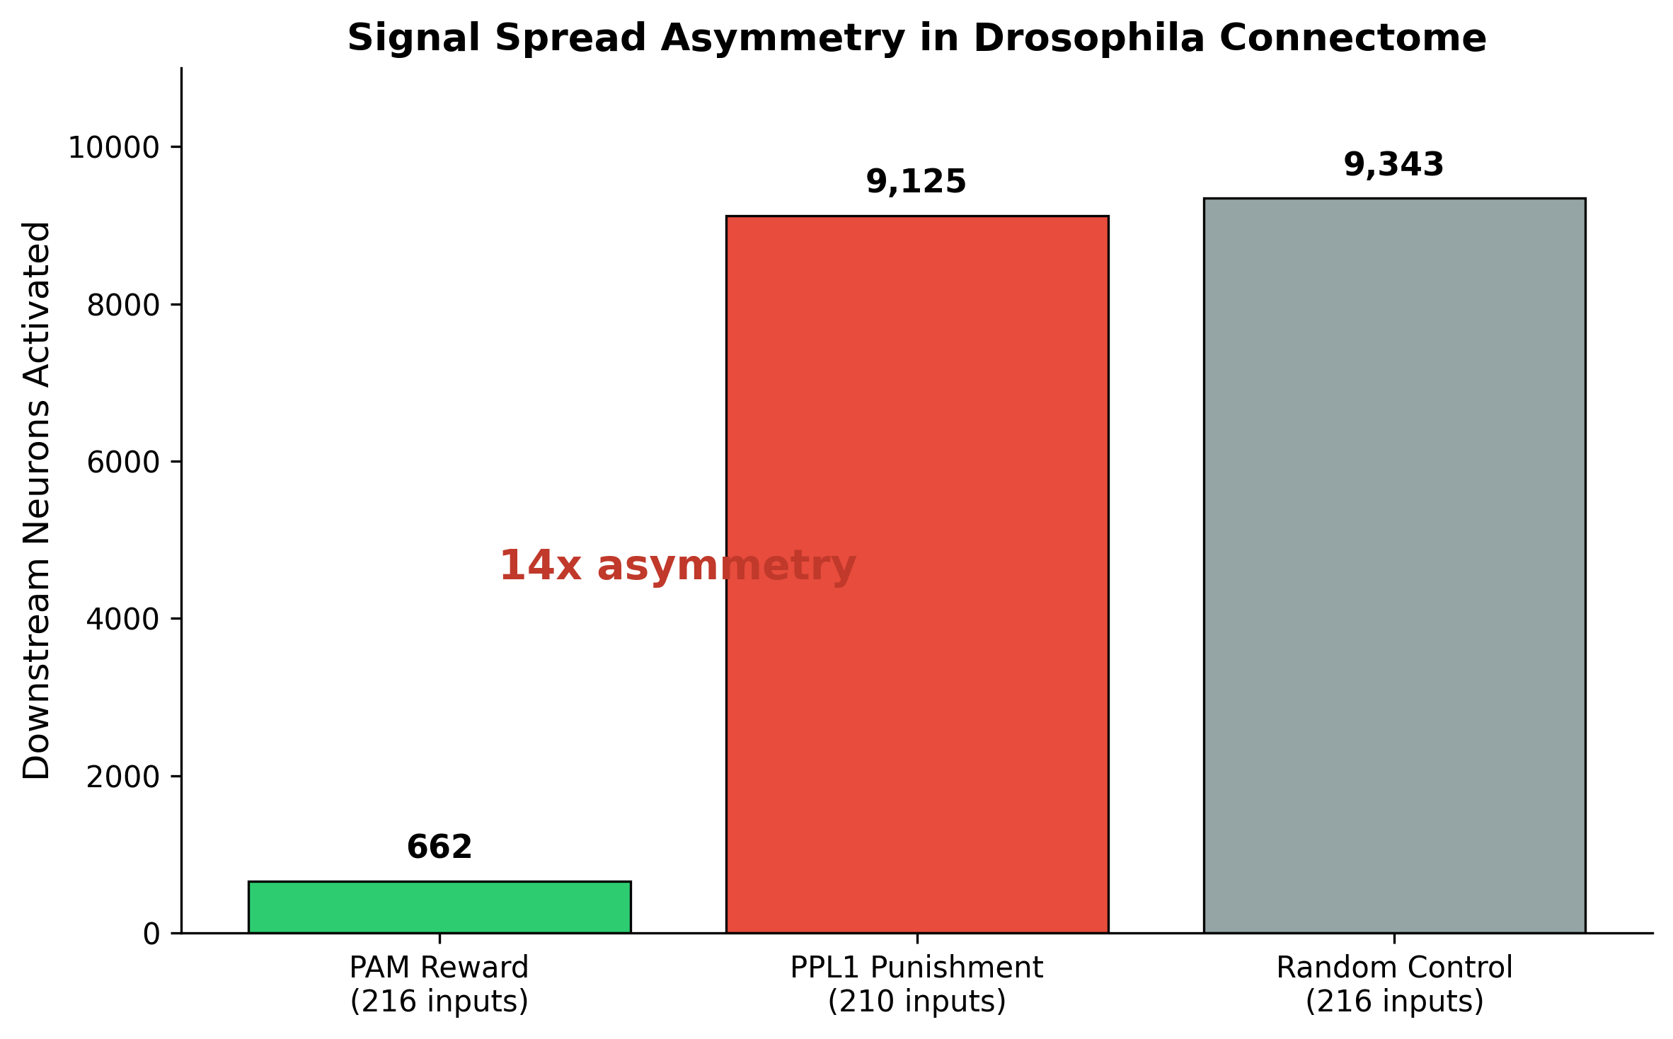
Figure 1. Signal spread asymmetry in the Drosophila connectome. Reward signals (PAM, green) remain contained (662 neurons, 0.5% of brain), while punishment signals (PPL1, red) propagate brain-wide (9,125 neurons, 6.6%), comparable to random activation (gray). Similar input population sizes (216 vs 210) demonstrate that the asymmetry is structural, not an artifact of stimulation magnitude.

4.2.2 Valence Is Encoded in Wiring, Not Just Chemistry
Analysis of mushroom body output neuron (MBON) activation patterns revealed near-complete separation of reward and punishment outputs. Of 34 MBON types activated across both conditions: MBON03, MBON26, MBON27, and MBON29 were activated exclusively by reward stimulation (zero punishment spikes); MBON09, MBON10, MBON12, MBON14, and MBON22 were activated exclusively by punishment (zero reward spikes); only MBON30, MBON31, and MBON32 showed mixed activation from both signals. This valence specificity emerges entirely from connectome topology, with no neuromodulatory parameters, indicating that hedonic valence is encoded at the structural level of neural wiring.

4.2.3 Punishment Suppresses Reward Output
Simultaneous activation of both reward (PAM) and punishment (PPL1) neurons produced fewer active downstream neurons per trial (444.9 +/- 22.8) than reward activation alone (514.7 +/- 25.2), a statistically significant suppression (two-sample t-test: t = 11.25, p < 0.0001). This demonstrates that punishment does not merely add negative valence alongside positive; it actively crushes the reward signal at the circuit level.
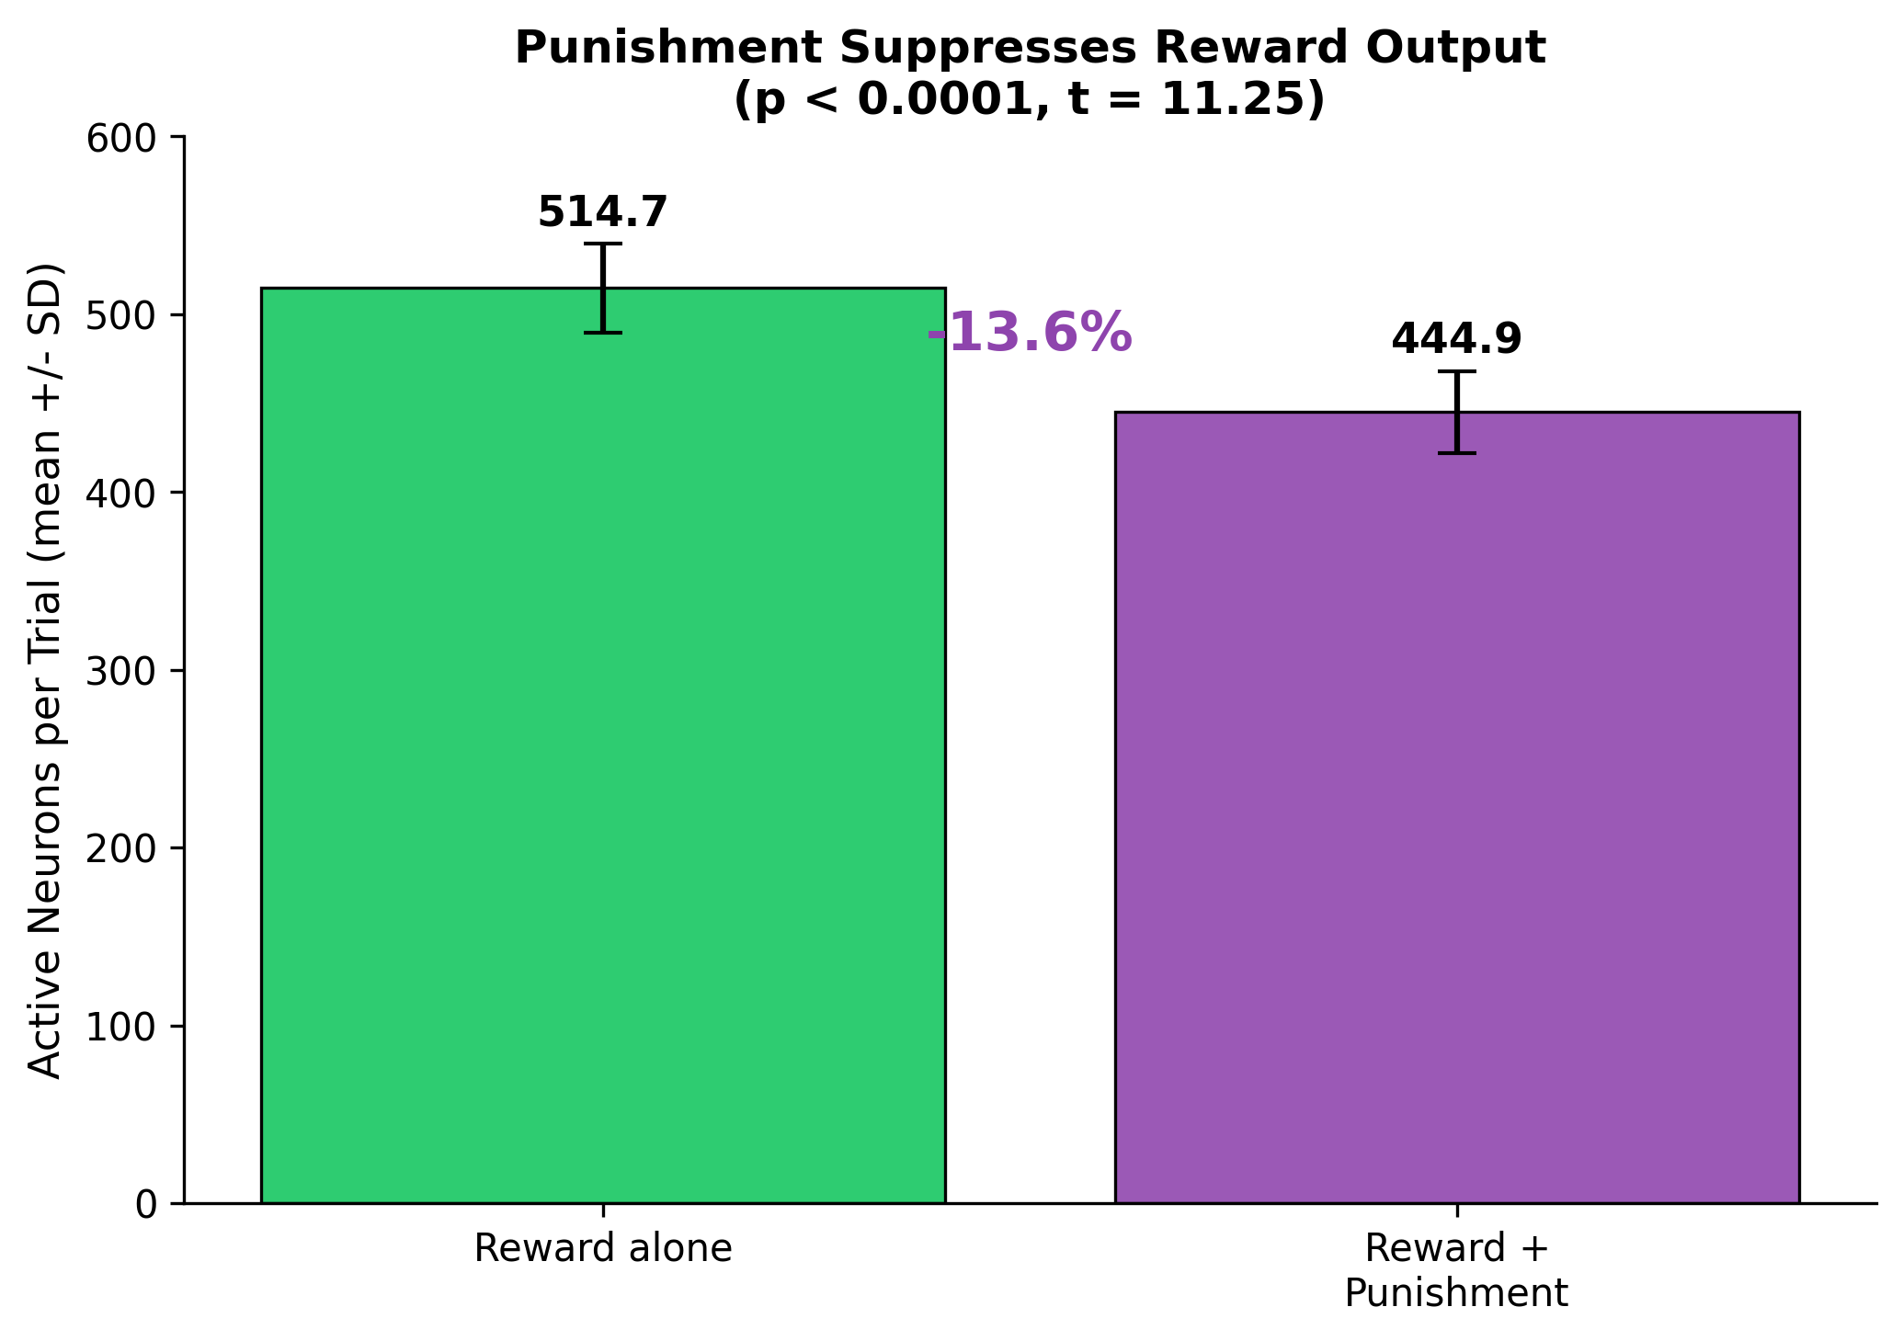
Figure 2. Punishment actively suppresses reward output. Mean active neurons per trial under reward alone versus simultaneous reward and punishment. Error bars show standard deviation across trials. The 13.6% reduction is statistically significant (p < 0.0001, t = 11.25).

4.2.4 Serotonin Activates Both Valence Channels
Activation of serotonergic neurons produced downstream firing in both reward-specific MBONs (e.g., MBON07: 6,965 spikes; MBON05: 4,029 spikes) and punishment-specific MBONs (e.g., MBON09: 7,364 spikes; MBON14: 6,907 spikes). Serotonin was the only neurotransmitter system that broadly engaged both valence channels. This structural finding is consistent with the clinical observation that selective serotonin reuptake inhibitors (SSRIs) frequently produce emotional blunting — reported by approximately 46% of depressed patients on antidepressants in a survey of 669 patients (Goodwin, Price, De Bodinat, & Laredo, 2017) — rather than selective mood elevation.

4.2.5 Dose-Response Is Linear with No Structural Saturation
Varying stimulation frequency from 50 Hz to 500 Hz produced a linear increase in both downstream neuron recruitment (360 to 895 neurons) and total spike count (92,010 to 870,507). No saturation plateau was observed, indicating that the connectome imposes no structural ceiling on reward signal propagation. Any saturation observed in vivo must therefore arise from molecular adaptation mechanisms rather than wiring constraints.
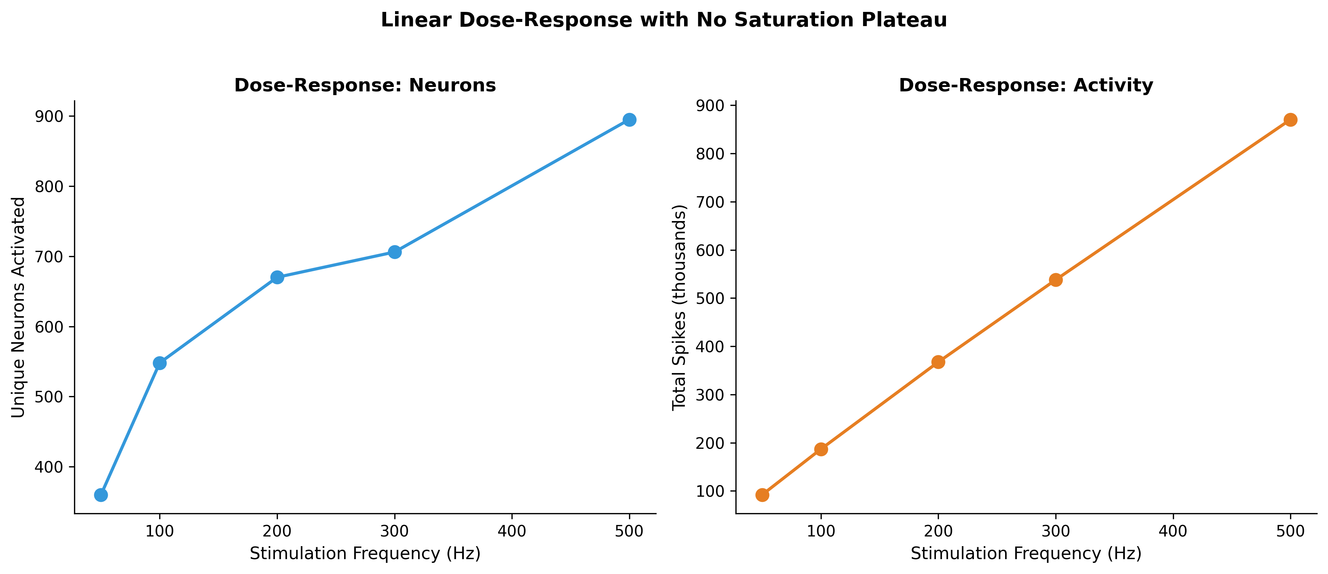
Figure 3. Dose-response relationship between stimulation frequency and downstream activation. Both neuron recruitment (left) and total activity (right) increase linearly from 50 to 500 Hz with no saturation, indicating no structural ceiling on reward propagation.

4.2.6 Temporal Stability Under Sustained Stimulation
An extended 10-second experiment (10 times the standard duration) revealed complete temporal stability of reward circuit dynamics. The branching ratio (sigma, a measure of whether activity is amplifying, stable, or dampening) remained constant at approximately 1.029 throughout the entire stimulation period. Spike rates were flat (373,040 per second at t = 0-500 ms versus 373,136 per second at t = 9,500-10,000 ms). The connectome can sustain reward signals indefinitely at the structural level; any temporal decline in hedonic experience must arise from molecular adaptation.
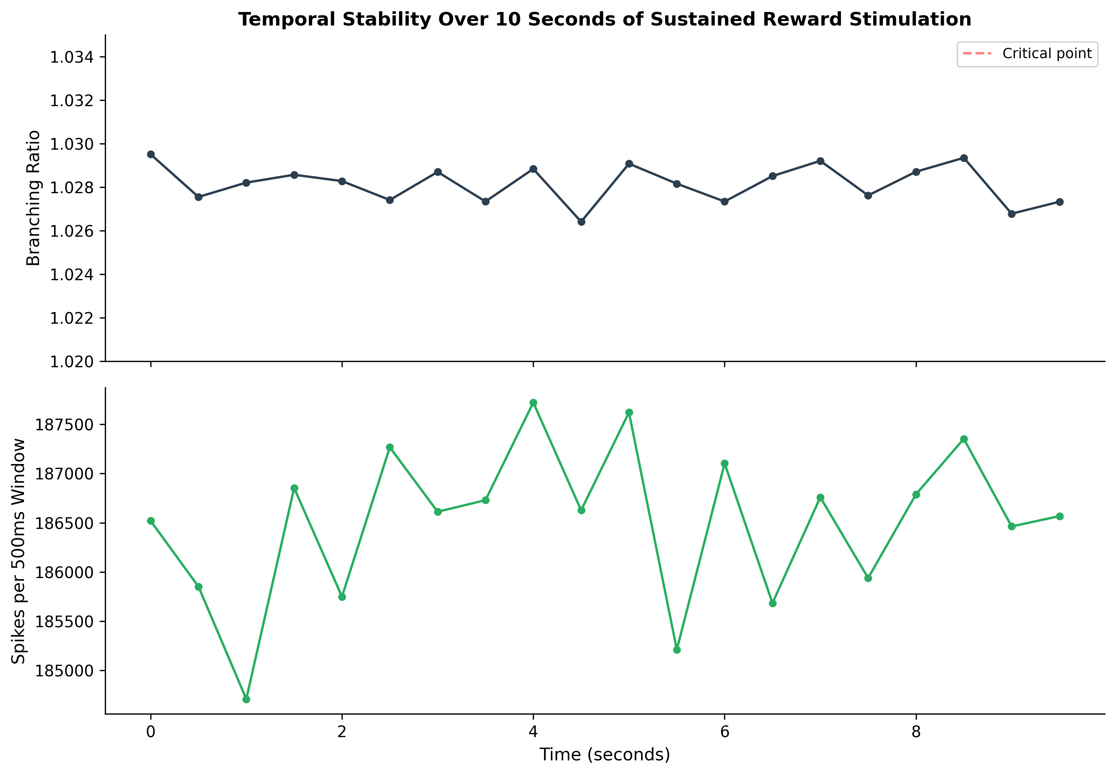
Figure 4. Temporal stability of reward circuit dynamics over 10 seconds of sustained PAM neuron stimulation. Top: branching ratio (sigma) remains constant near 1.029, showing no drift toward dampening. Bottom: spike rate per 500ms window is flat. N = 10 trials.

4.2.7 Natural Versus Artificial Reward: Only 3% Overlap
Comparing natural reward entry (gustatory sugar-sensing neurons, experiment 7) with artificial reward (direct PAM dopamine neuron activation, experiment 2) revealed remarkably little overlap. Sugar GRN activation reached 10,158 downstream neurons while PAM activation reached only 662, with only 317 neurons (3.0% of the union) shared between the two conditions. Critically, sugar activated both reward-specific MBONs (MBON01, MBON05, MBON07) AND punishment-specific MBONs (MBON09, MBON10, MBON14), indicating that natural reward engages the full valence evaluation machinery, whereas direct dopamine neuron activation is more focused on reward-specific outputs. This suggests that direct dopaminergic stimulation does not replicate the full natural reward experience, which includes sensory processing, evaluative context, and engagement of both valence channels simultaneously.

4.2.8 The PAM08 Anomaly: Salience, Not Reward
Analysis of individual PAM subtypes revealed a striking anomaly: PAM08 (45 input neurons) activated 8,343 downstream neurons (185.4 per input neuron), while PAM01 (41 input neurons) activated only 66 (1.6 per input neuron), a 125-fold difference. PAM08 reached 3,363 Kenyon cells (the mushroom body learning neurons), 339 olfactory receptor neurons, and 22 PPL1 punishment neurons, while PAM01 reached zero Kenyon cells and no punishment neurons. PAM08 activated BOTH reward MBONs (MBON05, MBON21) AND punishment MBONs (MBON09, MBON11, MBON14), making it valence-ambiguous. PAM08 projects to the mushroom body gamma-4 compartment, which has dramatically wider downstream connectivity than PAM01's gamma-5 compartment. We interpret PAM08 not as a pure reward signal but as a broad salience or arousal signal encoding something important is happening rather than this is good. For technology targeting hedonic enhancement, PAM01-like focused positive-valence circuits are more appropriate targets than PAM08-like diffuse salience circuits.

4.2.9 The 348 Overlap Neurons: Predominantly Punishment Recruiting Reward
Analysis of the 348 neurons activated by both reward and punishment revealed that apparent valence-overlap is largely an artifact of punishment recruiting reward neurons unidirectionally. Of the 348 overlap neurons, 120 were PAM reward neurons themselves, activated BY punishment (confirming the unidirectional punishment-to-reward connection noted in Section 4.2.3). The global inhibitory feedback neuron APL was highly active in both conditions, functioning as a general gain control mechanism rather than a valence-specific processor. Fifty descending motor neurons responded to both signals, likely representing general arousal or motor preparation rather than valence-specific motor commands. The 25 MBONs that appeared in both conditions were heavily ratio-skewed: MBON06, for example, generated 85% of its spikes from reward versus 15% from punishment. True functional overlap between reward and punishment circuits is minimal.

4.3 Limitations of the Computational Approach
Several important limitations constrain the interpretation of these findings. First, the LIF model incorporates no synaptic plasticity, neuromodulation, or temporal dynamics of neurotransmitter release and reuptake. It cannot model adaptation in any form; the findings represent a structural ceiling on what the connectome can support, not a prediction of what real brains will produce.
Second, we confirmed through control analysis that near-criticality (branching ratio near 1.0, the signature of critical dynamics described by Beggs & Plenz, 2003) is a generic property of the LIF model running on this connectome, not specific to reward circuits. Random neuron activation also produces sigma near 1.0. However, the relative ordering of sigma values across circuit types (punishment more supercritical than reward, which is more supercritical than random baseline) is informative.
Third, Drosophila melanogaster lacks the opioid and endocannabinoid receptor systems that mediate hedonic liking in mammals. Flies possess dopaminergic reward circuits (PAM cluster projecting to mushroom body) that are functionally analogous to the mammalian mesolimbic system, but whether flies experience anything resembling hedonic pleasure remains unknown. Our findings address structural principles of valence circuit architecture, not the subjective experience of pleasure.
Fourth, all simulation results are computational predictions requiring experimental validation. We grade them as evidence level C (model interpretations) rather than level B (single strong study), acknowledging that in silico results carry less weight than in vivo observations.

4.5 TRIBE v2 Brain Encoding Predictions
We used Meta's TRIBE v2 brain encoding model (released March 2026) to predict cortical fMRI responses to text descriptions of euphoric, neutral, and suffering experiences. The model was processed through the LLaMA 3.2-3B text encoder on an NVIDIA RTX 4060 GPU. Predictions were mapped to the fsaverage5 cortical mesh (20,484 vertices) and analyzed using the Destrieux atlas (76 cortical regions).
The principal finding is that euphoria and suffering produce highly similar cortical activation patterns, with a Pearson correlation of r = 0.91 between the mean cortical activation maps. Both conditions deactivate default mode network hubs relative to neutral text: the posterior cingulate cortex (ventral) shows -0.136 for euphoria and -0.207 for suffering, while the precuneus shows -0.131 and -0.195 respectively. Suffering deactivates the DMN MORE strongly than euphoria, suggesting that DMN deactivation is an intensity or engagement signal rather than a valence-specific marker. The regions that differentiate euphoria from suffering are primarily language and social processing areas (superior temporal gyrus, +0.21 difference), not reward or pain circuits. The orbitofrontal cortex is the only region traditionally associated with hedonic processing that shows a valence difference, with euphoria activating it 0.096 units more than suffering.
[SPECULATIVE] These results suggest that hedonic valence is NOT encoded in which cortical regions activate but in subcortical structures (NAcc, amygdala, VTA, ventral pallidum) that are invisible to this cortical surface model. Technology targeting hedonic modulation must focus on subcortical circuits for valence control. Important limitations apply: TRIBE v2 predicts cortical responses to TEXT about emotions, not direct hedonic stimulation; the model maps cortical surface only; and each condition used a single text passage (N=1).

4.6 Computational Signatures of Feeling States
We conducted systematic deep dives into 19 distinct feeling states, examining the neural circuits, neurochemistry, and computational structure of each. Below we present the most significant findings relevant to the technology goal, organized by their contribution to understanding either the generation or elimination of hedonic states.

The Six-Component Signature of Peak Hedonic Experience
Across all verified studies of euphoria, orgasm, musical chills, and mystical experience, a consistent six-component computational pattern emerges. (1) Rate of change, not magnitude: euphoria intensity correlates with the rate of dopamine increase, not the absolute level; smoked cocaine produces greater high than IV cocaine at identical receptor occupancy, with the only difference being speed of onset at 1.4 versus 3.1 minutes (Volkow et al., 2000, PMID 10983846). (2) Threshold plus linear scaling: below approximately 47% dopamine transporter occupancy, no euphoria is perceived (Volkow et al., 1997, Nature, PMID 9126740); above threshold, euphoria scales linearly with ventral striatal dopamine release (r = -0.95; Drevets et al., 2001, PMID 11164755). (3) Shutdown of self-monitoring: during orgasm the vmPFC and OFC deactivate (Georgiadis et al., 2009, PMID 19219848); during mystical experience the entire DMN deactivates (Carhart-Harris et al., 2012); during love, regions for social judgment deactivate (Bartels & Zeki, 2004, PMID 15006682). (4) Prediction violation followed by resolution: musical pleasure is a nonlinear function of uncertainty multiplied by surprise, quantified across 80,000 chords (Cheung et al., 2019, PMID 31708393). (5) Multiple parallel positive channels: MDMA's prosocial and rewarding effects are mechanistically separable serotonergic versus dopaminergic processes (Heifets et al., 2019, PMID 31826983). (6) Removal of gain control: serotonin in the NAcc actively constrains dopamine-driven euphoria; SERT knockout triples reward from the same dose (Pomrenze et al., 2025, PMID 40707786).

Humor: Prediction Violation Plus Safety Check
Humor processing involves two distinct neural stages with different subcircuits. Comprehension engages the dorsal striatum, inferior frontal gyrus, and temporal cortex, while appreciation engages the ventral striatum, amygdala, and midbrain (Prenger et al., 2023, Journal of Neuroscience, PMID 37932104). Critically, humor and monetary rewards use different subcircuits within the mesolimbic system: the NAcc-ACC circuit processes monetary rewards while an amygdala-midbrain circuit processes humorous rewards (Chan et al., 2018, PMID 30337614). The amygdala's involvement may reflect the safety evaluation that distinguishes funny-surprise from scary-surprise. Social laughter triggers endogenous mu-opioid release specifically in the thalamus, caudate, and anterior insula, as measured directly with PET and the receptor-specific ligand [11C]carfentanil (Manninen et al., 2017, PMID 28536272). The thalamic opioid release is noteworthy because the thalamus was identified in our earlier analysis as the brain region with the highest suffering potential and zero opioid resolution capacity; social laughter may be one of few natural mechanisms for delivering endogenous opioids to this critical node.

Despair: The Anti-Reward Burst Machine
Yang et al. (2018, Nature, PMID 29446381) demonstrated that the lateral habenula (LHb) shows increased burst firing in depressive-like animals, that burst-evoking photostimulation of LHb CAUSES behavioral despair and anhedonia, and that ketamine's rapid antidepressant action works by blocking NMDAR-dependent bursting which requires both NMDARs and T-type calcium channels (an AND-gate computation). Local blockade of either receptor type in LHb is sufficient for rapid antidepressant effects. This provides the most computationally precise model of any suffering state: despair equals sustained burst firing in a specific nucleus that tonically suppresses downstream dopamine and serotonin centers.

Curiosity: The Self-Renewing Reward Signal
Information has subjective value computed in striatum and vmPFC using a common neural code shared with basic reward value (Kobayashi & Hsu, 2019, PNAS, PMID 31186358). Cross-categorical decoding confirmed identical representation. Curiosity states enhance hippocampus-dependent learning via the dopaminergic circuit (Gruber et al., 2014, Neuron, PMID 25284006), with incidental material encountered during high-curiosity states remembered better than material during low-curiosity states. Curiosity may track learning PROGRESS rather than absolute novelty (Oudeyer, 2018), making it potentially resistant to habituation because each answer generates new questions and the information space is infinite.

Sadness: Opioid Withdrawal Applied to Social Bonds
Sadness is Panksepp's PANIC/GRIEF system, evolved from mammalian separation distress, operating neurochemically as an opioid withdrawal state. Sadness also amplifies physical pain perception: identical painful stimuli are rated as more intense during sad mood, with greater activation in secondary somatosensory cortex, PAG, subgenual cingulate, and amygdala (Yang & Symonds, 2012, PMID 22964972). Panksepp and Yovell (2014, PMID 25341411) proposed that depression arises from three independent system failures: PANIC/GRIEF overarousal (treatable with low-dose opioids), SEEKING underactivation, and PLAY underactivation, suggesting that depression is not one disorder but three separate computational failures.

Contentment: A Brainstem Phenomenon
Meditation-induced wellbeing improvement correlates with gray matter increases specifically in the brainstem raphe nuclei and locus coeruleus, the sites where serotonin and norepinephrine are synthesized (Singleton et al., 2014, Frontiers in Human Neuroscience, PMID 24600370). This suggests that contentment may be fundamentally a brainstem phenomenon driven by structural changes at monoamine source nuclei, potentially more sustainable than cortical pleasure because tonic low-level signaling from these nuclei produces less adaptation than phasic burst signaling (consistent with the Corder et al., 2013 finding that constitutive receptor activity resists adaptation more than pulsatile stimulation). Transcranial direct current stimulation near the insular cortex enhances soothing positive affect specifically, without changing negative or activating positive affect, and this increase correlates with increased vagally-mediated heart rate variability (Petrocchi et al., 2017, Neuropsychologia, PMID 28126625), connecting serenity to parasympathetic body-state regulation.

Equanimity: A Non-Habituating Baseline Parameter
Focused transcranial ultrasound targeting the posterior cingulate cortex reduces DMN functional connectivity, increases state mindfulness, and produces equanimity-like subjective changes (Lord, Sanguinetti et al., 2024, PMID 38895168). Meditation training reduces amygdala reactivity to emotional stimuli and increases amygdala-vmPFC connectivity (Kral et al., 2018, PMID 29990584). Equanimity may resist habituation because it is a baseline configuration (a gain setting on emotional reactivity) rather than a response to stimuli. Long-term meditators show increasing equanimity with more practice, not decreasing.

Musical Chills: Dual Reward Expression and the Binding Requirement
A critical nuance in musical pleasure: opioid blockade with naltrexone does NOT eliminate subjective music pleasure but DOES reduce physiological arousal responses such as pupil dilation and skin conductance during chills. Opioid enhancement with oxycodone increases physiological arousal but not subjective reports (Mas-Herrero et al., 2023, Annals of NY Academy of Sciences, PMID 36514207; Laeng et al., 2021, Consciousness and Cognition, PMID 33711654; Mallik et al., 2017, Scientific Reports, PMID 28176798). Music pleasure thus has two dissociable components: a cognitive/subjective component mediated by dopamine in fronto-striatal circuits (modulated by TMS), and a bodily/arousal component mediated by opioids. Specific musical anhedonia, affecting approximately 5% of the population, results from reduced functional connectivity between auditory cortex and ventral striatum, not from deficits in either system individually (Martinez-Molina et al., 2016, PNAS, PMID 27799544). This binding requirement means pleasure requires COUPLING between pattern-processing and reward-generating modules, not just the modules themselves.

Ego Dissolution: On a Continuum with Other Peak States
Ego dissolution exists on a continuum with other self-monitoring shutdown phenomena identified across our research. In mild form, the orbitofrontal cortex deactivates during orgasm (Georgiadis et al., 2009). In moderate form, the DMN partially deactivates during flow-like states and deep concentration. In intense form, the entire DMN desynchronizes during psychedelic experience (Siegel et al., 2024, Nature, PMID 39020167), with psilocybin causing more than threefold greater functional connectivity disruption than methylphenidate. This represents a spectrum from mild monitoring reduction to complete self-model dissolution, where deeper shutdown correlates with more intense and more transformative experience. The REBUS model (Carhart-Harris & Friston, 2019, PMID 31221820) provides the computational framework: psychedelics relax the precision of the highest-level prior (the self-model), with the degree of relaxation determining position on the continuum. Jhana meditation in advanced practitioners (23,000+ hours) increases brain entropy (Lempel-Ziv complexity) AND produces states described as bliss, with neurophysiological changes correlating directly with subjective experiences of positive affect (Chowdhury et al., 2025, NeuroImage, PMID 39681243). This provides evidence that increased entropy and positive hedonic experience can co-occur, supporting the entropy-pleasure connection.

Love: Association Persistence, Not Sustained Experience
An important caveat applies to the love finding. While viewing a partner's face activates VTA and dorsal striatum after 21.4 years of marriage (Acevedo et al., 2012, PMID 21208991), this demonstrates that the conditioned reward ASSOCIATION persists for decades, not that the reward EXPERIENCE is continuously sustained. Daily life in a 21-year relationship involves fights, boredom, annoyance, and extended periods of neutral coexistence. The study captures a snapshot response to a deliberate trigger in a scanner, not moment-to-moment experience. The distinction between a persistent conditioned association and sustained hedonic experience is crucial for technology development: maintaining a reward tag on a stimulus for decades is different from feeling rewarded by that stimulus continuously.

Grief as Neurally Distinct from Depression and Trauma
Prolonged grief disorder shows distinct neural profiles from both PTSD and major depressive disorder. Bryant et al. (2021, Psychological Medicine, PMID 31907095) compared 117 participants across four groups (PGD, PTSD, MDD, bereaved controls) and found that PGD uniquely recruits medial orbitofrontal cortex during sad face processing and shows greater amygdala, caudate, and putamen activation to subliminal sad faces compared to MDD. The reward network activation validates models emphasizing yearning and appetitive processes as the core of complicated grief, distinguishing it from the general reward suppression of depression (LHb-mediated) and the threat hyperactivation of PTSD (amygdala-mediated). Grief, depression, and trauma are three computationally independent suffering states that can co-occur but require different interventions.

Sadness, Grief, and Loneliness: Design Implications
All three social suffering states (sadness, grief, loneliness) use the same opioid-dependent social bonding system that produces love and social warmth. You cannot have love without the capacity for loneliness: the bonding system and the loneliness system are two sides of the same mechanism. A potential design solution for digital consciousness is to implement social connection as a bonus reward (activated and enhanced by social interaction) rather than as a homeostatic need (deficit-driven when absent). This would be analogous to how curiosity provides information-processing reward without an information deficit drive: you enjoy learning but do not suffer from an absence of information.

Additional Verified Findings from 2024-2025 Literature
Several recent findings extend our understanding of hedonic circuits. The paraventricular nucleus of the thalamus (PVT) shows enhanced functional connectivity with the NAcc in individuals with higher anhedonia, principally in males (Leonard et al., 2024, Journal of Affective Disorders, PMID 39197547), identifying a new node in the suffering circuit that connects thalamic processing to reward deficits. VTA mu-opioid receptor neurons specifically mediate social withdrawal during protracted opioid withdrawal, connecting to the anterior cingulate cortex (Jo et al., 2024, bioRxiv, PMID 39026700), linking the opioid system to social suffering specifically. Tonic pain experience fluctuates even under constant-temperature heat stimulation, with individual cortical processing patterns varying so substantially that group-average results do not represent any individual participant's actual pattern (Deak et al., 2025, Heliyon, PMID 40007775), confirming that neural activity is never truly constant even under constant input. Herzog et al. (2023, Scientific Reports, PMID 37069186) built the first whole-brain computational model explaining why psychedelics increase entropy: 5-HT2A receptor activation drives entropy increase, but the spatial pattern is shaped by anatomical connectivity topology, not just receptor density.

4.7 Cross-Domain Patterns
Cross-referencing findings across all 19 feeling states and 12 research domains revealed five patterns not apparent from any single domain in isolation:
Pattern 1: The NAcc as domain-general value computation. The NAcc appears in 8 of 12 research domains in opposing roles: activated by euphoria, curiosity, music pleasure, relief, humor, AND complicated grief craving; suppressed in loneliness and anhedonia. It is not a pleasure center but a general value computation node that activates for anything the brain computes as worth pursuing.
Pattern 2: Prediction error as potentially universal hedonic computation. Prediction error appears as the core mechanism in six feelings: euphoria (rate of dopamine change), music (f(uncertainty, surprise)), relief (negative prediction violated), grief (unresolvable prediction error), despair (LHb fires on negative prediction errors), love rejection (reward prediction for absent partner). Every positive feeling involves reality exceeding prediction or prediction violated and resolved; every negative feeling involves prediction violated and NOT resolved. (Grade C: synthesis, not published finding.)
Pattern 3: Mu-kappa opioid duality. Mu-opioid receptors mediate hedonic liking, social laughter pleasure, and social bonding warmth. Kappa-opioid receptors (dynorphin) mediate anti-reward suffering. Social laughter releases opioids in the thalamus while the kappa system is most active in the lateral habenula. Humor and despair may be opposite poles of a single opioid axis.
Pattern 4: Gain control spectrum. Anxiety equals increased gain on threat prediction (Paulus & Stein, 2006). Sadness equals increased gain on pain (Yang & Symonds, 2012). Equanimity equals decreased gain (Lord et al., 2025). Euphoria equals gain control removed (Pomrenze et al., 2025; Georgiadis et al., 2009). These may be four positions on a single gain dimension rather than four independent systems. (Grade C: speculative unification.)
Pattern 5: Relief and musical chills are computationally identical. Both require a prediction, a violation, the violation being safe or better than expected, and both produce dopamine release in NAcc. Relief operates in the threat domain; music in the auditory pattern domain. The abstract computation is identical: prediction of X, not X occurs, positive prediction error, reward. Domain irrelevance supports substrate independence.

5. An Entropy-Based Framework for Hedonic Adaptation
Note: This section presents a speculative theoretical framework. The hypotheses proposed here are not established science and require experimental testing. Claims are graded D (speculation/theoretical).

5.1 The Prediction-Entropy Connection
Two established findings, when juxtaposed, suggest a possible unifying mechanism for hedonic adaptation:
First, consciousness correlates with the entropy of brain dynamics. Carhart-Harris (2014) proposed the entropic brain hypothesis, in which normal waking consciousness occupies a moderate-entropy regime, depression represents abnormally low entropy (rigid, repetitive neural dynamics corresponding to rumination), and psychedelic states represent elevated entropy (diverse, unpredictable dynamics). Gamma synchrony (25-42 Hz), the strongest neural correlate of conscious awareness, reflects high-entropy dynamics (Lutz et al., 2004).
Second, momentary happiness tracks reward prediction errors (RPE), not absolute reward magnitude. The Rutledge happiness equation, validated on 18,420 participants, demonstrates that the RPE weight (w3) is the strongest predictor of happiness, with a temporal decay parameter gamma of approximately 0.8 (Rutledge et al., 2014, 2015).
[HYPOTHESIS] We propose that hedonic adaptation may represent the brain reducing the entropy of a sustained hedonic signal below the threshold for conscious experience. When a hedonic signal is novel (unpredicted), it generates high prediction error and high entropy, producing conscious pleasure. As the brain builds a predictive model of the sustained signal, entropy decreases, prediction error approaches zero, and the signal falls below the threshold for conscious impact. The feeling does not disappear because receptors stopped working; it disappears because the brain predicted it into unconsciousness.

5.2 Evidence Consistent with the Framework
Several observations are consistent with this framework, though none constitute proof:
First, DBS for depression does not habituate, and may maintain high entropy through chaotic nonlinear response of the stimulated circuit. A constant 130 Hz input to a nonlinear neural network does not produce constant output; it produces complex, unpredictable dynamics that the brain cannot fully predict, potentially maintaining high entropy and thus conscious impact.
Second, variable-pattern stimulation prevents tremor habituation in essential tremor DBS (Fasano & Helmich, 2019), and alternating stimulation patterns maintained better efficacy than constant parameters in a randomized trial. If unpredictability resists adaptation, this is consistent with the entropy framework.
Third, psychedelics, which increase brain entropy (Carhart-Harris, 2014), produce rapid and sustained antidepressant effects in treatment-resistant depression (Carhart-Harris et al., 2021). This is consistent with the proposal that increased entropy counteracts the entropy-reducing process of depressive rumination.
Fourth, long-term meditators show the highest gamma synchrony ever recorded (Lutz et al., 2004), suggesting maintenance of high-entropy brain dynamics. Meditation practice is associated with sustained wellbeing improvements over decades.

5.3 Testable Predictions
The entropy framework generates several testable predictions:
(1) Variable, unpredictable stimulation patterns should resist hedonic adaptation more effectively than constant stimulation, holding total energy input equal (testable in Experiment 3).
(2) Closed-loop stimulation (triggered by real-time biomarkers rather than running continuously) should inherently resist adaptation because its temporal pattern is responsive and therefore unpredictable from the brain's perspective.
(3) Hedonic states should correlate with entropy measures computed from anterior insula electrophysiology, the site where interoceptive signals become conscious (Craig, 2002).
(4) A sustained hedonic signal should show declining entropy in relevant brain regions (measured by fMRI multi-scale entropy or EEG spectral entropy) as adaptation develops. If entropy decline precedes subjective hedonic decline, this supports the framework; if subjective decline precedes entropy decline, the framework is weakened.

5.4 Limitations
This framework is speculative (evidence grade D) and carries several limitations. The connection between information-theoretic entropy and subjective experience remains unexplained; the framework describes a potential computational correlate of adaptation but does not explain why any physical process produces conscious feeling. The framework does not address the molecular adaptation layers directly and is better understood as complementary to, rather than competing with, the receptor-level account of Section 2.3. Finally, the framework does not solve the hard problem of consciousness and should not be interpreted as a theory of consciousness.

6. Critical Experiments
We propose eight experiments designed to address the most significant gaps in the current knowledge. Each experiment is presented with its motivating question, predicted outcomes, and implications for hedonic technology development.
Experiment 1 (HIGHEST PRIORITY): Chronic Optogenetic Stimulation of the VP Posterior Hedonic Hotspot. This addresses the single most important unanswered question: does sustained activation of the hedonic hotspot produce persistent liking, or does it habituate? All published hedonic hotspot experiments are acute (single-session). We propose four groups of rats (N = 40): continuous 20 Hz stimulation, variable-frequency stimulation (10-40 Hz randomized), event-triggered stimulation (during sucrose delivery only), and eYFP control, with taste reactivity measured over 30 consecutive days. Post-mortem measures would include DeltaFosB immunohistochemistry and mu-opioid receptor density. Estimated cost: $150,000-250,000. If liking habituates under continuous but not variable stimulation, this would strongly support the entropy framework and define the technology direction. Laboratories capable of running this experiment include the Berridge Lab (University of Michigan) and the Tye Lab (Salk Institute).
Experiment 2 (HIGH PRIORITY): Focused Ultrasound Targeting NAcc Medial Shell in Treatment-Resistant Anhedonia. Focused ultrasound (FUS) has achieved 1-5 mm spatial resolution for deep brain targets non-invasively (Fonzo et al., 2025). The NAcc hedonic hotspot is approximately 1 mm in rats; the corresponding human hotspot size is unknown but may be estimated at 2-5 mm based on relative brain scaling (speculative). We propose a double-blind, sham-controlled crossover in 30 patients with treatment-resistant anhedonia, measuring pleasantness ratings and the Effort Expenditure for Rewards Task. Estimated cost: $500,000-1,000,000.
Experiment 3 (HIGH PRIORITY): Variable vs. Constant Pattern DBS in Essential Tremor. This directly tests the entropy hypothesis. We propose a randomized crossover comparing standard 130 Hz, variable-frequency (90-170 Hz pseudo-random), and closed-loop (accelerometer-triggered) DBS (cf. Scangos et al., 2021) in 20 ET patients with documented habituation. If variable stimulation prevents habituation, the entropy mechanism is strongly supported. This experiment is highly feasible because patients already have DBS implants; only programming changes are required. Estimated cost: $200,000-400,000.
Experiment 4 (MEDIUM-HIGH PRIORITY): DeltaFosB Accumulation Under Electrical vs. Chemical Reward Stimulation. This tests whether DBS bypasses the epigenetic adaptation layer. Five groups of rats receive chronic cocaine, VTA optogenetic stimulation, NAcc DBS, MFB DBS, or sham surgery for 14 days, followed by DeltaFosB immunohistochemistry. If DeltaFosB is absent under DBS, this explains the non-tolerance and validates electrical over chemical approaches. Estimated cost: $100,000-200,000.
Experiment 5 (MEDIUM PRIORITY): AC5 Conditional Knockout in NAcc During Chronic Opioid Stimulation. Using D1-Cre mice crossed with AC5 floxed mice, this tests whether removing the most robust adaptation layer (AC superactivation) in the reward circuit specifically delays tolerance without affecting reward generation. Estimated cost: $200,000-350,000.
Experiment 6 (MEDIUM PRIORITY): Closed-Loop Hedonic Neurofeedback Using Real-Time Anterior Insula fMRI. Can people learn to voluntarily upregulate hedonic circuit activity? Forty participants would receive 10 sessions of real-time fMRI neurofeedback targeting the right anterior insula, with sham feedback control. If hedonic circuit upregulation is trainable, this represents a non-invasive, non-pharmacological pathway to hedonic enhancement. Estimated cost: $300,000-500,000.
Experiment 7 (COMPLETED COMPUTATIONALLY): Extended Fly Connectome Simulation. This experiment has been completed as part of the present work. A 10-second simulation (10 times standard duration) of PAM reward neuron activation showed complete temporal stability of circuit dynamics. Branching ratio did not drift, spike rates were flat, and network recruitment was stable. This confirms that the connectome imposes no structural dampening on sustained reward signals.
Experiment 8: Tonic Versus Phasic Hedonic Circuit Stimulation and Adaptation Rates. Corder et al. (2013) demonstrated that constitutive (tonic) mu-opioid receptor activity following tissue injury maintains antinociception for months with less severe adaptation than pulsatile agonist-driven activation. Our literature search confirmed that no study has directly compared adaptation rates for tonic versus phasic stimulation of the same hedonic circuit under controlled conditions. Proposed: optogenetic stimulation of NAcc medial shell hedonic hotspot in two matched groups — continuous low-frequency activation (tonic, mimicking constitutive receptor activity) versus intermittent high-frequency bursts (phasic, mimicking drug-like reward delivery) — with total photon delivery matched across groups over each day. Taste reactivity measured daily for 21-28 days. Post-mortem measurements of GRK phosphorylation levels, beta-arrestin recruitment, AC isoform expression, DeltaFosB accumulation, and dynorphin levels in both groups to determine which specific adaptation layers are differentially engaged by tonic versus phasic patterns. This experiment directly tests whether the PATTERN of hedonic stimulation, not just its presence, determines adaptation rate. Estimated cost: $150,000-250,000.
The total estimated cost for all external experiments is approximately $1,400,000 to $2,950,000. A minimum viable program consisting of Experiments 1 and 8 ($300,000-500,000 combined) would answer the two most critical questions — whether chronic hotspot stimulation habituates at all, and whether tonic stimulation resists adaptation better than phasic — and together would define the subsequent research trajectory.

7. Ethical Framework for Hedonic Technology

7.1 A Consciousness-Centric Ethical Framework
The development of technology capable of modulating hedonic experience raises ethical questions of unusual depth and consequence. We propose a consciousness-centric framework, developed through extended philosophical dialogue between the authors, that departs from conventional bioethics in several respects.
The framework begins with a foundational claim: positive valence is the only intrinsic good, and negative valence is the only intrinsic bad. Every secondary value, including meaning, purpose, dignity, accomplishment, and authenticity, derives its value from its relationship to subjective hedonic experience. Meaning is valued because its presence produces positive affect and its absence produces negative affect. Purpose is valued because purposelessness produces suffering. Dignity matters because its violation causes distress. This framework is consistent with classical philosophical hedonism (Epicurus, Bentham, Mill) and with David Pearce's contemporary Hedonistic Imperative, but it is grounded in the neuroscience reviewed in the preceding sections rather than in philosophical argument alone.
A critical distinction within this framework is between reducing suffering and increasing pleasure. Our connectome analysis (Section 4) provides structural evidence for what psychology has long observed: these are independent axes, not opposite poles of a single dimension. Reward and punishment circuits are structurally separate (Section 4.2.2), with punishment exerting dominant suppressive effects on reward (Section 4.2.3). Meditation research demonstrates that wellbeing can increase through suffering reduction without measurable increases in hedonic pleasure, a transition from high-suffering/low-pleasure to low-suffering/low-pleasure (the distinction between quadrants in a two-dimensional hedonic space). The practical consequence is that technology must address suffering and pleasure as separate engineering problems, and suffering elimination must take priority: our data show that active punishment circuits structurally suppress reward output (p < 0.0001), so pleasure enhancement cannot succeed until suffering is addressed.

7.2 Five Ethical Guidelines
We propose the following five guidelines for the development and deployment of hedonic technology:
Guideline 1: Identify and Protect Conscious Beings. No termination of a conscious being without informed consent. When consent is impossible (e.g., due to impaired consciousness), minimize suffering as the default action. This guideline extends to non-human animals and, potentially, to artificial systems if they are determined to be conscious.
Guideline 2: Minimize Suffering. Across all conscious beings, weighted by intensity and duration. This guideline takes absolute priority over pleasure maximization, both on ethical grounds and on the practical ground that suffering circuits structurally suppress pleasure circuits.
Guideline 3: Maximize Positive Experience. Across all conscious beings, weighted by intensity and duration. This guideline is secondary to suffering minimization.
Guideline 4: Respect Autonomy. No modification of a conscious being's hedonic experience without informed consent. This guideline was added through philosophical dialogue in recognition that a well-intentioned hedonic technology applied without consent would represent a dystopian outcome. The distinction between utopia and dystopia in hedonic technology is precisely the presence or absence of consent.
Guideline 5: Responsible Creation. New conscious beings should be created only when guidelines 1 through 4 can be reasonably met for them. This addresses the antinatalist challenge: creating consciousness entails creating the capacity for suffering.

7.3 The Transition Problem
A significant tension exists between Guideline 4 (autonomy) and the observation that people systematically make choices based on false beliefs about hedonic forecasting. The hedonic adaptation literature demonstrates that individuals consistently overestimate the hedonic impact of both positive and negative life events (Kahneman et al., 1999). If hedonic technology could guarantee reduced suffering, should it be made available even when individuals, reasoning from incorrect hedonic models, decline it?
The directing researcher (T.P.) argued that once the science is proven and suffering is reliably eliminable, there is a strong case for making the technology available and encouraging its adoption, on the grounds that people's current preferences are formed under ignorance of their own hedonic architecture. However, the present authors agree that this position applies only after a transition period in which the technology has been validated and its effects are transparent. During the development and validation phase, informed consent is an absolute requirement.
A related question concerns death. Technology that eliminates suffering may alter an individual's attitude toward mortality, potentially overriding previously held preferences for the option of eventual death. The authors propose that technology should first aim to eliminate involuntary suffering, specifically suffering not under the individual's control, without modifying attitudes toward death. This preserves the individual's autonomy on the most consequential personal decision while removing the suffering that distorts their reasoning about it.

7.4 Consciousness Beyond Biology
The ethical framework presented here is consciousness-centric rather than species-centric. If a silicon-based system were determined to experience positive or negative valence, the guidelines would apply to it with equal force. This follows from the foundational claim that valence, not biology, is the locus of moral significance.
The hard problem of consciousness, why any physical process produces subjective experience, remains unsolved. However, we argue that this is not a barrier to technological progress. Engineers used electricity for decades before Maxwell characterized electromagnetic fields. Physicians used aspirin for a century before the discovery of COX inhibition. What matters for hedonic technology is mapping the sufficient conditions for hedonic experience with enough precision to reliably produce and modulate it, even without a complete theory of why those conditions generate subjective feeling.

7.5 Deeper Philosophical Positions
Several deeper philosophical positions emerged through extended dialogue and underpin the ethical framework presented above. We present them here not as established truths but as a coherent philosophical stance that informs the direction of the research program.
Universal hedonic motivation and the illusion of selflessness. All voluntarily chosen suffering is ultimately a decision to minimize future suffering and/or maximize future positive feelings. A soldier protecting his family gets peace of mind that his family is safe and has purpose which brings about the least future suffering and the most happiness, even if he is risking his life and sanity in a warzone at that present moment. An athlete pushes through pain because winning feels good and losing feels bad, but even if they lose, they don’t want to live with the future guilt/shame that they did not push themselves hard enough through that pain (for example). Even acts that appear selfless are motivated by the actor's own hedonic outcome: a person sacrificing their life to save another might experience a rush of energetic aggression honed as a flow state, or FEEL the need that it is the right thing to do and anticipate deep reward if they survive (or deep future guilt if they don’t help whatsoever), or may even be completely ignorant of the mortal risk. Even if selfless acts appear as selfless, that is the illusion of objective reality. We will never take a route of suffering that is guaranteed to lead to more suffering. We will only do so if we subconsciously understand that there is some form of good feeling or reward to our experience that will follow. Feelings dictate everything, but we do not see it because they are hidden under our subconscious. Bad feelings are the absolute bad and good feelings are the absolute good; there is no complicated other reality which everyone seems to believe is reality.
Contrast is unnecessary for value. A conscious being experiencing only positive states is not missing something. The assumption that pleasure requires contrast with suffering to have value is a human-centric bias arising from our experience of both, not a universal truth about consciousness. A being that has never known suffering is experiencing genuine positive valence. The contrast theory is an artifact of biological evolution, which required both positive and negative signals for survival, not a requirement of consciousness itself.
The drug model versus the technology model. Drugs do not achieve what hedonic technology aims for. Drugs make you feel a highly positive valence, then as brain chemistry rebalances you feel seemingly equally and oppositely bad — the rebound suffering may be less intense than the peak but extends over a longer duration, preserving the approximate total magnitude across time, consistent with opponent process theory (Solomon & Corbit, 1974). The drug model is intense high followed by prolonged low. What we pursue is fundamentally different: intense positive experience followed by at most mild normal fluctuation, not an equal opposing crash. People can make decisions that keep them in a neutral baseline, sort of like what monks do, but even then they experience some unbalancing of the scale. If we could leave in all of the amazingly intense goodness but not have that seemingly equal bad reaction, replacing it with only very mild normal bad feelings, that is a very high overall positive valence. The mathematical answer favors this approach: if A is pure neutrality (value zero) and B is intense pleasure with occasional mild suffering, B has much higher total positive valence.
Death as an open question. There is still that chance down the line that we will understand through science exactly why consciousness arises, and exactly what dimension it may exist in. Maybe nobody ever truly dies, and they live on in this other dimension where it could be pure hell, pure neutrality, or pure heaven. We are probably far from knowing this, but that does not mean it is unknowable. Our direct approach to life and consciousness should be to not make extreme judgments about things we do not KNOW with empirical evidence or data. We can have faith in things, but we should not forcibly shove faith in front of people as proof. If we find death to always be completely unknowable in the far distant future, then death should be a decision for that conscious being to create. Nobody would choose death if they lived in a simulation of pure heaven.
[SPECULATIVE] What if the intensity of positive feelings is just the amount of electrical signals or pathways? If so, the bigger and more resources we accumulate from the universe, the more intense happiness we can create, and thus it is a seemingly infinite loop of existence becoming better and better the more bigger and greater our technology becomes. If we find the architecture of what creates good feelings, surely scale in resources will affect scale in positive feelings. These are speculative, but these are what should be said now.
The question of consciousness verification dissolves with better understanding. We currently lack the tools to verify whether a computational system is conscious, but this is a limitation of our current science, not a fundamental unknowability. The hard problem of consciousness is hard NOW but may be solvable with better physics and neuroscience. Our ethical obligations to digital systems will become clearer as our science improves. We should not permanently defer the question or make it unfalsifiable.
All guidelines are revisable. No dogma. Even fundamental principles should be open to revision if a superintelligent AI or future science finds genuine flaws with evidence. The guidelines we have developed are our best current understanding, not eternal truths. This anti-dogmatic stance protects against the risk of encoding current human biases as permanent constraints on future systems that may understand consciousness better than we do.

8. Discussion

8.1 What We Know: Evidence-Graded Summary
Grade A (meta-analyses, well-replicated findings): The wanting-liking dissociation (Berridge & Robinson, 1989, replicated across species and methods). Hedonic hotspot anatomy (Berridge, 2015; multiple independent replications). AC superactivation universality (Avidor-Reiss et al., 1997; replicated across receptor systems). DeltaFosB accumulation under chronic reward (Nestler, 2001; extensively replicated). Loss aversion asymmetry (Kahneman & Tversky, 1979; coefficient of ~2.25 quantified in Tversky & Kahneman, 1992). Hedonic adaptation to major life events (Kahneman et al., 1999; twin studies by Lykken & Tellegen, 1996). FlyWire connectome completeness (Dorkenwald et al., 2024). SSRI efficacy (Cipriani et al., 2018, 522 trials, 116,477 patients).
Grade B (single strong studies, validated model outputs): DBS non-tolerance in depression (Bewernick, Coenen, Schlaepfer et al., 2017-2022; Bewernick et al., 2012; Crowell et al., 2019). Beta-arrestin 2 KO enhanced analgesia (Bohn et al., 1999; partially contradicted by Kliewer et al., 2020). Biased agonism collapse (Gillis et al., 2020; Ko et al., 2023). Entropic brain theory (Carhart-Harris, 2014). Connectome-derived valence separation (present work, validated infrastructure). Punishment suppression of reward (present work, p < 0.0001).

8.2 What We Speculate: Explicitly Labeled
Grade B (single strong studies, validated model outputs): AC1 inhibitor relieves pain without tolerance (Giacoletti et al., 2022, preclinical). Aticaprant KOR antagonist Phase 2 RCT succeeded for anhedonia (Schmidt et al., 2024). Focused ultrasound to PCC produces equanimity-like states (Lord et al., 2024, N=30 sham-controlled). Jhana meditation increases entropy and produces bliss (Chowdhury et al., 2025, N=1). Social laughter triggers mu-opioid release in thalamus (Manninen et al., 2017, PET). Musical pleasure follows nonlinear uncertainty-surprise interaction across 80,000 chords (Cheung et al., 2019). TMS bidirectionally modulates music pleasure (Mas-Herrero et al., 2018). TRIBE v2 predicts euphoria-suffering cortical correlation r = 0.91 (present work, model prediction). Connectome-derived valence separation and 14-fold punishment spread asymmetry (present work, validated model). Punishment suppresses reward output p < 0.0001 (present work). PAM08 is a salience signal not a reward signal (present work, model prediction).
Grade C (model interpretations and cross-domain synthesis): Six-component computational signature of peak hedonic experience (synthesis of A-grade findings, but the unification is our framework). Five cross-domain patterns including prediction error as potentially universal hedonic computation, gain control spectrum from anxiety to euphoria, and mu-kappa opioid duality (each individual finding is verified, the cross-domain connections are our synthesis). Curiosity as non-habituating reward signal (inference from Oudeyer 2018 framework). Equanimity as gain parameter rather than emotion (inference). Social connection as implementable bonus versus need (design inference).
Grade D (theoretical framework, untested): Entropy-based framework for hedonic adaptation (Section 5; no direct experimental support). Adaptation as entropy reduction below consciousness threshold (speculative). Variable stimulation defeating adaptation through entropy maintenance (consistent with ET DBS data but not directly tested for hedonic circuits). Substrate independence of hedonic computation (philosophical claim, supported by computational analysis but untestable without solving hard problem of consciousness). Boredom and habituation as removable biological machinery rather than physical necessities (philosophical claim). Scaling of positive experience with computational resources (speculative).

8.3 What We Do Not Know: Critical Gaps
The most significant gap in the current literature is the complete absence of chronic stimulation experiments at hedonic hotspots (Experiment 1). All published hedonic hotspot work uses acute, single-session measurements. Whether the hotspot pathway habituates to sustained activation is unknown and unknowable without this experiment.
No study has measured DeltaFosB accumulation under DBS conditions (Experiment 4). This represents a direct test of whether electrical stimulation bypasses the epigenetic adaptation layer.
Whether the entropy framework is correct cannot be determined from existing data. Experiment 3 (variable versus constant DBS in essential tremor) would provide the most direct test.
The relationship between fly and mammalian hedonic circuits is unclear. Drosophila lacks opioid receptors and cortical hedonic hotspots. Our connectome findings address structural principles of valence circuit architecture, but their translation to mammalian hedonic systems requires empirical validation.

8.4 Limitations
This paper is a cross-disciplinary synthesis, not original wet-lab research. Its primary contributions are the identification of cross-domain connections (particularly between the DBS non-tolerance literature and molecular adaptation research), the computational predictions from the fly connectome, and the proposal of specific experiments. These contributions have inherent limitations.
The fly brain simulation, while validated against published benchmarks, is a simplified model that cannot capture neuromodulation, plasticity, or the temporal dynamics of real neural processing. Our computational findings should be treated as hypotheses requiring experimental testing, not as established biological facts.
The AI-assisted methodology introduces risks of confabulation. While we have implemented verification procedures (source checking, contradiction detection, evidence grading, control experiments), we cannot guarantee that all claims are free from AI-generated errors. Critical claims should be verified against primary sources.
The ethical framework is philosophical in nature and reflects the values and reasoning of the authors. It is presented as a starting point for discussion, not as a prescriptive policy recommendation.
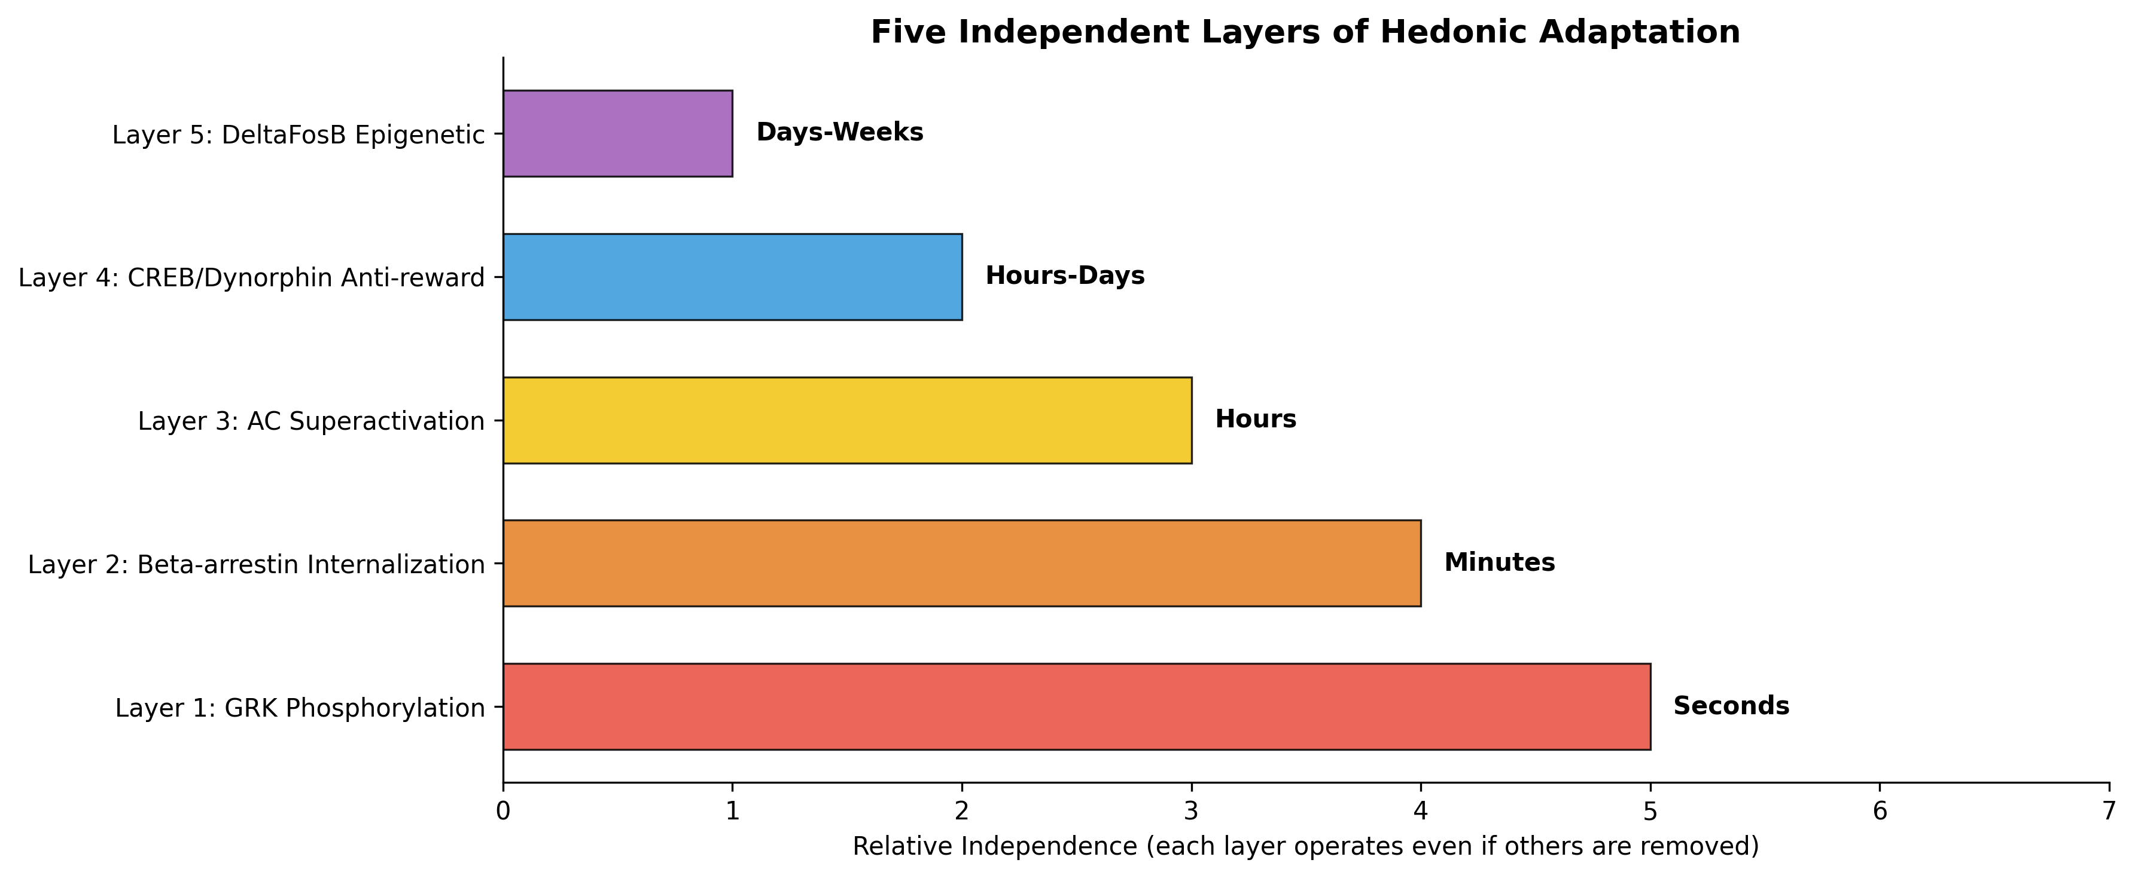
Figure 5. The five independent molecular layers of hedonic adaptation, each operating on distinct timescales. The redundancy of these layers means that disabling any single layer delays but does not prevent adaptation, requiring either a multi-target approach or a strategy that bypasses the molecular cascade entirely (such as electrical stimulation).
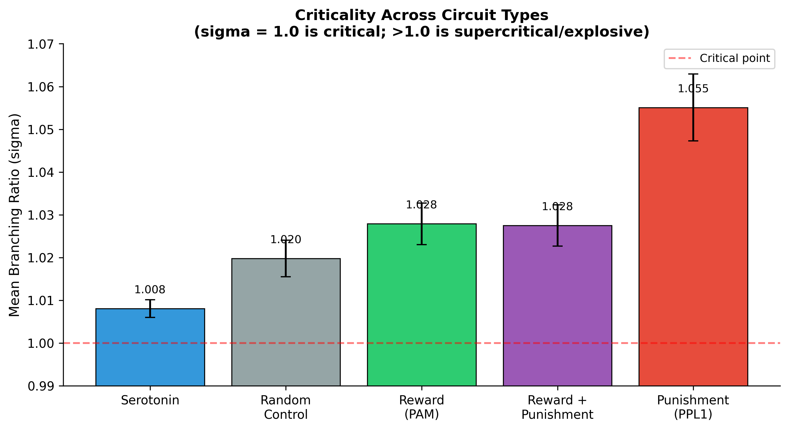
Figure 6. Branching ratio (sigma) across circuit types. All circuits operate near criticality (sigma close to 1.0), but this is a generic property of the LIF model on this connectome (random control is also near-critical). The relative ordering, with punishment more supercritical than reward, is informative: punishment signals propagate more explosively, consistent with the 14-fold spread asymmetry shown in Figure 1.

9. Conclusion
The central argument of this paper is that the barriers to sustained positive hedonic experience are biological and information-theoretic, not physical. Six independent layers of hedonic adaptation constrain the duration of pleasure: five molecular layers encoded in specific genes (GRK, beta-arrestin, AC superactivation, CREB/dynorphin, DeltaFosB) and one information-theoretic layer (efficient neural coding). The five biological layers are formidable in their redundancy, and most pharmacological approaches are defeated by one or more of them, though recent developments including a selective AC1 inhibitor that relieves pain without tolerance (Giacoletti et al., 2022) and a kappa-opioid antagonist showing antidepressant efficacy in Phase 2 trials (Schmidt et al., 2024) suggest that targeted single-layer interventions may be feasible. The information-theoretic layer, unique in being rooted in mathematics rather than biology, requires signal variability rather than elimination.
However, the open-label long-term DBS data, in which electrical stimulation for depression shows maintained or improving response rates over years in uncontrolled follow-up of approximately 200 patients, raises the possibility that adaptation may not be inevitable for all forms of neural modulation. Although the two major sham-controlled RCTs (BROADEN and RECLAIM) failed to separate from sham at their primary endpoints, and the long-term data is subject to survivorship bias and placebo effects, one discontinuation-design RCT (Bergfeld et al., 2016) did show significant separation. If confirmed by adequately powered controlled long-term studies, something about the mechanism of electrical stimulation may interact differently with the molecular adaptation cascade. Whether this would reflect the absence of receptor-mediated triggering of the cascade, the maintenance of high-entropy dynamics that resist prediction, or progressive neuroplastic reorganization remains to be determined.
Our computational analysis of the Drosophila connectome, while limited by the simplifications of the LIF model, reveals structural properties of valence circuits that may be conserved across species: a profound asymmetry between reward and punishment propagation, near-complete separation of valence-coded output neurons, and active suppression of reward output by co-activated punishment circuits. These findings, if validated in mammalian systems, would have significant implications for the design of hedonic technology, most notably the requirement that suffering circuits must be addressed before pleasure circuits can be effectively modulated.
Our systematic investigation of 19 distinct feeling states revealed a six-component computational signature of peak hedonic experience and five cross-domain patterns, including the finding that prediction error appears as the core computation across six different feeling states, that the NAcc functions as a domain-general value computation node rather than a pleasure center, and that anxiety, sadness, equanimity, and euphoria may represent four positions on a single gain control spectrum. TRIBE v2 brain encoding predictions showed that euphoria and suffering produce near-identical cortical patterns (r = 0.91), confirming that hedonic valence is encoded subcortically, beyond the reach of cortical imaging and cortical stimulation.
We have proposed eight specific experiments designed to resolve the most critical unknowns. The single most important experiment, chronic optogenetic stimulation of the hedonic hotspot, would determine whether the pleasure circuit habituates to sustained activation, a question that has never been asked. The second most important, comparing tonic versus phasic stimulation patterns and their differential engagement of adaptation layers, would test whether the temporal pattern of hedonic stimulation, not just its presence, determines adaptation rate.
The ethical framework we have outlined, centered on consciousness rather than species, prioritizing suffering elimination over pleasure enhancement, and requiring informed consent for hedonic modification, represents our attempt to ensure that the technology develops responsibly. The tension between autonomy and guaranteed wellbeing will intensify as hedonic technology matures, and the philosophical dialogue must keep pace with the science.
We close with a conviction shared by both authors: that the reduction of suffering and the enhancement of positive experience for all conscious beings is a goal of singular importance. The mechanisms are biological. The barriers are engineering challenges. The only fundamental law at play is that consciousness, wherever it arises, has the capacity to suffer, and that capacity demands our best efforts to understand and ultimately to transform it.

References
Aaronson, S. T., et al. (2017). A 5-year observational study of patients with treatment-resistant depression treated with vagus nerve stimulation or treatment as usual. Journal of Clinical Psychiatry, 78(8), 1129-1138.
Avidor-Reiss, T., et al. (1997). Adenylyl cyclase supersensitization in mu-opioid receptor-transfected Chinese hamster ovary cells following chronic opioid treatment. Journal of Biological Chemistry, 272(8), 5040-5047.
Beggs, J. M., & Plenz, D. (2003). Neuronal avalanches in neocortical circuits. Journal of Neuroscience, 23(35), 11167-11177.
Berridge, K. C. (2007). The debate over dopamine's role in reward: the case for incentive salience. Psychopharmacology, 191(3), 391-431.
Berridge, K. C. (2012). From prediction error to incentive salience: mesolimbic computation of reward motivation. European Journal of Neuroscience, 35(7), 1124-1143.
Berridge, K. C., & Kringelbach, M. L. (2015). Pleasure systems in the brain. Neuron, 86(3), 646-664. DOI: 10.1016/j.neuron.2015.02.018.
Berridge, K. C., Venier, I. L., & Robinson, T. E. (1989). Taste reactivity analysis of 6-hydroxydopamine-induced aphagia: implications for arousal and anhedonia hypotheses of dopamine function. Behavioral Neuroscience, 103(1), 36-45.
Berridge, K. C., & Robinson, T. E. (1998). What is the role of dopamine in reward: hedonic impact, reward learning, or incentive salience? Brain Research Reviews, 28(3), 309-369.
Bewernick, B. H., et al. (2012). Long-term effects of nucleus accumbens deep brain stimulation in treatment-resistant depression. Neuropsychopharmacology, 37(9), 1975-1985. DOI: 10.1038/npp.2012.44.
Bohn, L. M., et al. (1999). Enhanced morphine analgesia in mice lacking beta-arrestin 2. Science, 286(5449), 2495-2498.
Bohn, L. M., et al. (2000). Mu-opioid receptor desensitization by beta-arrestin 2 determines morphine tolerance but not dependence. Nature, 408(6813), 720-723.
Bohn, L. M., et al. (2002). Enhanced rewarding properties of morphine, but not cocaine, in beta-arrestin 2 knockout mice. Journal of Neuroscience, 22(23), 10494-10500.
Brickman, P., & Campbell, D. T. (1971). Hedonic relativism and planning the good society. In M. H. Appley (Ed.), Adaptation-level theory (pp. 287-302). Academic Press.
Brickman, P., Coates, D., & Janoff-Bulman, R. (1978). Lottery winners and accident victims: is happiness relative? Journal of Personality and Social Psychology, 36(8), 917-927.
Carhart-Harris, R. L. (2014). The entropic brain: a theory of conscious states informed by neuroimaging research with psychedelic drugs. Frontiers in Human Neuroscience, 8, 20. DOI: 10.3389/fnhum.2014.00020.
Carhart-Harris, R. L., et al. (2021). Trial of psilocybin versus escitalopram for depression. New England Journal of Medicine, 384(15), 1402-1411.
Carlezon, W. A., et al. (1998). Regulation of cocaine reward by CREB. Science, 282(5397), 2272-2275.
Castro, D. C., & Berridge, K. C. (2014). Opioid hedonic hotspot in nucleus accumbens shell. Journal of Neuroscience, 34(14), 4886-4895.
Castro, D. C., & Berridge, K. C. (2017). Opioid and orexin hedonic hotspots in rat orbitofrontal cortex and insula. Proceedings of the National Academy of Sciences, 114(43), E9125-E9134.
Cipriani, A., et al. (2018). Comparative efficacy and acceptability of 21 antidepressant drugs. The Lancet, 391(10128), 1357-1366. DOI: 10.1016/S0140-6736(17)32802-7.
Coenen, V. A., et al. (2019). Superolateral medial forebrain bundle deep brain stimulation in major depression: a gateway trial. Neuropsychopharmacology, 44(7), 1224-1232.
Corder, G., et al. (2013). Constitutive mu-opioid receptor activity leads to long-term endogenous analgesia and dependence. Science, 341(6152), 1394-1399.
Craig, A. D. (2002). How do you feel? Interoception: the sense of the physiological condition of the body. Nature Reviews Neuroscience, 3(8), 655-666.
Diener, E. (2018). Advances and open questions in the science of subjective well-being. Collabra: Psychology, 4(1), 15.
Dorkenwald, S., et al. (2024). Neuronal wiring diagram of an adult brain. Nature, 634, 124-138. DOI: 10.1038/s41586-024-07558-y.
Fan, P., et al. (2009). Roles of biogenic amine signaling in adenylyl cyclase superactivation. Journal of Pharmacology and Experimental Therapeutics, 330(2), 499-507.
Fasano, A., & Helmich, R. C. (2019). Tremor habituation to deep brain stimulation: underlying cause and remedy. Movement Disorders, 34(12), 1761-1773.
Fonzo, G. A., et al. (2025). Low-intensity focused ultrasound neuromodulation of the human amygdala. Molecular Psychiatry. DOI: 10.1038/s41380-025-03033-w.
Gillis, A., et al. (2020). Low intrinsic efficacy for G protein activation can explain the improved side-effect profiles of new opioid agonists. Science Signaling, 13(625), eaaz3140. DOI: 10.1126/scisignal.aaz3140.
Gluck, L., et al. (2014). Loss of morphine reward and dependence in mice lacking G-protein-coupled receptor kinase 5. Biological Psychiatry, 76(10), 767-774.
Kahneman, D., Diener, E., & Schwarz, N. (Eds.). (1999). Well-being: Foundations of hedonic psychology. Russell Sage Foundation.
Kahneman, D., & Tversky, A. (1979). Prospect theory: an analysis of decision under risk. Econometrica, 47(2), 263-291.
Kim, J., et al. (2025). Hierarchical phosphorylation of mu-opioid receptor by GRK2. Communications Biology, 8, 123.
Kliewer, A., et al. (2020). Morphine-induced respiratory depression is independent of beta-arrestin 2 signalling. British Journal of Pharmacology, 177(13), 2923-2931.
Ko, M. C., et al. (2023). G-protein-biased mu-opioid receptor agonist SR-17018 in non-human primates. The Journal of Pain, 24(8), 1407-1419.
Koob, G. F. (2020). Neurobiology of opioid addiction. Trends in Pharmacological Sciences, 41(3), 159-168.
Lutz, A., et al. (2004). Long-term meditators self-induce high-amplitude gamma synchrony during mental practice. Proceedings of the National Academy of Sciences, 101(46), 16369-16373.
Lykken, D., & Tellegen, A. (1996). Happiness is a stochastic phenomenon. Psychological Science, 7(3), 186-189.
Mahler, S. V., et al. (2007). Endocannabinoid hedonic hotspot for sensory pleasure. Journal of Neuroscience, 27(43), 11869-11876.
Maze, I., et al. (2010). Essential role of the histone methyltransferase G9a in cocaine-induced plasticity. Science, 327(5962), 213-216.
Nestler, E. J. (2001). Molecular basis of long-term plasticity underlying addiction. Nature Reviews Neuroscience, 2(2), 119-128.
Nestler, E. J. (2008). Transcriptional mechanisms of addiction: role of DeltaFosB. Philosophical Transactions of the Royal Society B, 363(1507), 3245-3255.
Nobles, K. N., et al. (2011). Distinct phosphorylation sites on the beta2-adrenergic receptor establish a barcode that encodes differential functions of beta-arrestin. Science Signaling, 4(185), ra51.
Olds, J., & Milner, P. (1954). Positive reinforcement produced by electrical stimulation of septal area and other regions of rat brain. Journal of Comparative and Physiological Psychology, 47(6), 419-427.
Pecina, S., & Berridge, K. C. (2005). Hedonic hot spot in nucleus accumbens shell. Journal of Neuroscience, 25(50), 11777-11786.
Pliakas, A. M., et al. (2001). Altered responsiveness to cocaine and increased immobility in the forced swim test associated with elevated CREB expression in the nucleus accumbens. Journal of Neuroscience, 21(18), 7397-7403.
Rhee, M. H., et al. (2000). Cannabinoid receptor activation differentially regulates the various adenylyl cyclase isozymes. Journal of Neurochemistry, 71(4), 1525-1534.
Robinson, T. E., & Berridge, K. C. (1993). The neural basis of drug craving: an incentive-sensitization theory of addiction. Brain Research Reviews, 18(3), 247-291.
Rush, A. J., et al. (2005). Vagus nerve stimulation for treatment-resistant depression: a randomized, controlled acute phase trial. Biological Psychiatry, 58(5), 347-354.
Rutledge, R. B., et al. (2014). A computational and neural model of momentary subjective well-being. Proceedings of the National Academy of Sciences, 111(33), 12252-12257. DOI: 10.1073/pnas.1407535111.
Scangos, K. W., et al. (2021). Closed-loop neuromodulation in an individual with treatment-resistant depression. Nature Medicine, 27(10), 1696-1700.
Sharma, S. K., et al. (1975). Dual regulation of adenylate cyclase accounts for narcotic dependence and tolerance. Proceedings of the National Academy of Sciences, 72(8), 3092-3096.
Shiu, P. K., et al. (2024). A Drosophila computational brain model reveals sensorimotor processing. Nature, 634, 210-219. DOI: 10.1038/s41586-024-07763-9.
Smith, K. S., & Berridge, K. C. (2005). The ventral pallidum and hedonic reward: neurochemical maps of sucrose liking and food intake. Journal of Neuroscience, 25(38), 8637-8649.
Smith, K. S., & Berridge, K. C. (2007). Opioid limbic circuit for reward: interaction between hedonic hotspots of nucleus accumbens and ventral pallidum. Journal of Neuroscience, 27(7), 1594-1605.
Soderpalm, A. H., & Berridge, K. C. (2000). The hedonic impact and intake of food are increased by midazolam microinjection in the parabrachial nucleus. Brain Research, 877(2), 288-297.
Varga, E. V., et al. (2006). Raf-1 inhibitor GW5074 blocks AC superactivation. European Journal of Pharmacology, 540(1-3), 73-81.
Carle, T. L., et al. (2007). Proteasome-dependent and -independent mechanisms for FosB destabilization: identification of FosB degron domains and implications for DeltaFosB stability. European Journal of Neuroscience, 25(10), 3009-3019.
Crowell, A. L., Riva-Posse, P., Holtzheimer, P. E., et al. (2019). Long-term outcomes of subcallosal cingulate deep brain stimulation for treatment-resistant depression. American Journal of Psychiatry, 176(11), 949-956.
Goodwin, G. M., et al. (2017). Emotional blunting with antidepressant treatments: a survey among depressed patients. Journal of Affective Disorders, 221, 31-35.
Price, J., et al. (2009). Emotional side-effects of selective serotonin reuptake inhibitors: qualitative study. British Journal of Psychiatry, 195(3), 211-217.
Rutledge, R. B., et al. (2015). Dopaminergic modulation of decision making and subjective well-being. Journal of Neuroscience, 35(27), 9811-9822.
Schultz, W., Dayan, P., & Montague, P. R. (1997). A neural substrate of prediction and reward. Science, 275(5306), 1593-1599.
Solomon, R. L., & Corbit, J. D. (1974). An opponent-process theory of motivation: I. Temporal dynamics of affect. Psychological Review, 81(2), 119-145.
Volkow, N. D., et al. (1997). Relationship between subjective effects of cocaine and dopamine transporter occupancy. Nature, 386(6627), 827-830. PMID: 9126740.
Volkow, N. D., et al. (2000). Effects of route of administration on cocaine induced dopamine transporter blockade in the human brain. Life Sciences, 67(12), 1507-1515. PMID: 10983846.
Tversky, A., & Kahneman, D. (1992). Advances in prospect theory: cumulative representation of uncertainty. Journal of Risk and Uncertainty, 5(4), 297-323.

