To,
Student Affairs Office
Rochester Institute of Technology
Tel: 585-475-6018

May 20th 2013

Dear Sir/Madam,

I write to you in regard to my application for the assistantship program for the academic year 2013-2014. I find in myself the best qualities and skills as required for the assigned post.

I am interested in the graduate assistantship programs in order to be independent and to help in the enhancement of the system with the best provided by me. Having good communication skills and ability to work independently and within group, I find it of great opportunity for learning. I have enclosed my resume for further consideration.

I would like to seek this opportunity with great importance and would like to provide additional information if needed. I would also like to thank the Student Affairs Welfare for giving the students such noble opportunity.

Sincerely,
Sarada Mantha
RIT ID: 605006174
305, Golden Sands 9, Mankhool St,
Dubai, UAE, 52288
+971509373070
saru1203@gmail.com

Curriculum Vitae
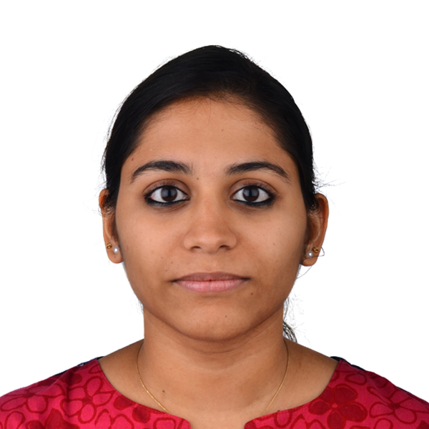

Name: Sarada Mantha
Phone Number: +971509373070
Email ID: saru1203@gmail.com

Academic Qualification:
Academic Qualification | Institute/ University | Year of Passing | CGPA
B.E (Hons) Computer Science | BITS, Pilani - Dubai | 2013 | 7.22/10  (7th Semester)
12th | Our Own English High School, Dubai | 2009 | 75% (CBSE)
10th | Our Own English High School, Dubai | 2007 | 80% (CBSE)

Computer Proficiency:
- Operating Systems : Windows, Linux, Mac
- Database : Familiar with relational databases such as MySQL
- Software Languages : C, C++, C#, Visual Basic, SQL
- Office and Other : MS Office, MS Word, MS Excel & MS PowerPoint

Summer Internship and Working Projects
DNV, Dubai, UAE August 2012 - January 2013
Det Norske Veritas (DNV) is one of the three major companies in the classification society business. I have briefed about the type of work I did during my internship term in DNV.
- Designed and developed several user-interface applications in MS Excel.
- Designed and developed several user-interface applications in VBA.
- Enhanced existing applications and created new tools upon request for the RC Console project in MS Excel, used by employees across DNV, Middle East.
- Worked on other operations based projects.
- Fixation of bugs was done on a daily basis.
Sanbook Quality Consultancy, Dubai, UAE June 2011 - August 2011
- Executed training on ISO 9001, OHSAS and ISO 13001 to employees of few organizations.
- Conducted audits for some companies in UAE as assistant auditor.
- Improved MS Office skills and also oratory skills through group discussions and management meetings.
Core Subjects:
- Microprocessors
- Operating Systems
- Data Structures and Algorithms
- Theory of Computation
- Computer Networks
- Database Management Systems
- Programming Language and Computer Compilers
- Advanced Computer Organization

Extra Curricular Activities and Achievements:
- Participated in Green Olympiad (Dubai) 2007
- Participated in TechnoFest 2012 under the project titled, “8x8x8 LED Cube”
- Participated in Pixels Inter-College Photography Event 2013
- Participated in ARTEX, College event
- Participated and secured third position in Spell Bee.
- Awarded District Level Winner in Chess 2002, India
- Awarded a Gold medal for TechnoFest 2012

Personal Information:
D.O.B : 12th March 1991
Nationality : Indian
Gender : Female
Languages Known : English, Hindi, Telugu
Current Address : 305, Golden Sands 9, Mankhool Street, PO Box 52288, Dubai, UAE
Hobbies : Photography, Chess, Sketching and Classical Dance (Bharatanatyam)
Passport Number : F7916683
Visa Status : Residence (Father’s Sponsorship)
Driving License : No
I hereby declare that the above written particulars are true and correct to the best of my knowledge and belief.

Date: 20th May 2013
Place: Dubai Sarada Mantha

