**Jessica Alexandra Kanes**

19 Lake Drive Phone: (914) 330-5072

Somers, New York 10589 Email: jak21@geneseo.edu

Rochester Institute of Technology

One Lomb Memorial Drive

Rochester, NY 14623

Dear Hiring Manager:

As a hardworking and dedicated Business Administration major at the State University of New York at Geneseo, I was excited to hear of your graduate assistantships on your admitted students’ webpage. I believe that my experience as a leader, as well as my passion for marketing allows me to be a qualified candidate for the position.

Under extensive coursework of the AACSB Accredited Business Administration program, I have achieved a 3.51 GPA. I have excelled in several upper-level marketing and business courses such as Marketing Communications and International Marketing and I plan to pursue my MBA. These specific courses have allowed me to gain experience creating full marketing plans for several new products. While working in a team, my group and I presented new marketing and advertising strategies in both oral and written forms to the class, persuading them to buy our product. The in-depth nature and the professionalism required for these projects have strengthened my communication and time management skills and teamwork ability. I am able to successfully balance a full-time course load, a part-time job, and several leadership roles. Currently, I am also participating in a focus group with members of the Marketing Club, gaining insight to what high school students think of a new lip balm product that is slowly being introduced into the Western New York region.

The acquisition of a leadership role in the athletic department of my college has allowed me to demonstrate my effective communication skills and reliability. As the student coordinator of game management, I must organize campus workers for each varsity athletic event that the college hosts. Conveying what tasks each worker must perform as well as when and where events are held is essential to having a fully effective staff. In addition, it is my responsibility to relay any important information from the Athletic Director or coaches to the student workers. These supervisors rely on me to make sure events run as smoothly as possible. Evident through my experience, I believe I express notable leadership and communication skills as well as the maturity to gain a great learning experience from this assistantship.

Please consider me for the 2012-2013 Graduate Assistantships. I would be more than happy to discuss and answer any questions you have about my résumé. Please call me at (914) 330-5072 at your earliest convenience so that we may arrange an interview to examine how my academic skills and leadership experience can benefit RIT. Thank you for your consideration.

Sincerely,

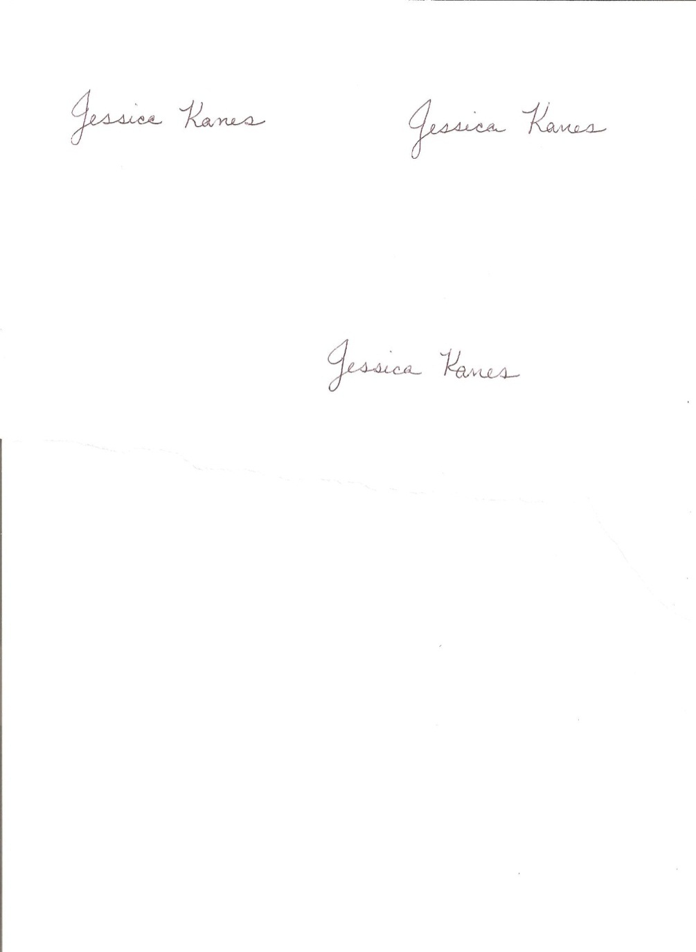

Jessica Kanes

Enclosure

**Jessica Alexandra Kanes**

19 Lake Drive Phone: (914) 330-5072

Somers, New York 10589 Email: jak21@geneseo.edu

**EDUCATION**

State University of New York: College at Geneseo

School of Business: AACSB Accredited

*Bachelor of Science in Business Administration: GPA: 3.51* *May 2013*

**WORK EXPERIENCE**

State University of New York: College at Geneseo Department of Athletics Geneseo, NY

**Student Coordinator of Game Management** *September 2011 - Present*

* Manage 30-35 student workers for all athletic events
* Oversee workers and train student employees for skilled positions
* Utilize various forms of communication to convey scheduling and task information

The Walt Disney Company – Walt Disney World Resort Lake Buena Vista, FL

**Food and Beverage** - Front of House Server (DisneyQuest) *June 2010 – October 2012*

* Interacted with guests on a personal level
* Responsible for restaurant efficiency and success
* Demonstrated teamwork to provide excellent service to guests

North Salem Recreation Day Camp North Salem, NY

**Head Camp Counselor** *Summers 2006-2012*

* Obtained senior counselor position, delegated tasks to junior counselors
* Supervised groups of 20 pre-k, kindergarten, and first grade children
* Resolved conflict between members of the group

Temple Beth Elohim Religious School Brewster, NY

**Hebrew Teacher** *September-June 2005-2009*

* Instructed third and fourth grade classrooms teaching the Hebrew language
* Created full lesson plans as well as quizzes and practice worksheets

**HONORS AND ACTIVITIES**

Geneseo Office of Admissions Guarantee Admission Program (GAP) Mentor *Fall 2012 – Present*

* Mentored and advised 5students planning to transfer to Geneseo

Geneseo Campus Round Table *Fall 2012 - Present*

* Member of Presidential committee that generates programming on campus

Geneseo Marketing Club *Fall 2012 - Present*

* Creates marketing plans and campaigns for small businesses and organizations

Geneseo Residence Life Hall Council – Saratoga Terrace *Fall 2011 - Present*

* Elected President of residence community (2012-2013)
* Gained Secretary and Historian officer positions (2011-2012)

Geneseo Office of Admissions Transfer Liaison  *Fall 2011- Present*

* Attend transfer sessions to answer questions and concerns from a student’s perspective

Geneseo Opportunities for Leadership Development (GOLD) *Spring 2010 - Present*

* Earned Emerald Career and Employee Development Certificate
* Working to obtain Ruby Certificate- Leadership for the Information Age

Geneseo Dean’s List *Fall 2012, 2011*

* GPA of 3.5 or higher for an academic semester

Geneseo Residence Life Move-In Volunteer *August 2012, 2011*

* Assisted freshman and transfer students in moving into dormitories

Girl Scout Gold Award *April 2009*

* Reorganized and gave structure to student resource room at religious school

**PROFESSIONAL SKILLS**

*Computer Software:* MS Word, MS Excel, MS PowerPoint, MS Access, Minitab, Adobe Photoshop