Rochester Institute of Technology

Club Certification Manual

Processes and Procedures

For SG Recognized Clubs Only



Table of Contents

Table of Contents 2
Contact Information 3
Club Responsibility 4
Budget Information 5
Student Government Club Financial Spreadsheets………………………………………....6-8
Financial Transactions 9
Planning an Event 9
EAF Form 10
How to Complete an EAF Form 11
Particular Transactions 12
Cash Needed 12
Reimbursements for Gas and/or Mileage-Non-Overnight Travel….............................…..……...13
Cash Boxes 13
Check Payment 14
W-9 Form 15
VISA 16-18
VISA Checkout Form 18
Gift Certificates/Gift Cards/Prizes 19
HUB 20
Office Max Purchases 21
Travel 22-23
Vehicle Rental 24
SG Additional Awards 25-26
Mileage Form 27
Application for SG Additional Funds /Application for Travel Funds 28-29
Sales Tax Exempt Form 30
Deposits/After Hours Deposits/Donations 30
Deposit Form...........................................................................................................................31
Contract Process 32-33
Contract Request Form 33
Office-Max Supply Form 34
Room Form 35
Official'sVoucher………………………………………………………………......………...36

Contact Information

Merry Schading, Center for Campus Life Financial Coordinator
Phone: 585-475-5658
Email: mlw0137@rit.edu
Fax: 585-475-6600

If you need to see the Center for Campus Life Financial Coordinator, please make an appointment at the Club Resource Center. The Club Resource Center is located in the RITreat.

Club Resource Center
Monday
9 am to 4:30 pm
Tuesday through Friday
10 am to 4:30 pm
Phone: 475-4111
Email: infosg@rit.edu

Financial Staff:
Dawn Rizzo, Assistant Financial Coordinator
Main Duties: SG Additional Awards/Reviews EAF Forms/Student Government Transactions/Journal Entries
Email: darccl@rit.edu Phone: 585-475-5798

Carol Giuliano, Clubs Budget Assistant
Main Duties: VISA Cards
Email: cagccl@rit.edu Phone: 585-475-6072

Please frequently check your club’s folder located in the Club Resource Center area.

Club Responsibility

This manual outlines the processes and procedures that Student Government recognized Clubs must follow in order to perform financial transactions here at RIT. In order to transact financial transactions, individuals—usually officers of the club—need to become Financially Certified by going through an online tutorial and passing a competency exam with a score of 75% or better. Please refer to http://campuslife.rit.edu/cfc/cfc.swf

When you require a financial transaction completed for your club, you will submit an Expense Approval Form (EAF) at the Club Resource Center. If the Financial Office needs additional information, receipts or backup that is missing from the EAF, an email will be sent to the requestor, the Advisor of the club, and the Assistant Director of Campus Life Programs.

If a second or third email needs to be sent regarding your EAF and there hasn’t been sufficient action on the part of your club to rectify any problems, your club may be asked to meet with the Assistant Director of Campus Life Programs and/or the Center for Campus Life Financial Coordinator. Additionally, your club may be asked to have one or more members/officers recertified. If your club neglects to submit certain required paperwork such as receipts or does not make efforts to follow processes and procedures, your club may be “frozen or placed on hold” When your club is “frozen,” your club is unable to transact financial transactions until the “frozen” status is removed.

It is your responsibility as a financially certified member to submit requests properly. On the occasion where there is a problem with an EAF form, it is your responsibility to get in touch with the Center for Campus Life Financial staff to rectify the problem immediately. You may do this by way of email or appointment.

We complete club financial requests as quickly as we can. Our turn-around time for most requests is 3 days or less. Please give us sufficient time to complete your requests. Because of work load, we cannot be expected to honor last minute requests. Please think ahead and be courteous.

Budget Information

Information on the Student Government Club Budget Process can be found in the Clubs and Organizations section under Resources of the club website, http://campuslife.rit.edu/main/clubs/resources

Once your club’s budget has been approved or allocated by Student Government, you can start making expenditures any time after July 1. RIT is on a fiscal year accounting basis. Our fiscal year starts July 1st and ends June 30th of the following year. You must spend your entire allocated budget by 6/30 of the following year in order to get your club’s entire allocated budget amount. Additional awards you may have been awarded through Student Government during the year do not count toward your total actual expenditures for the year, nor does any departmental support your club receives.

Example:

You were allocated a budget of $500. At the end of the fiscal year, June 30, your total expenditures are listed on the Spreadsheets from the Center for Campus Life Financial Coordinator as $1500. You received an Additional Award from Student Government for a trip your club took in the amount of $800 and your club received $100 for Departmental support for the trip. You must subtract the Additional Award of $800 from your total expenditures of $1500 and the $100 Departmental support to get a net amount of $600 for actual net expenditures.

Your club’s end of the year budget adjustment:
You compare $600 actual net expenditures to the allocated budget of $500. You spent your entire budget and you will get the full budget adjustment amount of $500.

Rollover
Your club’s fundraising will rollover to the next year depending on the amount of actual expenditures and fundraising your club makes.

Student Government Club Financial Spreadsheets

RIT works on a fiscal year basis. This means that the year starts July 1 and ends June 30 of the following year.

The Center for Campus Life Financial Coordinator keeps an up-to-the-minute spreadsheet that keeps track of all your expenses and deposits. Your club spreadsheet acts like a check register would for your personal checking account. The Center for Campus Life Financial Coordinator uses these spreadsheets in conjunction with RIT’s Oracle Financial Program. These spreadsheets list your beginning balance at the beginning of the fiscal year and summarize all transactions.

Your organization will be given a copy of your spreadsheet in the form of a print out (shown on the next page) each month after the Financial Coordinator has reconciled your club’s account. This spreadsheet print out for the previous month’s activity will be placed in your club’s mail folder in the RITreat after reconciled. This should be approximately the 20th of the following month.

The “Total Accumulative Balance Available to Spend” on the statement represents your organization’s current balance. This is the amount you have available to spend.

09.5XXXX.XXXXX.00.XXXXX.00000 |  |  |  |  |  |  |  |  |  | Statement as of
 |  |  |  |  | Budget Allocation | Expenses |  | Income
Account |  |  |  |  | Budget Allocation | In-Transit | RIT Records | In-Transit |  |  | RIT Records | Balance
Beginning Balance |  |  |  |  |  |  |  |  |  |  |  | $0.00
External Expense Accounts
63190 |  | Transfers |  |  | $0.00 | $0.00 | $0.00 | $0.00 |  |  | $0.00 | $0.00
70050 |  | Admin/Professional Salaries |  |  | $0.00 | $0.00 | $0.00 | $0.00 |  |  | $0.00 | $0.00
70450 |  | Tech./Clerical/Sec. Salaries |  |  | $0.00 | $0.00 | $0.00 | $0.00 |  |  | $0.00 | $0.00
70750 |  | Part-time Reg. Tech. Salaries |  |  | $0.00 | $0.00 | $0.00 | $0.00 |  |  | $0.00 | $0.00
70850 |  | Temp. Prof. Salaries |  |  | $0.00 | $0.00 | $0.00 | $0.00 |  |  | $0.00 | $0.00
70900 |  | Reg. Prof. Staff-Special Assignment |  |  | $0.00 | $0.00 | $0.00 | $0.00 |  |  | $0.00 | $0.00
70925 |  | Faculty-Special Assignment-SA |  |  | $0.00 | $0.00 | $0.00 | $0.00 |  |  | $0.00 | $0.00
70950 |  | Reg. Hourly Spec. Assign. Salaries |  |  | $0.00 | $0.00 | $0.00 | $0.00 |  |  | $0.00 | $0.00
71100 |  | Non-RIT Student Salaries |  |  | $0.00 | $0.00 | $0.00 | $0.00 |  |  | $0.00 | $0.00
71150 |  | Grad. Asst. Salaries |  |  | $0.00 | $0.00 | $0.00 | $0.00 |  |  | $0.00 | $0.00
71250 |  | Student Salaries |  |  | $0.00 | $0.00 | $0.00 | $0.00 |  |  | $0.00 | $0.00
71350 |  | Student Work-Study Salaries |  |  | $0.00 | $0.00 | $0.00 | $0.00 |  |  | $0.00 | $0.00
72050 |  | Benefits-Pooled Expenses |  |  | $0.00 | $0.00 | $0.00 | $0.00 |  |  | $0.00 | $0.00
72300 |  | Benefits-Tuition Waiver |  |  | $0.00 | $0.00 | $0.00 | $0.00 |  |  | $0.00 | $0.00
73100 |  | Copying/Duplicating |  |  | $0.00 | $0.00 | $0.00 | $0.00 |  |  | $0.00 | $0.00
73150 |  | Supplies-Office |  |  | $0.00 | $0.00 | $0.00 | $0.00 |  |  | $0.00 | $0.00
73159 |  | Supplies-Office I |  |  | $0.00 | $0.00 | $0.00 | $0.00 |  |  | $0.00 | $0.00
73500 |  | Supplies-Maintenance |  |  | $0.00 | $0.00 | $0.00 | $0.00 |  |  | $0.00 | $0.00
73550 |  | Subscriptions |  |  | $0.00 | $0.00 | $0.00 | $0.00 |  |  | $0.00 | $0.00
73600 |  | Dues |  |  | $0.00 | $0.00 | $0.00 | $0.00 |  |  | $0.00 | $0.00
73700 |  | Signage & Info Media |  |  | $0.00 | $0.00 | $0.00 | $0.00 |  |  | $0.00 | $0.00
74250 |  | Postage |  |  | $0.00 | $0.00 | $0.00 | $0.00 |  |  | $0.00 | $0.00
75000 |  | Professional Fees |  |  | $0.00 | $0.00 | $0.00 | $0.00 |  |  | $0.00 | $0.00
75050 |  | Honoraria |  |  | $0.00 | $0.00 | $0.00 | $0.00 |  |  | $0.00 | $0.00
75100 |  | Advertising |  |  | $0.00 | $0.00 | $0.00 | $0.00 |  |  | $0.00 | $0.00
75150 |  | Temp. Hourly Salaries |  |  | $0.00 | $0.00 | $0.00 | $0.00 |  |  | $0.00 | $0.00
75800 |  | Freight & UPS |  |  | $0.00 | $0.00 | $0.00 | $0.00 |  |  | $0.00 | $0.00
76950 |  | Equipment Rentals |  |  | $0.00 | $0.00 | $0.00 | $0.00 |  |  | $0.00 | $0.00
77250 |  | Telephone |  |  | $0.00 | $0.00 | $0.00 | $0.00 |  |  | $0.00 | $0.00
78000 |  | Travel |  |  | $0.00 | $0.00 | $0.00 | $0.00 |  |  | $0.00 | $0.00
78200 |  | Auto Mileage |  |  | $0.00 | $0.00 | $0.00 | $0.00 |  |  | $0.00 | $0.00
78550 |  | Hospitality |  |  | $0.00 | $0.00 | $0.00 | $0.00 |  |  | $0.00 | $0.00
79250 |  | Recruitment-Students |  |  | $0.00 | $0.00 | $0.00 | $0.00 |  |  | $0.00 | $0.00
80000 |  | Maintenance & Repairs-Bldgs. |  |  | $0.00 | $0.00 | $0.00 | $0.00 |  |  | $0.00 | $0.00
80200 |  | Equipment Repairs |  |  | $0.00 | $0.00 | $0.00 | $0.00 |  |  | $0.00 | $0.00
80400 |  | RIT Vehicles-Maintenance |  |  | $0.00 | $0.00 | $0.00 | $0.00 |  |  | $0.00 | $0.00
84000 |  | Equipment Purchases under $1500 |  |  | $0.00 | $0.00 | $0.00 | $0.00 |  |  | $0.00 | $0.00
16200 |  | Equipment Purchases over $1500 |  |  | $0.00 | $0.00 | $0.00 | $0.00 |  |  | $0.00 | $0.00
86000 |  | Miscellaneous |  |  | $0.00 | $0.00 | $0.00 | $0.00 |  |  | $0.00 | $0.00
Internal Chargeback Accounts
90000 | Corporate Education & Training |  |  |  | $0.00 | $0.00 | $0.00 | $0.00 |  |  | $0.00 | $0.00
90100 | Campus Connections |  |  |  | $0.00 | $0.00 | $0.00 | $0.00 |  |  | $0.00 | $0.00
90145 | Public Safety (Van Certification) |  |  |  | $0.00 | $0.00 | $0.00 | $0.00 |  |  | $0.00 | $0.00
90160 | ETC Services |  |  |  | $0.00 | $0.00 | $0.00 | $0.00 |  |  | $0.00 | $0.00
90170 | Facilities Mgmt Services |  |  |  | $0.00 | $0.00 | $0.00 | $0.00 |  |  | $0.00 | $0.00
90180 | Food Service Hospitality |  |  |  | $0.00 | $0.00 | $0.00 | $0.00 |  |  | $0.00 | $0.00
90182 | Food Service/Flex |  |  |  | $0.00 | $0.00 | $0.00 | $0.00 |  |  | $0.00 | $0.00
90185 | Food Service Catering Sales |  |  |  | $0.00 | $0.00 | $0.00 | $0.00 |  |  | $0.00 | $0.00
90200 | HUB - Copy Charges |  |  |  | $0.00 | $0.00 | $0.00 | $0.00 |  |  | $0.00 | $0.00
90205 | HUB - Postage Charges |  |  |  | $0.00 | $0.00 | $0.00 | $0.00 |  |  | $0.00 | $0.00
90210 | HUB - Printing Charges |  |  |  | $0.00 | $0.00 | $0.00 | $0.00 |  |  | $0.00 | $0.00
90215 | HUB - Proprietary |  |  |  | $0.00 | $0.00 | $0.00 | $0.00 |  |  | $0.00 | $0.00
90220 | HUB - Work Orders |  |  |  | $0.00 | $0.00 | $0.00 | $0.00 |  |  | $0.00 | $0.00
90221 | HUB – Misc. Charge |  |  |  | $0.00 | $0.00 | $0.00 | $0.00 |  |  | $0.00 | $0.00
90295 | RIT Inn - Room Charges |  |  |  | $0.00 | $0.00 | $0.00 | $0.00 |  |  | $0.00 | $0.00
90296 | RIT Inn - Hospitality |  |  |  | $0.00 | $0.00 | $0.00 | $0.00 |  |  | $0.00 | $0.00
90297 | RIT Inn - Conference Charges |  |  |  | $0.00 | $0.00 | $0.00 | $0.00 |  |  | $0.00 | $0.00
90240 | Tech Crew |  |  |  | $0.00 | $0.00 | $0.00 | $0.00 |  |  | $0.00 | $0.00
90310 | Misc. Chargeback |  |  |  | $0.00 | $0.00 | $0.00 | $0.00 |  |  | $0.00 | $0.00
90370 | Telephone - Rentals/Long Distance |  |  |  | $0.00 | $0.00 | $0.00 | $0.00 |  |  | $0.00 | $0.00
90375 | Telephone - Service |  |  |  | $0.00 | $0.00 | $0.00 | $0.00 |  |  | $0.00 | $0.00
 | Subtotal Expenses: |  |  |  | $0.00 | $0.00 | $0.00 | $0.00 |  |  | $0.00 | $0.00
Revenue Account
54000 | Donations |  |  |  | $0.00 | $0.00 | $0.00 | $0.00 |  |  | $0.00 | $0.00
59000 | Fundraising |  |  |  | $0.00 | $0.00 | $0.00 | $0.00 |  |  | $0.00 | $0.00
59001 | Additional Funds Awards |  |  |  | $0.00 | $0.00 | $0.00 | $0.00 |  |  | $0.00 | $0.00
59030 | Departmental Support
59300 | Budget |  |  |  | $0.00 | $0.00 | $0.00 | $0.00 |  |  | $0.00 | $0.00
 | Subtotal Revenue: |  |  |  | $0.00 | $0.00 | $0.00 | $0.00 |  |  | $0.00 | $0.00
Current Year Sub-total |  |  |  |  |  |  |  |  |  |  |  | $0.00
Total Accumulative Balance Available to Spend |  |  |  |  |  |  |  |  |  |  |  | $0.00
 |  |  | TOTAL ACTUAL RECONCILED BALANCE AS OF |  |  |  |  |  |  |  | (office use only) | $0.00

Financial Transactions

In order for your club or organization to operate, you will need to initiate and carry out financial transactions. A financial transaction is any activity that ultimately causes an exchange of funds into or out of your organization’s financial account.

It is recommended that your organization keep financial records to substantiate all financial transactions. For each deposit, you will be given a receipt by the Club Resource Center Staff Assistant. Record this deposit in your organization’s records and file all receipts in a systematic way.

For each and every transaction that occurs through your organization, you must submit to the Club Resource Center Staff Assistant a completed Expense Approval Form (EAF form) shown on the next page. Make certain that this form is completely and legibly filled in with all information and include necessary signatures of advisors and descriptions as the form indicates. Make sure in the upper right corner of the EAF form that you have indicated the date the transaction needs to be completed by. Do not indicate ‘As soon as possible.’ You may get copies of the EAF form at the Club Resource Center. Please follow the instructions on how to complete the EAF form.

Turnaround time for financial requests is normally 3 days for most requests. If you wish to have a check drawn, plan on at least 2 weeks.

It is recommended that you keep copies of all EAF forms you submit and record this disbursement of funds in your organization’s records.

Planning an Event

All Events need to be registered with EVR (Event Registration). You must be EVR-certified in order to register an event.

Start early to plan your event. There are many details that need to be decided and arranged before your event may be held. The most successful events are those that are planned well ahead. It is recommended that you build into your plans an extra amount of time to accommodate snags in the plan if they should occur.

It is highly recommended that when planning an event, you include an appointment with the Center for Campus Life Financial Coordinator. This way you can clarify your financial needs so your event might be more financially successful.

No alcoholic beverages are allowed to be purchased nor reimbursed through club accounts.

Expense Approval Form (EAF) Generated EAF Number_____________
THIS FORM MUST BE FILLED OUT FOR ANY EXPENDITURE YOUR CLUB MAKES.
****** Please allow 3 days turnaround for most requests; 7-10 days for check requests******

VISA____________(Office use only) Date you need this Transaction done by______________

Requestor’s Name_______________________________ Today’s Date____________________________

Email____________________ Phone________________ Club__________________________________

Alternate Contact Name_____________________________________Phone____________Email_____________________

Account number to be used: 09.5_ _00. _ _ _ _ _. 00. _ _ _ _ _ .00000 Office use only

Method of Payment/Transaction needed: TIME STAMP HERE
Cash Needed (Maximum cash allowed is $200. Give Details Below.)  (You must submit receipts within 5 days. Use Tax Exempt Certificate.)  Check Payment (RIT Requires Official Backup in order to draw a check. Attach invoices/receipts /W-9 for all Check Requests. If check is for a student, student needs to complete Direct Deposit Authorization Form—Accounts Payable) | Office-Max Purchase  Travel  Vehicle Rental (From Outside RIT agency need appointment with Financial Coordinator)
Hub (After purchase, return invoice to Club Resource Center)   VISA (This includes purchases to be made at the RIT Bookstore) |  AFAF/ATF Approved Funds  Award #_____________________   Transfer of Funds _______________________
Event Name____________________ Destination____________________ Event Date_______________
Company/Individual that you will be paying:

Name____________________________________ Company’s Phone#____________________________

Address__________________________________ Company’s Fax#______________________________

City/State/Zip_____________________________ Student’s University ID#________________________

Detailed Description of Purchase: (List details of your event including names of attendees or number of expected attendees/items to be purchased and the purpose of the purchase....if you are requesting change for an event, list denominations of cash needed and amounts)

Total $________________________________

Advisor’s Name (Please print)__________________________ E-mail ________________________________

Advisor’s Signature_______________________________ Advisor’s Phone #_______________________

Please fill this form out completely. Your request could be delayed if any information is missing. Check your club’s mail folder often!
Shipments

T SHIRT APPROVAL____________________________ __________________________ ___________
(Signature of Center for Campus Life Professional/Manager Staff) Signature Pick Up Date

How To Complete An EAF Form

You will be requesting different transactions; however, each EAF form should have the following filled out:

      - At the top of the form, be sure to indicate the date when you need the transaction completed.
      - Fill in your name, today’s date, your email address, your phone number and your organization’s name.
      - Fill in an alternate contact name, phone number, and email address.
      - For Method of Payment/Transaction Needed, check off what type of transaction is needed.
      - Note: If the purchase is SG Award related, indicate Award number from your Award letter
      - Indicate Event Name, Destination if travel related, and Event Date
      - Fill in all contact information for Company/Individual you are paying. This includes name, complete address, phone #, fax#, and if paying student, their University ID.
      - Provide a complete description of your purchase. See EAF form for details.
      - List total $$ amount you are spending or plan to spend.
      - Fill in Advisor’s Name, phone number, and e-mail address. Advisor’s signature is required !
      - For T-shirt/Clothing purchase, you must get approval of design by any Center for Campus Life manager or your club’s liaison prior to purchase by presenting them with a sample of the design.

For instructions on specific types of transactions, please see the “Particular Transaction” section.

It is the responsibility of the Center for Campus Life Financial Coordinator to give out account numbers for clubs.

Never give out your club’s account number!

Particular Transactions

Important Note:
It is your club’s responsibility to make certain the Center for Campus Life Financial Coordinator is aware of all expenses for your events. If you overspend, your club is responsible for any deficits. Please deposit all fundraising at the Club Resource Center. Do not spend from Fundraising!

Cash Needed:

Organizations are strongly discouraged from spending money, then seeking reimbursement. All expenses need to be reviewed and approved before they are paid or incurred. If you pay out of your own pocket, you run the risk of not being able to get your money back. If you pay out of your own pocket, you also run the risk of the establishment charging you sales tax. You also have to wait for a reimbursement. You cannot get reimbursed for sales tax ever.

Never pay for services (such as DJ, Speaker, referee, Recording Studios, Graphic Artist) with cash and expect reimbursement. You cannot get reimbursed for such expenses. Services such as must be paid for either through the Accounts Payable process or the RIT Payroll process and therefore must be paid by RIT check.

RIT strongly encourages the use of RIT’s Corporate VISA cards. Student Government has the use of Departmental VISA cards that clubs may use. If a VISA credit card may be used for your purchase, please refer to heading “VISA”. If you request cash and a VISA card may be used for your purchase, you will be notified and a VISA card transaction will be required.

If you have indicated that you need cash, the Center for Campus Life Financial Coordinator may call or email you to inquire about using the RIT VISA card. If it is imperative that you have cash, please see below:

- Follow complete instructions for filling out EAF Form
- On the EAF form check Cash Needed
- Indicate the amount needed (Please note that there is a $200 limit on all cash requests.)
- We offer no travel advances.
- In the “Detailed Description of Purchase” section indicate either the name of the company where you will be making your purchase or the person’s name that is to be reimbursed. Describe items purchased.
- If you need cash in order to make change for an event (an advance) , please let us know the denominations you will need and the quantity of each.
- Submit the EAF form to the Club Resource Center Staff Assistant
- You will be notified via email when you may pick up the cash. See the Club Resource Center Staff Assistant to pick up cash. You will get the cash in an envelope that gives us pertinent information to find your organization’s paperwork for this purchase. Please keep the envelope to put receipts and leftover cash in when your purchase is complete. Only the requestor or the alternate contact may pick up the cash.
- DO NOT PAY TAX! Use the RIT Tax Exempt Certificate. RIT will not reimburse you for tax. Sales Tax Exemption forms are available from the Club Resource Center Staff Assistant for valid RIT purchases. You may photocopy these forms.
- Submit all receipts taped on an 8 ½” X 11” piece of paper and all remaining cash in the envelope provided to the Club Resource Center Staff Assistant within 5 days.

Reimbursements for Gas and Mileage for Non-Overnight Travel

Please be aware that if you use your personal car for local non-overnight club business, you may ask for a reimbursement for mileage after your trip. You can receive the cash (Up to $200), when you come back from a non-overnight trip simply present a completed mileage form, which can be found at the Club Resource Center along with an EAF form.

If you need to get reimbursed for the use of a rental vehicle (SG Van/Public Safety van/Outside rental agency) for local non-overnight travel, you would present the gas receipts and an EAF form in order to get reimbursed after your trip.

Reimbursements or Advances for Gas and/or Mileage for Overnight Travel
There are no cash advances for Overnight travel. We would be happy to reimburse you after your trip is completed.

Cash Boxes

No EAF form is required to use a Cash Box!

- Cash boxes are available at the Club Resource Center for organizations that are having an event and need them. Boxes are First Come, First Served.

- See the Club Resource Center Staff Assistant to sign one out in your organization’s name.

- Submit cash to the Club Resource Center Assistant to deposit each day. Do not keep cash overnight. For safety, all cash collected should be deposited into your organization’s account immediately.

If you need some money to make change for an event, please remember that when you sign out a cash box, it isn’t automatically filled with change for your event. ☺ You must submit an EAF form to request a cash advance indicating how much you need and in what denominations.

Check Payment

We cannot draw a check with an EAF only! RIT requires official backup to draw checks. Make sure you have sufficient backup for checks, which includes a W-9, an invoice, original receipts and/or a contract.

If you require a check for a student, we will need their University ID# on the EAF form and the student needs to complete a Direct Deposit Authorization Form—Accounts Payable. This form is available at the Club Resource Center. This form should not be confused with the Direct Deposit Authorization Form—Payroll

- Follow complete instructions for filling out EAF Form
- On the EAF form, check Check Payment
- Complete section “Company/Individual that you will be paying” indicating the person to be paid, his/her complete address and University ID if a student needs a check
- Attach a completed W-9 form to the EAF form. You may obtain a copy of this form at the Club Resource Center.
- If the check payment is for services of a referee, attach an Official’s Voucher to the EAF form. Have the referee fill out and sign an Official’s Voucher form and a W-9 form. Official Voucher forms are available from the Club Resource Center.
- If the payment is for merchandise, registration, hotel charges, etc., attach an invoice to the EAF form. Most of these charges, however, should be paid for with the VISA Procurement card. Some small companies do not accept VISA charges. In this case we would pay the invoice by way of check.
- When putting on an event for your organization, certain services require the use of a contract. If a contract is involved, the Clubs Financial Office will be receiving a copy of the contract and W-9 from EVR once received. When you register your event, EVR will explain the contract process.
- If the check is for registration fees and the vendor does not accept VISA, attach a copy of a completed registration form as back up.
- Submit the EAF form to Club Resource Center
- If the check is for a student, the student’s bank will be credited. If the check must be picked up for a DJ, for instance, you will be notified by email when the check is available for pick up. See the Club Resource Center Staff Assistant to pick up all checks. Only the requestor or the alternate contact may pick up the check.

W-9 Form

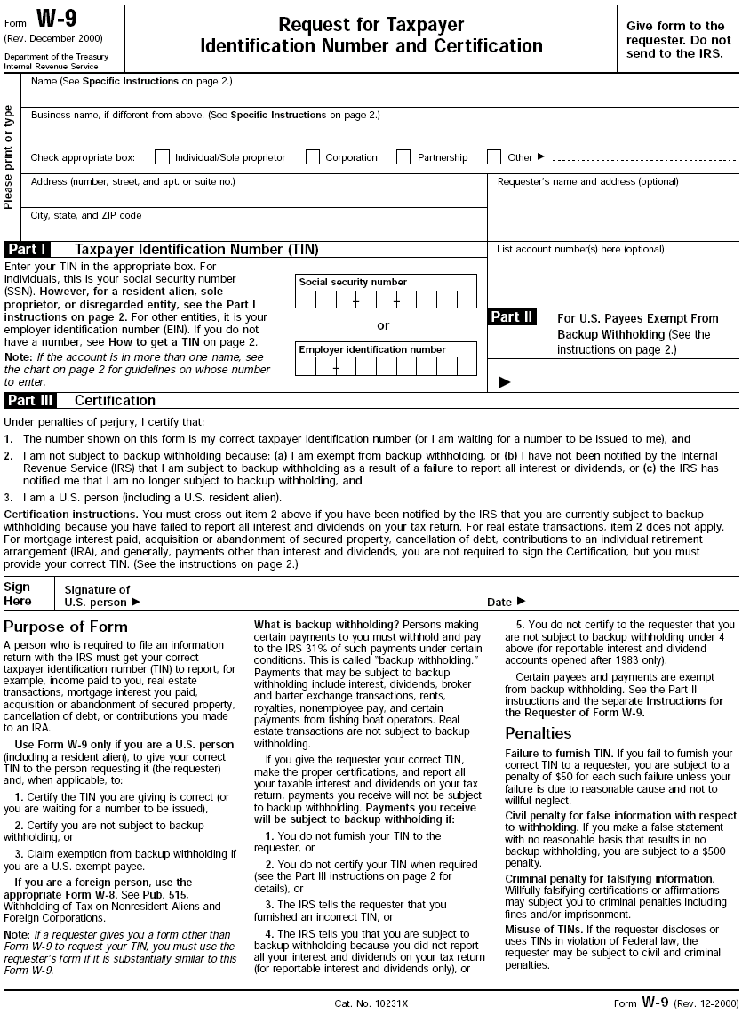

VISA

By using the RIT VISA cards, your organization can easily and quickly purchase what they want, when they want it. RIT Accounting encourages the use of credit cards.

A certified Finance representative from your organization needs an appointment with the Clubs Budget Assistant. The Club Resource Center Staff Assistant may make an appointment for you or if she is free, she can see you when you require a card.

Only those who have been financially certified will be allowed to take out a VISA card. Please have several members of your club certified to assure that your club always has a representative that can perform financial transactions. Members go on co-op, drop out of clubs, get sick, or are too busy and cannot take the VISA card out to do the shopping. If your club only has one person certified, you may have problems at some point when you most need to take out a VISA card because there is no available financially certified member.

- If you intend to purchase from more than one company, you will need one EAF for each company. Please bring these forms to your appointment with the Clubs Budget Assistant.
- Follow complete instructions for filling out EAF Form
- On the EAF form, check VISA
- Financially certified representative should bring the completed EAF form to the appointment with Club Budget Assistant.
- He/she will be given the VISA card after signing the Visa Checkout Form that states he/she promises to:
  - Use the card only according to EAF form.
  - Return the card and all receipts (without sales tax) or a print out of the Website the next business day by 11:00 A.M. to the Club Resource Center Staff Assistant. Please check your receipts for no tax before leaving the vendor where the transaction occurred, including any online sites you may have used. We do not pay sales tax. If necessary, you will have to fax the tax exempt certificate to the online site. This is your responsibility. You may use the fax machine in Student Government office.
  - Send a representative to return the card and receipts or print out of the Website if you cannot make it by 11:00 A.M. the next day.
- After you have made your purchases, your organization’s spreadsheets will be updated with the proper amounts charged.

When using an online site: Print out the order, confirmation page, and/or invoice to return with card when you are through using the card.

If your organization does not follow the above procedure, you risk losing the privilege of using the VISA card. Your club may be charged a $25.00 penalty fee if the card and/or receipts including a print out of the Website used are not returned in time.

Additionally, if the RIT VISA card is misused, for any reason, Public Safety will be called in to investigate such impropriety.

Certain expenses, including any travel expense such as airfare, hotel, gas, and restaurant charges, may not be made on these VISA cards. See the Travel Section of this manual for more information.

When initiating orders with the RIT VISA Card, please stipulate the following:

- Shipping Address:
RIT Clubs Financial Office – (Your Club Name Here)
VC Order
Bldg SAU-4 Room 1150
Rochester, NY 14623
Phone: (585) 475-4111

It is important to have all orders shipped to our central Receiving Department listed above. If you have orders shipped to your home and they get stolen or lost, Clubs Financial Office will not be responsible, your club will be. If you have them shipped to the above address, RIT will assist if there are any problems.

- Billing Address:
RIT Clubs Financial Office - (Your Club Name Here)
127 Lomb Memorial Drive
Rochester, NY 14623

- When your order arrives in the Club Resource Center, your club will be notified via email to pick it up. Packages can only be picked up by the Requestor or by the Alternate Contact indicated on the EAF Form (with proper ID). Please pick up your order as soon as possible.
- If using an Internet site to order, please print out the order, confirmation page, and/or invoice to return with card when you are through using the card.
- If making a verbal phone order, make sure you have the company fax/email you a sales order as back up for the charges and submit sales order when you return the credit card.
- It is your responsibility to make certain that for each order you make, you have a receipt and/or print out of Website to submit to the Clubs Budget Assistant.

Merry Schading Phone: 585-475-5658
Fax: 585-475-6600

Note: Any purchase over $1500 we may have to order via purchase order.
Please see the Center for Campus Life Financial Coordinator for additional information.

Visa Checkout Form

VISA RESPONSIBILITY PLEDGE
By signing this form you promise to:
1 |  | Only use the card according to your EAF form. Your club has $________________, do not overspend.
2 |  | FOR SHOPPING IN ESTABLISHMENTS: Return the card and all receipts, without tax, the next business day by 11 a.m., or send a representative to return the card and receipts if you can not make it by 11 a.m. Be sure to check your receipts for tax before you leave the establishment. If you return the receipts with tax, you will be resolving the problem the next day.
3 |  | FOR SHOPPING ONLINE: Please print out a copy of your order and give us this copy when you return the card. We need to know the online site and their USA mailing address. If the mailing address is within New York State, you might be charged sales tax. Make sure your online order does not charge tax. If need be, fax tax exempt form from Clubs Financial office. It is your responsibility to make certain that your online orders do not contain tax. Failure to abide by these rules may subject your club to penalties.
4 |  | For Wal-Mart / Wegmans / Office-Max Purchases: Make sure to obtain the appropriate card for these establishments. It is recommended that Office-Max purchases be ordered using the Office-Max Supply Form.
5 |  | If you are purchasing gift certificates/cards, make sure the process for this is explained to you.
6 |  | If you are purchasing for an event, make sure the event is registered with EVR.
7 |  | Is this purchase Student Government Additional Award related?
8 |  | Is a package expected to be delivered from this order? |  |  |  | yes | no
9 |  | Notify Clubs Financial Office immediately if the card is lost or stolen.
By Signing this form you understand that:
1 | Your club may be placed on “HOLD’ and/or fined $25 if you do not return the card and receipts on time.
2 | You must leave your RIT student ID with the Clubs Financial Office until you return the card and receipts.
3 | If the RIT Visa card is misused, for any reason, Public Safety will be called to investigate such impropriety.
Visa Card #_____________
Date/Time Card Signed Out: |  |  |  |  | Date/Time Card Returned:
Print Name |  |  |  | Print Club Name |  |  |  | Signature

Gift Certificates/Gift Cards/Prizes

For purchasing gift card(s) from Ben & Jerry’s, Java Wally’s, Tiger Bucks, outside vendors, etc.

- Fill out an EAF form

- Make an appointment with the Clubs Budget Assistant as you would for any Visa transaction. (She will then go through the proper procedure for checking out a VISA card for a gift certificate).

- You may then purchase the gift certificate at the authorized location.

4. Under RIT regulations, if you purchase a gift certificate or item for a student for less than $250, we do not have to fill out a Gift Certificate Given Form nor provide a W-9 form. However if you give any amount of gift certificate or item for any amount to staff or faculty, we need them to fill out a Gift Certificate Given Form.

Hub

- Please remember that there is a three day turnaround time for Hub forms.
- Follow complete instructions for filling out EAF Form
- Check Hub on the EAF form
- In “Detailed Description of Purchase” section describe the work you want the Hub to do. If you intend to make copies, please include a copy of that material for approval.
- Submit EAF form to Club Resource Center Staff Assistant
- A Hub Services Request form will be placed in your club’s mail folder within 3 days. Take this form to the Hub.
- Get an invoice from the Hub and bring it back to the Club Resource Center Staff Assistant. Your organization’s spreadsheet will be updated with exact amount of charges.

Free Copying at the Hub

Clubs are allowed up to 175 free single sided, black and white copies at the Hub per Academic year.

Office-Max Purchases

- Check Office-Max Purchase on the EAF form
- There is an Office-Max catalog available from the Club Resource Center Staff Assistant that you may use to shop. We get special pricing from this catalog. Most items are discounted to varying degrees. Office-Max carries a wide variety of items. Items you may not guess would be available. It isn’t just office supplies. Please check Office-Max BEFORE purchasing anywhere else.
- Make certain that you fill out Name of Event, Date of Event and total amount to be spent if appropriate.
- If this purchase is Student Government Additional Funding related, indicate the award number where indicated on EAF form.
- Print advisor’s name and email address
- Get advisor’s authorizing signature plus their phone number
- Fill out an “Office-Max Office Supply Order Form”. These forms are available from the Club Resource Center Staff Assistant.
- Submit the Office-Max Office Supply Order Form and the EAF form to Club Resource Center Staff Assistant.
- Your order will be placed after your organization’s balance has been affirmed.
- You will be notified via email when your order is available for pick up. Office-Max orders are delivered approximately 24 hours from time of order.

Travel

- The first step, if you are planning any travel related activities for your club, is to register your trip through EVR On-line. You should register your trip at least three weeks prior to date of trip for low risk activity
You should register your trip at least one month in advance for high risk activity, long distances, or trips for which you are making a request for additional funding. Making plans far enough ahead of time helps to insure lower costs for airfare and availability of hotel rooms. Additionally if there are any problems or issues with your travel arrangements, if plans are made further in the future, we have time to correct those problems.
  - Register trip online with EVR
  - If you are requesting additional funding through Student Government for your travel, you need to provide EVR additional information when you register your trip.
  - Once you have registered your trip online, an email notification will go out to the distribution list of individuals who are involved in the approval process for your travel. You will be included on this distribution list, as well as other individuals.
  - If you have indicated that your club is requesting additional funding through Student Government, your request will be forwarded by EVR to the SG Finance Director.
- Follow complete instructions for filling out EAF Form
- Check Travel on the EAF form
- If this is an SG Additional Awards related expense Check AFAF/ATF approved funds and indicate the award number. The award number was listed on the email you received when it was awarded.
- Investigate online travel sites for costs of hotels, airfare vehicles....whatever you need. Do not make any arrangements on your own. We will assist you with this.
- Make sure you have the correct spelling of first and last names of all students who will be traveling. This information must match their Photo IDs.
- If your arrangement will be for hotels:
  - Make sure you know if all of you will be arriving at your destination at the same time and therefore checking into the hotel together.
  - Fill out a room chart available at the Club Resource Center
  - Know what type of room needed—two double beds—King—Smoking—Non-Smoking
  - Know date of arrival and date of departure and times for each.
  - Have several hotels researched in case one hotel does not have vacancies.
  - Most hotels will allow 4 people to a room, but may charge more. Please plan for this extra cost.
  - Center for Campus Life policy states that males and females must have separate rooms.
  - Go to Step #9
- If your arrangement is for airfare:
  - Make sure you know day and time the travelers will be capable of traveling. Please be aware, when we sit down to make arrangements, airfare on certain flights might have changed. Make sure you get other times and days that would be acceptable for each person. It is expensive and time consuming to change airfare itineraries. It is best to make arrangements properly the first time.
  - If your arrangements are for a speaker or performer, please be aware that a Contract Request Form needs to be completed. Please bring a copy of this form to your meeting with the Travel Representative.
  - Make sure you are aware of accurate times when the speaker or performer can travel as well as various airport locations that are acceptable to the speaker.
d. Go to Step #9

- Make an appointment with the Travel Representative at the Club Resource Center. At the appointed time, please bring your completed EAF form and research information.
- If travel arrangements are to be made for 10 or fewer people, one hour will be set up. If travel arrangements are for more than 10 people, an hour and a half will be allocated for your appointment.

- Student Government funds for travel and other expenditures come directly from RIT student activities fees. We need to be thrifty and wise in spending these funds. We also want to ensure that travel funds are being disbursed fairly by all.
- If you need any other type of travel arrangement or expenditure, please make an appointment with the Center for Campus Life Financial Coordinator.

Vehicle Rental

Van Charges

- You must be a van-certified driver in order to operate a Student Government Van, Public Safety Van,
or outside van. There must be a certified driver for every 150 miles.
- Student Government has 3 vans that may be reserved free of charge. Please see the Student Government Office Manager to check for van availability. Then, go online to register your trip.
- It is the organization’s responsibility to make certain that the vans are returned with a full gas tank.
- There are penalties/violations fees that are charged to those individuals/organizations that return vans without refueling. Consult the Van Contract which is included on the Travel Form.
- If there are no Student Government Vans available to use, there are Public Safety vans available. You will be charged $65 per day.
- EVR will assist you with the process of reserving a Public Safety Van.
- For more information on reserving Student Government Vans or Public Safety Vans, please talk with the Student Government Office Manager at 5-2204.
- If you require an outside vehicle, we will make every effort to reserve the vehicles you require, but please be aware that it is sometimes problematic reserving vehicles to underage drivers. Again, we require that drivers are certified in order to reserve from outside vehicle rental organizations.

Bus Charges

- Follow complete instructions for filling out EAF Form
- Note: In order to charter a bus, your trip must be registered with EVR. Once that is done, you may make an appointment to meet with the Travel Representative to reserve the bus.
- Please bring to your appointment a completed EAF form with your advisor’s signature to reserve a bus. RIT must use certain bus companies because of insurance issues.
- Check Vehicle Rental on EAF form and purpose of trip.
- Costs vary. We will call the bus companies when you come for your appointment.
- Your organization’s spreadsheets will be updated with the estimated cost.
- When the actual charges come through, spreadsheets are updated with the exact cost.

Application for Additional Funds for Travel, Events or other Club needs...

Now and then organizations need additional funds in order to complete special projects, events, or trips. Additional funding awards are available through Student Government. These awards are decided by the Student Government Finance Committee, which is made up of representatives from the Major Student Organizations here at RIT. The Major Student Organizations are: Student Government, NTID Student Congress, OCASA, WITR, CAB, BACC, Global Union, RHA, and Greek Council, Student Athletic Advisory Committee and OUTSpoken.

Clubs may apply for additional funds awards. All these funds come from Student Activity Fees. Forms may be obtained from the Club Resource Center Staff.

If you are applying for funds for equipment and events, use form entitled “Student Government Application for Additional Funds.” This form should be filled out completely and handed in to the Club Resource Center Assistant at least one month or more before you need the funds.

If you are applying for travel funds, you will need to go through Event Registration online. There will be a travel section for you to complete. It is suggested that if you intend to request additional funds for travel you do so at least a month or more in advance of when you need the funds. Your request for additional funding for travel will be forwarded by Event Registration to the Finance Committee.

When the Application for Additional Funds Form and/or the Application for Travel Funds are received by the Finance Committee, you will be notified via email when the Finance Committee will meet to review your request. You should be present for this review. When the Finance Committee meets, they will decide if and/or how much Student Government will fund your request. You will be notified promptly, via email, of their decision. Purchases that are award-related are completed in the same way as club purchases—with the VISA card. Travel that is award-related is completed in the same way as club travel.

After you have completed your award transaction, it is advised that clubs follow up with the Assistant Financial Coordinator to make certain their award has been properly credited to your club.

Additional Awards Continued:

When you want to access the funds you were awarded:
In order to process your Additional Funds award, your organization MUST show expenses in your organization’s account spreadsheets totaling the amount of the SG Additional Award and for the purposes that the award was made. If you spent less than expected, your account will only be credited for the amount spent.

For Application for SG Additional Funds Requests for Equipment and Supply purchases or for Event Funding:

- Follow complete instructions for filling out EAF Form
- On the EAF form Check approved funds?
- Make certain that you fill out Name of Event, Date of Event and total amount to be spent
- Indicate the award number on EAF form.
- Choose the method of payment:
VISA card purchases are strongly recommended as the mode of purchase. However, if your
transaction requires a check or cash, please follow the process as outlined above.

Please be aware that an SG Additional Award does NOT count toward your total expenditures for budget purposes. This is a reimbursement of part of your expenses.

For Awards for Travel Funding:

- Follow complete instructions for filling out EAF Form
- On the EAF form Check AFAF/ATF approved funds?
- Check ⁯ Travel
- Make certain that you fill out Event Name (Name of Conference, for example), Destination, Event Date (Date of Travel)
- Indicate the award number on EAF form.
- Follow steps in Travel Section

Please be aware that an SG Additional Award does NOT count toward your total expenditures for budget purposes. This is a reimbursement of part of your expenses.

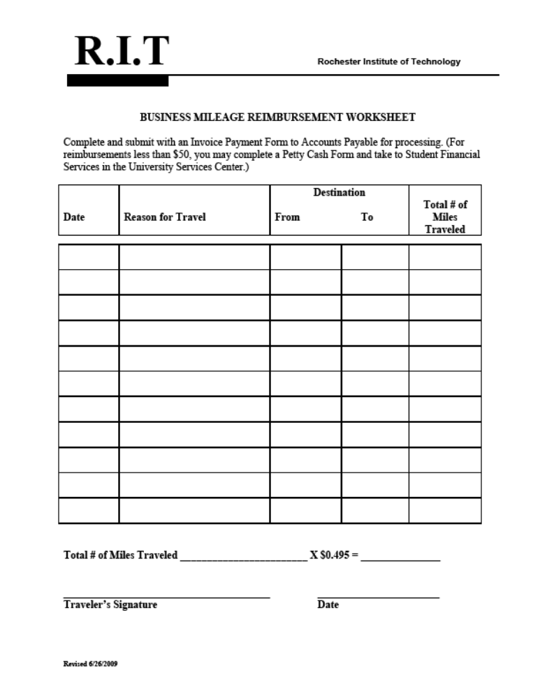
$0.43 =
$0.43 =

Award Number: _______________
Time Stamp: ____________________________
Award Amount: _______________
Finance Secretary Approval:
________________________

NOT FOR TRAVEL

Student Government
Application for Additional Funds
For Student Government Clubs/Departments/Individuals/Other Organizations

Use this form for making a request for additional funds for events, programs, or equipment purchases. Please read the Finance Committee Guidelines available at www.sg.rit.edu and return this completed form with the attached memo (instructions on reverse) to the Club Resource Center. If your event requires Event Registration, please see the EVR staff at the SAU info desk before submitting this paperwork to SG.

INFORMATION ABOUT THE CLUB/ORGANIZATION/INDIVIDUAL

PART A.
Club/Organization Name:______________________________________________________
Event Name________________________________________Event Date_______________
Start Time_________ End Time________
Requestor:
Name: __________________________ Position: _______________________________
Phone: __________________________ RIT Email: _____________________________
Alternate Contact (optional):
Name: __________________________ Position: _______________________________
Phone: __________________________ RIT Email: _____________________________
Advisor:
Name: __________________________ Signature: ______________________________
Phone: __________________________ RIT Email: _____________________________
Amount Requested: ________________ Date Needed: ___________________________
Purpose:_______________________________________________________________________________________________________________________________________________
Are you also requesting funds from other sources? □Yes □No If yes, please list in memo.
Have you completed Event Registration (if applicable)? □Yes □No

-INSTRUCTIONS ON BACK-
Please submit the completed form and memo to the Club Resource Center. After handing in the completed proposal, you will be contacted by email from the SG Director of Finance with further instructions. You may be asked to come and speak to the Finance Committee to clarify your request. Please be prepared to give as much information as possible about your activity.

PART B.

INSTRUCTIONS FOR MEMO:
Please include section I and/or II in your memo. Be sure your memo answers the following questions: Who? What? Where? When? Why? How? Also, make sure you supply other sources of income for your organization if applicable.

I. Events or Programs:
1. In your memo please explain the theme and/or function of the
event/program.
- Explain how it will benefit your organization and the RIT community.
- What methods will you and/or your organization use to advertise the event?
- What is the estimated attendance?
- Explain fundraising efforts your club/organization has already completed or plans to do.
- Include in table format a detailed list of all expenses and income that will be associated with the event.

II. Equipment Purchases or other Acquisitions:
- In your memo please give a detailed explanation as to how the purchase will benefit your club/organization.
- Please include official estimates of the costs indicating the company who provided the estimate.
- Include any fundraising efforts your club/organization has done and plans to do.
- To assist with this request, be sure to include where your club/ organization will be storing the equipment or purchase if storage will be needed.

5/17/06

Sales Tax Exempt Form

RIT does not reimburse for any sales taxes paid. Please make sure you have a Sales Tax Exempt Form for all purchases or travel expenditures. The Sales Tax Exempt form may be photocopied. This form should be used for all legitimate RIT financial transactions. You may obtain a copy of the Sales Tax Exempt Form from the Club Resource Center Staff Assistant.

Deposits

Make certain that you promptly bring in any funds collected by your organization for fundraising. You run the risk of losing the money or having the funds stolen if they are not deposited promptly. Your organization will not be reimbursed if you lose funds. Please give your deposits to the Club Resource Center Staff Assistant. You will be asked to count out the money and will be given a receipt to verify the amount. Make sure you ALWAYS get a receipt for your deposit. This is your proof that you made a deposit in the correct amount. Keep this deposit receipt along with your organization’s other important financial records.

After Hours Deposits

For after hours deposits, please use the Cash Drop Box. It is located in the RITreat, across from “Club Resource Center Desk” on the door of Room 1109. After hour deposit envelopes are located to the left of this door. Please fill out completely and deposit funds in this envelope. A receipt will be placed in your club folder the next business day.

*It is your responsibility as a recognized Student Government club to always deposit all fundraising. If you spend out of your fundraising and do not properly document your fundraising or expenses through the Clubs Financial Office, it is not only against Student Government procedures; but your documented fundraising will be understated and so will your expenses Your standing as an SG Club could be jeopardized. In the event you apply for additional funding or budget funds, it looks like your club isn’t active and doesn’t need extra funding. In addition to all of this, if you wish to progress upward in club tier, you need to make sure all financial transactions show your club growth. Please deposit and spend out of your club’s account.

Donation Deposits
If your deposit represents a donation from an individual or company, you must let the Club Resource Center Staff Assistant know it is a donation. Otherwise, the donation will be recorded as fundraising. Your club should send a Thank you letter to the donor mentioning the amount given to the club and submit a copy of this letter along with the donation check or cash to the Club Resource Center. You must also supply certain information such as below:

Business Donation Individual Donation
Contact Name Donor’s Name
Company Name Complete Home Address
Complete Company Address Any other related documentation Any other related documentation

Process of Fundraising

- Your club is required to fill out a Deposit Form whenever you are depositing any funds into your club. See form below. This document, when signed, verifies that any money you collected from members for trips or events; money collected from donors; money collected from an event you charged admission is the total amount you are depositing.
- Deposit Forms are available at the Club Resource Center.
- All fundraising should be deposited as soon as possible after the event.
- If a club wants to deposit fundraising and they do not have a completed form, they will be allowed to deposit at the Club Resource Center, but the club will not be credited until we receive a completed form.
- If your club sold T Shirts or similar items your club will need to remit sales taxes. Please make sure you account for sales tax when calculating the sale price of the T shirts or like items. 4% sales tax is charged for clothing.

DEPOSIT FORM
Today’s Date________________

We verify that the amount we are depositing today $____________________represents all funds collected or given to our club. These funds are best described as:

□ Fundraising

_____________________________ ____________________________
(Name of Event) (Date of Event)

□ Donation □ Members’ contributions to club
List all contact names on back of this form This might be contributions to a trip, dues etc.

□ Other
Please describe:

Signed_________________________________________
(Signature of Club member or Officer)

Signed__________________________________________
(Signature of Club member or Officer)
Note: If you do not have this form completed at the time you need to deposit fundraising at the Club Resource Center, you may still deposit your fundraising at the Club Resource Center. Your club account will not be credited, however, until we receive this completed form.

Contract Process

When you are having an event the occasion may arise where you need to pay a DJ or a speaker. This type of payment will require a contract and W-9 form. Students, Advisors and Student Clubs may not enter into nor sign any contracts The only individuals that can sign contracts for Student Government Clubs are managers in the Center for Campus Life Offices.

Please be aware that if a DJ happens to be performing for your club and not charging a fee, a contract is still necessary. Your club has spent money and time in planning this event and your club needs to make sure the DJ will appear.

If you require any Travel arrangements for your speaker or artist, please make a copy of your completed CRF and bring the copy to your travel arrangements appointment.

Looking to have a DJ or Speaker or another type of Artist at your next event? Follow these steps to bring them to RIT:
Clubs should start the Contract process one month before the event is to take place.

1) Register Event with EVR Monday through Friday 1 p.m. to 4 p.m.
  - During the intake, the EVR staff will ask if your club is having a DJ or Speaker. If so, EVR will give the club a Contract Request Form (CRF).

    - Once the Contract Request Form (CRF) is completed, it should be returned to EVR or the SAU Information Desk. This should be done no less than three weeks before the event so that payment is requested in an effort to be made to them on the day of service.
    - Please make sure that the CRF is COMPLETE. All blanks should be filled in, and no line should be left empty (even if there is no charge, please write “Zero Dollar.”)
    - If your DJ/Speaker/Artist has their own contract, it should be attached to the CRF and returned to EVR or the SAU Information Desk.
  - The Center for Campus Life has professional staff who will create a contract based on your CRF, after receiving it from the club/respresentative. If the artist has their own contract, please attach it to the CRF for the Center for Campus Life to review.
  - EVR will send the contract and W-9 to DJ both by fax and regular mail.
    - The DJ is responsible for signing the contract and W-9 and returning them to EVR at least two weeks prior to the event.
  - EVR will forward the completed contract and W-9 to the Financial Coordinator.
  - The Financial Coordinator will request a check from RIT Accounts Payable (This process can take 10-14 days.)
  - The Club representative will be notified when the check is available to be picked up from the Club Resource Center.
  - If these time frames are not followed, we cannot guarantee payment for the day of service. It will be your responsibility to communicate that to the DJ, Speaker or Artist
Last Revision on 3/10/06

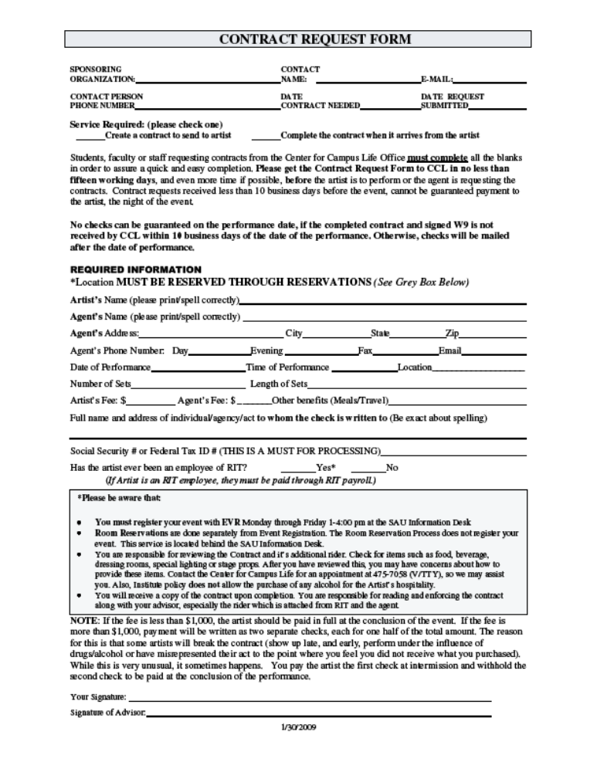

Office Max Supply Form

Please Print Neatly

Club name

Qty | Office-Max # | Description | Cat. Pg # | Price

Room Form

ROOM # 1 ROOM # 5

1)__________________________________ 1)_________________________________

2)__________________________________ 2)_________________________________

3)__________________________________ 3)_________________________________

4)__________________________________ 4)_________________________________

ROOM # 2 ROOM # 6

1)__________________________________ 1)_________________________________

2)__________________________________ 2)_________________________________

3)__________________________________ 3)_________________________________

4)__________________________________ 4)_________________________________

ROOM # 3 ROOM # 7

1)__________________________________ 1)_________________________________

2)__________________________________ 2)_________________________________

3)__________________________________ 3)_________________________________

4)__________________________________ 4)_________________________________

ROOM # 4 ROOM # 8

1)__________________________________ 1)_________________________________

2)__________________________________ 2)_________________________________

3)__________________________________ 3)_________________________________

4)__________________________________ 4)_________________________________

Official’s Voucher

Please print carefully to avoid delay of payment

OFFICIAL’S NAME_____________________________________________________

SOCIAL SECURITY #___________________________________________________

STREET ADDRESS_____________________________________________________

CITY/STATE/ZIP_______________________________________________________

****************ATTACH W-9 FORM************************************

ARE YOU EITHER AN RIT FACULTY/STAFF OR A STUDENT WHO IS PAID A REGULAR PAY CHECK THROUGH OUR PAYROLL DEPT?

YES_____________NO______________

CLUB NAME___________________________________________________________

GAME: RIT VS_________________________________________________________

DATE:_________________________________________________________________

AMOUNT DUE OFFICIAL$______________________________________________

