Population in Austrian regions from 1994 to 2014 by gender
Population in Austrian regions from 1994 to 2014 by gender

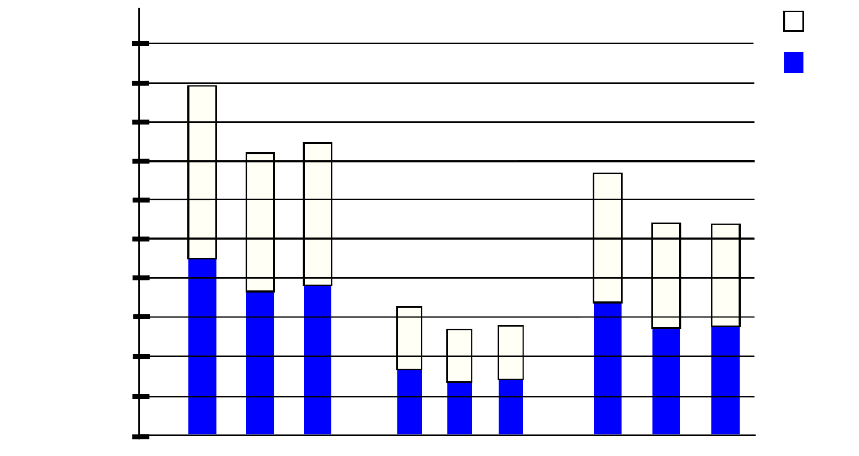
Male
Female
Upper
Austria
Salzburg
Styria
385200
577800
770000
963000
1155000
94
0
192600
04
14
94
04
14
94
04
14
1350000
1540000
1730000
1920000

Male

Female

Upper
Austria

Salzburg

Styria

385200

577800

770000

963000

1155000

94

0

192600

04

14

94

04

14

94

04

14

1350000

1540000

1730000

1920000

