Population in Austrian regions from 1994 to 2014 by gender
Population in Austrian regions from 1994 to 2014 by gender

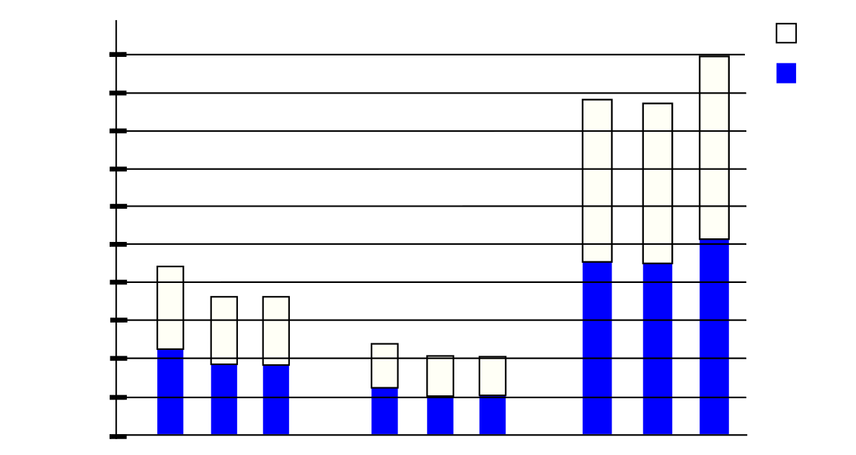
Male
Tirol
Vorarlberg
Vienna
0
192600
385200
577800
770000
963000
Female
1155000
94
04
14
94
04
14
94
04
14
1350000
1540000
1730000
1920000

Male

Tirol

Vorarlberg

Vienna

0

192600

385200

577800

770000

963000

Female

1155000

94

04

14

94

04

14

94

04

14

1350000

1540000

1730000

1920000

