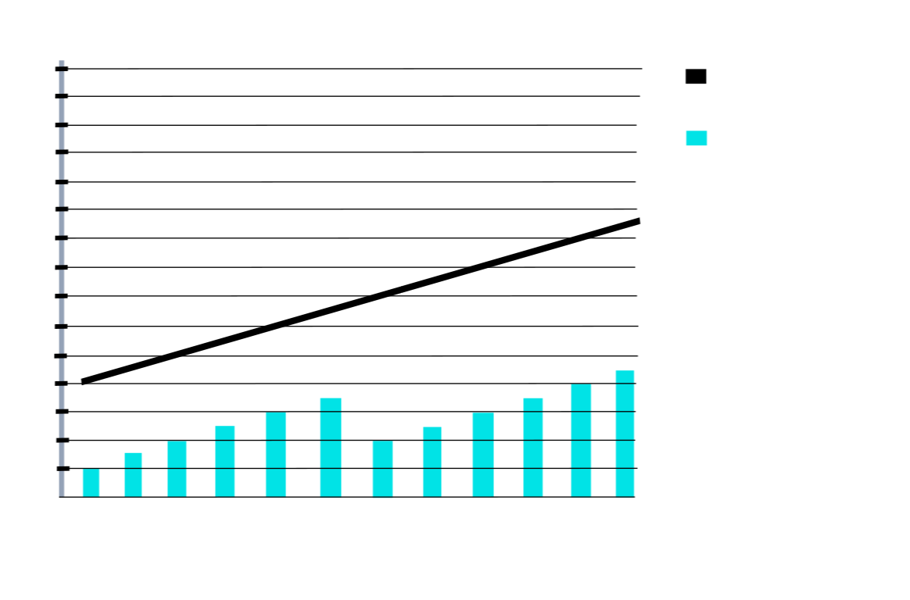
Age of Leonardo DiCaprios Girlfriends (years 1999 to 2010)
Leonardos Age
Leonardos
Girlfriends
Age
Gisele Bundchen
Bar Refaeli
46
44
42
40
38
36
34
32
30
28
26
24
22
20
18
16
99
00
01
02
03
04
05
26
27
28
29
10

