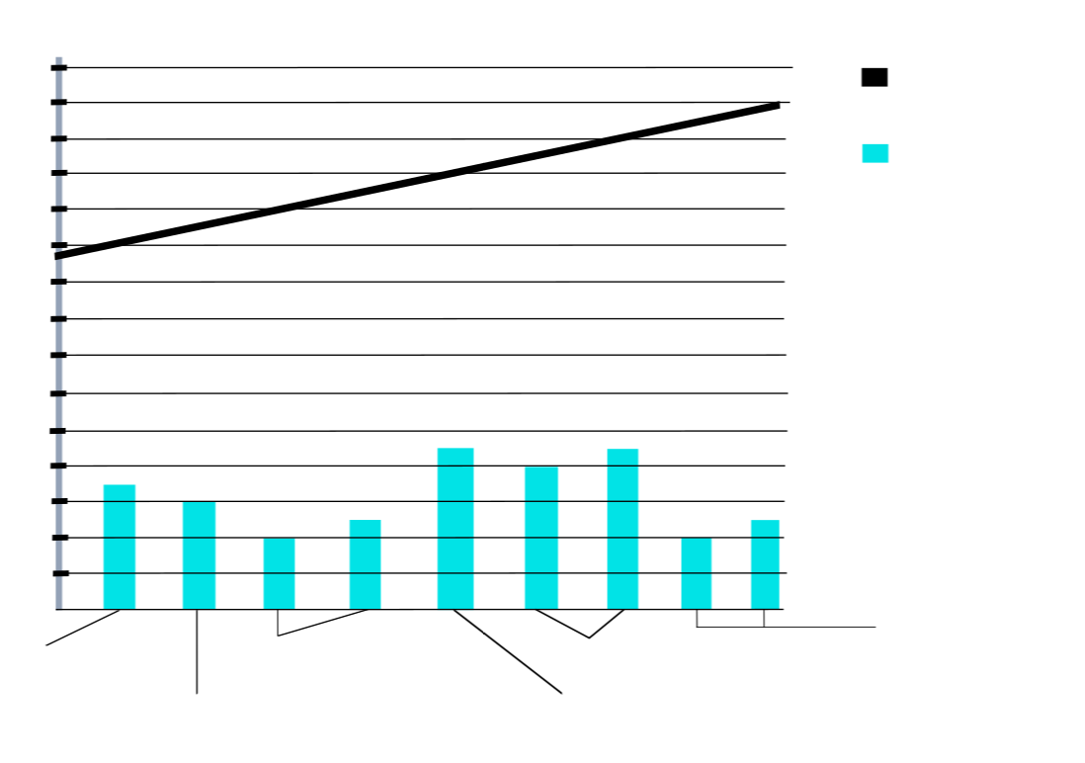
Blake
Lively
Erin Heartherton
Toni Garrn
Kelly Rohrbach
Camila
Morrone
Nina Agdal

Age of Leonardo DiCaprios Girlfriends (years 2011 to 2019)

Leonardos Age

Leonardos
Girlfriends
Age

Blake
Lively

Erin Heartherton

46

44

42

40

38

36

34

32

30

28

26

24

22

20

18

16

11

12

13

14

15

16

17

18

19

Toni Garrn

Kelly Rohrbach

Camila
Morrone

Nina Agdal

Age of Leonardo DiCaprios Girlfriends (years 2011 to 2019)
Leonardos Age
Leonardos
Girlfriends
Age
46
44
42
40
38
36
34
32
30
28
26
24
22
20
18
16
11
12
13
14
15
16
17
18
19

