Population in Austrian regions from 1994 to 2014 by gender
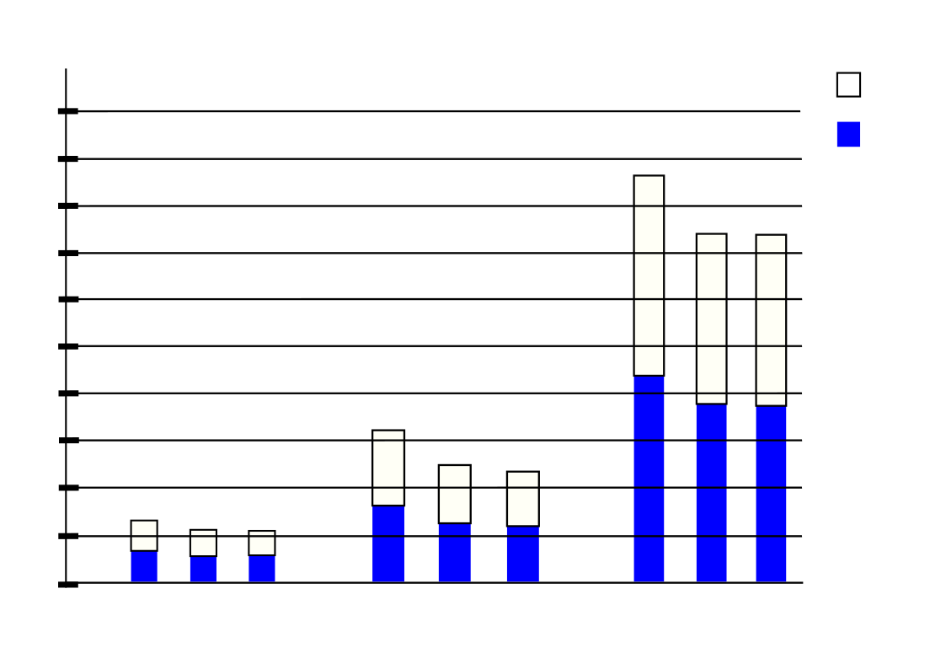
Number of people
Male
Female
Burgenland
Carinthia
Lower Austria
0
192600
385200
577800
14
770000
963000
1155000
94
04
14
94
04
14
94
04
1350000
1540000
1730000
1920000

