Population in Austrian regions from 1994 to 2014 by gender

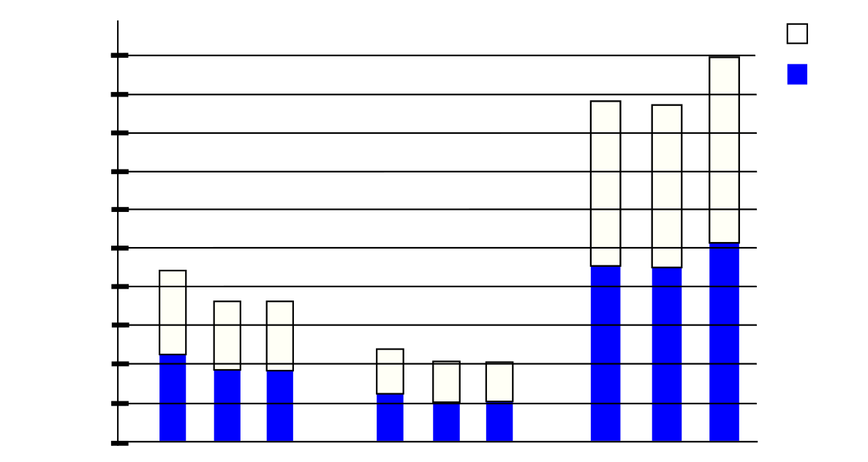
Male
Tirol
Vorarlberg
Vienna
0
192600
385200
577800
770000
963000
Female
1155000
94
04
14
94
04
14
94
04
14
1350000
1540000
1730000
1920000

