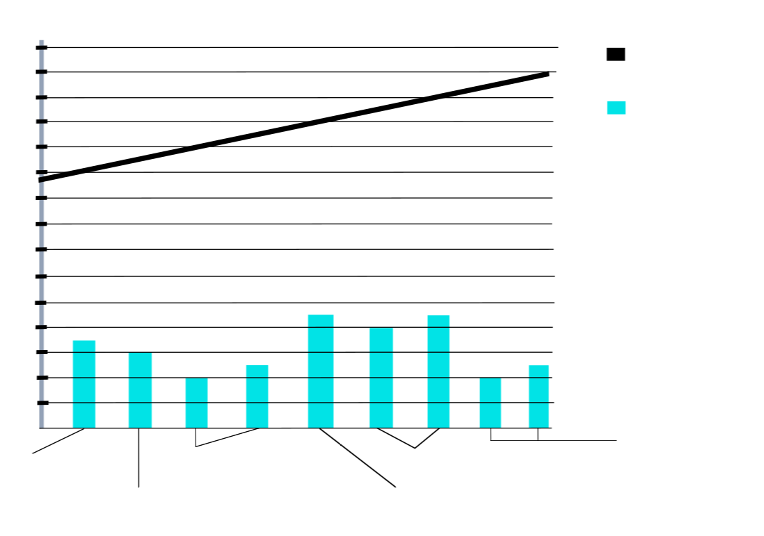
Blake
Lively
Erin Heartherton
Toni Garrn
Kelly Rohrbach
Camila
Morrone
Nina Agdal
Age of Leonardo DiCaprios Girlfriends (years 2011 to 2019)
Leonardos Age
Leonardos
Girlfriends
Age
46
44
42
40
38
36
34
32
30
28
26
24
22
20
18
16
11
12
13
14
15
16
17
18
19

