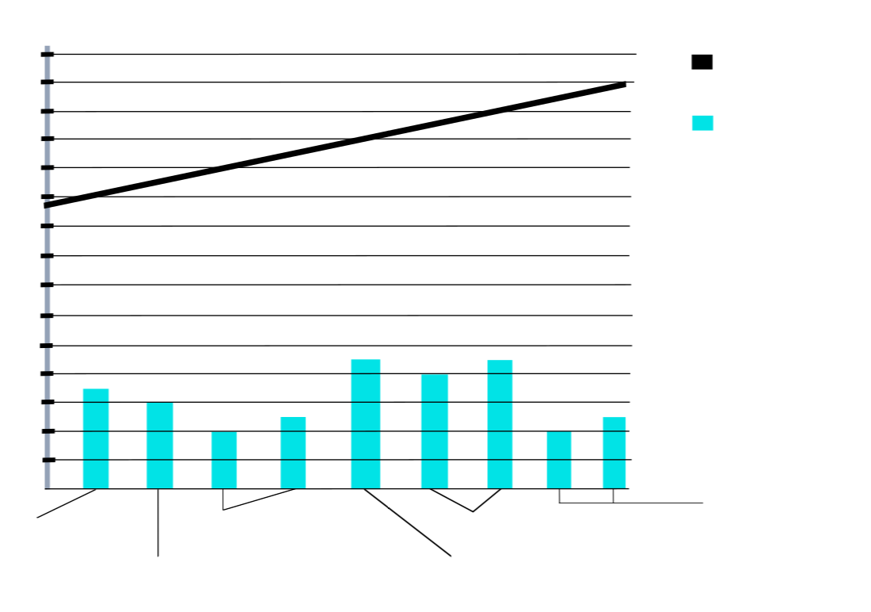

Camila

Morrone

Nina Agdal

Kelly Rohrbach

Toni Garrn

Erin Heartherton

Blake

Lively

19

18

17

16

15

14

13

12

11

22

18

16

20

24

26

28

30

32

38

34

36

40

42

44

46

Leonardos

Girlfriends

Age

Leonardos Age

Age of Leonardo DiCaprios Girlfriends (years 2011 to 2019)