Population in Austrian regions from 1994 to 2014 by gender

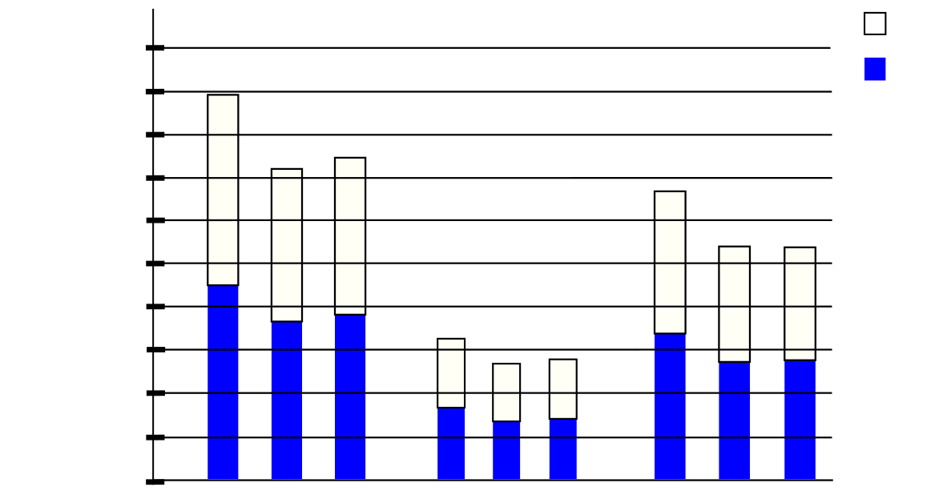

04

04

14

94

04

14

94

14

Styria

Upper

Austria

963000

1155000

1350000

1540000

1730000

1920000

Male

Female

Salzburg

94

385200

577800

770000

192600

0