Population in Austrian regions from 1994 to 2014 by gender

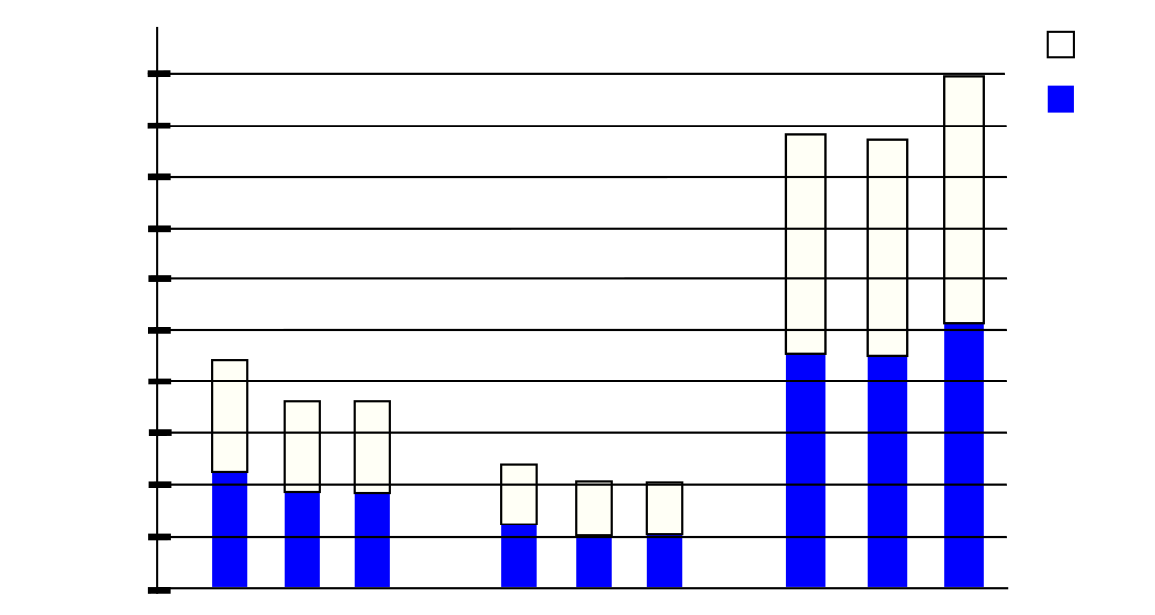

Female

Male

Vienna

Vorarlberg

94

04

14

04

94

14

14

04

94

385200

577800

770000

963000

1155000

1350000

1540000

1730000

1920000

192600

0

Tirol