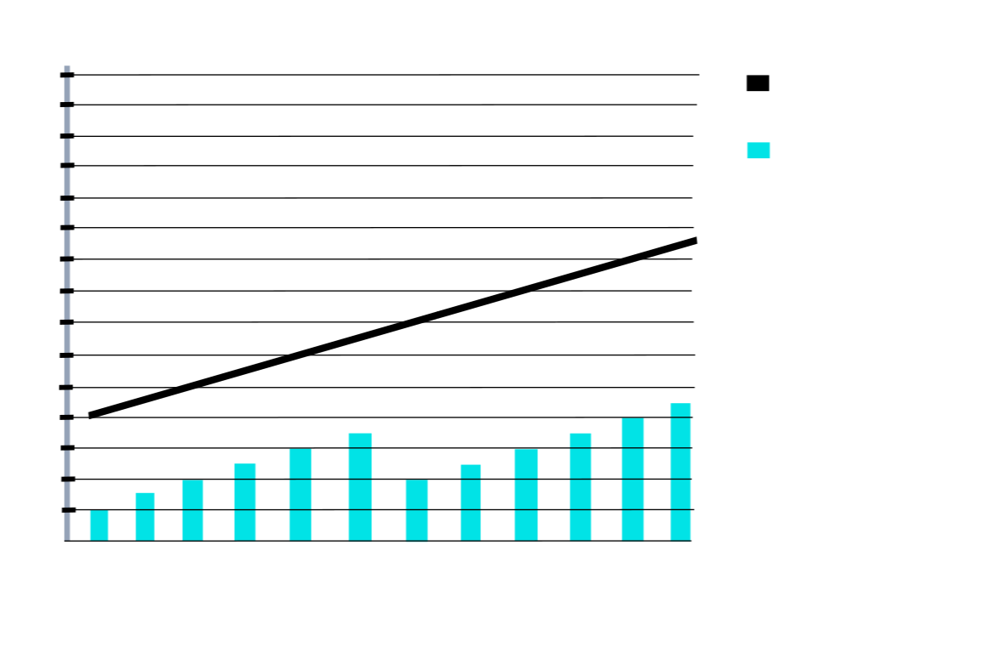

Age of Leonardo DiCaprios Girlfriends (years 1999 to 2010)

10

29

28

27

26

05

04

03

02

01

00

99

22

18

16

20

24

26

28

30

32

38

34

36

40

42

44

46

Bar Refaeli

Gisele Bundchen

Leonardos

Girlfriends

Age

Leonardos Age