**XVIII International Symposium on Computer Simulation in Biomechanics**

**July 2021, Stockholm**

**CO-ACTIVATION IS A ROBUST MINIMAL EFFORT STRATEGY – COMPARISON OF TWO STOCHASTIC OPTIMAL CONTROL APPROACHES TO SIMULATE ROBUST HUMAN MOVEMENT**

# Tom Van Wouwe1, Lena H. Ting2,3, Friedl De Groote1

1Department of Movement Sciences, KU Leuven, Leuven, Belgium

2W.H. Coulter Dept. Biomedical Engineering, Emory University and Georgia Institute of Technology, Atlanta, GA, USA

3Department of Rehabilitation Medicine, Emory University, Atlanta, GA, USA

Email: tom.vanwouwe@kuleuven.be

**INTRODUCTION**

Stochastic optimal feedback control has the potential to take our understanding of human movement a step further. It allows predicting the effect of physiological noise on optimal movement kinematics, modulation of feedback control and application of feedforward strategies such as muscle co-activation.

Muscle co-activation is thought to stabilize the musculoskeletal system during movement against the effects of noise through two mechanisms: (a) by increasing intrinsic muscle impedance and (b) by allowing an agonist-antagonist dual corrective approach where agonist activity is upregulated from the co-activated state and antagonist activity is downregulated from the co-activated state [1].

Recently we proposed an approximate deterministic formulation to perform stochastic optimal control simulations of movement [2].

Our deterministic formulation allowed the application of efficient trajectory optimization techniques to generate solutions. Our approach predicted co-activation mechanism (a), but not (b) as our approximation of the exact stochastic system neglected some necessary features to predict (b).

For a stochastic system $\dot{x}\left(t\right)=f\left(x\left(t\right),u\left(t\right),w\right)$, with $w$ a stochastic disturbance, the approximation of the problem occurred at two levels: **(1)** the non-Gaussian distribution of the stochastic state trajectories was approximated by a Gaussian distribution, allowing a description of the full state space by the mean state trajectory $x_{mean}\left(t\right)$ and state covariance trajectory $P\left(t\right)$; and **(2)** the discretized propagation (with time-step $δ$) of the state-covariance was approximated, by assuming invariant dynamics around $x_{mean}\left(t\right)$, resulting in the discrete Lyapunov equation:

$$P_{k+1}=A_{k}P_{k}A_{k}^{T}+C_{k}∑_{w}A_{k}^{T}$$

$A_{k}=δ\frac{∂f}{∂x}(x_{k},u_{k},w=0)$, $C_{k}=δ\frac{∂f}{∂w}(x_{k},u_{k},w)$.

which corresponds to the propagation rules applied in the Extended Kalman Filter (EKF).

Due to the assumption of local invariance of the dynamics to propagate the state-covariance matrix, non-linearities in the dynamics that present themselves around the mean state trajectory are ignored for the propagation of P. Intuitively this means that sudden abrupt changes (such as the clipping of muscle activation below 0) in the dynamics around the mean trajectory are not ‘seen’, leading to predicting ‘optimal’ behaviour that might be far from optimal for the exact stochastic system.

A deterministic approach to overcome the limitation of approximation **(2)**, is the unscented transform [3] to propagate $x_{mean}\left(t\right)$ and $P\left(t\right)$.

We apply both approaches to predict co-activation mechanism (b) during the stabilization of a single inverted pendulum as a model of upright standing, where the two antagonistic actuators are limited between 0Nm and 250Nm. We show that the new UKF approach (‘UKF’) is more exact than the EKF approach (‘EKF’) and that the increased accuracy affects the optimal control policy and state trajectory where the UKF approach predicts antagonistic co-activation, whereas the EKF approach does not.

**METHODS**

Consider a deterministic system $\dot{x}\left(t\right)=f\left(x\left(t\right),u\left(t\right)\right)$ for which we discretize the simulation using trapezoidal integration: $G\left(x_{k},u_{k},x_{k+1},u_{k+1},δ\right)=0.$

In the unscented Kalman filter approach (‘UKF’) we discretize the simulation of the stochastic dynamics $f\left(x\left(t\right),u\left(t\right),w\right)$ as follows, given $P_{k}$ and $x_{k}$ and the trajectory $u$:

$$L_{k}L_{k}^{T}=P_{k}$$

$$X_{k}=[x_{k} x_{k}+{cL}_{k}{ x}_{k}-cL_{k}]$$

$$G\left(X_{k},u_{k},Y_{k},u_{k+1},δ\right)=0⇒Y_{k}$$

$$x_{k+1}=W_{m}Y_{k}^{T}$$

$$P_{k+1}={(Y}_{k}-x_{k+1}) W_{c}{{(Y}_{k}-x_{k+1}) }^{T}$$

$x_{k}$ mean state vector at $t=t_{k}$, $X_{k}$ samples at $t=t_{k}$, $Y_{k}$ transformed samples $X_{k}$ to time $t=t_{k+1}$, $L_{k}$ a lower triangular matrix, c a tunable positive scalar, $W_{m}$ the weights to compute the mean from the samples and $W_{c}$ the weights to compute the covariance from the samples.

The discretized propagation over one time-interval of the mean trajectory and state-covariance can be interpreted as (1) sampling the normally distributed state, (2) non-linear transformation of these samples – i.e. the integration step through the non-linear dynamics, (3) approximating the state at $t_{k+1}$ as normally distributed by computing the mean and covariance of the transformed samples.

We simulated an inverted pendulum model ($\ddot{q}=g.l.cos\left(q\right)+T_{total}$) actuated by two antagonistic ideal torque actuators determined by a constant feedforward torque and constant PD feedback: $T^{+}=T_{base}^{+}+K_{p}^{+}\left(q-π\right)+K_{v}^{+}\dot{q}; T^{-}=T_{base}^{-}+K_{p}^{-}\left(q-π\right)+K_{v}^{-}\dot{q}$. The total torque ($T_{total}$) applied to the IP was corrupted by motor noise and clipped between 0 and 250Nm with a smooth but accurate approximation of a clipping function: $T_{total}=f_{clip}\left(T^{+}\right)-f_{clip}\left(T^{-}\right)+T_{noise},$ with $T_{noise}$ zero-mean Gaussian noise (SD: $σ_{noise}$). We solve for $[T_{base}^{+},T_{base}^{-},K^{+},B^{+},K^{-},B^{-}]$ that minimize the expected effort $\int{T_{total}^{2}dt}$ and achieve an upright equilibrium posture: $[q, \dot{q},\ddot{q}]=0$, that is stable: $P_{k}=P_{k+1}.$ We solve this stochastic optimal control problem with both the EKF and the UKF approach for increasing $σ_{noise}.$

We compare baseline torques and feedback gains of the two approaches. Next, we validate the accuracy of these approaches by performing a 100s stochastic forward simulation under the found optimal control policies. We compute the RMS sway resulting from these forward simulations (‘estimated’) and compare to the RMS sway from the trajectory optimization solution (‘predicted’).

**RESULTS & DISCUSSION**

Because we have a symmetric system around the operation point $[q, \dot{q},\ddot{q}]=0$, the ‘+’ variables ($T_{base}^{+},K_{p}^{+},K_{v}^{+}$) are in a feasible and optimal solution equal to the ‘-’ variables ($T_{base}^{-},K_{p}^{-},K_{v}^{-}$). We therefore only show the ‘+’ variables.

UKF predicts an increasing baseline torque (i.e. co-activation) with increasing motor noise. EKF predicts minimal baseline torque (no co-activation). EKF ignores the presence of the strong bending of $f_{clip}$ close to the operating point $(T_{base}^{+}=0.01Nm)$, and thus assumes that feedback driven corrections will result in negative torques, allowing for a correction of both $T^{+}$ and $T^{-}$ in case of a deviation from the operating point. UKF, samples around the operating point and detects the saturation at 0Nm. Therefore the operating point, and thus baseline torque, is shifted to allow for a correction of both $T^{+}$ and $T^{-}$ in case of a deviation from the operating point.

Feedback gains are larger in UKF compared to UKF. Since UKF detects the saturation of the corrective torque actuation, larger positive corrections are necessary in the antagonistic torque to correct for a given perturbation compared to EKF where equal positive and negative corrections are assumed to be possible.

Predicted sway is similar for UKF and EKF, and increases with increasing motor noise. However, UKF predictions are more accurate: the difference between estimated and predicted sway is small for UKF but large for EKF. From motor noise with variance 1000Nm².s onwards for EKF and for motor noise with variance 5000Nm².s for UKF the estimated sway is >100°: the pendulum ‘fell’ and the controller was not able to return it to upright position.

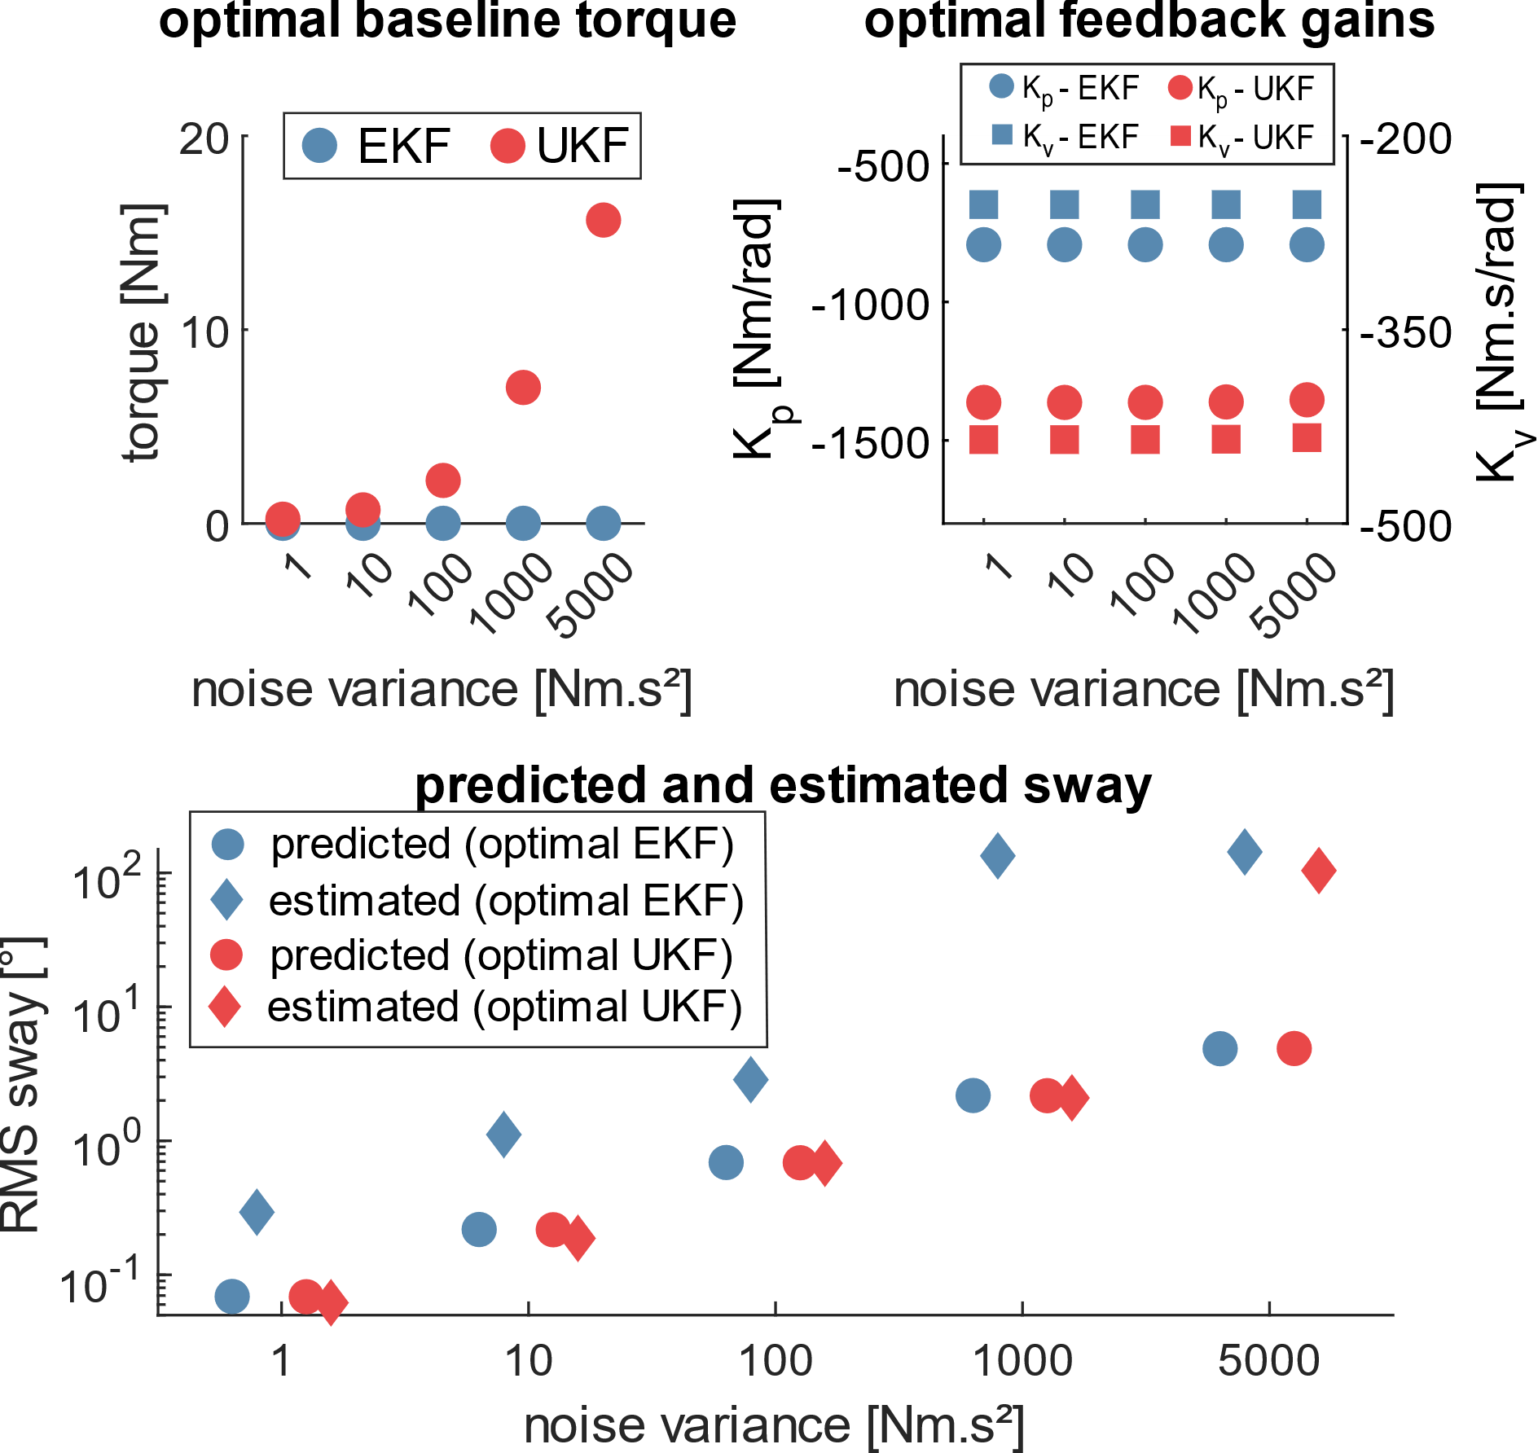

Figure 1 **Upper left**: Optimal baseline torques predicted by EKF and UKF. **Upper right**: Optimal feedback gains($K_{p}^{+},K_{v}^{+},K_{p}^{+},K_{v}^{+}$) predicted by EKF and UKF. **Lower**: Optimal predicted sway for EKF and UKF and estimated sway from 100s forward simulations, in the presence of the appropriate motor noise, under the predicted optimal controllers by EKF and UKF.

**CONCLUSION**

The presented approach allows accurate predictive simulations of stochastic non-linear systems using efficient trajectory optimization approaches. It improves our previous approximation by incorporating non-linearity in the propagation of both the mean state and the state covariance matrix.

Therefore, we believe it can become an important tool to analyze and predict human movement and coordination to better understand contributions of sensorimotor feedback and feedforward strategies (such as co-activation) in generating robust movement.

**REFERENCES**

[1] Saliba et al. (2020), Biorxiv

[2] Van Wouwe et al. (2020), ASB conference

[3] Julier (2004), Proc. of the IEEE

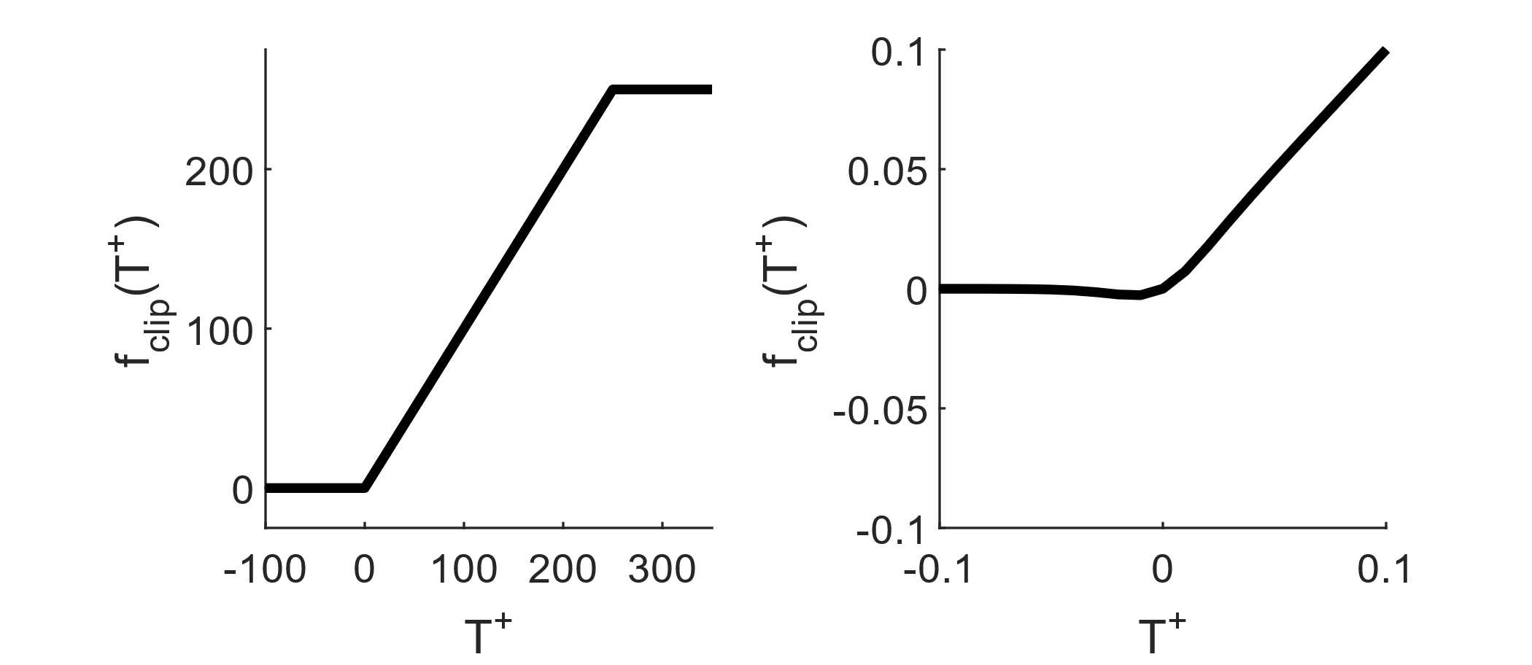

Figure 2 – Clipping function based on tanh functions for smoothing. Left full domain; right zoomed to illustrate the small error introduced by tanh approximations. To make sure the operating point is on the ascending limb we impose $T_{base}^{+}$ and $T_{base}^{-}$ > 0.05Nm.