1. How do you evaluate the performance of a project in agile?

Ans:

The performance of a project in agile can be evaluvated by following the steps below:

Performance review during the course of project

- The Business value is another major factor that results in evaluating the performance of a project in an agile. Business value is the outcome , that is, the features that are useful for the customers.
- The burndown graph explains how much work is remaining of the project.
- Defect analysis is done to find the rate at which the defects are removed or resolved
- Flow analysis: is a technique implemented to identified items that is in a bottleneck or acting as an impediment and to find whether they are in a transition state.
- Release chart: shows what are teh tasks reamining during the project.
- Hit rate: is to determine whether the work in a particular timebox has been completed or not.
- Work Remaining on a Task: To determine the work remaining on each active task
- CPI is found to determine whether the project is going in or out of the allocated budget.
- SPI is used to determine whether the project can be completed late or early.
- Velocity lag: is used to determine the project is running according to the ideal base velocity.

Performance review after the completion of project

- Prepare a sprint report card which measures the customers overall satisfaction score. From this we will be also getting customers opinion.

- Determine the number of user stories delivered and how much has been carried over to the next sprint. Then the performance is rated based on the number of defects carried over or resolved.
- Receive the project report card from the customer to the team which shows the rating by the customer for the teams ability to change to changes, number and quality of product increments delivered
- Product owner report card: This is from the Product owner to the team which comprises of teams overall score on teamwork and other traits., teams adaptability to changes and the technical ablities used to resolve issues.
- Project peer review: This is the scoring done between the members of a team

2. Compare traditional monitoring & control with agile monitoring & control with respect to metrics generation

Ans:

Traditional monitoring and control | Agile monitoring and control
Focusses on all the story points | Focus on the story points that add customer value
Assumes requirements are fixed and cost and time are variables. | Keep requirements as variable and estimates fix time and cost
CPI and SPI are caluclated to track the cost and duration | CPI, SPI and the business value of the project.
Limited scope | Crowdsourcing
The features are including the user stories that does not deliver any value | The chores are seperated from the features that have business value
Metrics relate more to the process used to complete the work | Metrics relate more to the outputs of the work

3. With a total project budget of $ 175,000, and having completed one out of four Iterations, we have this product backlog and these actuals:

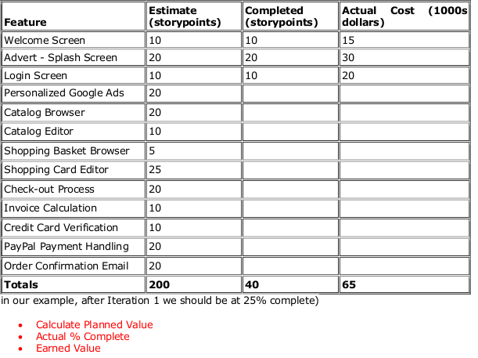
Ans:

Planned value: Total budget * Planned completion rate=$175000 *25%=$43750

Actual % complete: No of story points completed/Total story points=(40/200) *100=20%

Earned value: Actual Percent Complete* Total Budget= (20/100)*175000=$35000

