1. When to use (Rapid Application Development) RAD model
When not to use (Rapid Application Development) RAD model

Ans:

RAD model is used when there is
- High availability of skilled people and designers for modelling.
- This model is applied for projects that have high budget as the cost increases when there is high use of automated tools for code generation.
- The whole team should have high business knowledge to produce the system in a very short span of time which might ne 2 to 3 months.
- This model is applied when the customer requires rapid product increments.
- The customer collaboration is high through the whole life cycle.
- RAD model is applied when the user requirements are well known.

RAD model is not used when
- There is no avalilability of skilled, knowledgeable or experienced employees.
- The project has Low budget for the project as automated code generation cannot be applied and cannot afford designers for modelling
- The system cannot be modularized, that is, when the system cannot be broken down into smaller modules.

2. Define an ER diagram of a software Organization with all the relationship model that was discussed in the classroom

Ans:

Operations Department
First name
Last name
Employee location
Works for
1

Employee name
0,M
1
Supports
Employee Details
Works on
DoB
1

Age
Emp_Degree
1,1
M

Project
Client id
1
Client
Requests
1

Project name
Project id
Project location
Client location

3. Describe the Entity Relationships for the following diagram

Ans:

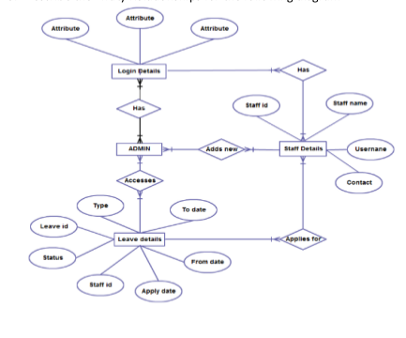

Enitity
- Login Details
- Admin
- Staff Details
- Leave Details

Entity1: Login Details

Login details has 3 attributes according to the diagram

Attributes can be : 1)User name
2)Password
3)Change password

Entity2: Admin

Entity3: Staff Details

Attributes:
1)Staffid (Primary key)
2)Staffname
3)User name
4)Contact

Entity4: Leave details

Attributes:
1) To date
2)From date
3)Apply date
4)Staff id (Foreign key)
5)Status
6)Leave id
7)Type

Scenario1:

- Different Admins are there at different locations and Different Admins have different login details(Many login details have many admins)
- After they have entered in the system as an admin of a particular department, many admins adds many staff details.
- Many staff applies for many leave.
- Each Admin(Branch Level) has acess to many leave details of the staffs

Scenario2:

- Different login details have access to different Staff details.
- Many staffs can applies for many leave details.

