All About Spiritual Portraits
Including: How to Draw a Personality
By Tom W. Hartung

© Copyright 2019 Tom W. Hartung and JooMoo WebSites LLC. All Rights Reserved.
On the cover: ???????????????????????????????????

Other ideas for the title:
- Who, What, Why, and How About Spiritual Portraits
- How and Why You Might Want to See Your Personality
- Visualizing Personalities for Dummies
- The Why, What, Who, and How Book About Spiritual Portraits
- Why Would You Want a Spiritual Portrait?

Table of Contents
Preface 4
Observations and Choices 4
Preferences Happen 4
Abstract Personalities, Abstract Images 5
Limitations of the Analysis 8
Introduction 9
Why Draw Personalities? 11
Finding Work That Suits Your Personality 11
Insight Into Yourself and Others 12
Death - Yours and Mine 13
Mild, Clear, and Extreme Preferences 14
Chameleons Have Mild Preferences 14
Most People Have Clear Preferences 15
The Hazards of Extreme Preferences 17
Mindfulness 18
Too Busy - or Afraid of the Unknown? 19
Willful, Blissful Ignorance? Whatevs 19
Learn How to See Past the Surface 20
What the Images Represent 21
Carl Jung’s Archetypes 21
What Does Phoenix Do? 22
Perceptions and Actions 22
Difficulties Due to Differences 22
Facts and Ideas 23
Difficulties Due to Differences 24
The AI’s “Preference” for Facts 25
Emotions and Logic 26
Difficulties Due to Differences 26
The AI’s “Preference” for Logic 27
Out There and In Here 28
Difficulties Due to Differences 28
Recap/Summary 30
Who Would Most Appreciate a Spiritual Portrait? 31
Conclusion - The Pitch 33
Benefits 33
Pricing 33
Appendix 34
How to Draw a Personality 34
Choose the Traits to Portray 34
Choose How to Portray the Traits 35
Find or Write a Questionnaire 36
Write the Program 36
Get Personalities and Create Images 37
Creating Images 37
A Personal Note 38
The Real Lessons of Abstract Art 38
Real Artists Wanted 38

List of Images
Tony Soprano & Travis Bickle 6
Tom W. Hartung 8
Your Name Here 12
Leia Organa, Fidel Castro, & Jon Snow 14

Illustration Index
Tom Hartung - Draws Images of Personalities 8
Your Portrait? 12
Jon Snow – Game of Thrones 13
Princess Leia – Star Wars 13
Fidel Castro – Cuban Dictator 13
Alexander Hamilton - Author of the Federalist Papers and First Secretary of the Treasury 15
George Washington – Revolutionary General and First President of the United States 15
Thomas Jefferson - Author of the Declaration of Independence and Third President 15
Norm Peterson – Barfly on Cheers 16
Tywin Lannister – Patriarch on Game of Thrones 16
Margaret Lanterman – Log Lady on Twin Peaks 16
Sam Malone - Manager and Sometimes Owner of Cheers 22
Carla Tortelli - The Real Boss on Cheers 22
R2-D2 – Small Astromech Droid on Star Wars 24
Obi-Wan Kenobi – Jedi Master on Star Wars 24
Lucy Ricardo - Starstruck Wife on I Love Lucy 26
Ricky Ricardo - Lovestruck Husband on I Love Lucy 26
Zeronimo - Outgoing Tuxedo Kitty Cat 28
Mildred - Shy Grey Tabby Kitty Cat 28

Preface
The idea behind visualizing personalities is really quite simple.

Observations and Choices
Every living thing is constantly:
- Observing: perceiving, gathering and assimilating information, and
- Doing: making decisions based on our observations – and observing the results
Even when we are going through the motions on a typical day, even when dreaming, we are either observing or doing something – or both.
Sometimes – such as when we are using muscle memory and on automatic pilot – we can even be doing both at the same time!

Preferences Happen
Every living thing - animals and more recently even some machines – has a preference for either observing or doing something.
This preference may be subconscious, and it may be big or small.
To create a spiritual portrait I combine a person's preference for observing or choosing with a few other, similar preferences into an image I like to call call a Groja,^{[1]} for Graphical Representation of Jungian Archetypes.

Abstract Personalities, Abstract Images
Personalities are abstract – an idea we get about people whom we get to know. Preferences are an abstraction – generalizations based on multiple instances - based on the observations and decisions made over the course of a lifetime.
Visualizing a personality based on a person's preferences requires using an abstract image.
If you are familiar with the fictional characters Travis Bickle from the film Taxi Driver and Tony Soprano from the tv show The Sopranos, then you know they have very different personalities.
Tony runs a crew in the DiMeo Crime Family. He’s well-liked by both of his families, but generally remains cool and calm – and can sometimes be cold and heartless. He’s all about making money and can be warm with his friends, but gets angry quickly when crossed.
Travis drives a taxi. He’s doesn’t have many friends, but is warm and friendly with his customers – and full of ideas. He dreams of somehow cleaning up the streets in New York City, but some of his ideas are a bit off due to his experiences as a soldier in the Viet Nam War.
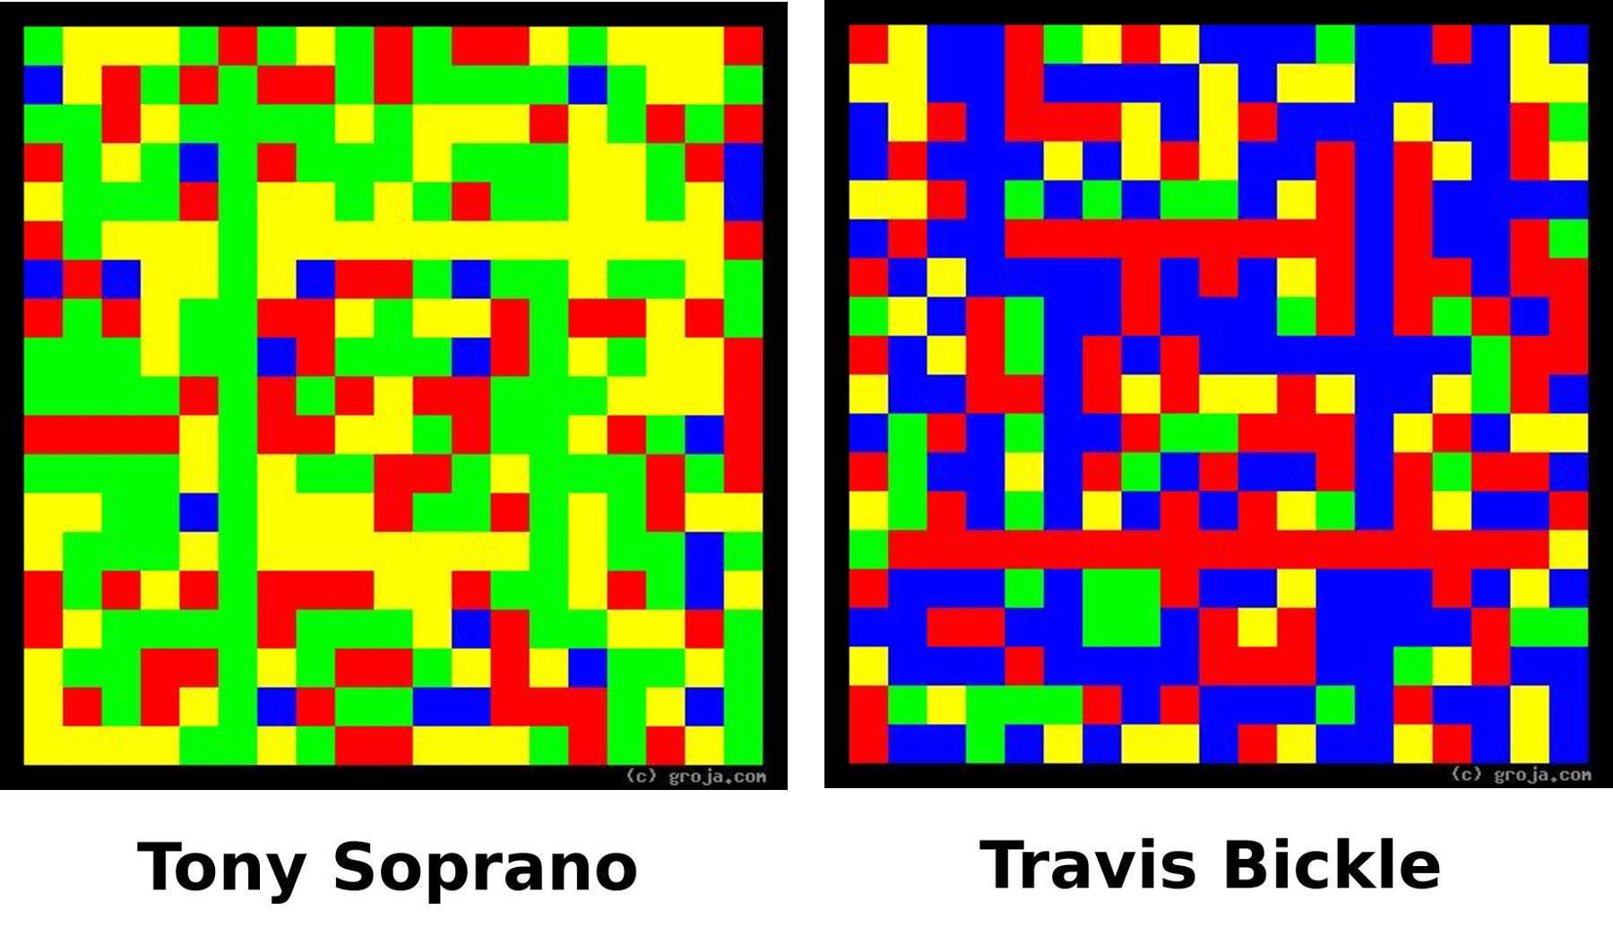
If you know them, then which one – Travis or Tony – would you say tends to prefer observing, and which prefers doing? Which one is the watcher, and which is the action guy?
If you don’t know one or the other or both, then which of these two images feels more open, and which feels more active?
Images of personalities are necessarily abstract.
When done right, the images give us a feel similar to what we get from the person.
If I draw these images properly – and I believe I do – and if you can open yourself up to how primary colors can elicit certain feelings, you don’t need to understand psychology!
It's really just that simple!

Limitations of the Analysis
In life there are good people, bad people, and a lot of people whose moral sense falls some place in between.
Personality profiles based on Jungian Typology do not incorporate morality in any way.
The fact that these images contain nothing that depicts whether the subject is good, bad, or something in between may be disappointing for some. However refraining from taking morality into account has many advantages.
Most significantly, if the questionnaire forming the basis for the profiles contained questions concerning morality, dishonest people would probably lie!
By focusing solely on objective personality traits – qualities for which there are no right or wrong answers – using this technique helps ensure people will answer the questions honestly.

Introduction
Hi, my name is Tom Hartung, and here is an image of my personality.
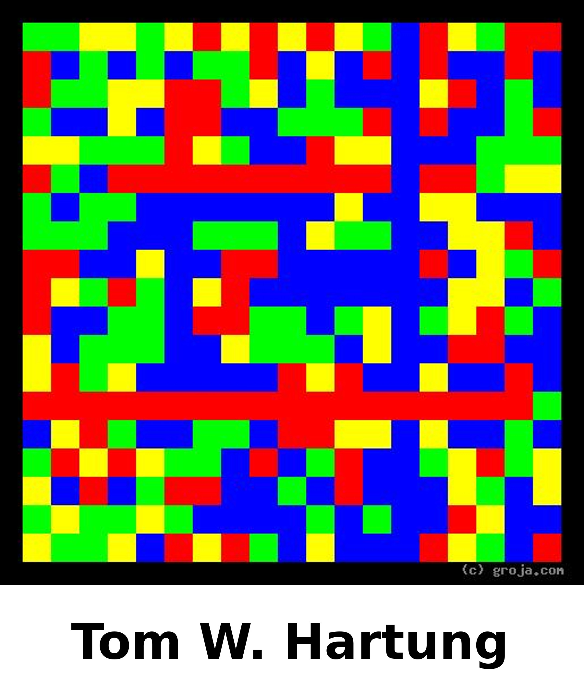
I tend to prefer observing to deciding. I prefer ideas to facts, and first got the idea to draw personalities in graduate school in the late 1980s.
It’s difficult for me to imagine myself being a crime boss – or most any other kind of boss, for that matter.
It’s much easier for me to imagine driving a taxi, and I’m a bit like Travis Bickle, in an abstract way. Luckily^{[2]} I never served in Viet Nam so, although I have ideas, they’re not like the ones Travis has. I’m fortunate to not be as troubled as he is.
It's only natural for me to ask a lot of questions. Here are a handful that I am thinking about right now:
- How well do you know yourself?
- Do you ever wonder why other people aren't more like you?
- Could your relationships be better?
- Do you ever wonder where other people are coming from?
- Would you like to know why some people just rub you the wrong way, right from the start?
- Could your team work better together?
- Are you as happy as you could be?
- Do you go through life without direction, just responding to things, like flotsam?
The next section explains how having an image of your personality - something I call a spiritual portrait or Groja^{[1]} - can help answer these questions.

Why Draw Personalities?
[This section must address **all** questions in the previous section.]

The fact that we are all going to die is a big reason you might want to get your spiritual portrait! These images also offer insight into your personality and how you relate to other people, both real and fictional.
Spiritual portraits can also provide a framework for better mindfulness, help you identify the type of work you are best suited for, and give you instant feedback on the strength of your preferences.

Finding Work That Suits Your Personality
Spiritual portraits can help you learn what sort of work you enjoy and are well-suited for. For example, if you are naturally drawn to work that is easily automated, wouldn't you want to know about it?
But if you take a little time to learn what the questionnaire results and the image means, it will help you identify what type of jobs will be easiest for you.
You can't just input your preferences and have the perfect career pop out, but a little self-knowledge can go a long way when it comes to understanding your strengths and weaknesses.
Some examples of how having your spiritual portrait can help you find suitable work are:
- If you have a tendency to be decisive, you may prefer being a boss.
- If you have a tendency to be perceptive, you may prefer just doing the work.
- If you tend to be more emotional, you will probably prefer working with people.
- If you tend to be more logical, you will probably prefer working with things.
- If your preferences are slight, you may prefer working for yourself.
- If your preferences are strong, you may prefer working for a large company.
Chapter 3, What the Images Represent, describes how you can use your spiritual portrait to learn what your tendencies and preferences are – and how these claims make perfectly simple, logical sense!
This is just a small taste of what you can learn from having your spiritual portrait. Once you understand your preferences and can visualize the strength of them, there are books and websites that can help you find the type of job best suited to your strengths, weaknesses, and preferences.

Insight Into Yourself and Others
As we go through life, all of us are continually expressing these preferences, and demonstrating the resultant personality traits in our daily actions. Also, many of us are already processing this information, to varying degrees, consciously or subconsciously.
Spiritual portraits make these invisible personality traits visible. This means having your spiritual portrait allows you to better understand:
- Why we do the things we do
- Where others are coming from
- Why we relate better to some people - both real and fictional - than to others
- What can cause difficulties we have with some types of people to happen again and again
People are aware of their preferences to varying degrees. Regardless of how well you know yourself, being able to visualize your personal preferences in a Groja^{[1]} is incredibly enlightening.
Knowing yourself is the fist step, knowing others in your life the second. Taking these steps is not like taking a magic elixir that will fix everything immediately, but rather the start of a foundation which can be built upon.

Death - Yours and Mine
If you die without getting your spiritual portrait, no one will ever know what it looks like!
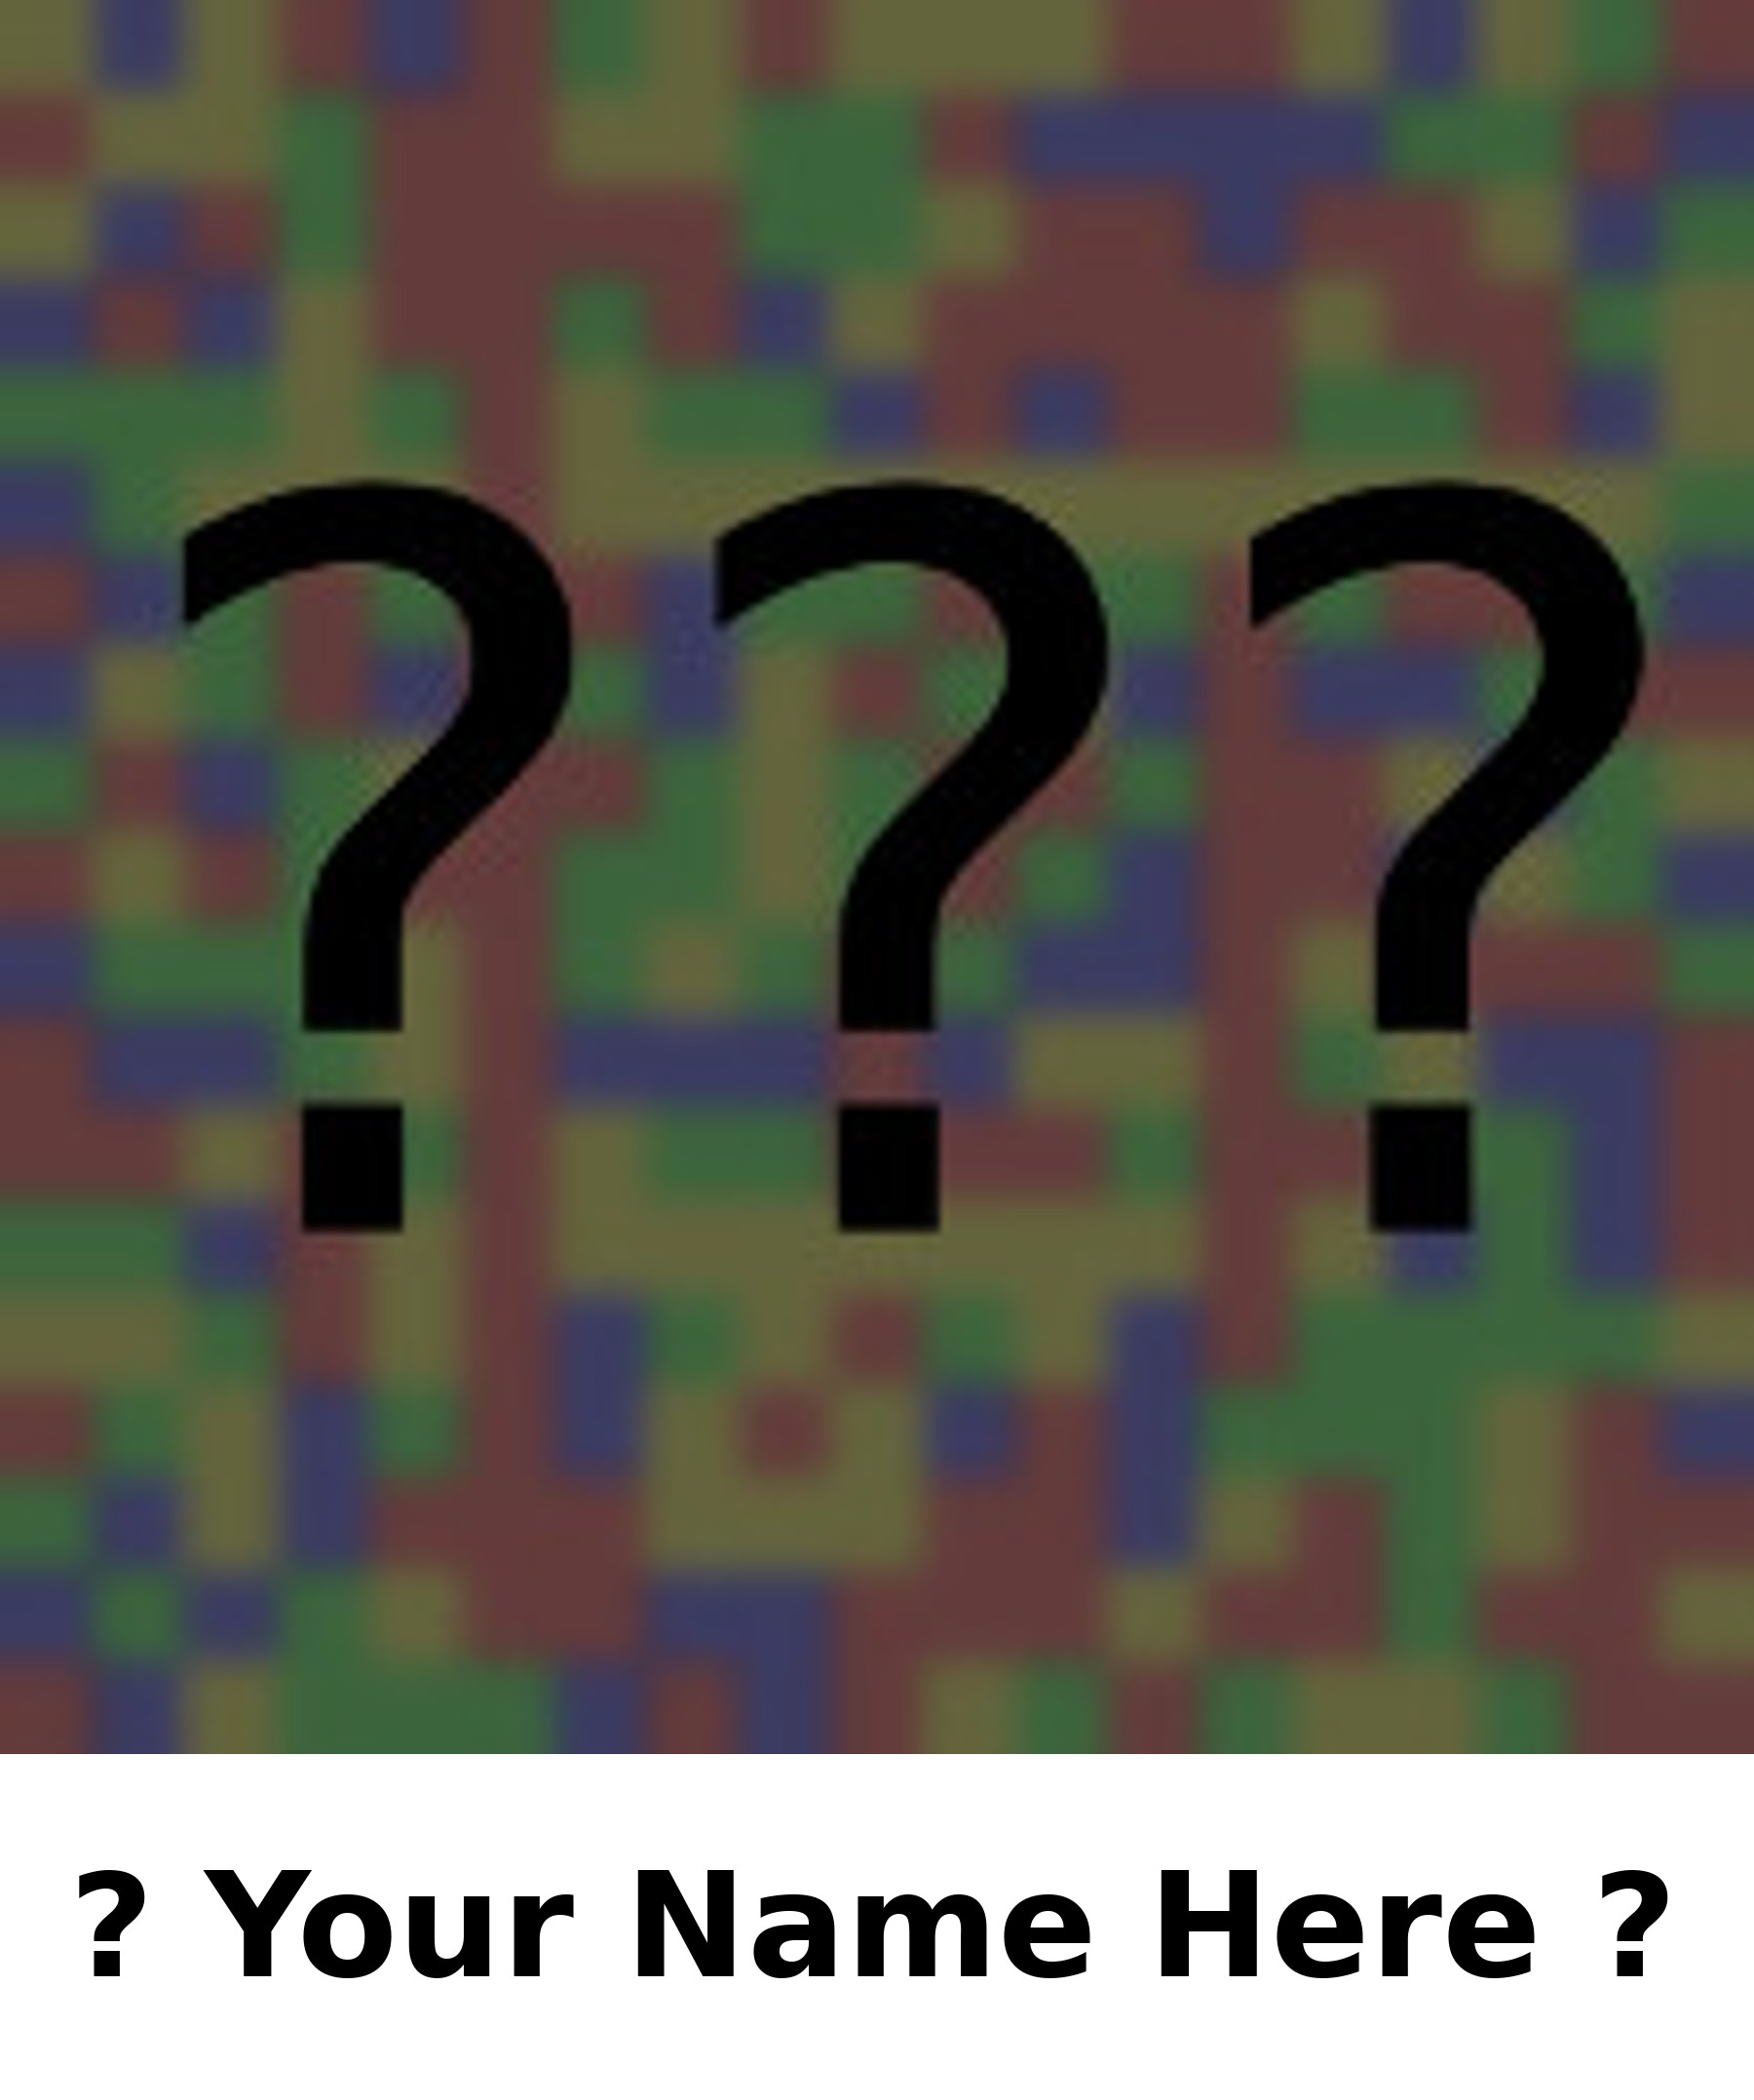

These portraits are based on the answers to a questionnaire, and you cannot answer the questions when you are dead. Someone else could answer them for you, but their answers will never be as accurate as yours.
Another thing to consider is, if I die before you get your spiritual portrait, it will be only an imitation, not the real thing.
I have been drawing personalities like this for over forty years. When I am gone, someone might take an interest in this project and they might be able to replicate my process, but I am the only person who can create the real thing.
The best way to get the most accurate image of your personality is for me to make your spiritual portrait while we are both still alive.
It is understandable for you to be interested in getting your portrait but still hesitant for some reason, because it’s a new idea! You will find it is an idea that won’t go away, and you should realize once it’s too late for one of us the result will at best be only an imitation, not the real thing.

Mild, Clear, and Extreme Preferences
We all have good reasons for being who we are, and we tend to expect others to be similar to us. When someone does something unexpected, it’s only natural to wonder why.
Spiritual portraits reflect not just a person's preferences but also the strength of them.
When a person is flexible and has mild preferences, it’s easy for a wider variety of people to see themselves in them. In real life these people are well-liked and in fiction they serve as an ordinary person – an everyman. I call them chameleons and refer to people like this as being chameleonesque.^{[3]}

Chameleons Have Mild Preferences
People who have slight preferences and balanced tendencies have colorful images. Here are a few examples, hopefully you are familiar with one or more of them.
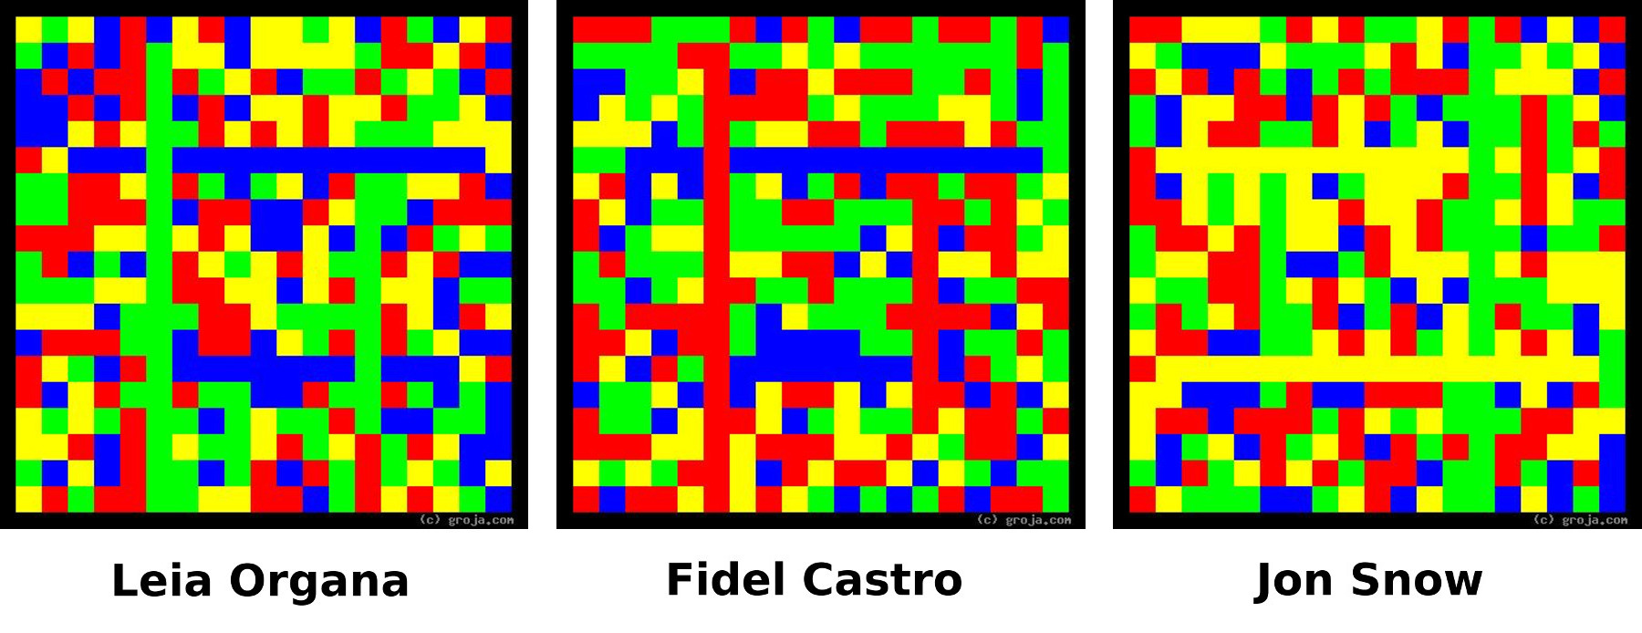

Many people – including the author – exhibit chameleonesque qualities to a certain extent, but these three are more remarkable than most.
The hosts of the Game of Thrones podcast I listen to deride Jon Snow for being a bathroom sign guy,^{[4]} someone that anyone can see themself in because he has nothing to make him unique.
As the leader of the Rebel Resistance, Princess Leia stands up to the evil Darth Vader yet allows herself to fall for the roguish Han Solo – and is revered as a modern feminist icon.
And as Prime Minister then President of Cuba from 1959-2008, Fidel Castro was able to use his versatility to be everything to everyone on the island.
People with chameleonesque personalities may prefer working for a small company or for themselves – or running a company or an entire country as a dictator, as the case may be – so they can exercise their versatility by taking on a variety of duties.

Most People Have Clear Preferences
People with clear preferences are different from those with mild preferences - and the images I create reflect the difference.
The spiritual portraits I create reflect the relative strengths of a personality’s preferences by varying the amounts of the primary colors used in the image.
In other words, images of personalities with stronger preferences contain more of just one or two colors, making them less colorful than the images of personalities with mild preferences.
People with clear, strong preferences may prefer working for a larger company or corporation. That way they can focus their strengths on work that uses their strengths and not worry about needing to perform tasks that made difficult due to their corresponding weaknesses.
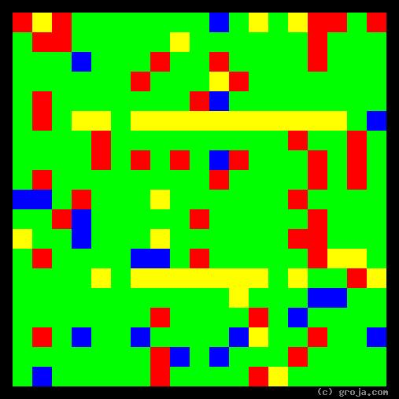Portrait 1: Alexander Hamilton - Author of the Federalist Papers and First Secretary of the Treasury | 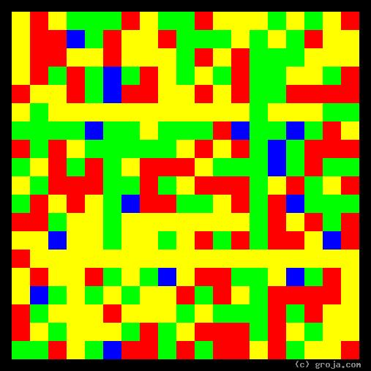Portrait 2: George Washington – Revolutionary General and First President of the United States | 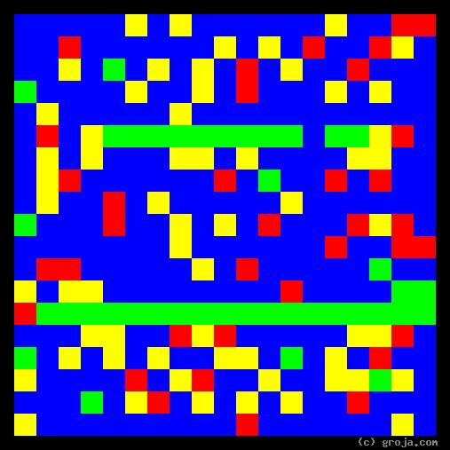Portrait 3: Thomas Jefferson - Author of the Declaration of Independence and Third President
These spiritual portraits show the personalities of three of the Founding Fathers who played major roles in creating the United States of America.
The images of Alexander Hamilton’s and Thomas Jefferson’s personalities show they have strong preferences and are quite different from one another. Combined with their different backgrounds, it’s easy to see how their different personalities would make it difficult for them to see eye-to-eye on the issues they faced.
In contrast, George Washington’s preferences are fairly mild. Although his personality is more like Hamilton’s than Jefferson’s, Washington and Jefferson were both Virginians who owned large country estates, giving them many shared interests.
The American people greatly admired Washington because he led the Continental Army to victory against the British. He was unanimously elected to the new office of President for two terms, and set a precedent for future presidents by stepping down when those two terms were done.
Hamilton’s and Jefferson’s personalities are strong but not extreme. They were political rivals but shared a commitment to seeing their new country not just survive but thrive. These images show how Washington could serve as an impartial mediator between these two, allowing them to exercise their strengths without one interfering with the other unnecessarily.
The lesson in these images is, regardless of the strengths of your preferences, being able to visualize them can help you understand why you do the things you do. They can also enable you to find team members who will help you shine – and perhaps be sensitive to and identify attempts by others to stifle your contributions.

The Hazards of Extreme Preferences
Fictional people with extreme preferences give insight into these tendencies and how important it is to recognize their relative strengths. Specifically, images of personalities with extreme preferences show a predominance of a single color, causing them to immediately stand out from the personalities in the more colorful crowd.
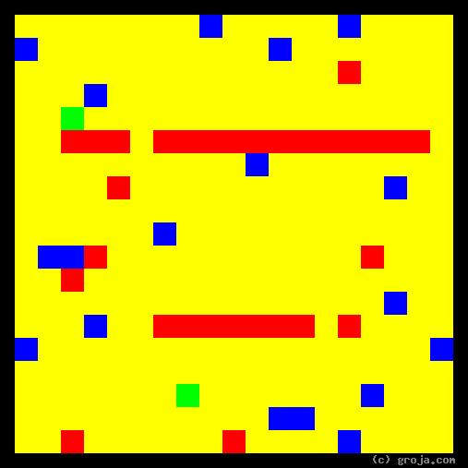Portrait 4: Norm Peterson – Barfly on Cheers | 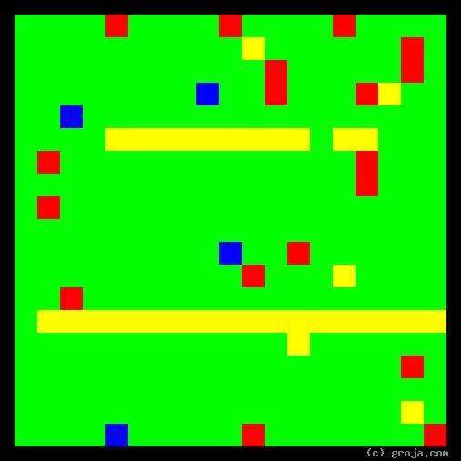Portrait 5: Tywin Lannister – Patriarch on Game of Thrones | 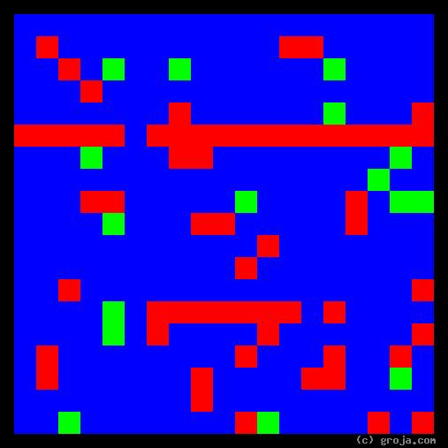Portrait 6: Margaret Lanterman – Log Lady on Twin Peaks
Norm Peterson is completely open, easy-going, and accepting of others. Everyone likes him, but he can’t hold a steady job, and ultimately gives up working completely. Norm is likable but incredibly lazy and ultimately just a friendly parasite who serves as a proxy for viewers.
Tywin Lannister puts his legacy ahead of everything else. Everyone fears him and even his own children find it impossible to talk to him. Tywin is wealthy and ambitious, but he lives a life devoid of love.
Margaret Lanterman is more like Norm than Tywin, and is also open, easy-going, and accepting of others. The difference with her is she lives in a world of her own – one in which she gets messages from a log she carries around town with her. Margaret must have some kind of pension so she can pay her bills, but most everyone in Twin Peaks thinks she’s crazy.
None of these people are living up to their potential. In her book Gifts Differing Isabel Meyers-Briggs explains why. She dedicates an entire chapter^{[5]} to warnings about how a strong supporting function is essential for all personality types.
If you have clear, strong preferences, hopefully yours are not as extreme as these fictional examples! And if after seeing your spiritual portrait you think or feel they are too strong, you can decide to learn and introspect about this – and maybe find more happiness by being mindful and adjusting your thinking a little bit!

Mindfulness
Bringing unconscious tendencies and biases to the surface, where we can think and talk about rather than be victimized by them, is always interesting.
In my mind, getting your spiritual portrait and becoming more aware of your tendencies and preferences is somewhat similar to practicing mindfulness, in that it involves taking a step back and looking at yourself objectively.
In today’s culture we have more options than ever before for how to spend our time, and we all want to make the best of the limited time we have here.
Some people are more aware than others of the power of their perceptions and the impacts of their decisions. This awareness tends to increase as we get older – particularly if we start being more mindful of our observations and actions – and we feel good about improving ourselves by learning from our mistakes.
Spiritual portraits can give mindfulness a fresh framework for understanding who we are and how we might improve.
Of course, mindfulness is not for everyone. Indeed, some people steadfastly refuse to learn from their mistakes, thinking that somehow shows they are weak. If you prefer to go through life blindly responding to stimuli without a second thought, then you would probably not appreciate having your spiritual portrait.

Too Busy - or Afraid of the Unknown?
My spiritual portraits are reasonably priced, so what do you have to lose?
For many people, answering a questionnaire may seem like too much work. It may bring back unpleasant memories of the quizzes, tests, and exams we suffered through in school.
For others, I have another theory: some people are afraid of their own subconscious.

Willful, Blissful Ignorance? Whatevs
Are you afraid of your own subconscious? Regrettably, I feel some people are.
Some people just want to go through life naturally. Some may be afraid that seeing their spiritual portrait might reveal a "dark side," or something else they want to keep secret.
There is nothing unnatural about a spiritual portrait – it's just an idea I had one day and have only lately decided to pursue.
One of my images will never reveal whether you are good or bad – but it can reveal your motivations, which may be subconscious – for being the way you are.
If you prefer to just coast through life, responding instinctively rather than consciously to whatever it throws at you, you will not appreciate having your spiritual portrait.
Not everyone will appreciate these images. To learn how likely it is that you will like yours, see Chapter 4.

Learn How to See Past the Surface
Drawing personalities has taught me that there is more to people than meets the eye. Working to silence that critical voice in my head that for some reason wants to judge people whom I don’t know based on how they look is challenging – and rewarding.
This mindfulness has helped me become more attentive and sensitive to what people say and do rather than how they look on the surface.
Maybe it’s my imagination, but I believe people appreciate this!
I am living proof it’s possible to make seeing past the surface a habit. It requires some effort but I am convinced many people pick up on this and appreciate it!

What the Images Represent
This chapter expands on the ideas introduced in the Preface.

Carl Jung’s Archetypes
The archetypes Carl Jung described in Psychological Types^{[6]} form the basis of the spiritual portraits I create. The book was first published in German in 1921.
In the 1940s and 1950s Isabel Briggs Myers, along with her mother Katherine Briggs, created a questionnaire based on Jung’s work. Known as the Myers-Briggs Type Indicator or MBTI®, the output from this questionnaire is summarized in a four-letter type such as ENFJ or ISTP.
These four-letter types are popular and carry a lot of information in a very small space – for those familiar with Jung’s archetypes and the MBTI. The images I draw contain this same information in a format allowing a more detailed understanding of the personality – for those familiar with what the colors and lines mean.
Familiarity with Jung’s typology and the Briggs’ four-letter types is NOT necessary to understand the spiritual portraits I produce – but it can certainly help.
In an effort to appeal to the broadest possible audience, this chapter makes minimal use of Jung’s terms and the Briggs’ four-letter types. I include them only to help those already familiar with Jung’s archetypes see the connections.
If you’re not familiar with the jargon, don’t worry about it!
And if you want to see what personalities look like using a different methodology, see the Appendix, which is about How to Draw a Personality.

What Does Phoenix Do?
Personalities are abstract things, and understanding and portraying them requires thinking abstractly. Because these abstractions apply to all people – and more - it helps to have an imaginary friend we can describe without conjuring any sort of specific imagery.
In other words, to facilitate thinking abstractly, we will look at an entity entirely free from any specific exterior qualities, such as gender, race, age, species, planetary origin, or biology.
In this chapter we look at Phoenix, an invisible, imaginary, conscious entity whose gender is unknown and who might even be an animal or extraterrestrial – or a machine equipped with artificial intelligence (AI).^{[7]} As far as we’re concerned, Phoenix is invisible!
The only requirement of our friend is they must be able to see things and do things – just like us. More generally, our friend can perceive and decide.

Perceptions and Actions
As a non-gendered conscious entity that might even be an animal, alien, or AI, our friend Phoenix gathers information and makes decisions. And as they do so, they will tend to develop a preference for one or the other.
In most cases, this preference is unconscious, and in many cases – such as for AIs and people with pushy peers and parents – it may actually be programmed into their subconscious.[8]
Carl Jung recognized this pair of opposite tendencies in his patients and called them Judging and Perceiving, and Myers-Briggs refers to them using the letters J and P. In the spiritual portraits I draw, Green and Red represent a tendency to make decisions, and Blue and Yellow represent a tendency to gather information.

Difficulties Due to Differences
People with a tendency to be decisive are hailed as being strong and worthy of respect – and derided as being manipulative and deserving of only defiance. People with a tendency to gather information are hailed as being open and easy-going – and derided as being wish-washy and hapless.^{[9]}
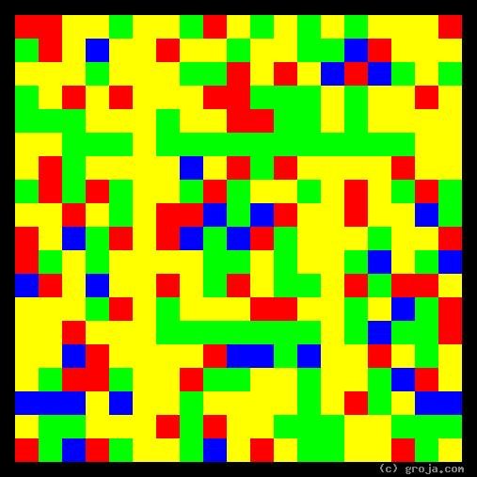Portrait 7: Sam Malone - Manager and Sometimes Owner of Cheers | 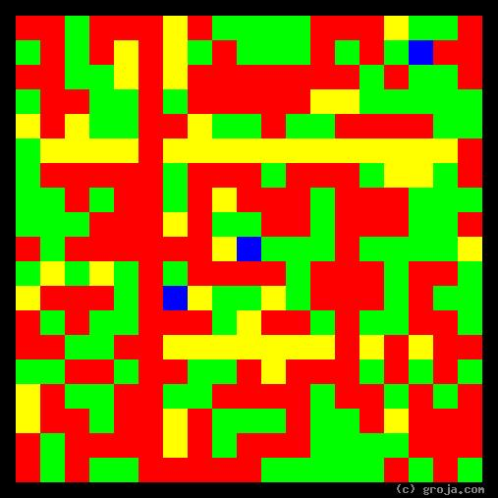Portrait 8: Carla Tortelli - The Real Boss on Cheers
Sam Malone is the Manager of Cheers. He’s ostensibly the boss, but he identifies more as a womanizing jock – a minor celebrity who was a relief pitcher for the Boston Red Sox.
Carla Tortelli is a single mom making her way as a waitress at Cheers. Sam may be the boss, but Carla is far more decisive. She knows what needs to be done and she wastes no time in doing it, so there’s no need for Sam to “manage” her.
Spiritual portraits can show us the difference between someone who has a title of “Boss” and someone for whom the title is unnecessary and redundant.
Forget your title and official position for a moment and consider this: are you more of a boss or a worker?

Facts and Ideas
As our friend Phoenix, who could be a person, an animal or an alien, but also might be invisible and so has no known gender, has experiences and learns about life, they can learn by gathering plain old everyday facts, and by getting ideas. The facts are based on the various senses, and the ideas are based on lessons they are taught and patterns perceived in the facts.
Carl Jung took his analysis of personalities a step further and identified two ways of gathering information:
- We can use our senses – sight, hearing, touch, taste and smell – to gather facts
- We can use our intuition to find patterns and lessons in the facts we have learned
Jung called this pair of opposite tendencies Sensing and Intuition, and Myers-Briggs refers to them using the letters S and N. In the spiritual portraits I draw, Yellow represents a tendency to use our senses gather information, and Blue represents a tendency to use intuition to glean information by finding patterns and lessons in the facts.

Difficulties Due to Differences
People with a tendency for gathering facts are hailed as being pragmatic and down-to-earth – and derided as being shallow and superficial. People with a tendency to gather information are hailed as as being open and easy-going – and derided as being wish-washy and hapless.^{[9]}
These opposing tendencies to see the world in terms of either facts or ideas are the biggest difference separating people.
If two people look at the same thing and see something different, how can they ever agree on what to do? Those with a strong tendency to see the world one way or the other are as different as night and day.
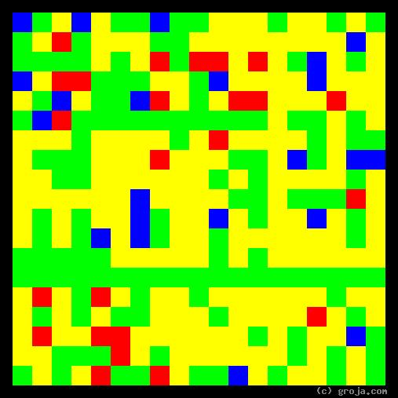Portrait 9: R2-D2 – Small Astromech Droid on Star Wars | 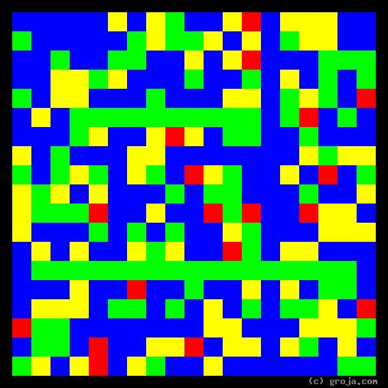Portrait 10: Obi-Wan Kenobi – Jedi Master on Star Wars
R2-D2 is a robot in the original Star Wars movies. He’s full of facts and can interact with all manner of machines, but has no clue when it comes to understanding something as abstract as The Force.
Obi-Wan Kenobi is a Jedi Master in the original Star Wars movies. He’s full of wisdom about the powers of The Force – which cannot be seen, heard, touched, tasted, or smelled – and disinterested in facts. Obi-Wan has so much power of mind over matter he ultimately finds a way to transcend death – to a certain extent, anyway.
Are you more of an R2-D2 or an Obi-Wan?

The AI’s “Preference” for Facts
At this time, seeing patterns in the facts is something humans can do more easily than machines. However, teaching machines to recognize patterns is becoming easier with the rise of Machine Learning (ML).
If you are concerned about losing your job to an AI, this fact – and knowing the strength of your preference for either gathering facts or finding patterns – is something you may want to think about!

Emotions and Logic
As our friend Phoenix, who may be human or an extraterrestrial or even an AI, matures and continues through their life, they eventually find they need to make decisions. Generally speaking, Phoenix can make these decisions in one of two ways, either with their heart and gut feelings, or using their head and rational logic.
Carl Jung saw this and took his analysis of the human psyche another step further and identified two ways of making decisions:
- We can make emotional decisions based on how we feel
- We can make logical decisions based on rules we have learned
Jung called this pair of opposite tendencies Feeling and Thinking, and Myers-Briggs refers to them using the letters F and T. In the spiritual portraits I draw, Red represents a tendency to make emotional decisions, and Green represents a tendency to make logical decisions.

Difficulties Due to Differences
People with a tendency to be emotional are hailed as being warm and personable – and derided as being unpredictable and overly dramatic. People with a tendency to be logical are hailed as being cool and objective – and derided as being cold and unfeeling.^{[9]}
These opposing ways of making decisions are the source of most difficulties between people.
If one person always favors their heart and the other always goes with their head, how can they ever agree on anything? Those with a strong tendency to do things one way or the other can argue indefinitely without making any progress – until one decides to compromise or they decide to go their separate ways.
People in touch with their emotions have warm personalities, while those prefering logic are the cool ones – and my images reflect the feelings we get from them.
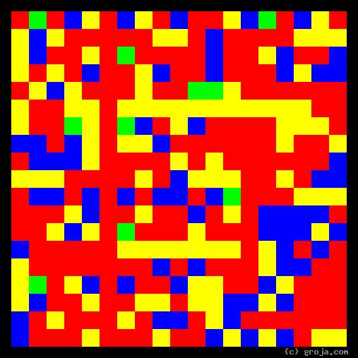Portrait 11: Lucy Ricardo - Starstruck Wife on I Love Lucy | 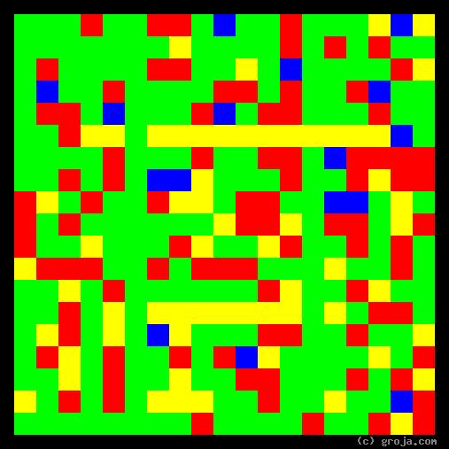Portrait 12: Ricky Ricardo - Lovestruck Husband on I Love Lucy
Lucy is infatuated with movie stars and stardom. Ricky sees himself as the boss, and wants her to stay home and take care of their child and apartment. Lucy tries to comply with Ricky’s desires, but never really succeeds – and hilarity ensues!
Ricky is usually the one who ends up compromising, and we can see why. He has quite a bit of emotion – there is quite a bit of Red in his image – while Lucy has very little logic – as seen by the very tiny bit of Green in her image.
In a typical episode, if worse turns to worst, she breaks down and turns on the tears. In turn, Ricky usually finds a compromise or just completely caves, Lucy smiles and dries her tears, and we all live happily ever after.
Are you more of a Lucy or a Ricky?

The AI’s “Preference” for Logic
At this time, a tendency to make emotional decisions is something humans can do much more easily than machines. An AI has no choice in this matter because it is ultimately built entirely on logical circuits running logical programs written in logical programming languages.
Today, teaching machines to be more emotional than logical seems problematic and unprofitable – but who knows what the future might hold? Might it be worthwhile to teach a Voice User Interface (VUI) such as Alexis, Cortana, the Google Assistant, or Siri, to be compassionate? I think so!
Again, if you are concerned about losing your job to an AI, this fact – and knowing the strength of your preference for being either emotional or logical – is something you may want to think about!

Out There and In Here
As our friend Phoenix, who may be human but is not necessarily so, comes to know others, who likewise might be people but could just as well be an animal or AI, they develop a tendency to be either outgoing or relatively reticent.
Carl Jung saw these tendencies in people and once again – this is the last one, I promise – took his analysis of personalities a step further. He identified two ways of relating to the worlds inside and outside our minds:
- We can be more outgoing, and gain strength by using our energy to deal with other people and things
- We can be more reticent, and gain strength by directing our energy internally
Jung called this pair of opposite tendencies Extraverted and Introversion, and Myers-Briggs refers to them using the letters E and I. In the spiritual portraits I draw, Vertical lines represent a tendency to be outgoing, and Horizontal lines represent a tendency to be more reticent.

Difficulties Due to Differences
People with a tendency to be outgoing are hailed as being gregarious and sociable – and derided as being uninhibited and overly talkative. People with a tendency to be reticent are hailed as being soft-spoken and bashful – and derided as being aloof and reclusive.^{[9]}
Outgoing people are easy to understand, but it takes some time to get to know more reticent people. As is the case with the other opposing pairs of preferences, many people are not either one or the other but a little bit of both – they are ambiverts.
Members of western societies read from left to right and top to bottom, and it’s natural for us to view images in the same manner. The spiritual portraits I create use a Vertical line near the left side of the image to represent outgoing personalities – because both are apparent to the viewer right away. Similarly, the images use a Horizontal line near the bottom of the image to represent more reticent personalities – because both are not apparent right away.
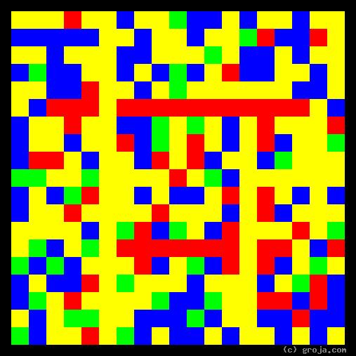Portrait 13: Zeronimo - Outgoing Tuxedo Kitty Cat | 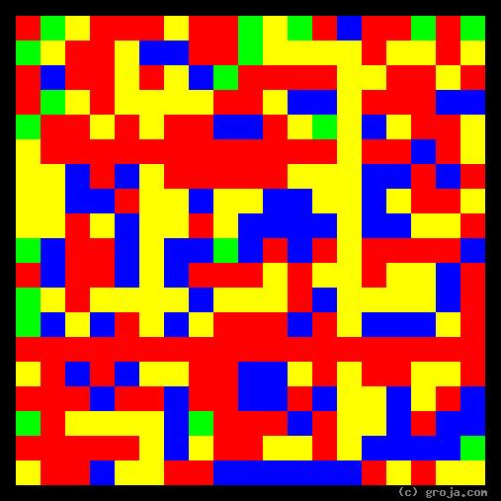Portrait 14: Mildred - Shy Grey Tabby Kitty Cat
Just like us, our pets have personalities! These spiritual portraits are of two of my kitty cats, an outgoing tuxedo kitty named Zeronimo and a shy grey tabby kitty named Mildred. Mildred was here first, but Zeronimo quickly made the space his own.
When my friends brought Mildred over, she ran upstairs and hid under the bed. At night while bed I could hear her walking around and getting some food, but for the most part she stayed there the entire weekend – from Friday night until Sunday afternoon. Even after we got to be friends she stayed hidden whenever I had friends over.
Zeronimo is the opposite. When I brought him home from the Denver Dumb Friends League, trying to follow their recommendations to keep him separate from Mildred for at least a day was extremely difficult! Zeronimo was determined to not be left alone and needed access to the entire household immediately! He was all over my friends whenever they’d come visit and would even get jealous when I’d talk on the phone.
Mildred and Zeronimo are extreme examples. I think most people and pets are somewhere in between.

Recap/Summary
It’s doubtful Carl Jung and Isabel Myers-Briggs ever thought about how animals, aliens, and AIs might exhibit these characteristics – but I have! Human beings are not the only entities that can gather information and make decisions.^{[7]}
Here is an overview of how these images use colors and abstract forms to represent personality traits:
- Direction – may be outward or inward
  - Extraverted: a Vertical line represents an outward direction
  - Introverted: a Horizontal line represents an inward direction
- Observing – learning facts or ideas
  - iNtuition: Blue represents a tendency to perceive ideas
  - Sensing: Yellow represents a tendency to perceive facts
- Deciding– using emotions or logic
  - Feeling: Red represents a tendency to listen to the heart and make emotional decisions
  - Thinking: Green represents a tendency to listen to the head and make logical decisions
- Strongest – is either observing and “Perceiving” or deciding and “Judging”
  - Perceiving: More Blue and Yellow represents a stronger preference for observing
  - Judging: More Red and Green represents a stronger preference for deciding
For anyone interested in more, there are many websites and books with more details about Jungian Typology and the MBTI®.

Who Would Most Appreciate a Spiritual Portrait?
How to determine whether you would like to see your Spiritual Portrait.
- World's Shortest Personality Quiz - or Something
- Instant Personality Quiz?
- Two questions, pick where you are on the continuum
- Use at least positive, neutral, and negative synonym on each side
- Use the colors subtlely in the continuum - a gradient with white in the middle might be nice
- S ------- N - where are you, on a scale of 1-10?
- T ------- F - where are you, on a scale of 1-10?
What your score means:
- If your score is 10 or more, you will like your spiritual portrait
- The higher your score, the better chance you will like it
- If your score is less than 10, a spiritual portrait is not for you
- The lower your score, the less probability you will like it
How it works
- Personality traits and images of personalities are abstract
- If you are more N than S,
- If you are more Blue than Yellow,
- If you prefer ideas to facts,
- If you are more comfortable with abstractions than most,
- Then you will understand the images more easily
- Personality traits and images of personalities are all about people
- If you are more F than T,
- If you are more Red than Green,
- If you prefer emotions to logic,
- If you'd rather work with people than things,
- Then you will understand the images more easily

Conclusion - The Pitch
[Review Daniel Pink's book before completing this section.]

Benefits
Grojas can help with:
- Self-awareness
- Relationships - personal & professional teams - explain how briefly
- Etc. - review salient points from the Selling Points section.

Pricing
Pricing is variable.
If you see us running a special offer, you would be wise to take advantage of it.
- Increased demand:
- May well drive up the price of hand-crafted images
- May push me to better automate production, so the price will always be reasonable
- Images of similar personalities will look similar, but no two images will never be identical

Appendix

How to Draw a Personality
Drawing personalities is so easy and fun, I don’t understand why more people don’t do it! Certainly this disconnect is because I, like most people, tend to project my preferences on others and also because I, unlike most people, am weird!
This Appendix is for:
- People who want to understand how I draw personalities
- Anyone who wants to draw personalities using their own methodology
If you are thinking about trying this yourself, you should check out a couple of experimental compositions I tried some years back that are now in their own gallery on SeeOurMinds.com.

Choose the Traits to Portray
Drawing personalities requires deciding what qualities should appear in the images. Do not assume all images of personalities have to use Carl Jung’s theory of archetypes!
Psychologists have identified many personality traits, and there are critics of Jung’s theories. I knew about this at the time I wrote the first version of the Groja program, and briefly considered using a different methodology – such as the Big Five personality traits – but chose to use Jungian Typology for a variety reasons.
For some reason, I have always been interested in Carl Jung. An additional advantage to using the archetypes he identified is they are objective and nonjudgmental. The questions in a Jungian Typology Questionnaire have no right or wrong answers, so people who take it do not have to worry about what it reveals. It stands in stark contrast to the MMPI which is designed to identify people whose minds are not working properly.
There’s no need to pick a single methodology right away, but it’s essential to be aware of the choices available before proceeding to the next step.

Choose How to Portray the Traits
Because personalities are abstract, drawing personalities requires knowing about abstract art. For this step I recommend starting with two books by Wassily Kandinsky, Concerning the Spiritual in Art and Point and Line to Plane. They are very short but highly revealing.
After reading those, consider seeking out similar works. In my case, Piet Mondrian turned out to be a huge inspiration. I would love to see work inspired by a different artist, if it’s at all possible.
This is the key step, and it helps to be aware of a variety of personality trait theories while working through this.
Ideally you want the resultant image to have the same feel that people get from the person in the portrait.
It turns out that my interest in Jung, Kandinsky, and Mondrian all came together perfectly. Jung’s theory may be too simple for clinical psychologists, but they correspond very well with a superset of four primary colors.
The Grojas I draw use the following methodology:
- Red to portray a tendency to make emotional decisions – what Jung called Feeling – because it represents the blood that flows when emotions run high
- Green to portray a tendency to make logical decisions – what Jung called Thinking – because it is a cool, neutral, yet strong color
- Yellow to portray a tendency to see facts – what Jung called Sensation– because when the night is over it’s time to wake up to the facts
- Blue to portray a tendency to things in terms of ideas – what Jung called Intuition – because they tend take precedence during the night time, in the form of dreams or a nagging conscience
- Vertical lines to portray the function that is most noticeable in outgoing people – what Jung called Extraversion – because vertical lines quickly interrupt the flow of our vision as we scan an image left-to-right
- Horizontal lines to portray the function that is most noticeable in more reticent people – what Jung called Introversion – because we tend to not see the horizontal lines right away
Keeping this part simple and intuitive is key to making it easy for others to understand your images – and for being able to write a computer program to create them.
Remember, you are not limited to using just colors! Other attributes of abstract images, such as shape, size, and incorporating both static and dynamic direction, are all valid ways to represent the traits you decide to portray.

Find or Write a Questionnaire
The next step is to find a questionnaire identifying the traits the images are to portray.
It is fine to use a questionnaire written by someone else, as long as you do not violate the author’s copyright somehow, for example by publishing it without authorization.
Writing your own questionnaire is great because it demonstrates you know what personality traits you are looking for, and frees you from having to worry about a copyright violation. But it’s not absolutely essential to have your own quiz before getting started.

Write the Program
If the images are to be consistent, it is best to write a computer program to generate them.^{[99]} Assuming the personality questionnaire being used consists of a set of multiple-choice questions, it should be possible to process
The Groja program uses a combination of fixed and random positioning for the rectangular elements. I feel this works well and when creating a portrait I typically generate and select from five or more images.
Working with the program – first writing it then later using it – is my favorite part!

Get Personalities and Create Images
When the program is done it’s time to get people to answer your questionnaire so you can draw their personalities.
When I finished writing the first version of the Groja program I would invite friends over for Groja parties. Of course, my friends are less well-known than famous fictional and real people, so to demonstrate I know what I’m talking about, I decided to start drawing the personalities of people whose names are recognizable.
As a life-long learner, creating new images satisfies a deep-seated need I have for new, unique information. As stated earlier, seeing the first images of a newly analyzed personality is my favorite part!

Creating Images
[Copied from the Got book, this needs to be better integrated into the flow of this Appendix.]
Here is the process I use to create these images:
- Watch the show repeatedly, and all commentaries at least once
- Answer a Jungian typology questionnaire the way I think one or more characters might
  - I have found it to be to be much more efficient to do two or three characters at once instead of doing just one a time[3]
  - It also helps to have the show going in the background when answering the questionnaire
- Plug the results into the Groja© program
- Generate four to six images for each personality
- Pick the image I like the best, and save it in a .jpg file
- Post the .jpg and some explanatory text to SeeOurMinds.com and possibly to ArtsyVisions.com
To learn how I came up with this process, the whole idea of drawing personalities in the first place, as well as the number of times I’ve written and rewritten the Groja© program, see the About page on Groja.com.

A Personal Note
Thousands of years ago the first artists used primitive pigments to draw scenes from their lives on cave walls. Over thousands of years paintings grew increasingly realistic until finally the camera came of age, effectively making realistic paintings obsolete.

The Real Lessons of Abstract Art
Painters responded to the commoditization and automation of their hard work by photographic technologies and switched their focus from the external to the internal. They started drawing and sharing what they saw inside, confusing plenty of people but delighting and enlightening plenty more.
In the meantime, technology has now advanced to the point where virtually everyone has constant access to a video camera in their pocket. No one needs to wait for their paint to dry, their film to develop, and a museum curator or other customer to find value in it – we can use any one of a variety of social networks to share our work with the world instantly!
Today we have a wide selection of powerful programming languages and other tools capable of creating realistic virtual environments. Commercialization rules and people seem unaware they have the potential to build surrealistic landscapes previously unimaginable.
Each of us has all manner of tools to support our creative potential, yet we continue to realize only a small fraction of it.

Real Artists Wanted
Where have all the real artists gone – the people sensitive to their unique internal worlds and willing to share their personal visions with the world? Have they gone to Facebook and Twitter, everyone? “When will they ever learn?”
I am fully aware that many people think I’m nuts to spend years working on a project with minimal monetary compensation. I can see they are disappointed in how I choose to spend my time, but few of them know I feel the same way about them.
It would be nice if I could make some money off of the huge amount of time I’ve spent on this project, but it would be nicer still if I could motivate others to use modern technology to create their own unique project.
Look at the cave walls, the canvas paintings, the photographs and films and tv shows, and consider, what might be next, and what might be your unique role in it? Then build it and share it with me, I’ll be waiting!

